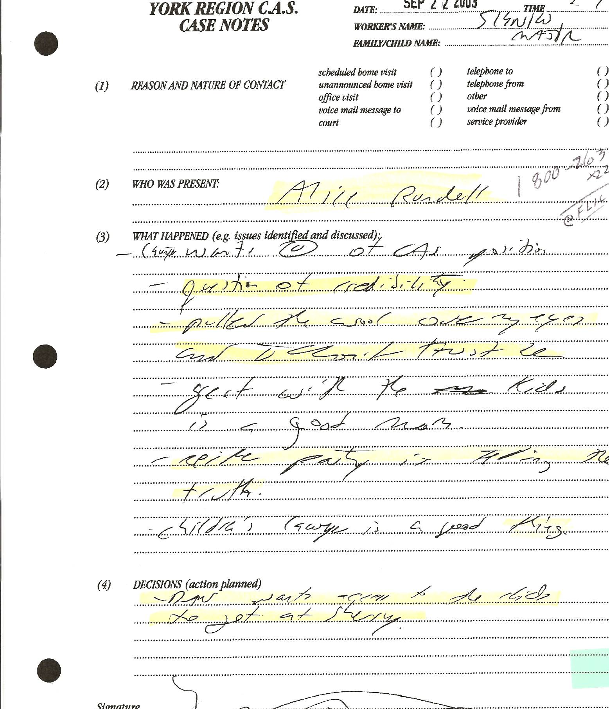

Dan’s Notes:
Walter Sienko (CAS) met with Alice Rundell of Yellow Brick House (Women’s shelter/assistance), who advised him of the considerable “question of credibility” concerning Sherry’s allegations against Dan (who was currently out on bail pending the Oct 28/03 trial date). Sienko further noted Alice advised Sherry had “pulled the wool over my eyes and I don’t trust her.”
Bottom line: CAS knew Sherry was not to be believed yet did nothing to correct their false assertions against Dan and instead actually encouraged Sherry to criminally abscond with the kids.

“DECISIONS (action planned) – Dan wants access to the kids to get at Sherry”

Dan’s Notes:
-despite the CAS being FULLY AWARE Sherry is TOTALLY UNRELIABLE AND DISHONEST they still overlook anything and everything she does – likely because their arrogance prevents them from admitting they were wrong all along – sadly, they can easily abuse their position of power and trust by labeling Dan as the problem – they then continue to do that FOREVER, thereby forcing me into the current situation

