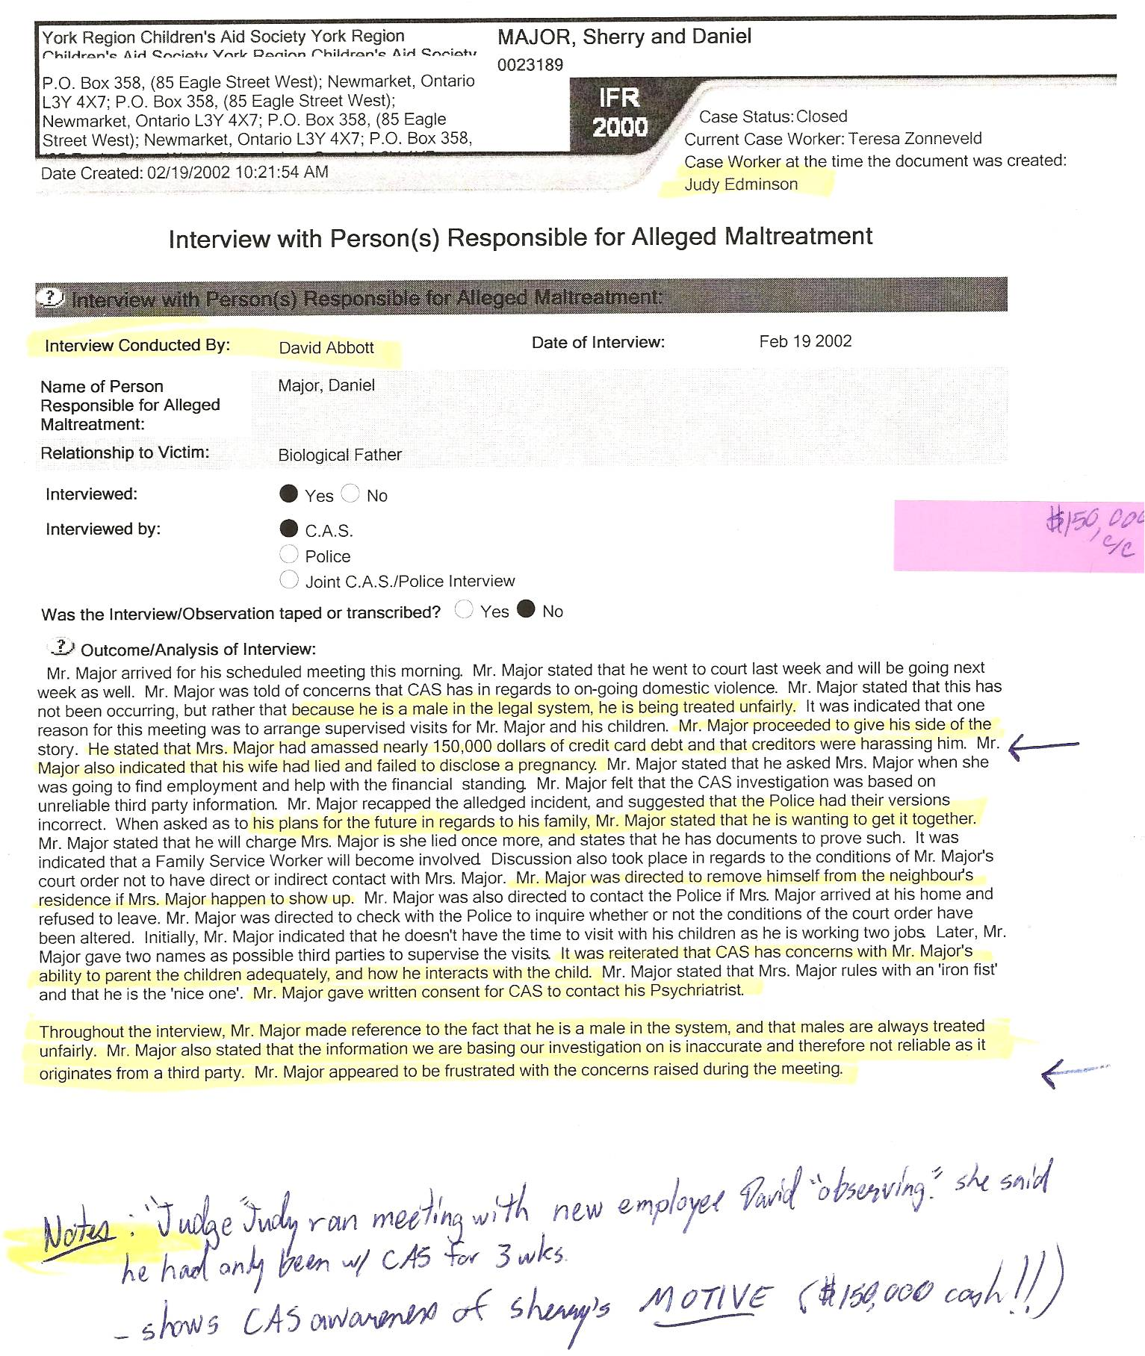
FACT:
-(because he had nothing to hide) “Mr. Major (readily) gave written consent for CAS to contact his Psychiatrist” (they did so that day, had the report faxed that afternoon noting my psychiatrist’s report that Dan “continues to be mentally stable”)
-before Dan’s 16-month detainment (beginning Feb 20/02) the CAS was fully aware of Sherry’s MOTIVES to lie – Dan provided them with facts regarding means, motive and opportunity that were never investigated by police or CAS.
-“Mr. Major appeared to be frustrated …”
-meeting was run by July Edminson, NOT David Abbott – he was merely a non-speaking observer, new with the CAS for merely 3 weeks – at the beginning of the meeting Judy Edminson threatened that she would ensure Dan wouldn’t see his kids “for a long time,” despite Dan’s protests that Sherry’s story (of abuse, etc.) was all lies and that his side of the story was never investigated – Abbott never spoke except when Dan asked him to acknowledge Judy’s threat – Abbott claimed he “wasn’t listening that closely” – Dan left the meeting since Judy refused to take seriously any of his claims – at least she acknowledged them here!

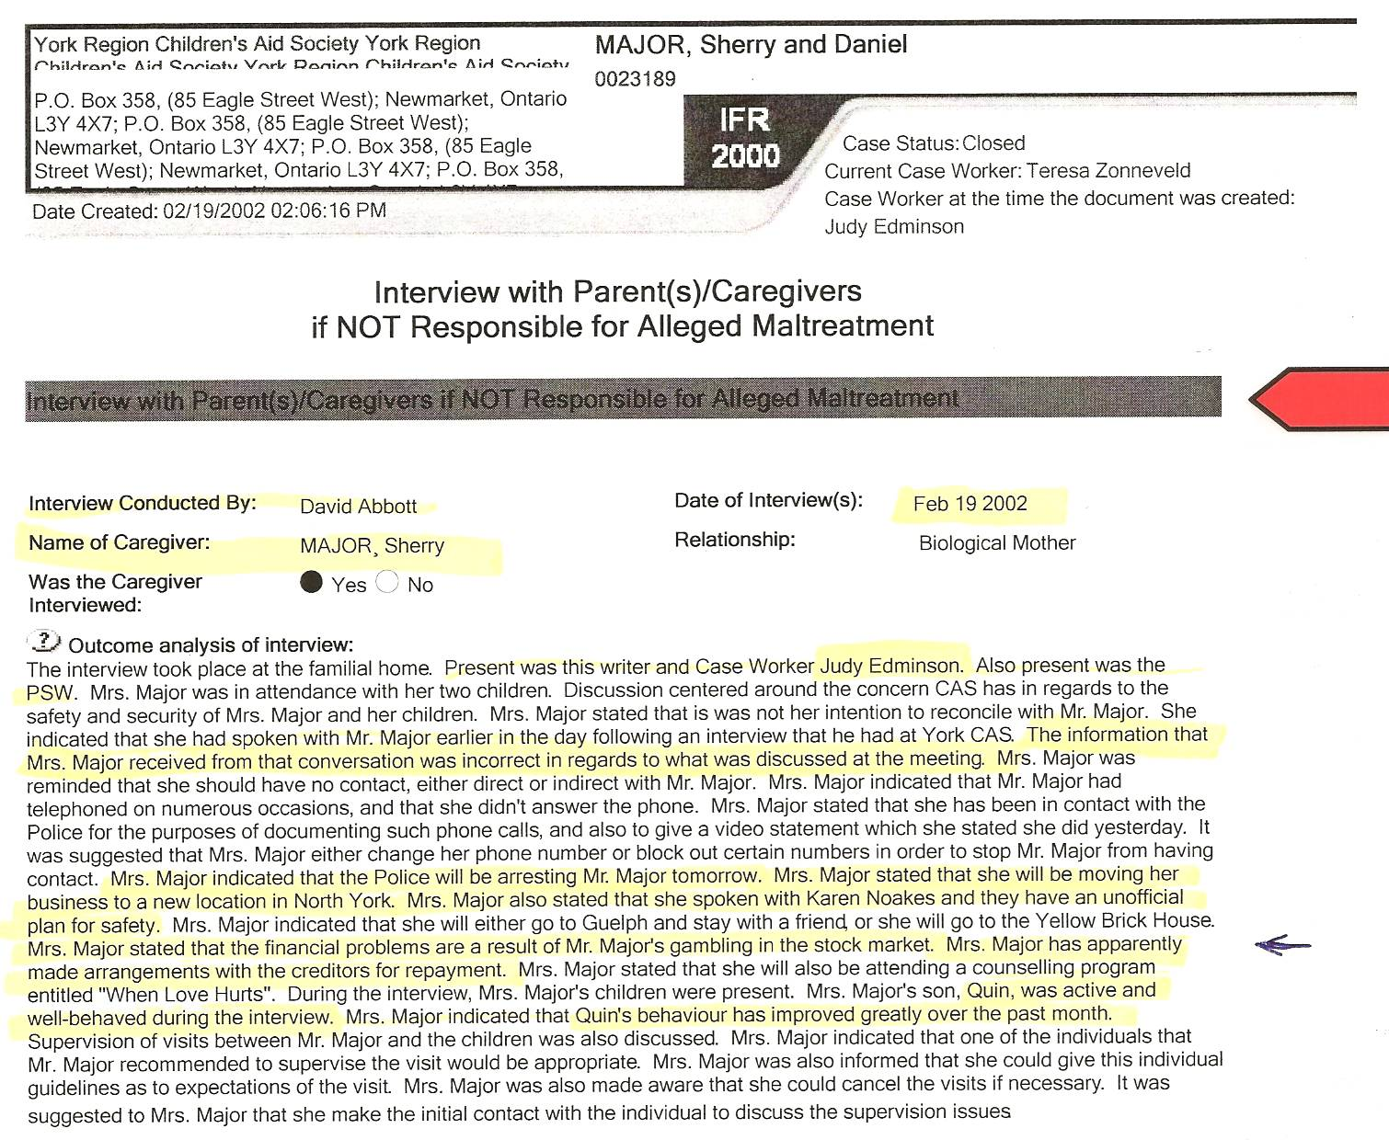

-“Mrs. Major stated that the financial problems are a result of Mr. Major’s gambling in the stock market. Mrs. Major has apparently made arrangements with the creditors for repayment.” (total fiction!!)

FACT: (TRUTH be DAMNED – and buried in files!)

-more evidence suggesting Sherry is a Pathological LIAR (no need to claim she would repay Dan’s (alleged) debt) – in reality, the debt was fully incurred due to Sherry’s fraud, as noted by Dan to the CAS earlier that day
-“moving her business” – she moved b/c she bilked her landlords, Helmut & Elizabeth Brosz, of over $5,000! She did move the business and then bilked her next commercial landlord, Dr. Pirouzi, of over $7,000! She then moved her residence to Aurora and subsequently also bilked that landlord, Hector Nesta, over over $5,000!
-“go to Guelph and stay with a friend” – Sherry bilked that friend, Genny Wygergangs, of many thousands of dollars! (details on request)

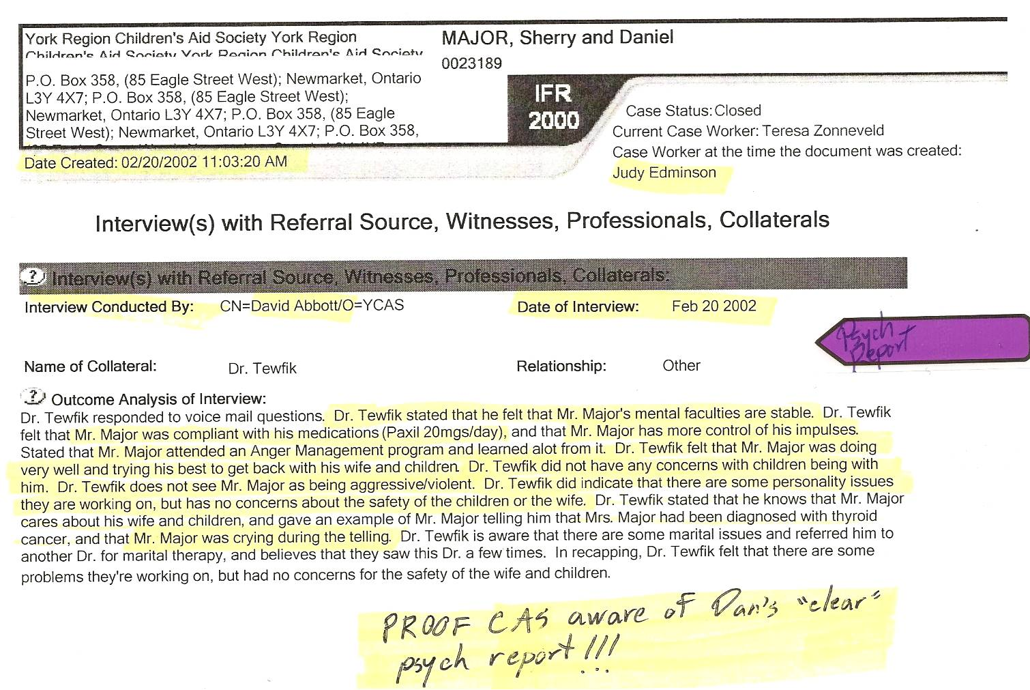

PROOF CAS aware of Dan’s Psychiatric Report – declared “mentally stable”

