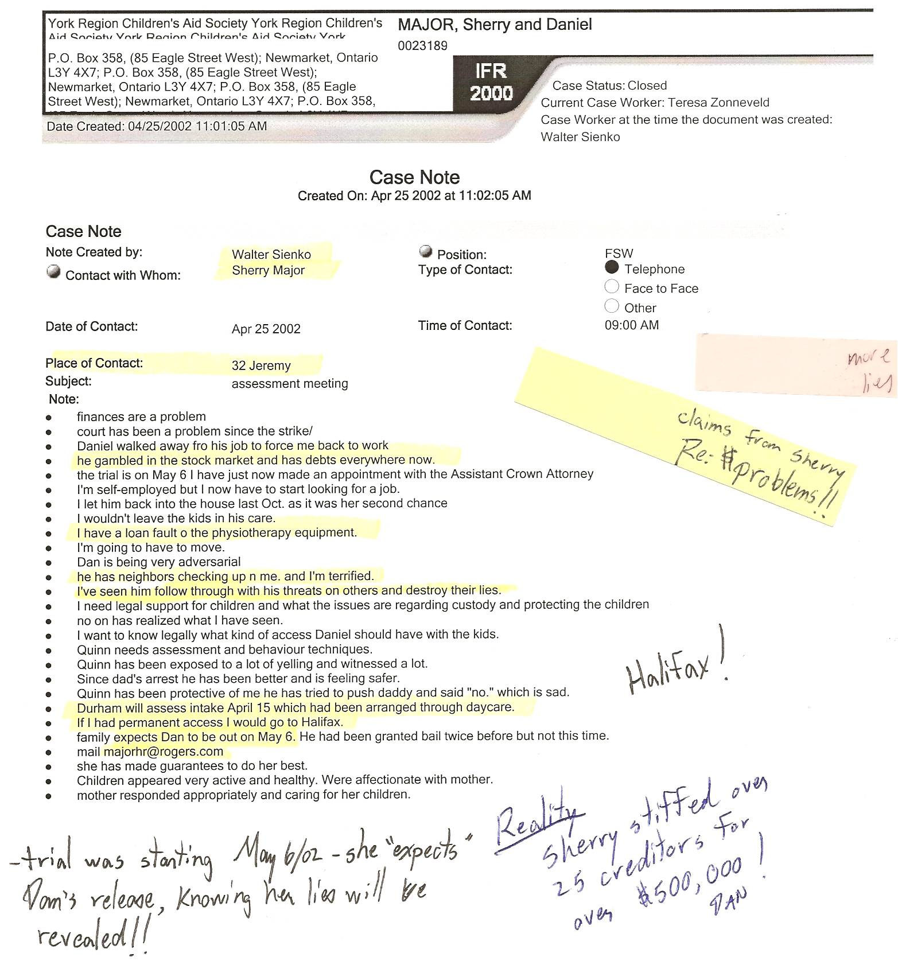

FREUDIAN SLIP ☺ “I’ve seen him follow through with his threats on others and destroy their lies (sic – s/b lives)” – Dan does expose lies! This supposedly destroys people’s lives?

CAS awareness of Sherry’s desire to move to Halifax, N.S.
-“If I had permanent access I would go to Halifax”

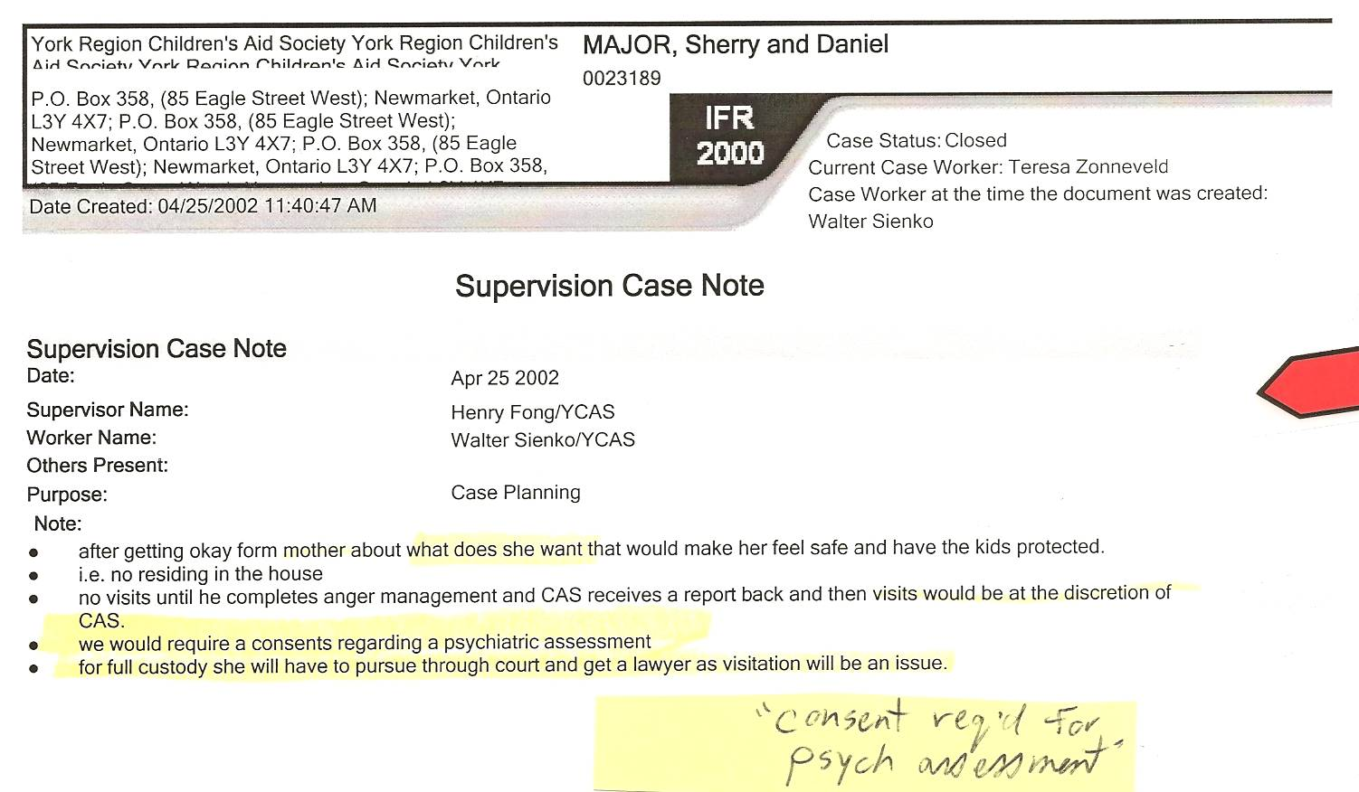

-If CAS knowingly requires consent regarding a psychiatric assessment (which Dan refused to do a second time), and have already gained “psych clearance” from Dan’s psychiatrist, Dr. Tewfik, then why do they continue to withhold access to the children for many years, the excuse being that Dan refuses to comply with their request for a psych assessment? They are abusing their position since the court has not ordered a psychiatric assessment!

