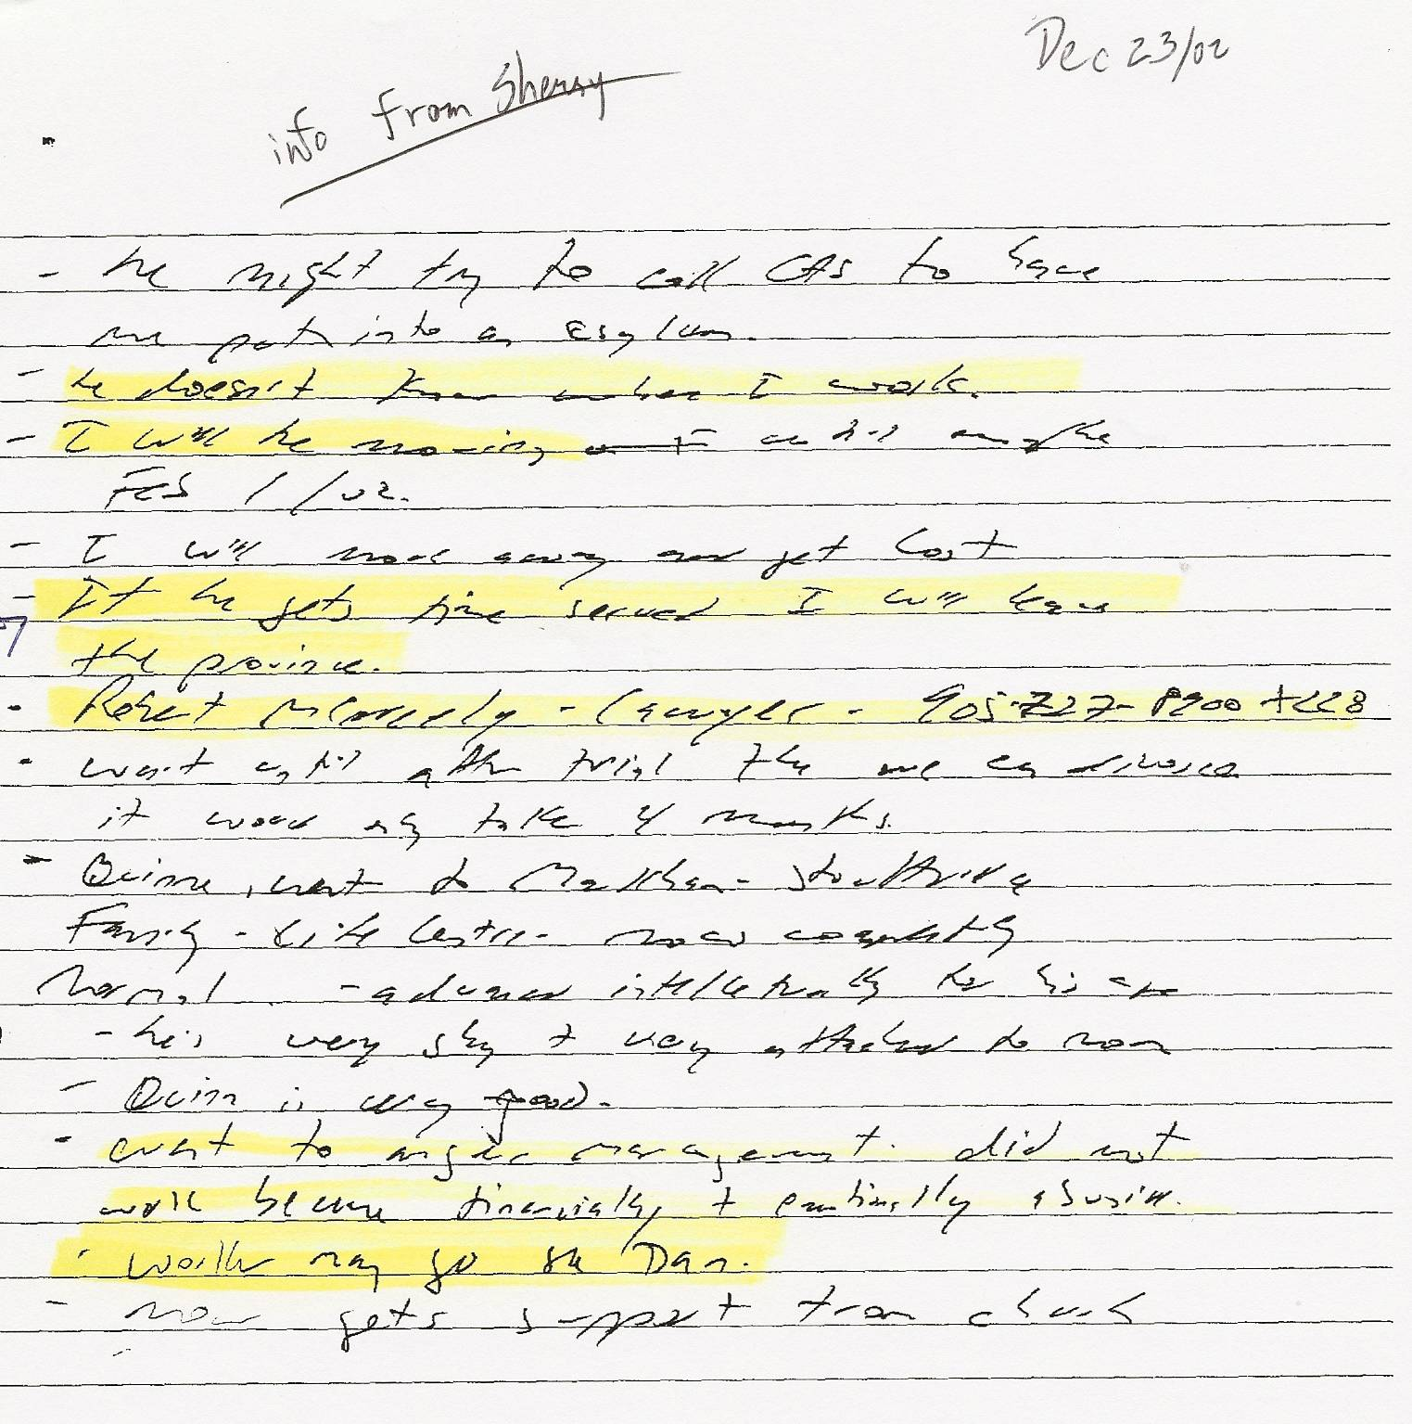
Notes and translation of poor CAS handwriting Re: CAS meeting with Sherry Dec 23, 2002
(Dan was detained in a maximum-security prison from Feb 20, 2002 to Sept 5, 2002, followed by 9-1/2 months of house arrest)
-“he might try to call CAS to have me put into an asylum”
-“he doesn’t know where I work”
-“I will be moving … Feb 1/02”
-“I will move away and get lost”
-“if he gets time served I will leave the province”
-“Robert McNeely – lawyer – 905-727-8900 x228”
-“wait until after trial then we can discuss – it would only take 4 months”
-“Quinn went to Markham-Stouffville Family Life Centre – now ??? normal – advanced intellectually for his age”
-“he’s very shy + very attached to mom”
-“Quinn is very good”
-“went to anger management. Did not work because financially + emotionally abusive”
-“worker may go see Dan”
-“now gets support through church”

