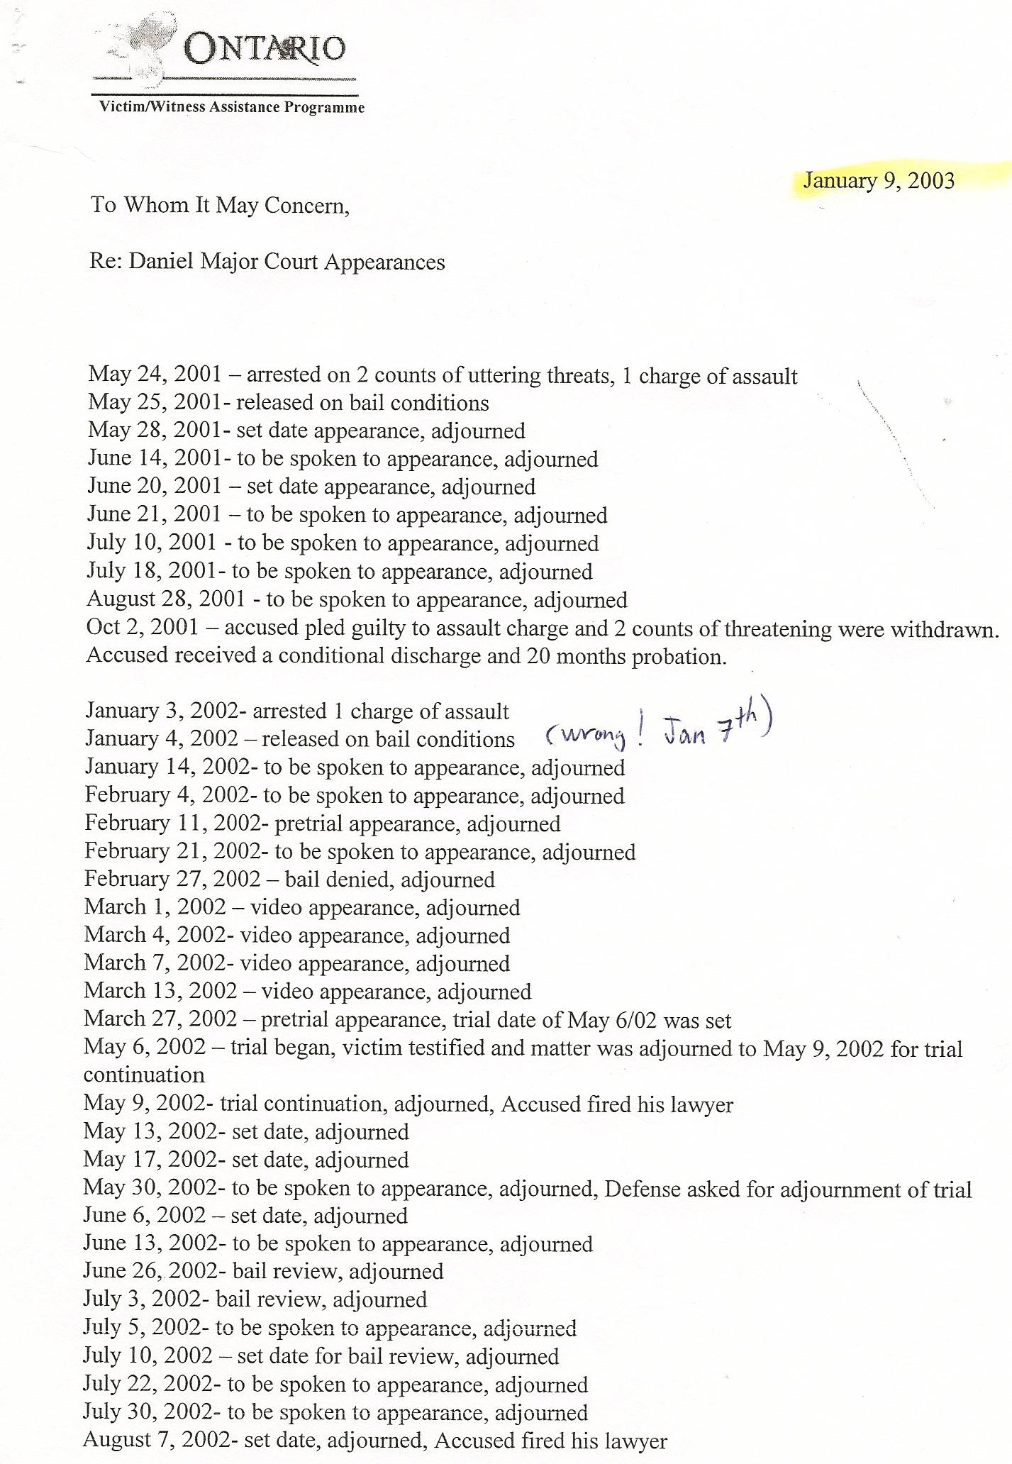

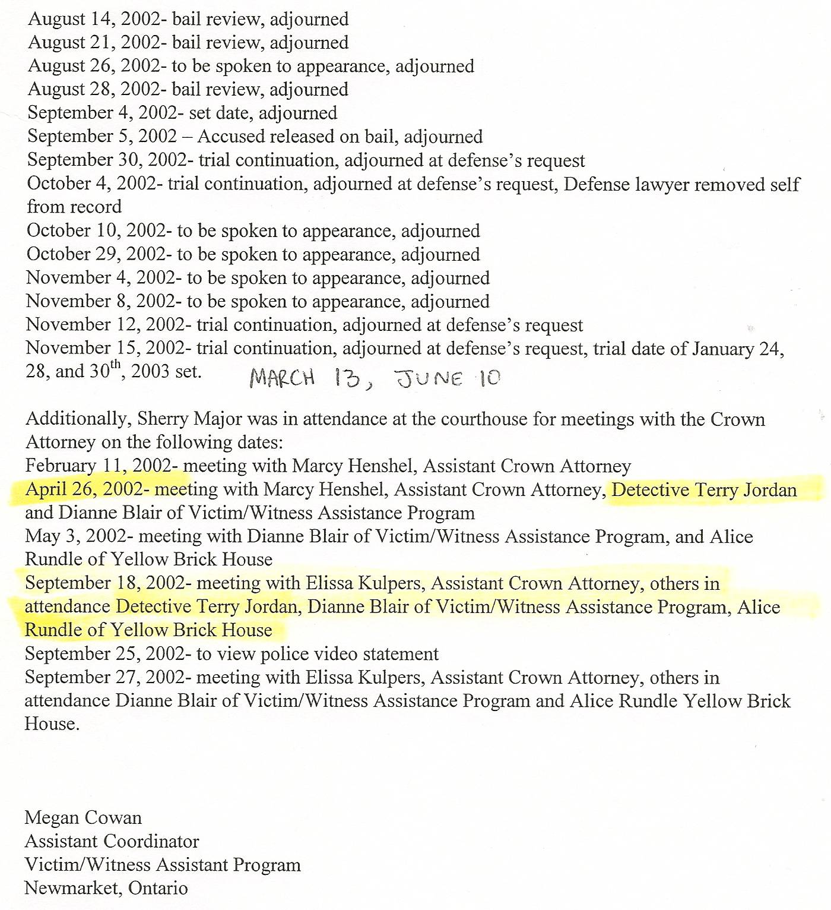

Dan’s Notes:
-even in July 2010 Det Jordan claimed in writing he was no longer involved in Dan’s case after testifying at the Feb 27, 2002 bail hearing – once again, this PROVES JORDAN IS A LIAR!!

