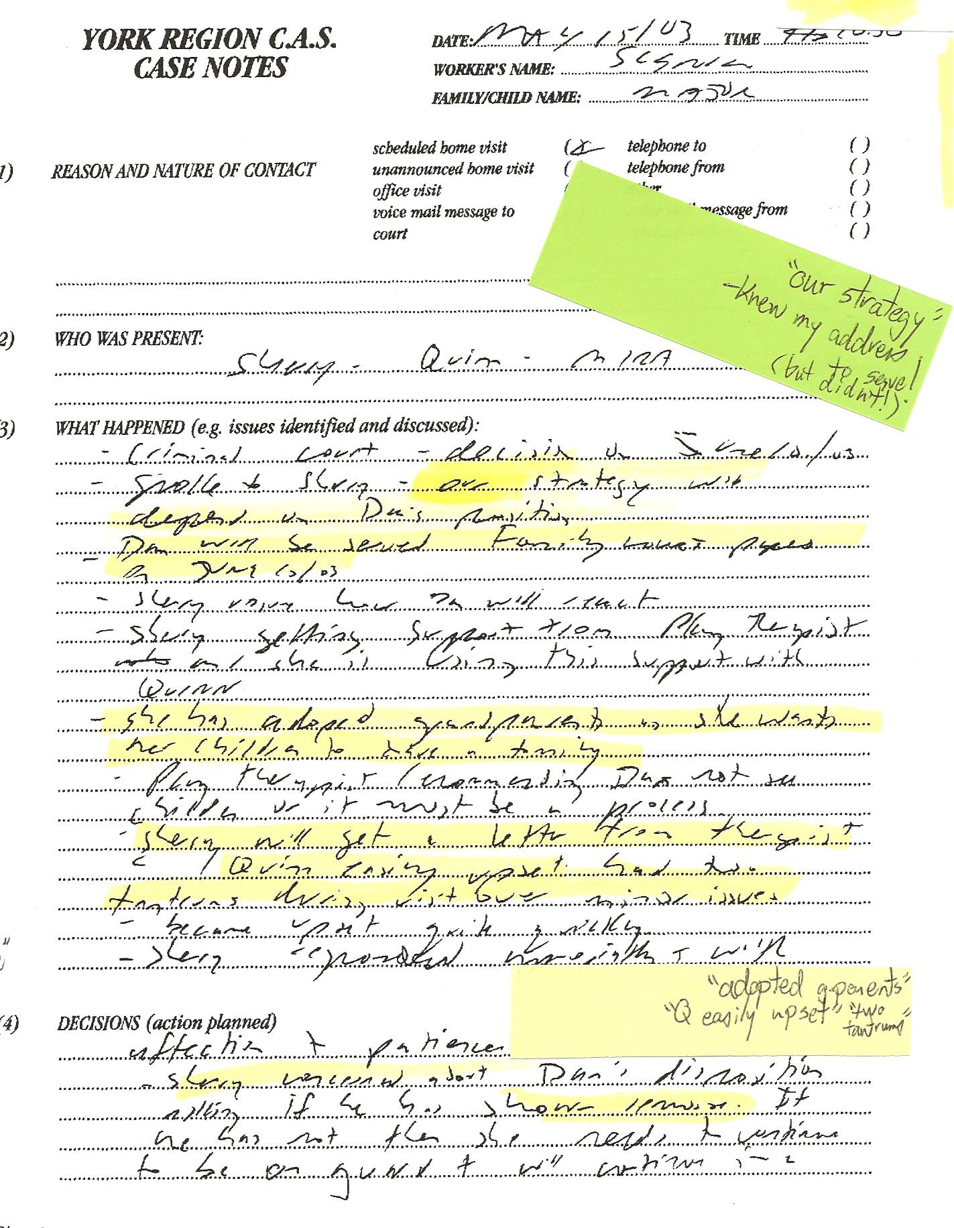

CAS notes deciphered:
-“criminal court decision on June 10, 2003”
-“spoke to Sherry – our strategy will depend upon Dan’s position”
-“Dan will be served Family Court papers on June 10, 2003”
-“Sherry ?? how she will react”
-“Sherry getting support from Play Therapist and she is using this support with Quinn”
-“she has adopted grandparents as she wants her children to have a family”
-“play therapist recommending Dan not see children or it must be a process”
-“Sherry will get a letter from therapist Quinn easily upset – had two tantrums during visit over minor issues”
-“became upset quite quickly”
-“Sherry responded appropriately with affection and patience”
-“Sherry concerned about Dan’s disposition – asking if he has shown remorse. If he has not then she needs to continue to be on guard and will continue ??”

CONTEXT: CAS caseworker Walter Sienko met with Sherry. Dan’s trial is over but he has not yet been released. The judge has delayed the “sentencing date”. Sadly, it was repeatedly delayed and I wasn’t released until June 18th. However, Sherry knows she was revealed as a massive liar under oath and that no one else testified. Therefore, she knew it was highly unlikely that I would be convicted of anything.

Dan’s notes:
-more proof the CAS colludes with Sherry to strategize against me!!!
-“Dan will be served Family Court papers on June 10/03” PROOF Sherry spoke with CAS, they acknowledged earlier in file having my contact info, yet Sherry did NOT serve papers, claiming to not know Dan’s address – so she could get uncontested temporary full custody through lies!! – one NIVA condition was FULL CUSTODY (NOT shared – Sherry could only accomplish this through lies!)
-surely the CAS “experts” could detect mental health issues with Sherry!! They knew Dan’s family lived relatively close and that Sherry maintained contact with my mother until Mom discovered the truth about Sherry – and also when Sherry refused to make payments on the $23,500 that she admitted in writing she owed mom!!! Sherry only wanted new grandparents to avoid her duties – both moral and financial!!!

