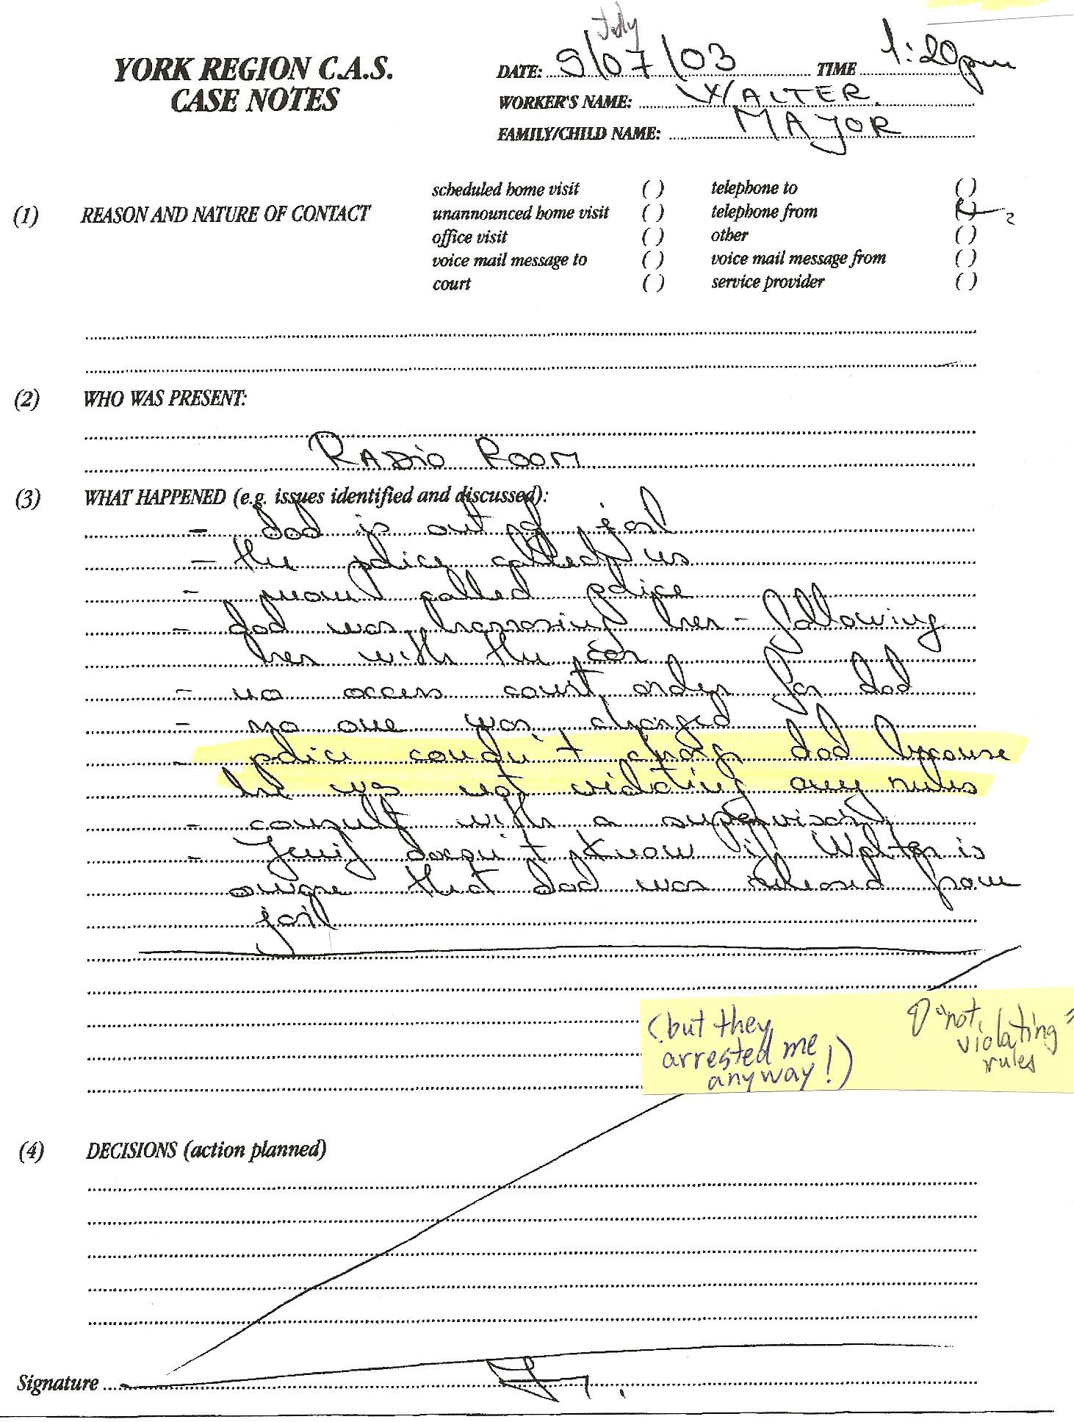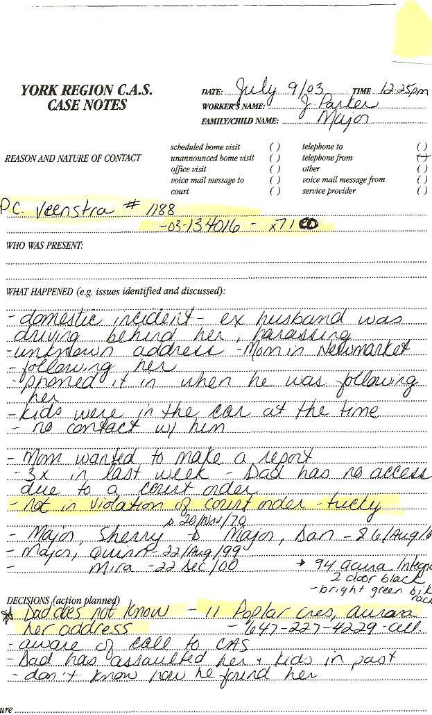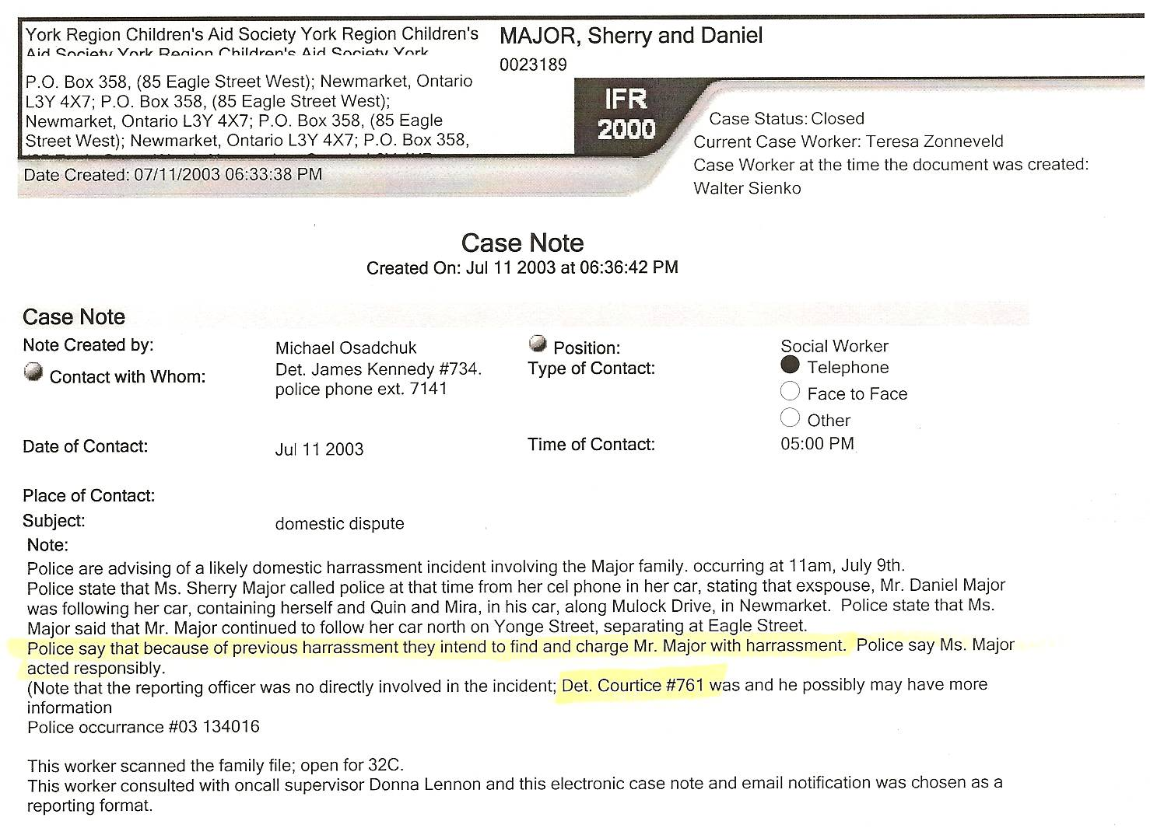

Dan’s Notes: blatant Police Harassment???
-Dan had just been released after 16 months of unjust detainment. All 15 charges against him dismissed since Sherry was found to be a massive liar – the CAS knew this since Dan spoke by phone with the caseworker, Walter Sienko – obviously Dan would go to Family Court seeking access to his kids and also return to his church on Sunday morning – Sherry knew this very well, then claimed Dan was a “terrorist” that was stalking her – she set him up with her lies! He was arrested for alleged harassment pertaining to driving to the courthouse for a Family Court appearance and also for attending the daycare at the church to ensure Sherry no longer went there (since he didn’t want to violate the Restraining Order in effect at the time). All 8 charges were later dropped at the opening of the scheduled trial.
-the CAS file clearly acknowledges “Dad does not know her address”
-CAS notes state the “police couldn’t charge dad because he was not violating any rules,” and police claim Dan is “tricky”
-despite Dan admittedly not being guilty of any crime, the YRP clearly advises the CAS worker that “because of previous harassment they intend to find and charge Mr. Major with harassment.” (This is despite the CAS and YRP being fully aware that Dan has no criminal convictions and has been fully exonerated by the truth!)
-Dan set up a meeting with CAS caseworker Walter Sienko on July 15, 2003 to deliver trial transcripts that exposed Sherry as a massive fraud – Walter tipped off the YRP of the meeting and they arrested Dan in the foyer upon entering the building
-after viewing the transcripts in the cruiser (and realizing how much of a liar Sherry was), the cops (Helm & Hengeveld) advised other cops at the courthouse to “Take it easy on Major. He’s got himself a black widow.”

Notes: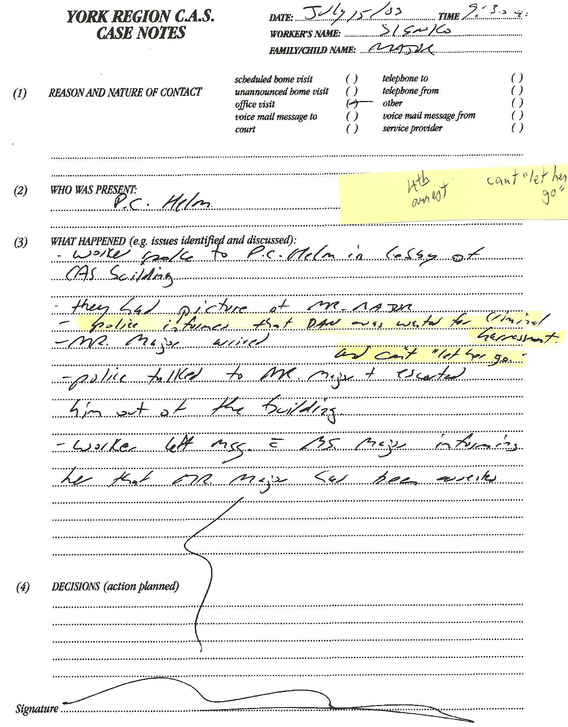

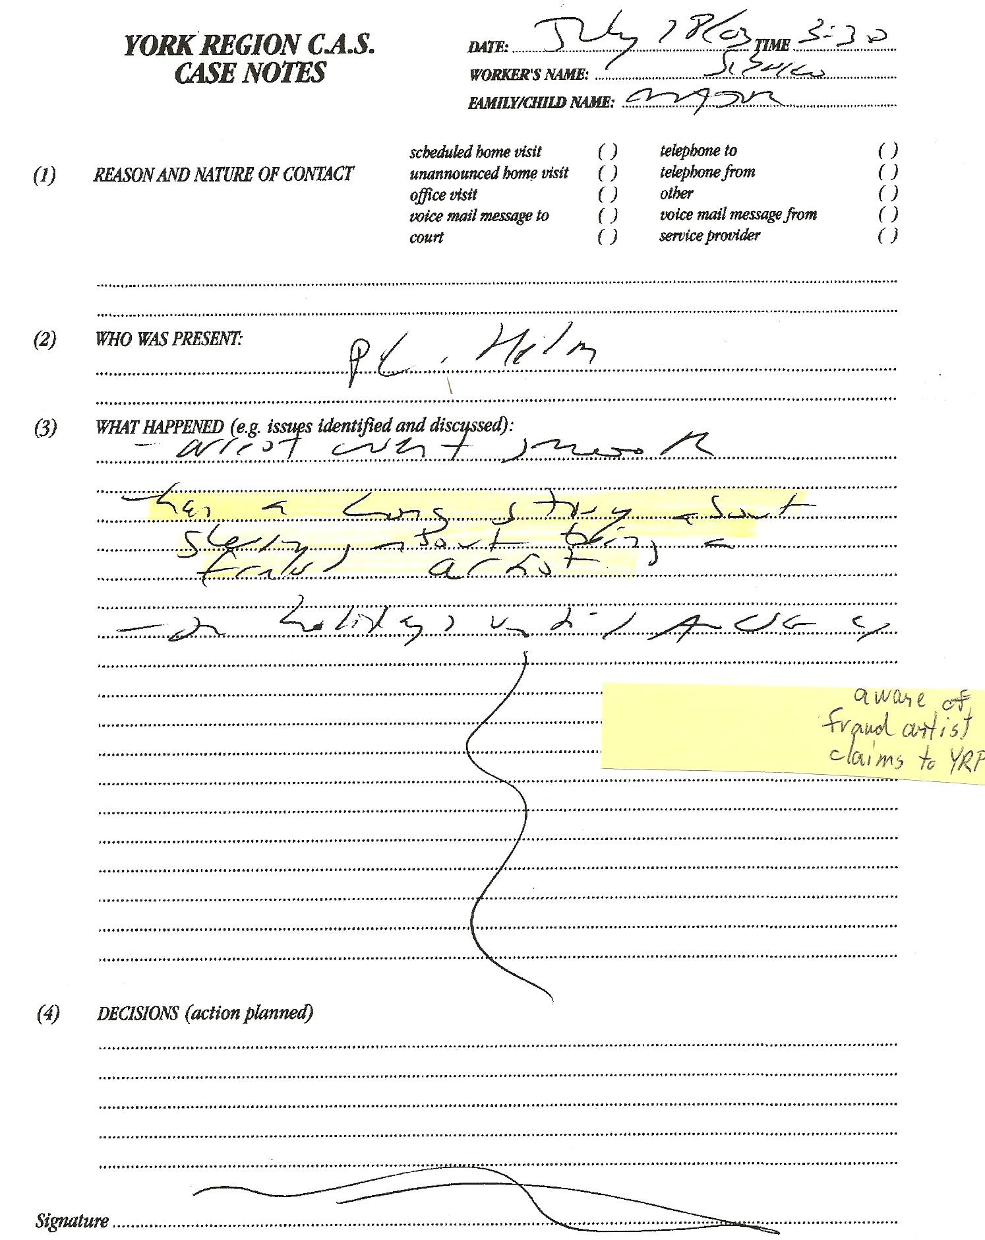

Dan’s Notes:
-reads “arrest went smooth” and “has a long story about Sherry, about being a fraud artist”

