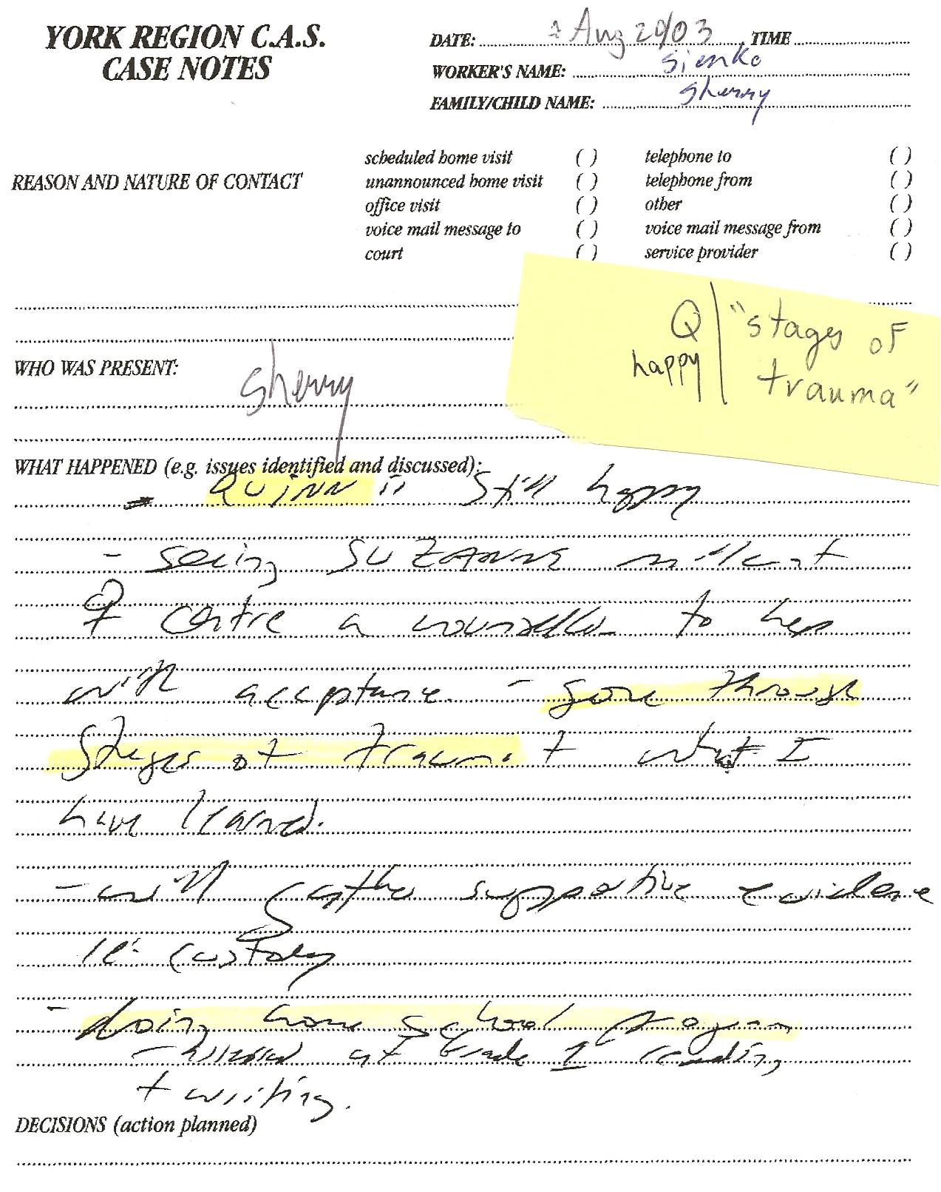
-“seeing Suzanne Miller at Women’s Centre – a counsellor to help with acceptance - “gone through stages of trauma”+ what I have learned
-“will gather supportive evidence re: custody”
-(Quinn – age 4) “doing home school program – assessed at Grade 1 reading + writing”

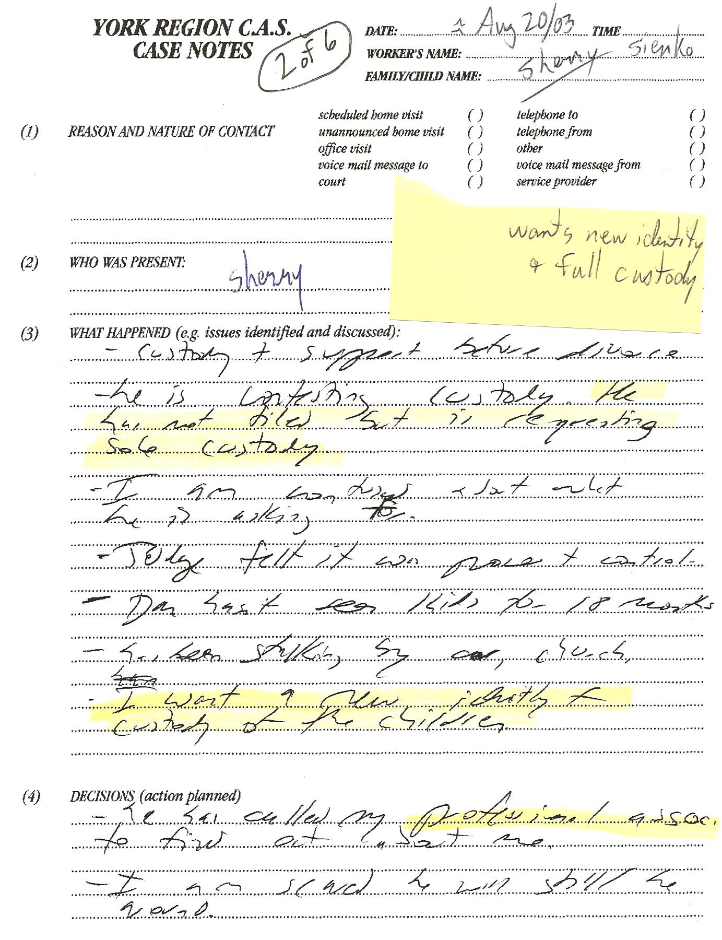
-“he is contesting custody. He has not filed but is requesting sole custody. I am anxious about what he is asking for. Judge felt it was power + control. Dan hasn’t seen kids for 18 months – has been stalking by car, church”
-“I want a new identity + custody of the children”
-“I am scared he will still be around.”

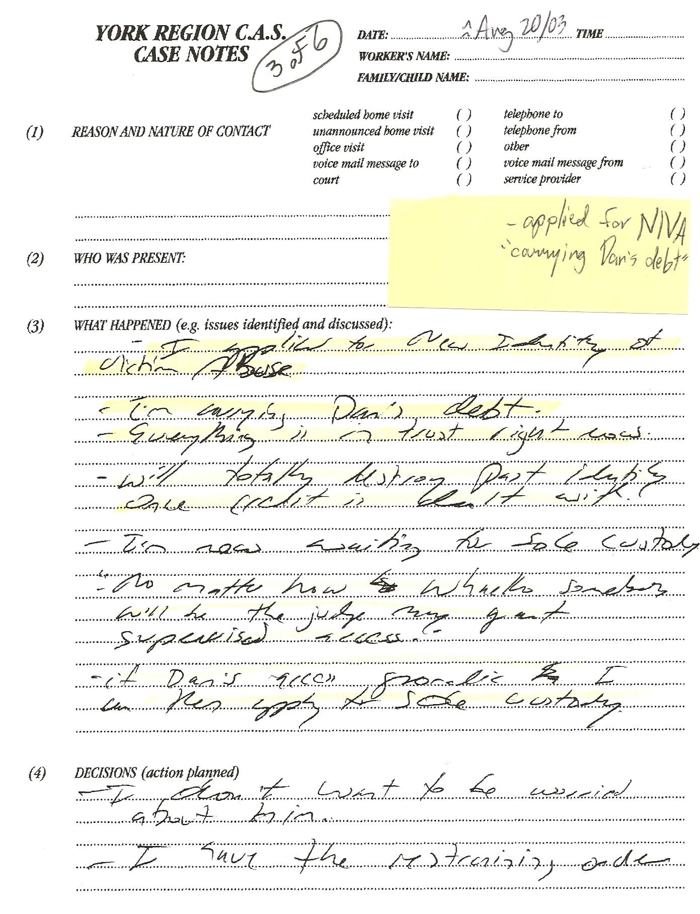
-“I applied to New Identity of Victim Abuse”
-“I’m carrying Dan’s debt.” “Everything is in trust right now. Will totally destroy past identity once credit is dealt with. I’m now waiting for sole custody.” Knew her only hope for sole custody was to lie and not serve Dan, keeping him unaware of the proceedings!
FACT: Dan’s debt was Sherry’s massive ($500,000) FRAUD!!!
MOTIVE: -“No matter how whacko somebody will be the judge may grant supervised access. If Dan’s access sporadic I can then apply for sole custody.”(Sherry continually told courts/CAS that Dan was bipolar, manic depressive, schizophrenic, etc. Dan’s psychiatrist did NOT concur. Sherry simply resorted to more lies to thwart Dan’s attempts at access/custody.)

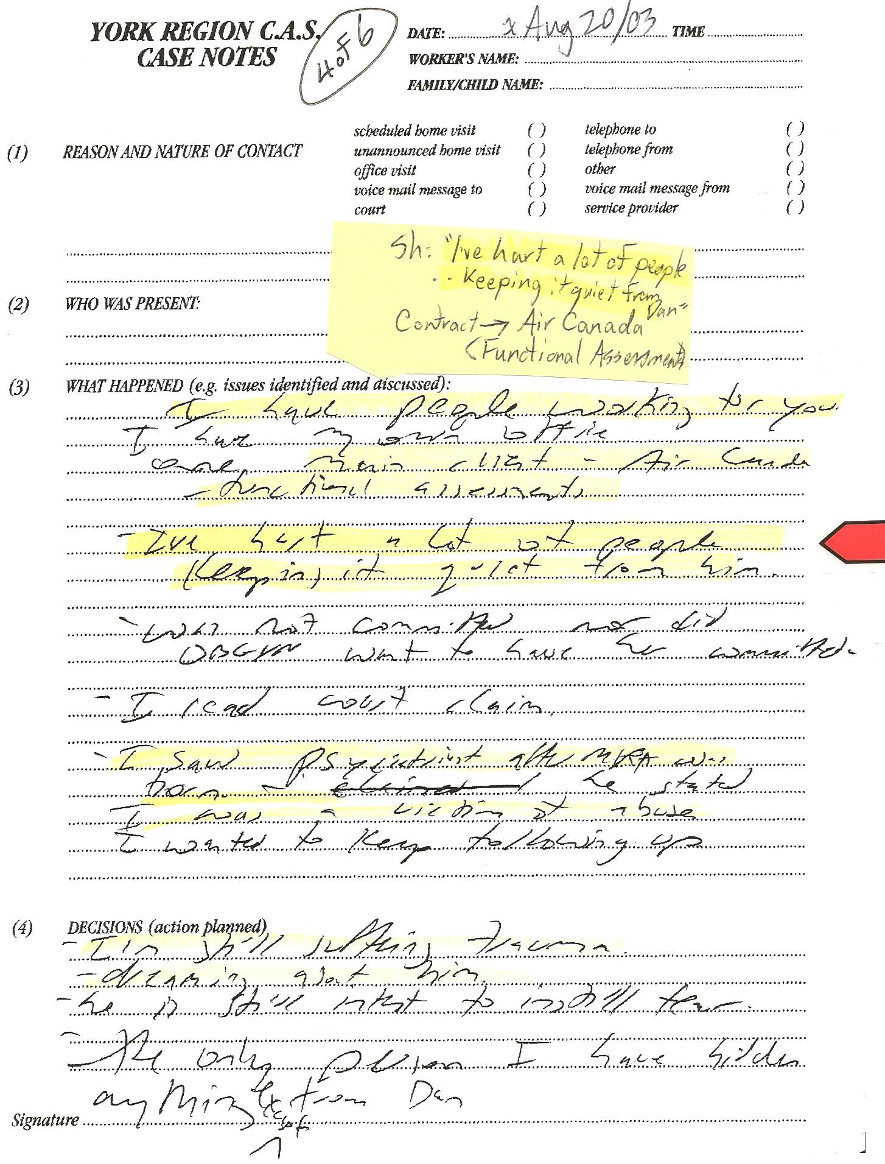
-I have people working for you. I have my own office. One main client – Air Canada – functional assessments”
-“I’ve hurt a lot of people – keeping it quiet from him.”
-“was not committed nor did OBGYN want to have her committed” (Dr. Chang of Mkm-Stouffville Hospital DID threaten to put Sherry in the Psych ward after the bogus Toronto Star baby story.)
-“I’m still suffering trauma – dreaming about him – he is still intent to instill fear”
-“the only person I have hidden anything ^except from (is) Dan” (LIES!)
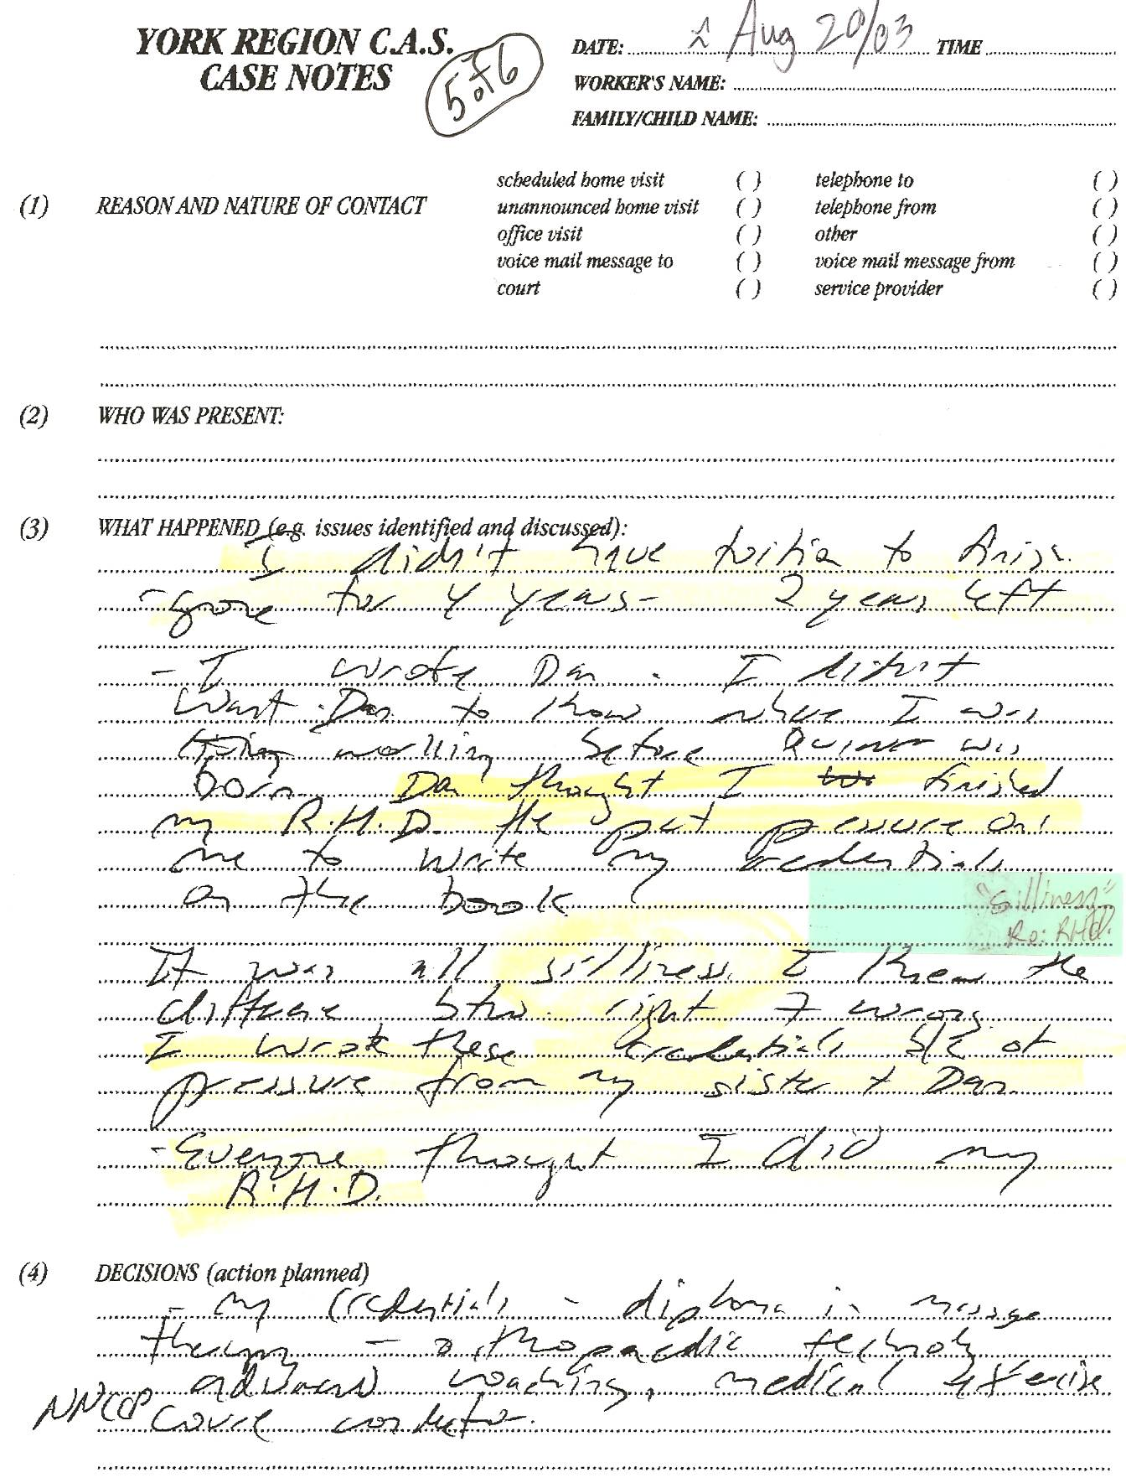
-“I didn’t have tuition to finish – gone for 4 years – 2 years left”
-“I wrote Dan. I didn’t want Dan to know where I was working before Quinn was born. Dan thought I finished my Rh.D. He put pressure on me to write my credentials on the book.
-“It was all silliness. I knew the difference between right and wrong. I wrote the credentials b/c of pressure from my sister + Dan. Everyone though I did my R.H.D.”
FACT: -Sherry tells more lies about education. She already admitted at trial in Jan 2003 that she was NEVER in the doctorate program and did not even have any undergrad degree (the prerequisite for the post-grad program)!

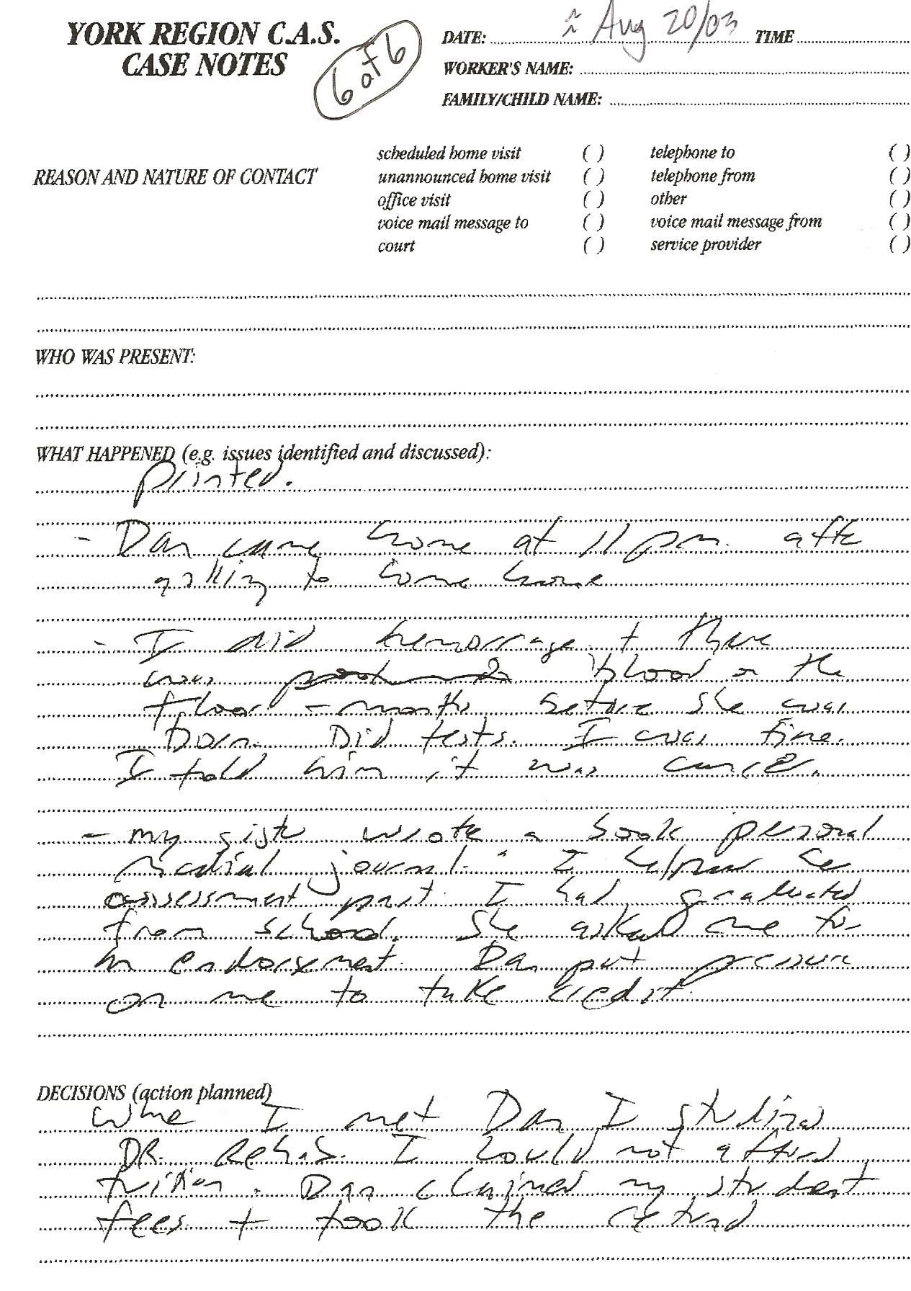
-“When I met Dan I studied Dr. Rehab. I could not afford tuition. Dan claimed my student fees + took the (tax) refund.”
FACT: More pathetic LIES since she already admitted otherwise at trial in Jan 2003!
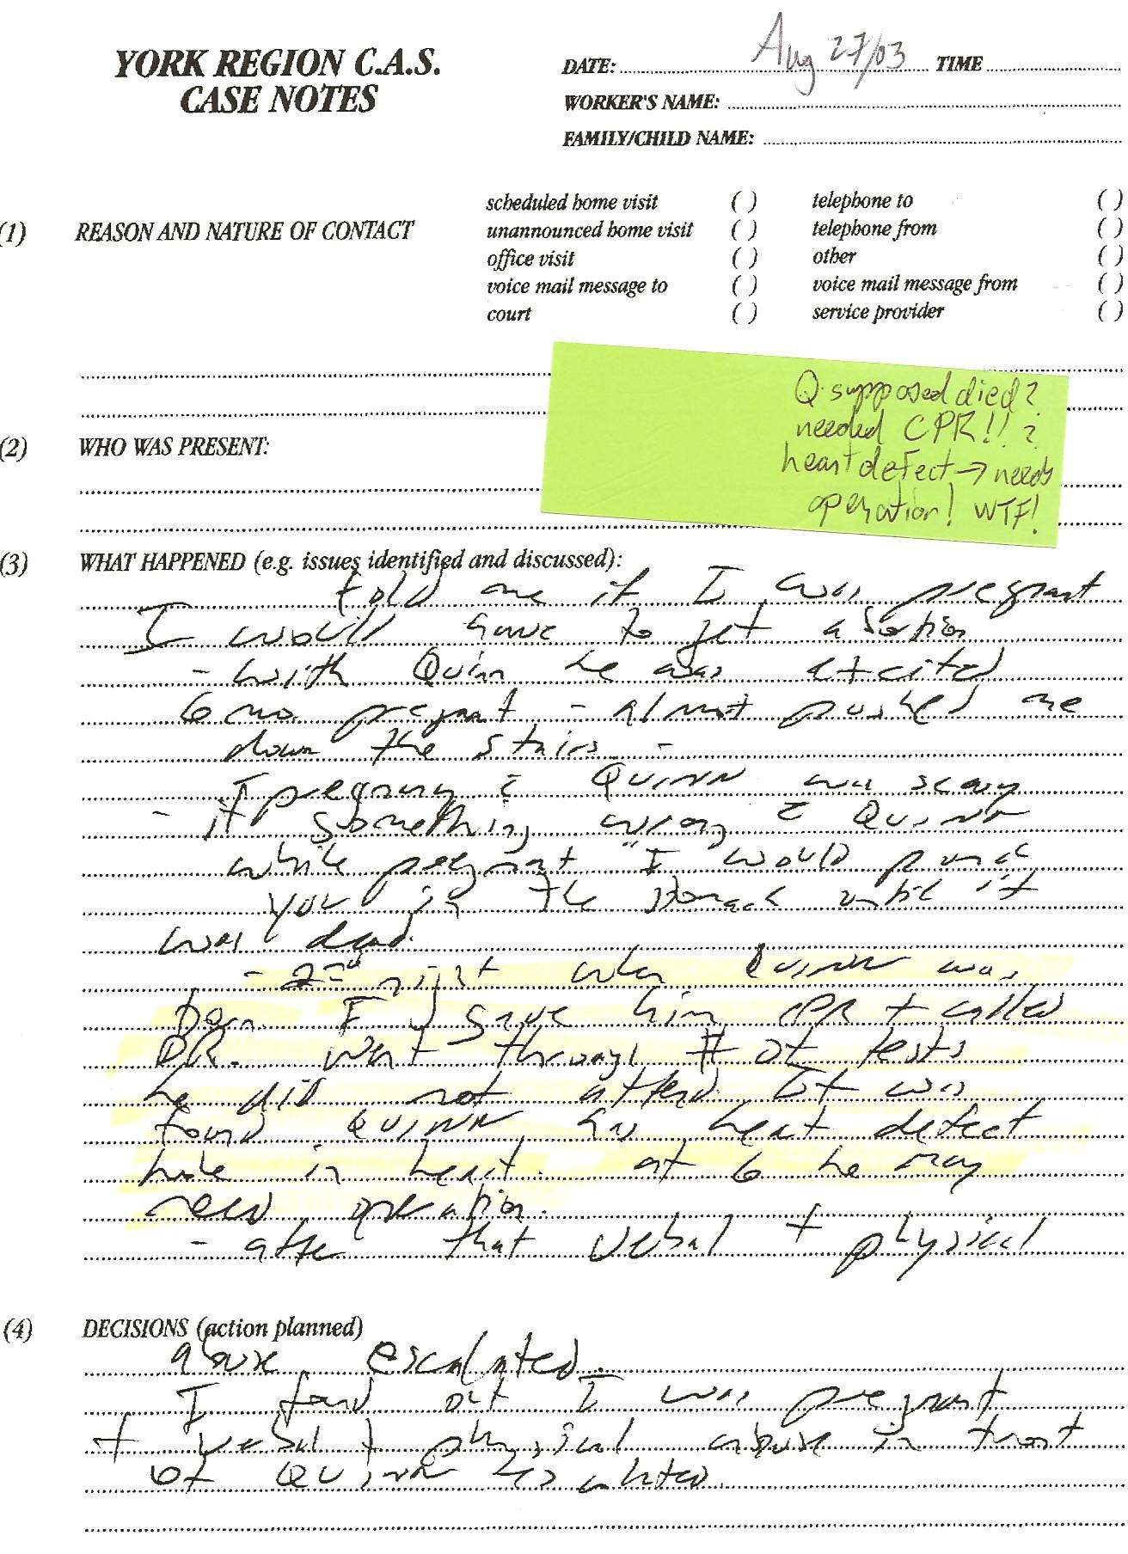
MENTAL INSTABILITY – not in kids’ best interest!
-“told me if I was pregnant I would have to get abortion – with Quinn he was excited – 6 mos. pregnant – almost pushed me down the stairs – pregnancy with Quinn was scary – if something wrong with Quinn while pregnant (Dan) would punch you in the stomach until it was dead.”
-“2nd night when Quinn was born I gave him CPR + called Dr. Went through # of tests. He (Dan) did not attend. It was found Quinn has heart defect hole in heart. At 6 he may need operation.”

FACT: Dan had never heard this story before. Is this just another of her bizarre lies? If Quinn does have a heart defect this shows how crazy she is – she refused to provide Quinn’s health card to Dan in Aug 2008 – could Q have died due to lack of having the card in an emergency??? There is documentation from Nova Scotia that Sherry has told other people of Quinn’s (supposed) congenital heart defect.

Sherry has told numerous people in N.S. that Dan beat her so badly while pregnant that she had a miscarriage.
Sherry has told the kids that they had a “baby brother that died in mommy’s belly.”
There are “love letters” between Sherry and YRP Detective Terry Jordan referring to their great loss (of their love child – barf bag not included).
Sherry’s medical records should have a record of any miscarriage, which will obviously NOT coincide with any pregnancy associated with Dan. If there is a record of a 2003 miscarriage, then that lends further credibility to the improper relationship between Jordan and Sherry. If there is no medical report of a miscarriage, then perhaps the entire story is yet another lie, thereby leading any sane person to seriously question Sherry’s mental stability. Either way, Sherry’s questionable actions and mental health once again come to the forefront.

