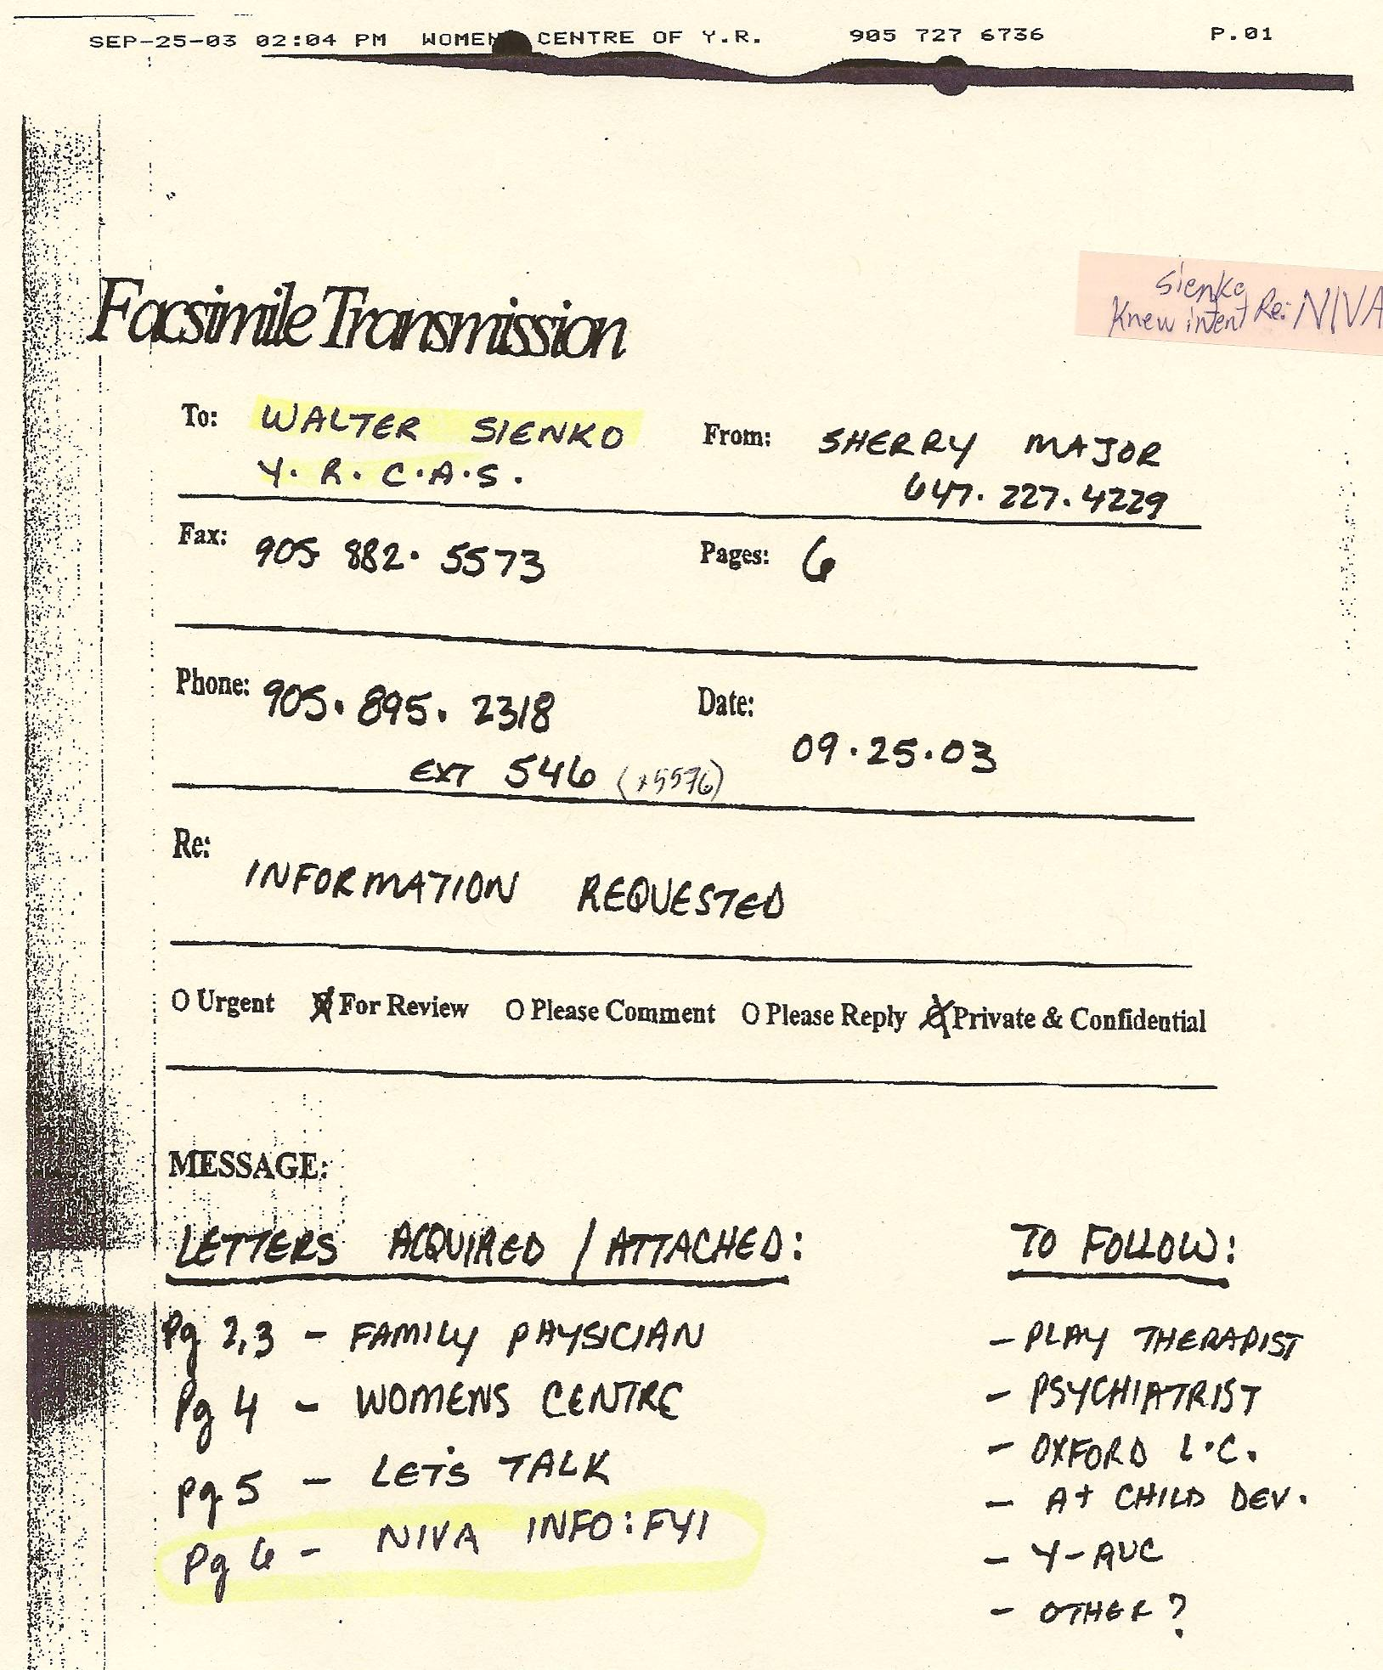

Notes:
-proof CAS worker Sienko knew of Sherry’s intent to disappear through the NIVA (New Identities for Victims of Abuse) – he did nothing to discourage the injustice

