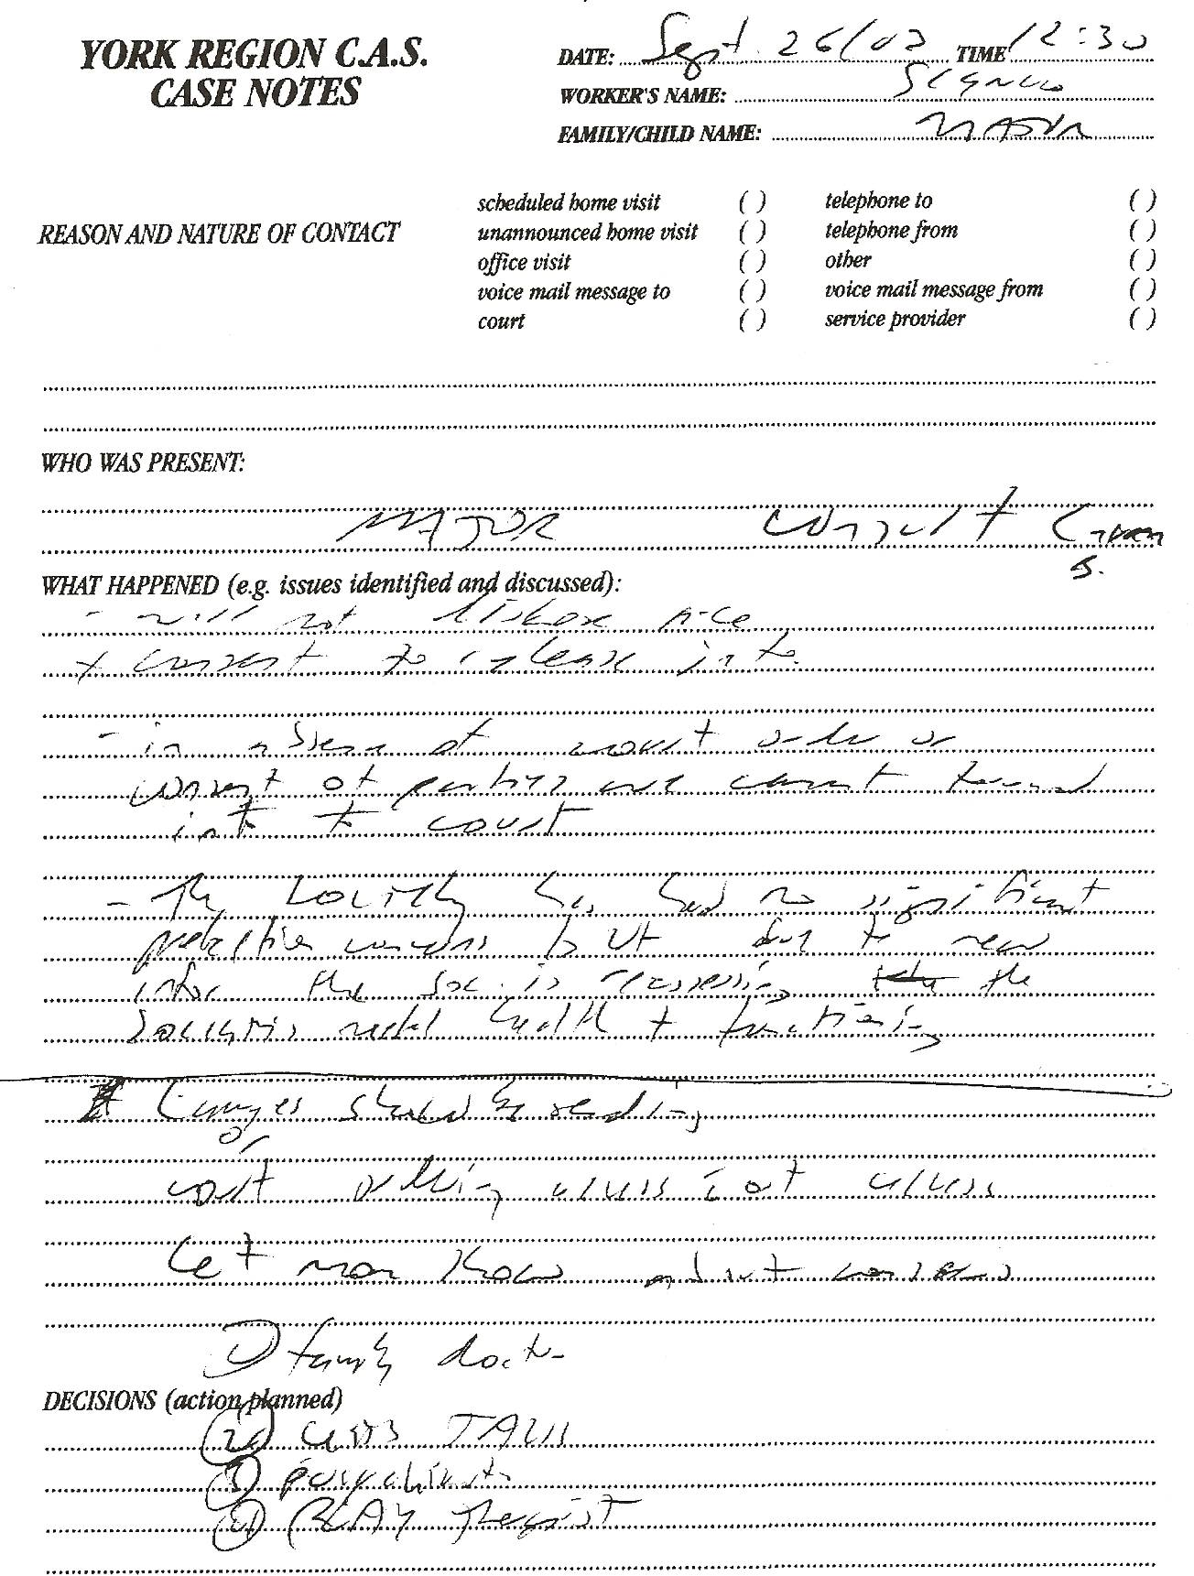
-(Sherry) “will not disclose file + consent to release info” (probably b/c Alice Rundell of Let’s Talk has bad things to say about Sherry – knows she lied in court since Alice was there! see Sept 22 notes!)
-“in absence of court order or consent of parties we cannot forward info to court”
-“the Society has had no significant protection concerns but due to new info the Society is reassessing the Society’s needed …….? + functioning?
-“lawyer should be ?sending? court ordering access without ?access? concerns?”
-“Let mom know about concerns”
1)Family doctor 2)Let’s Talk (kids’s program) 3)psychiatrist 4)play therapist
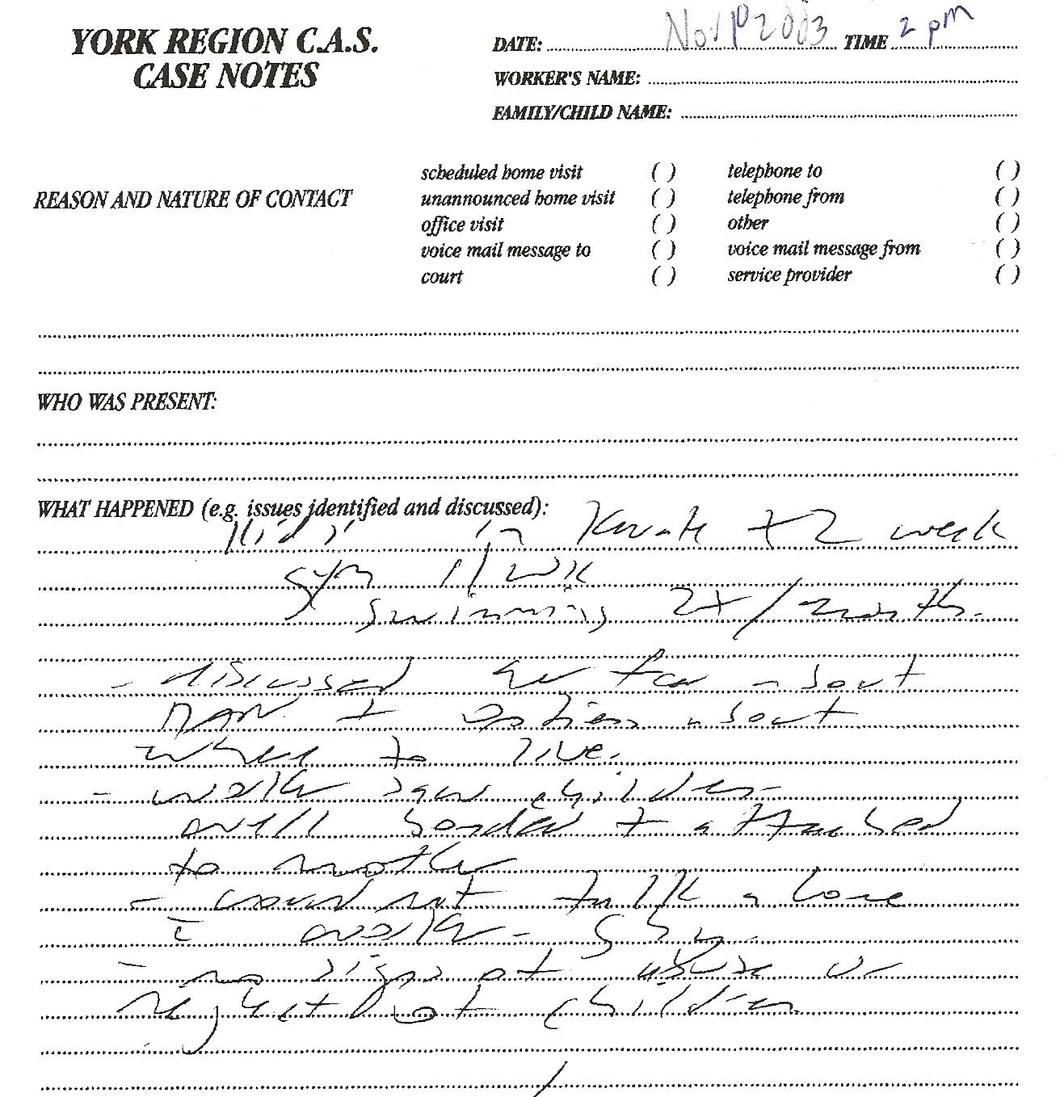

-“kids in karate x2 week gym 1/wk swimming 2X/month”
-“discussed her fear about Dan and options about where to live”
-“worker saw children well bonded + attached to mother”
-“could? not? talk alone with worker ..shy? Sherry?”
-“no signs of abuse or neglect of children”

Dan’s Notes:
This indicates a discussion about where, when and what Sherry was going to do re: living/moving. The past file notes acknowledge her desire to go to Halifax. Surely this was discussed at the meeting. She was currently at a Transition House and the file had a form from “Transition House Association of Nova Scotia.” It is known she first lived in a transition house in Truro, before subsequently bilking several landlords for tens of thousands of dollars in unpaid rent. The file shows York CAS knew Sherry’s criminal intent to abscond with the children to N.S.! Sherry testified in Aug 2008 that CAS encouraged her to make the move!
-file also had NIVA intentions!!! (on Sept 25, 2003 file) (Sherry NEVER qualified for NIVA program - once they did a background search on her and readily realized she had massive outstanding debts – however, Sherry still had the NIVA letterhead form and used it to dupe her future landlord in Truro, Paul Drake, over of $40,000 by convincing him she was in the program!!)

