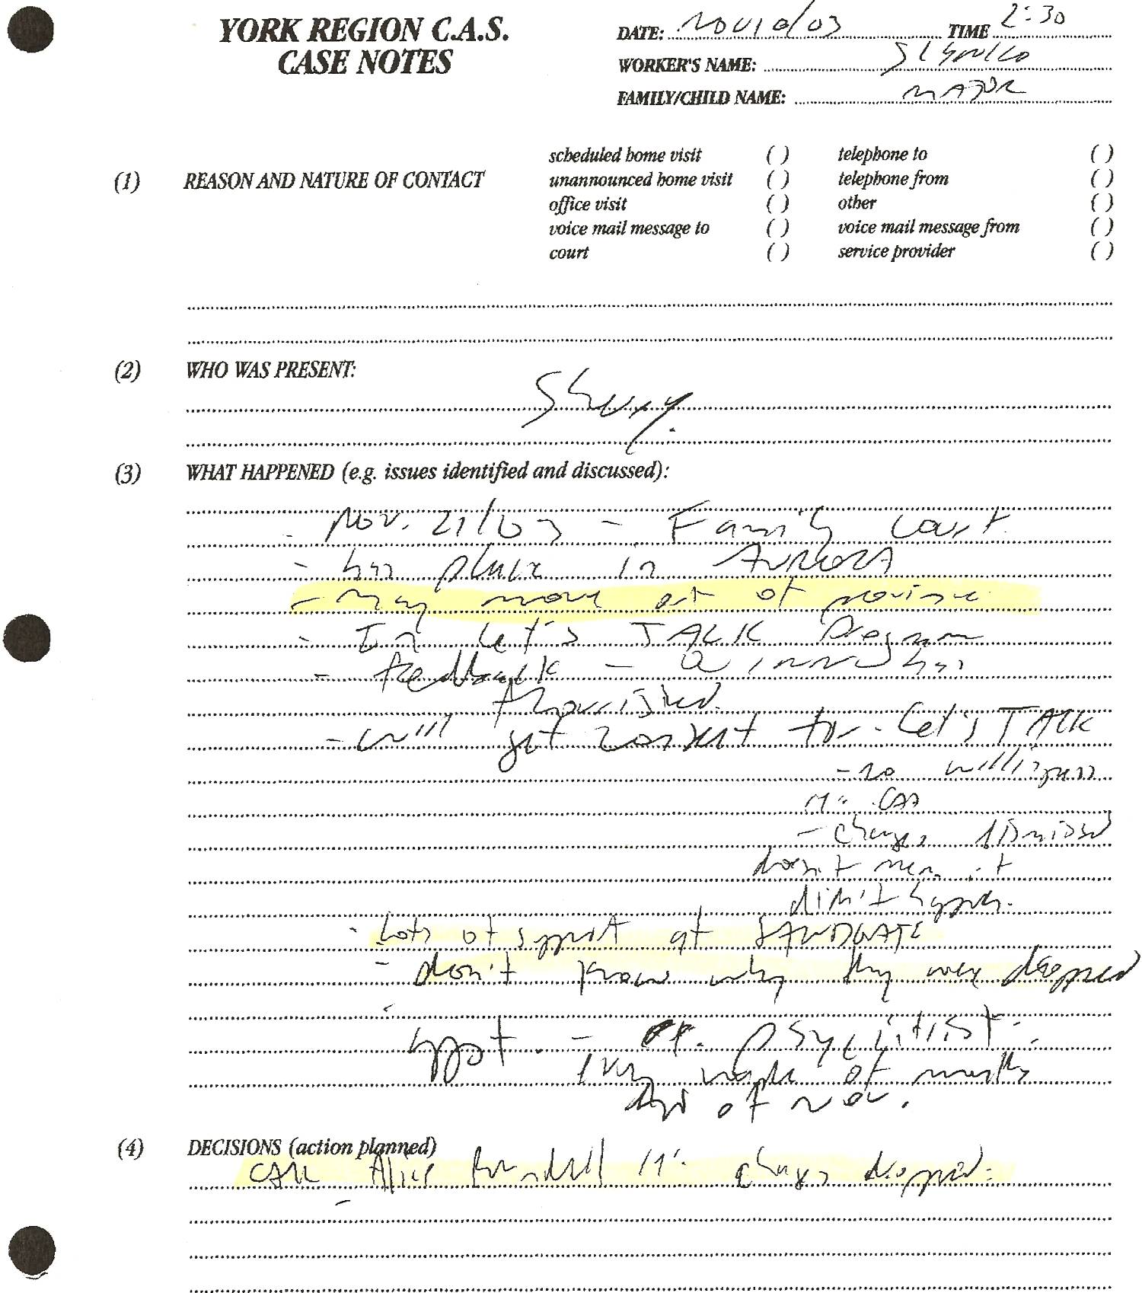

Dan’s Notes:
Nov 10/03 -Sherry advises Sienko she “may move out of province” and “doesn’t know why (Dan’s) charges were dropped.”
-they had a copy of the trial transcript, letters from me and Oct 22 notes from meeting with Alice Rundell (“pulled the wool over my eyes”) so they KNEW the truth!!! This is criminal intent they encouraged!!!
