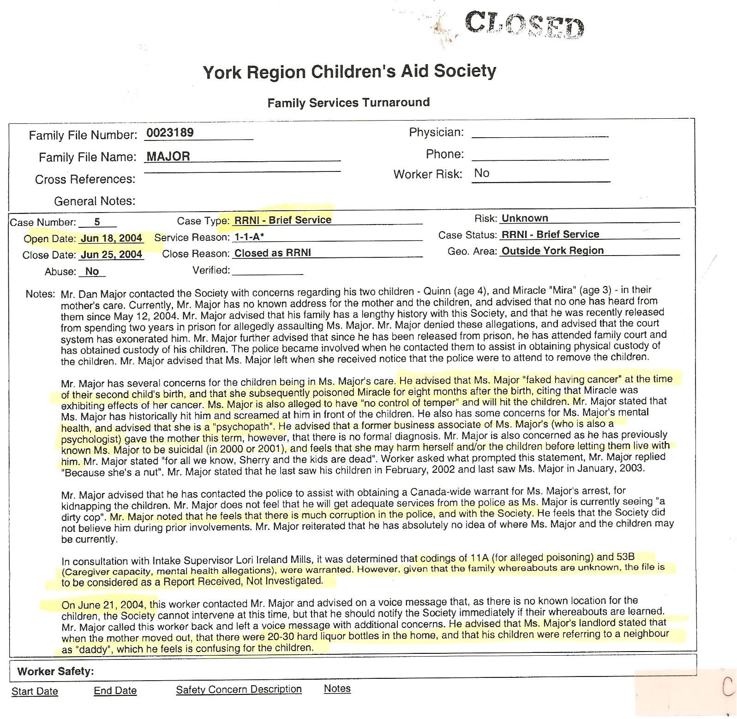
Dan’s Notes:
-CAS totally ignores my plight that they greatly assisted to create – they mark the file RRNI (Report Received, Not Investigated) – isn’t is remarkable that a valid allegation of poisoning a child has been made and they don’t investigate this!!!
-aware I told them dirty cop Terry Jordan had lots of booze at Sherry’s house and Quinn had called Hector (the landlord) “daddy” yet they still refuse to investigate!
-file notes the CAS’s own concern with Sherry’s mental health, just as I also reported!!!

