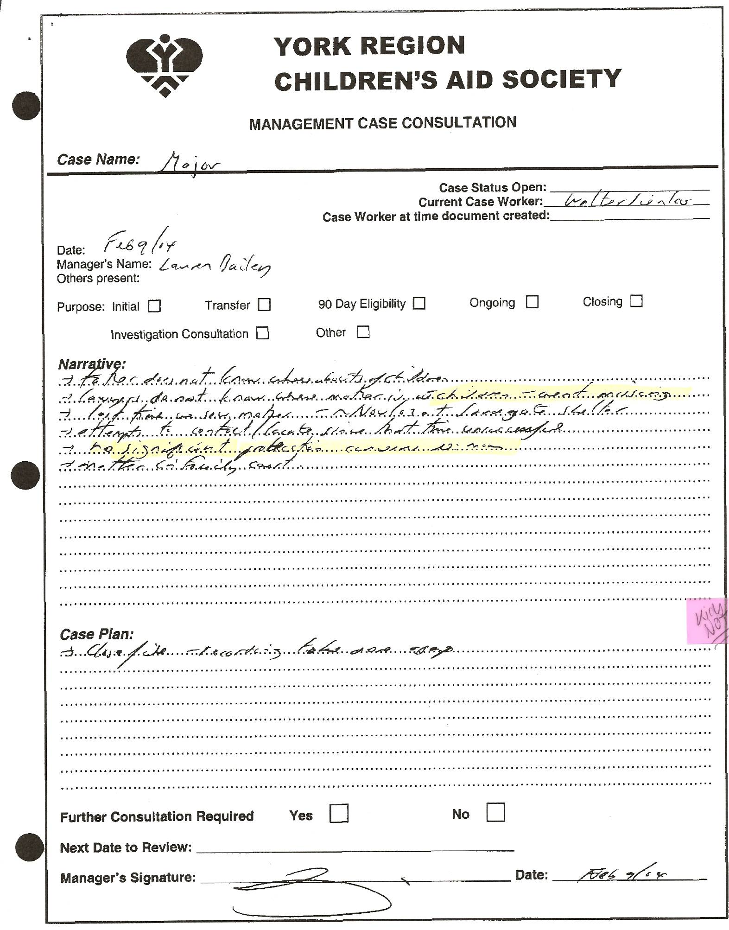

Translation:
-“lawyers do not know where mother is with children – aren’t missing”
“no significant protection concerns re: mom”
Case Plan: “close file”

Notes:
-CAS knows Dan can’t find his kids but claim the kids are not missing!

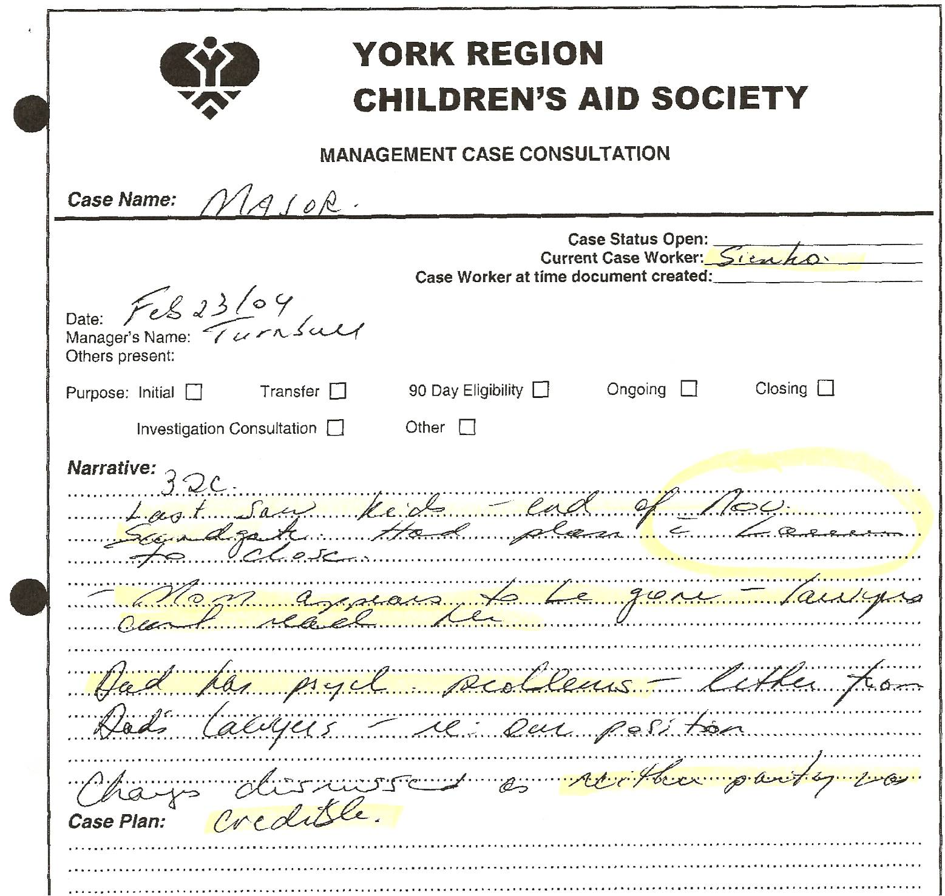

Translation:
-“last saw kids end of Nov – Sandgate (women’s shelter) had plan with Lauren (CAS caseworker) to close.”
-“Mom appears to be gone – lawyers can’t reach her”
-“Dad has psych problems – letter from Dad’s lawyers – re: our position”
-“charges (against Dan) dismissed as neither party was credible” (How can Dan not be credible? He never even testified at trial!!)

Notes:
-CAS continually blames Dan and neglects to mention the letter in file from psychiatrist stating “he continues to be mentally stable” – Dan was NEVER unstable – they manufactured this story with Sherry

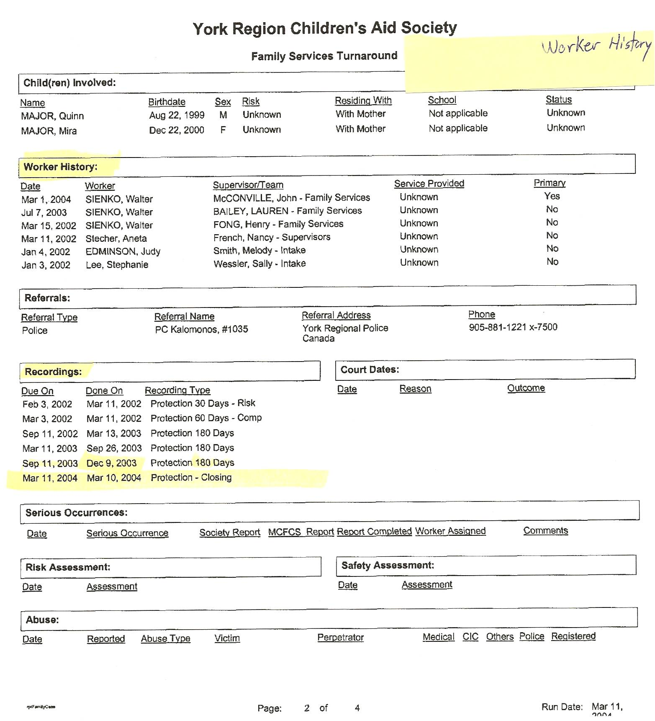

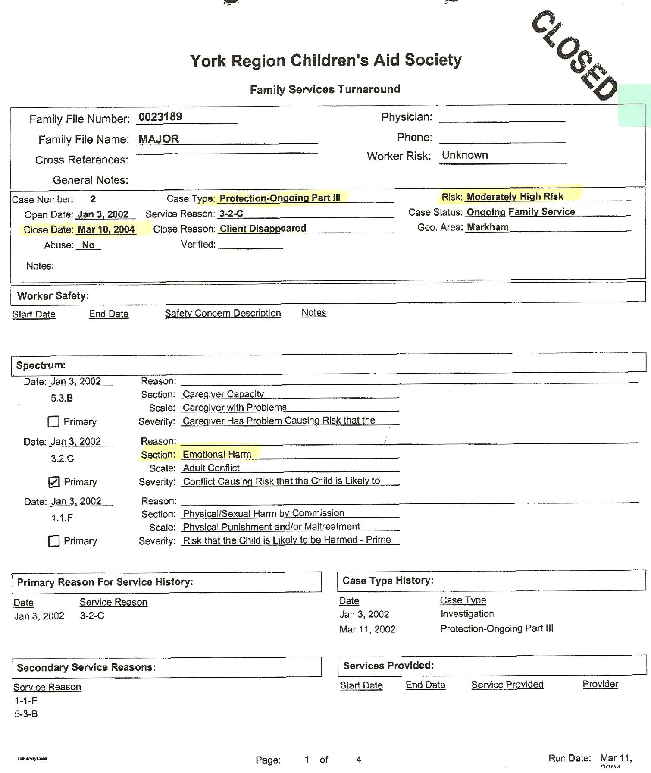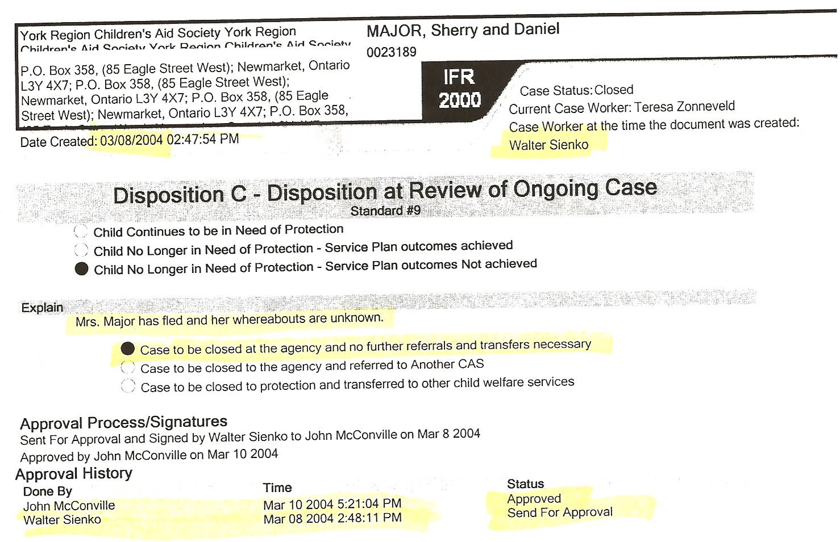
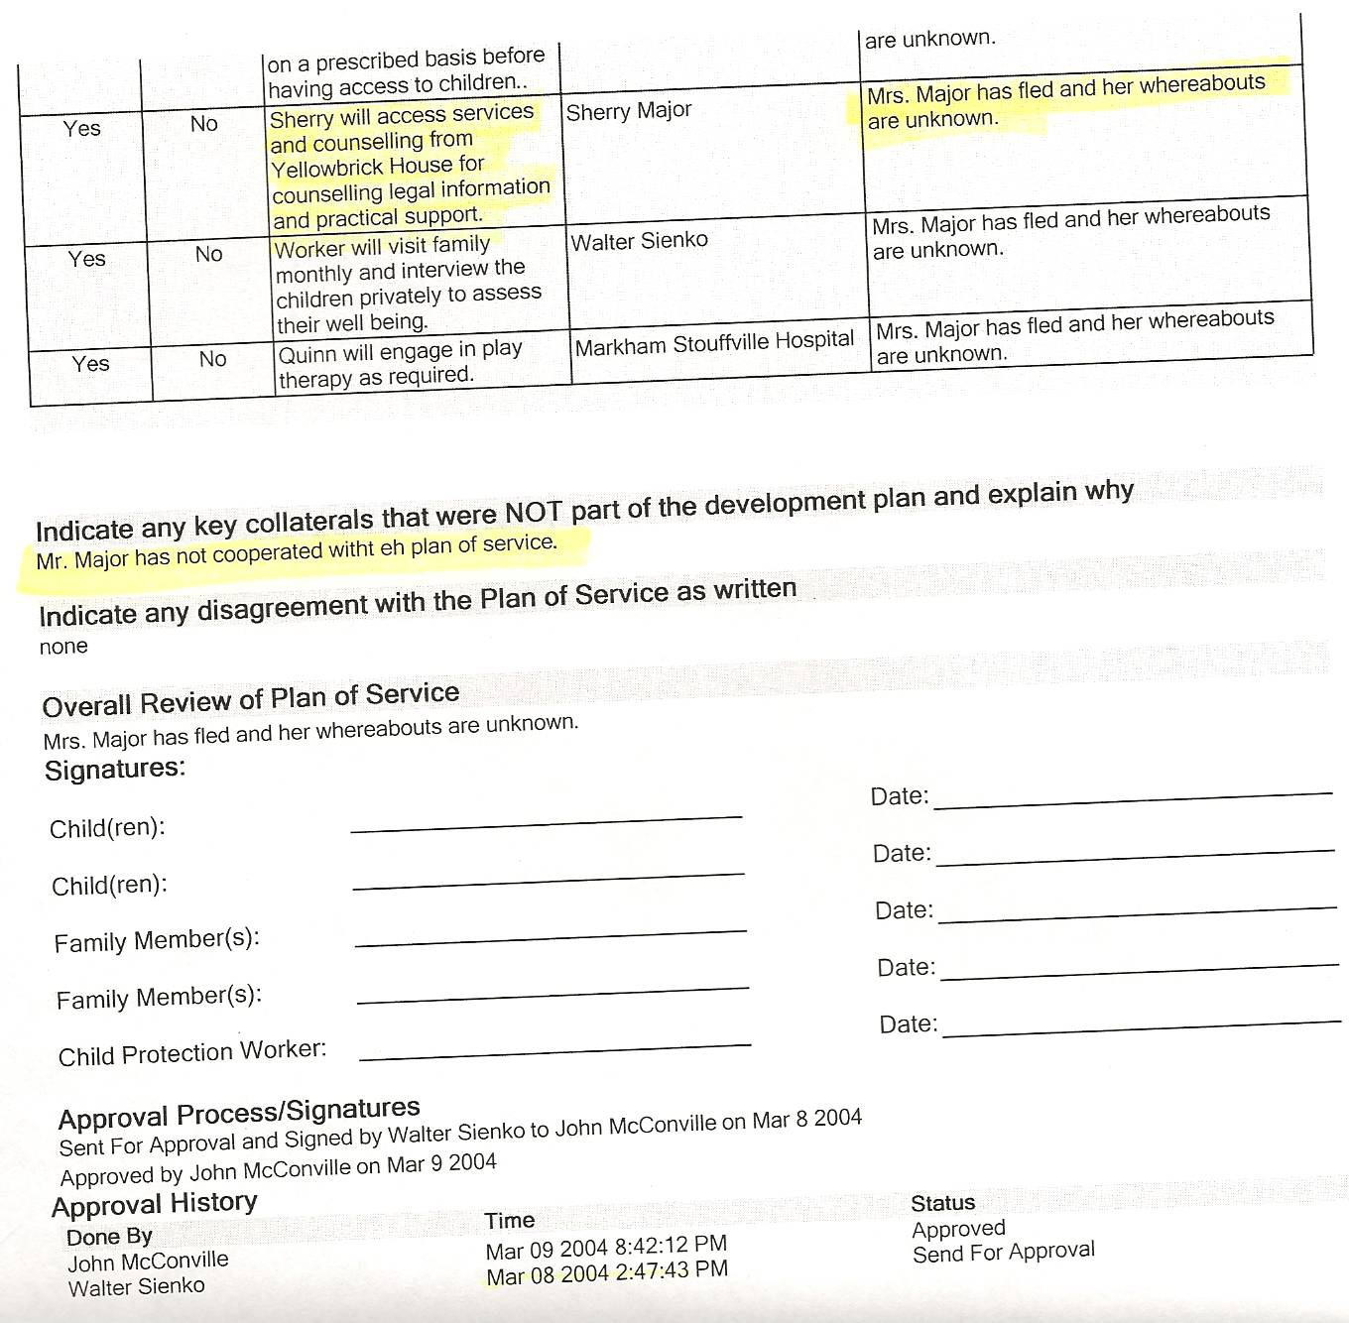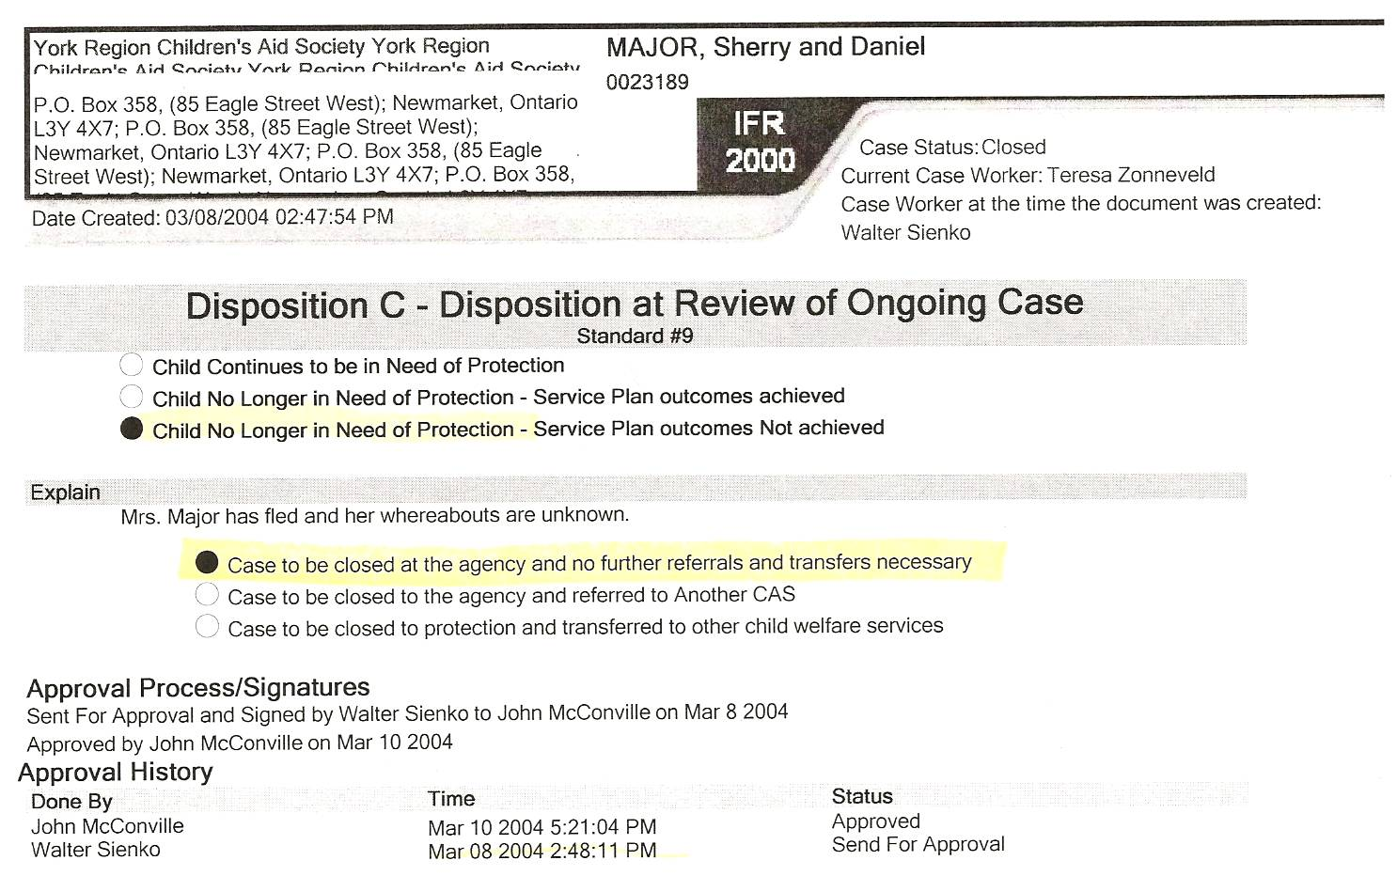

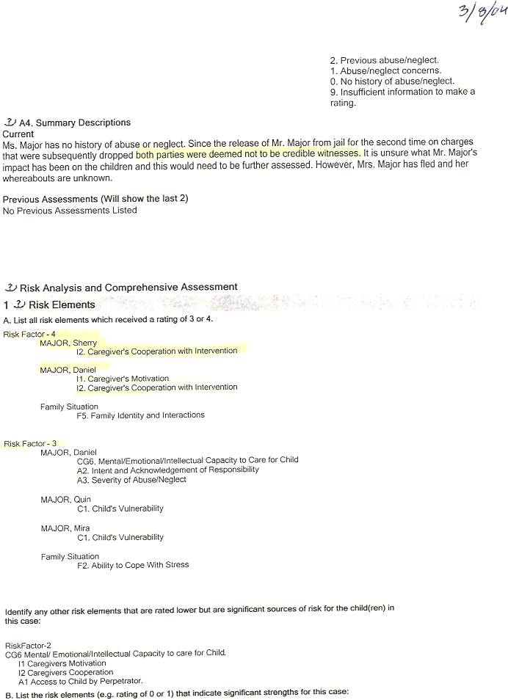

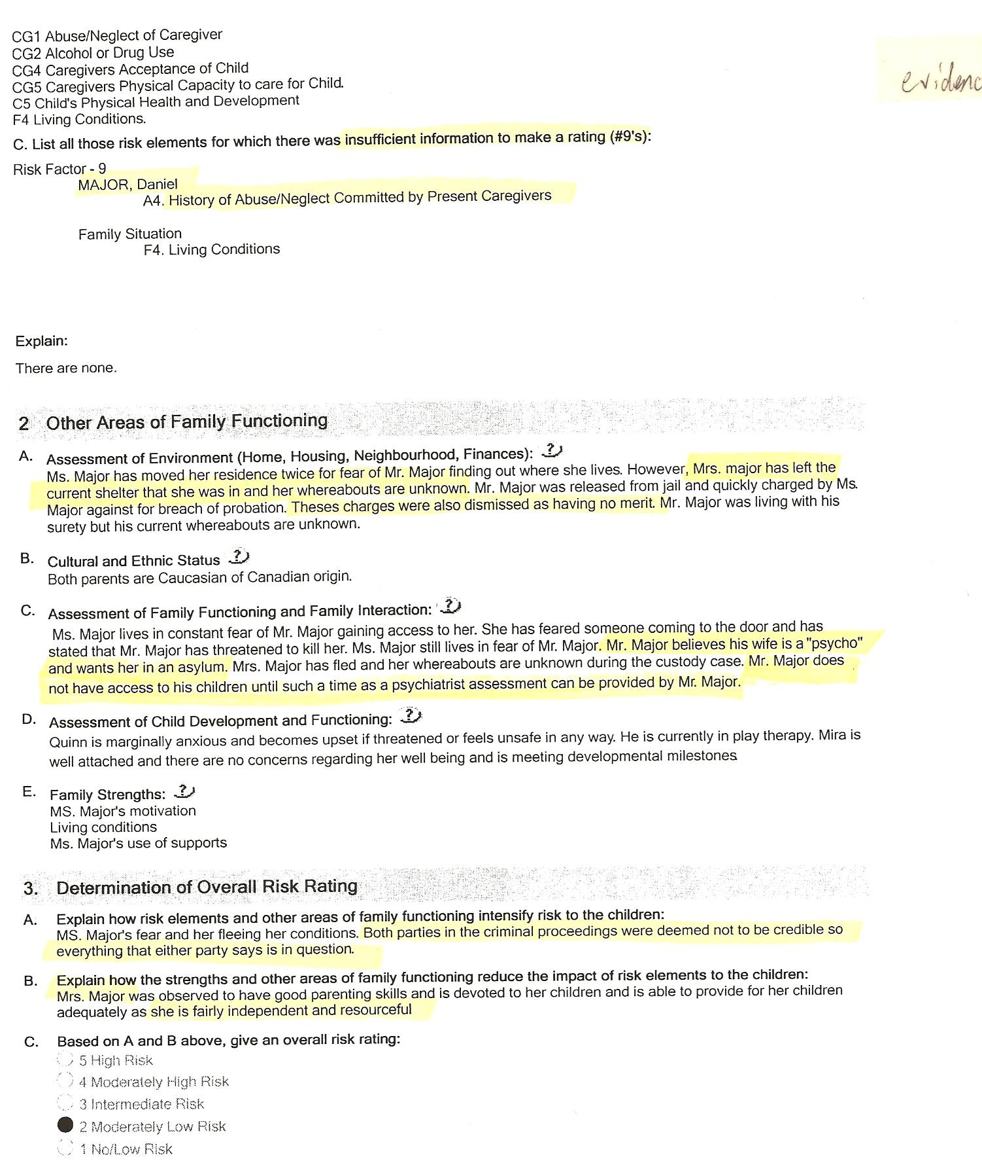

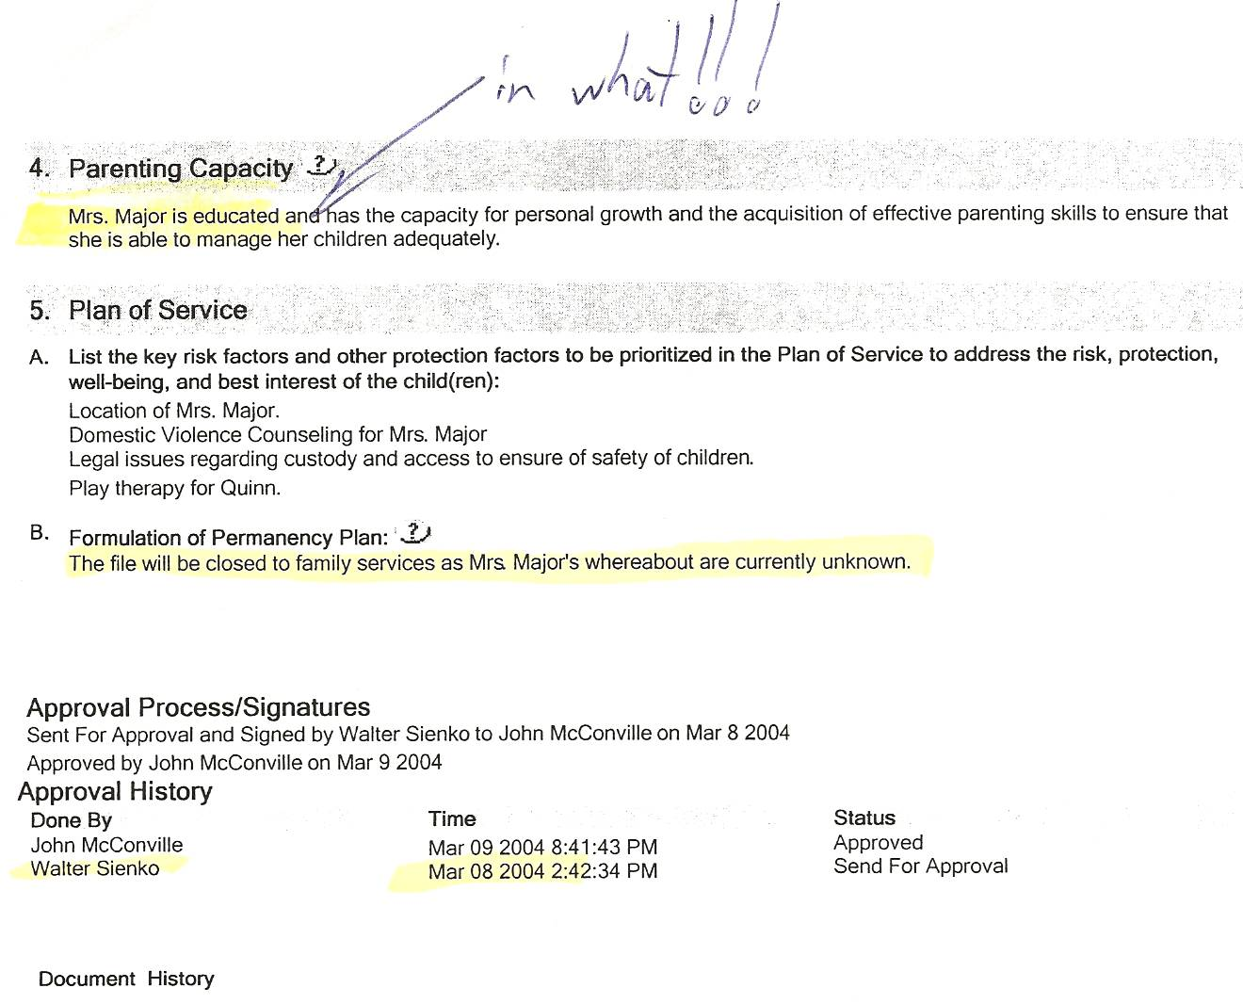

Notes:
-there are earlier indications in the CAS file that they, and specifically caseworker Walter Sienko, strongly encouraged Sherry to leave the province. Sherry gave testimony to this effect in August 2008.

