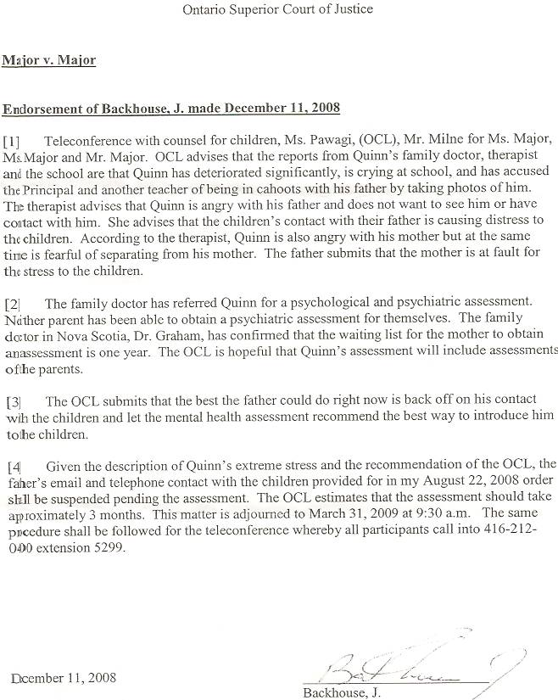

Dan’s Notes:
-via teleconference, Backhouse terminated all contact Dan had with his kids, with no warning, with no recommendation from any counselor and without taking pertinent factors into consideration
-this Endorsement was mailed to me
-both Backhouse and the OCL refuse to acknowledge that it would be useful that any counselor, be it for the kids or Sherry, have details as to Sherry’s background and mastery of deception – Backhouse said “I have faith they’ll figure it out.” I asked her why we’re playing this game, allowing my kids to not be properly diagnosed and treated, and pointed out that Sherry’s counselor, Brian Schrock of Christian Ministries Counselling, hadn’t yet figured it out in 3 years.

Dan’s Notes:

Re: December 11, 2008 Endorsement from Backhouse

(contact # is 416-212-0400 – was cut off on original)

This joke of an Endorsement to entirely end all contact I have with my children was put forth solely upon the recommendation of the OCL lawyer, who later admitted to me that no counselor would ever recommend terminating the children’s contact with either parent. Despite this, the OCL lawyer had the audacity to deny to me that she gave the recommendation to the judge that terminated my contact with the children. This judge’s endorsement proves the OCL lawyer is lying (item 4: “… the recommendation of the OCL”). The woman is nothing other than a stereotypical, diabolical two-faced politician, a true wolf in sheep’s clothing.

FACTS:

Item (1) failed to note Quinn was crying at school once, since he discovered the previous evening that his mother would not give him and Mira the gift packages I had sent to them. He’s caught in the middle but lives with his mother and obviously needs to appease her.

Item (3) clearly shows that only the OCL suggested my contact with the children should be terminated. They later admitted having no contact with the children since October and also that they were unaware Sherry had moved twice in 60 days since her return to Truro. Nor did they advise the judge that Sherry had spent considerable time in Small Claims Court, having two more judgements levied against her. Obviously, these factors all play into her parenting situation and ability.

Item (3) talks of introducing the kids to me. It neglects to acknowledge that they already know me and had no problem with the transition from NS to Ontario. (I previously submitted 150 pictures to the court to indicate this, along with witnesses Affidavits and testimony.) The problem lies solely in what, and how, Sherry presents to them. Their perceptions are obviously based upon the lies she feeds them. However, the OCL and judge refuse to acknowledge this vital fact.

Nowhere is it mentioned that I had earlier advised the OCL that Sherry is lying to the children and their counselor and that the counselor should be fully informed as to the children’s background situation created by their mother.

The good news? I discovered that Backhouse can NOT be the judge if and when we ever have a custody trial. That is great news since her actions clearly indicate her intentions to maintain status quo and leave the children with Sherry forever. With a different judge I would at least have a small glimmer of hope.

