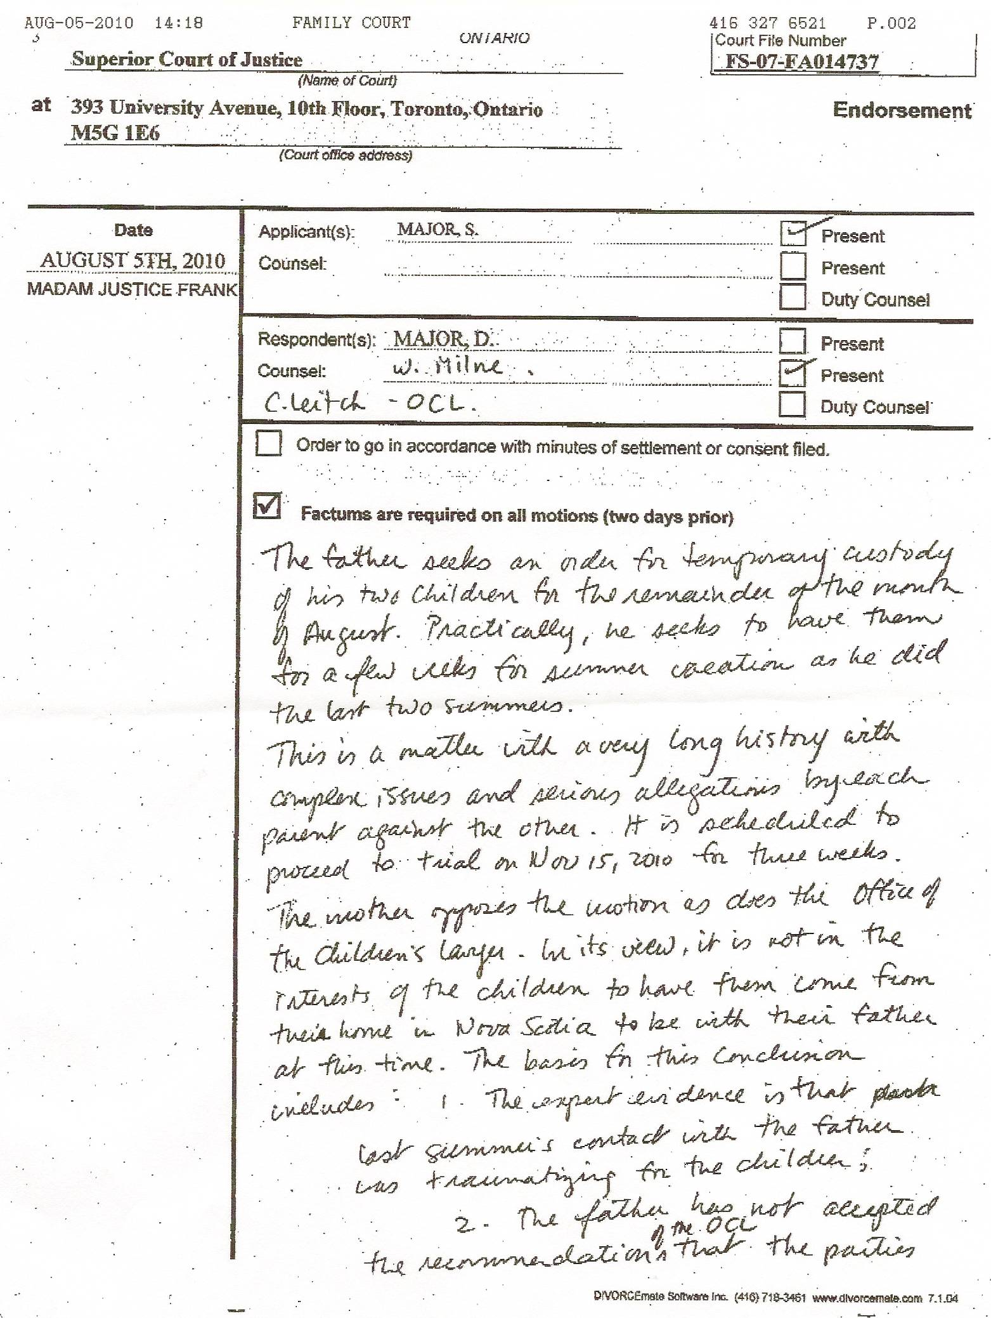
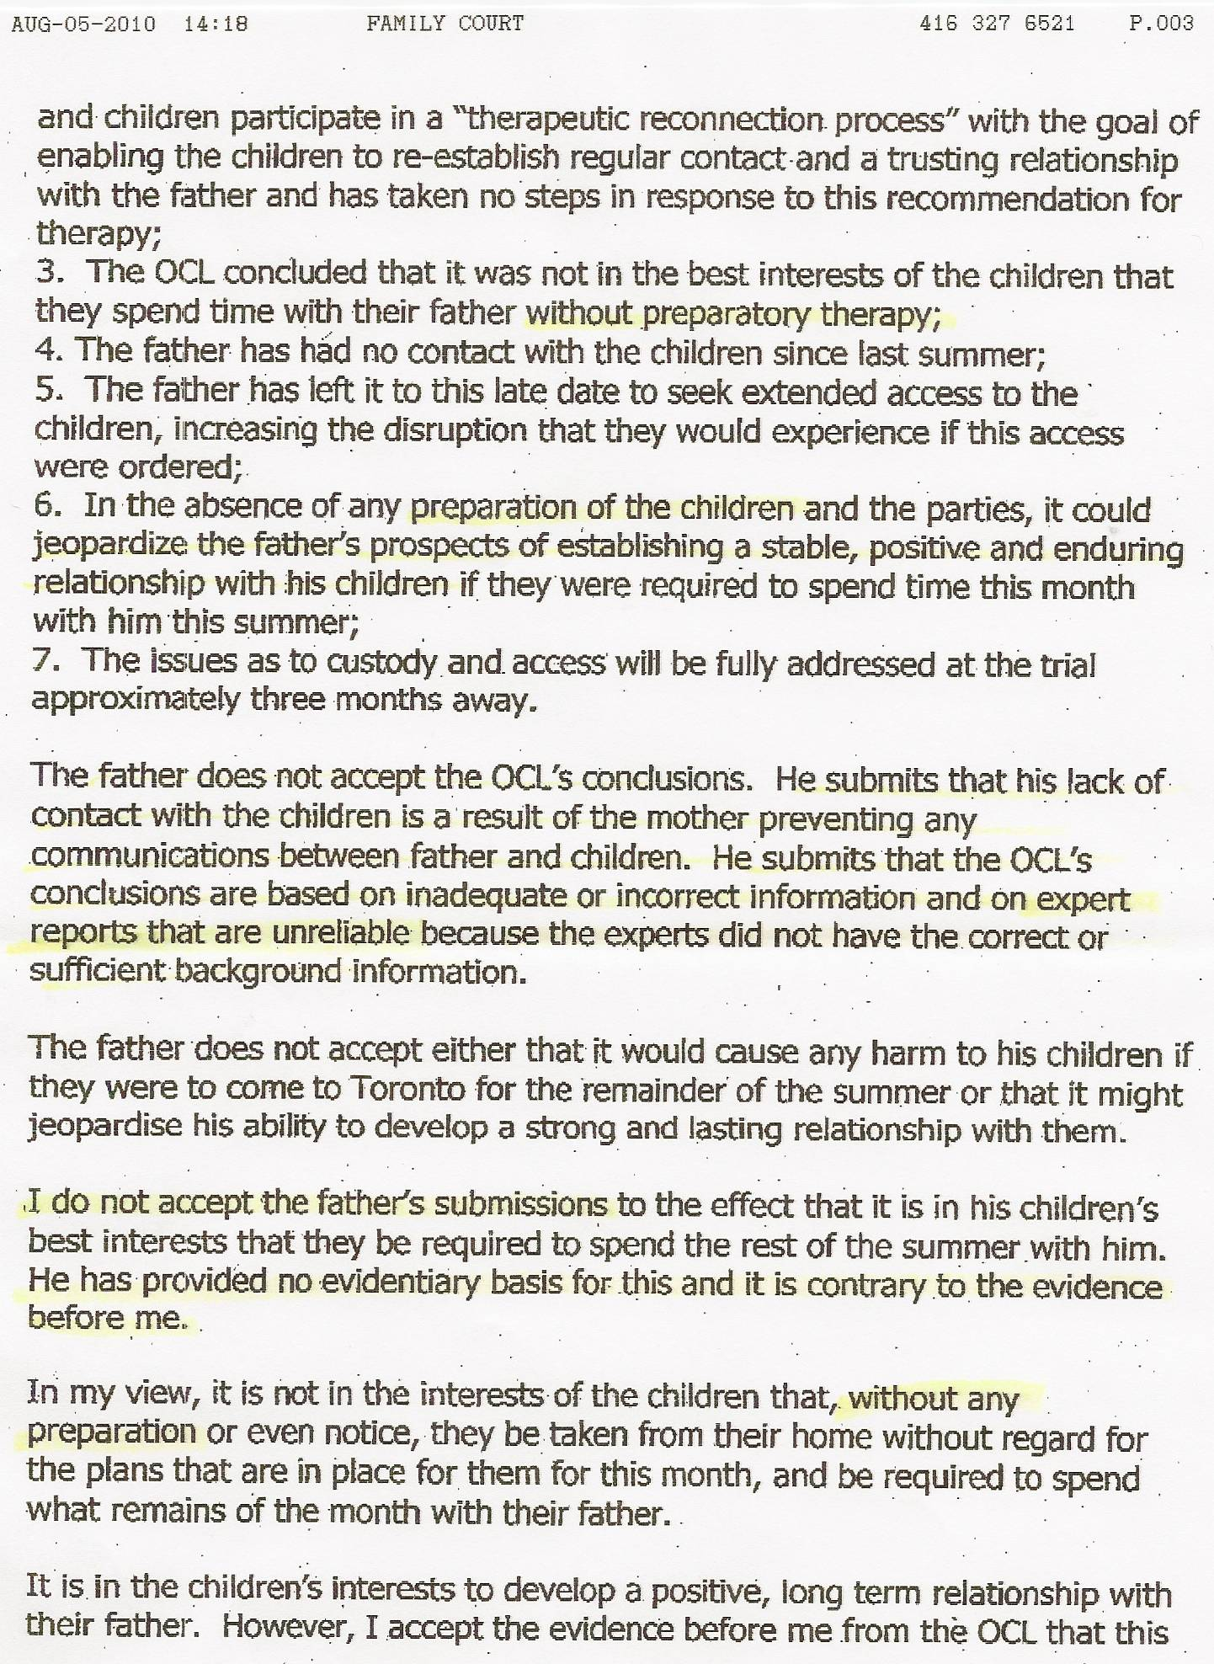
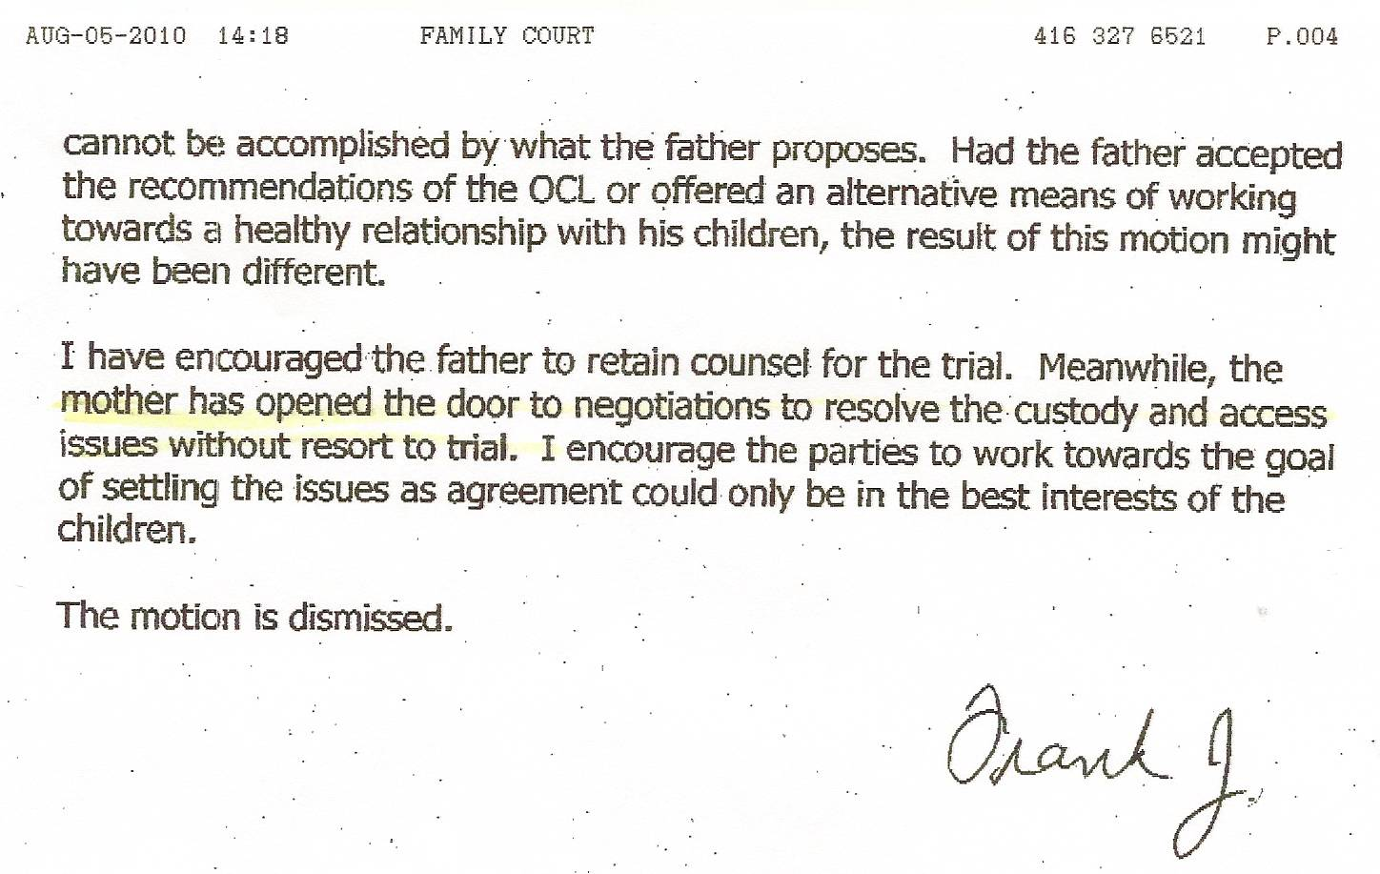

Dan’s Notes on what REALLY happened at this court appearance:

My Affidavit, Factum and brief opportunity to speak made it clear that I considered the entire matter a political butt-covering exercise with FALSE claims of being in the kids’ best interests. The judge repeatedly said she was “very disheartened” that I felt that way and she just couldn’t understand why since our (Canadian justice) system is one of the best in the world. I noted that I am simply a REALIST and that my view is entirely based on supporting factual evidence – the system has totally let me down and I have nine years of proof and cover-ups to support my view. She really didn’t like my statement.

-I started off by asking if the OCL even knew where the children lived – the judge cut me off, claiming it was irrelevant – I eventually managed to point out that the kids once again were evicted on July 9 due to mother’s ongoing patterning of not paying rent, noting that mother’s lawyer tipped off the landlord that “there is no settlement” (and I referenced mother’s use AGAIN of telling a landlord she was in the process of getting a $350,000 divorce settlement) – I suggested the kids spending time with me might allow mother to find new accommodations – judge was not in agreement and said the issue was not relevant to my access – I noted that I disagreed with her and did consider it relevant since how is it in he kids’ best interests to continually have eviction notices posted on their doors and windows by the Sheriff’s Department – judge refused to discuss the matter and digressed

Re: Item 4 – “The father has had no access to the children since last summer” – I pointed out, as the OCL were fully aware of, that MOTHER IMMEDIATELY & CONTINUALLY BREACHED THE COURT ORDER for telephone access as soon as the kids returned to N.S. last August!

-I continually tried to get the judge to admit that since the kids’ counsellors have never been informed of mother’s malicious lies and total misrepresentation of me to both the kids and the counsellors that the kids have therefore obviously been misdiagnosed and would then obviously be treated incorrectly (in therapy) due to the misdiagnosis. The judge disregarded my view and essentially refused to address my concern, claiming it was not accurate. I pointed out that both the counsellors and kids have essentially been told I’m an “axe murderer” (this was hyperbole, with the intent to show how severe the misrepresentations by mother have been). I noted that mother claims the birth scar on her neck is from me trying to slit her throat and that I supposedly was convicted of attempted murder and sent to prison for 10 years. The judge said “I’ve read the file and … blah, blah, blah … highly doubt that” - she basically accused me of exaggerating.

I pointed out that there are several 2008 Affidavits from people in N.S that refer to this story from mother. The judge
(1) didn’t like that I pointed out she wasn’t aware of the facts
(2) continued to claim total faith in the OCL’s “expert” handling of the case.

-I continually pointed out the fallacy of claims that the OCL and courts are working in the kids’ best interests if they don’t get them properly assessed with pertinent FACTS – the judge simply refused to address the matter, instead expressing her faith in the OCL. The judge also repeatedly claimed the kids required “preparation” before seeing me. I asked if this meant filling their heads with even more “malicious lies”. I suggested that the CAUSE of the problems needs to be dealt with – mother’s total life of lies. The judge repeatedly refused to deal with the facts! Even worse, she refused to specify what this alleged “preparation” would actually be, instead just skirting around the matter with empty words.

When the judge declared no access for me I said that I expected such a decision. She said “I hope that’s because you understand it’s because the OCL needs to ensure the children are prepared … “ I said, “Definitely not.” Again, she was “very disheartened” I refused to agree with her claims. She preached about how there are not pre-determined outcomes, as I had stated in my Affidavit. She claimed I would definitely be given a fair chance and the November custody trial. I noted that I didn’t agree, pointing out that this case is one of severe parental alienation and numerous other issues that the “experts” refuse to do anything about. I called the trial process a “kangaroo court” (note that at my last appearance I stated “I feel like Omar Khadr – knowing that I won’t get a fair trial.”)

Upon leaving the courtroom the smug OCL lawyer said “You’re going to have to prove alienation.” I mentioned that her attitude is a big part of the problem since she hides behind rhetoric and false claims of “children’s best interests” while using the law to hide the truth, pointing out she wants me to “prove the obvious, such as 2+2=4 when everyone knows it does.” I pointed out that things might be out of my hands between my civil lawyer and the YRP since they might review the case and decide to follow through on charges against Sherry that should have happened years ago but were covered up and that if they did mother would be extradited to Ontario if that happens, so the custody trial might be a moot point. OCL lawyer: “You just assume you’ll get the kids if that happens.” (showing her intent that the OCL is probably opposed to me having/seeing the kids under any circumstances)
My response: “Actually, no I don’t. I assume the OCL will continue to try to cover their butts just like everyone else has.” She got a bit pissy that I don’t like her attitude or approach, then she huffed off to the elevator, saying “I’ll call you in September.” I responded, “Don’t bother.”

-unlike the June 30 judge that basically openly scoffed at the OCL’s recommendations and said “Who’s going to pay for all of this?” (referring to the OCL recommendations for “reunification therapy” that would cost tens of thousands of dollars – I noted I was expected to pay for everything) judge Frank never addressed the matter other than claiming I was at fault for not participating in their suggested program (refusing to acknowledge that money doesn’t grow on trees for me)

The claim “mother has opened the door to negotiations to resolve the custody and access issues without resort to a trial” is 100% WRONG! I’m the one who raised the topic, noting that Sherry’s lawyer made the suggestion to discuss the matter when we attended court on June 30th. I noted that negotiating with her was akin to “negotiating with a terrorist” and as such was likely doomed to fail. Her lawyer has yet to make any suggestions or offers.

Bottom line
This was probably the worst judge this matter has seen in quite some time. She had her political lines well prepared, just as I expected. She was either unaware of pertinent facts – or chose to ignore them if they didn’t fit her view.

