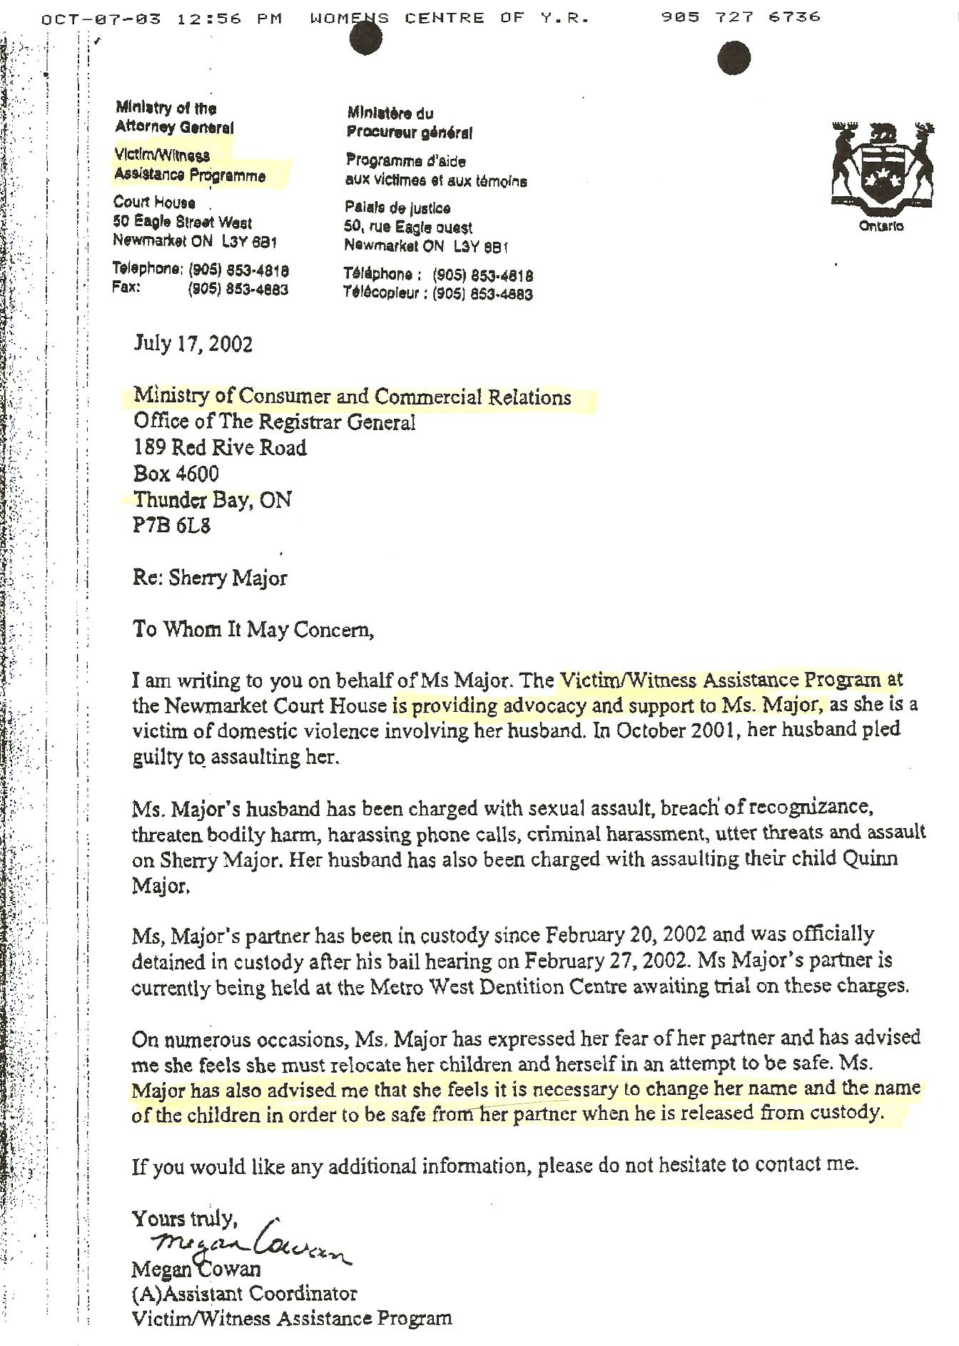

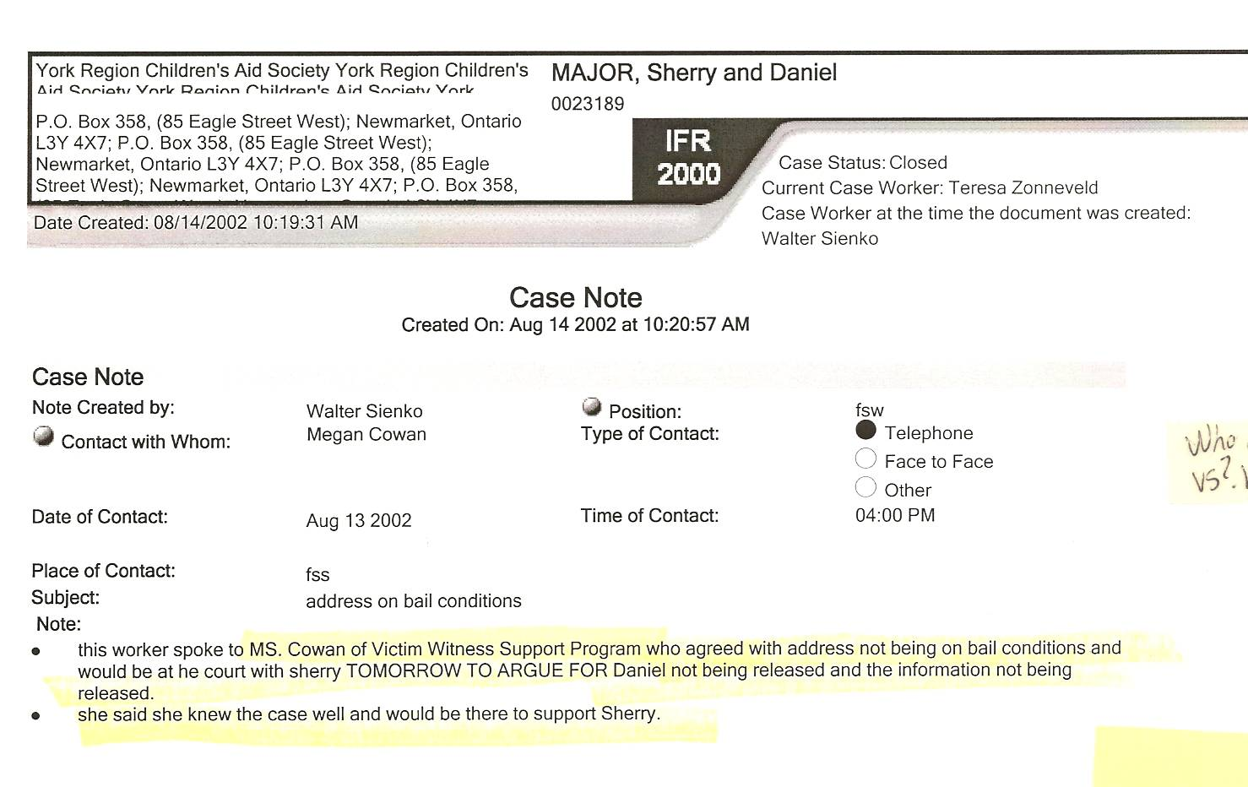

Dan’s notes:
This letter to NIVA (New Identities for Victims of Abuse) was in the York CAS file obtained by Court Order in 2008. Proves CAS (then caseworker Walter Sienko) worked against Dan to assist in Sherry’s flight – and was totally aware of Sherry’s intent to try to get an identity change and relocation.

Note that when I “pled guilty” in October 2001 it was only so I could go back home to live in my house with my wife and children, not knowing Sherry was colluding against me. I moved home the very day I copped that plea. If Sherry was truly scared of me she simply could have made arrangements (behind my back) with the Crown Attorney’s office to not even have a plea bargain made available to me – and to not sign the document that permitted my return home!

Isn’t it ironic that while I was only accused of charges I was removed from my home yet as soon as I said “okay, I’ll cop a plea and say what you want me to say, just so I can go home. Okay, I did it. I’m guilty” that I was allowed to go home that very day!!! This shows that the system is about politics, not right and wrong, since it knowingly will attempt to use any plea bargain against the individual in future matters.

