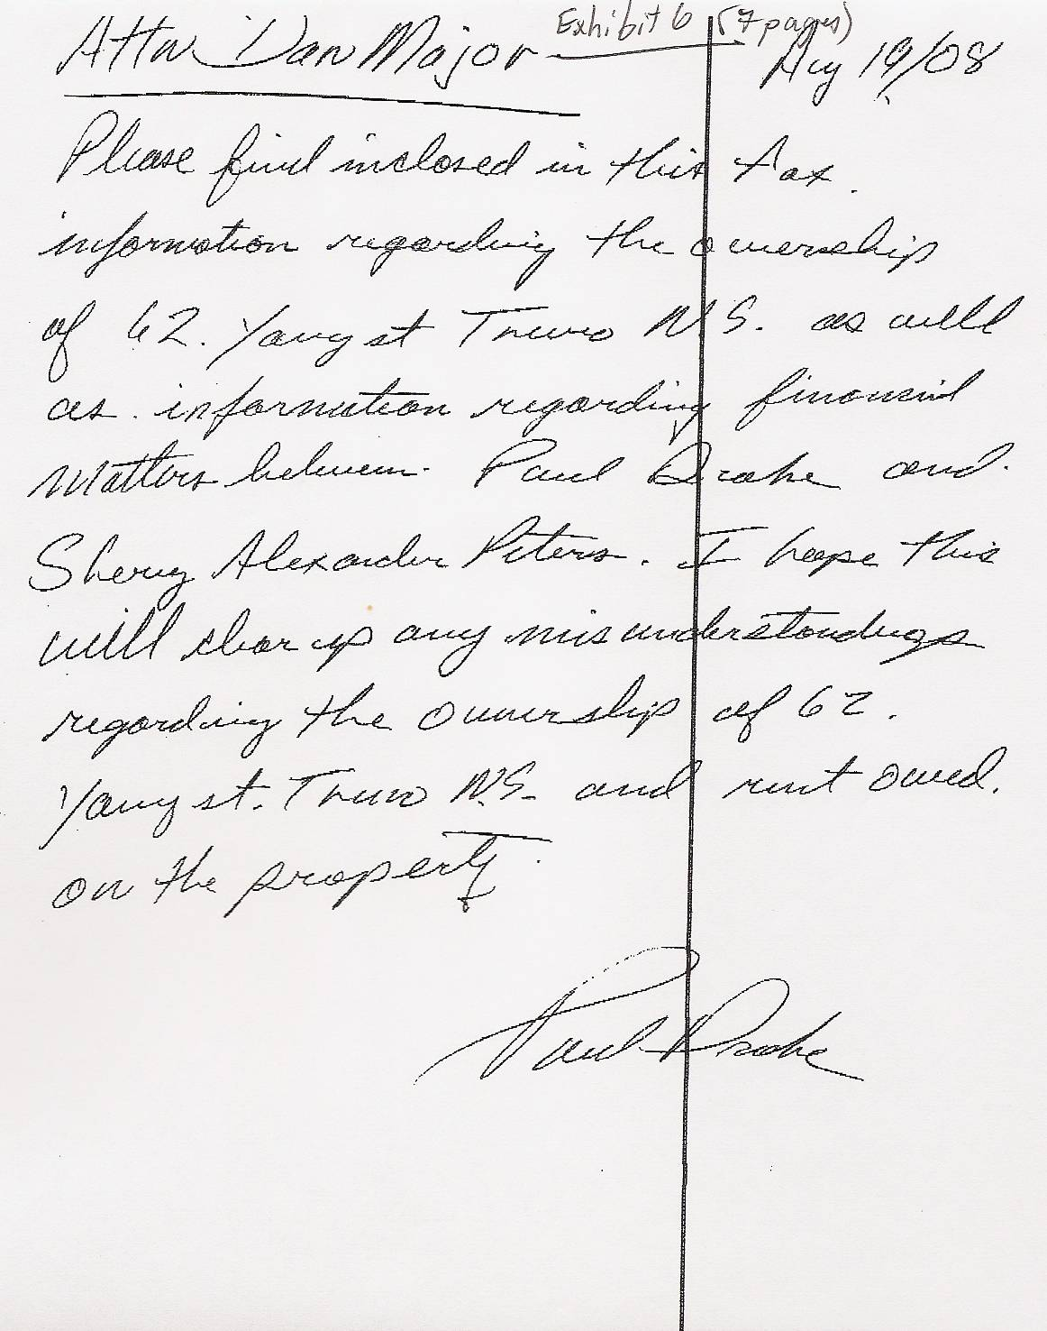

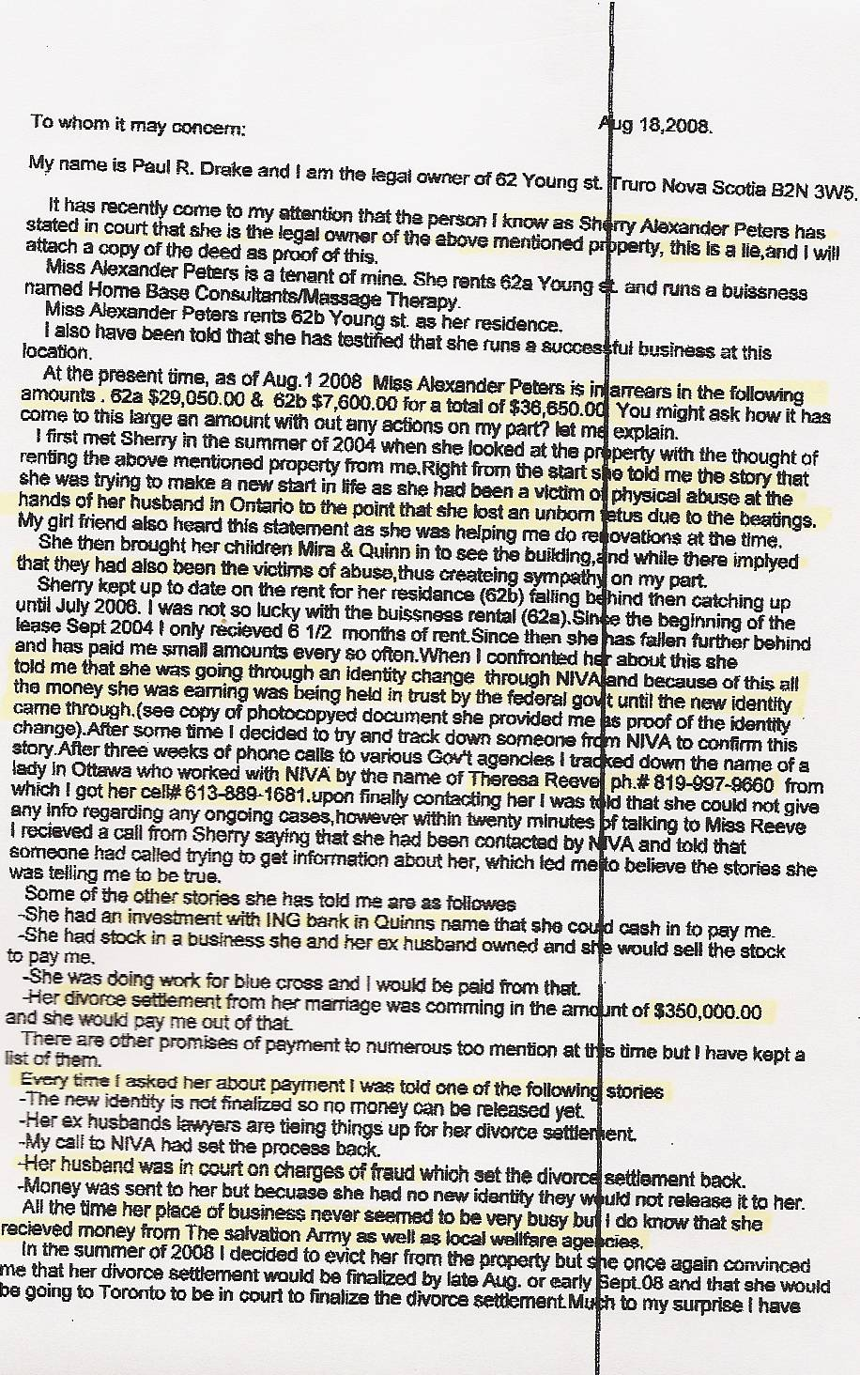
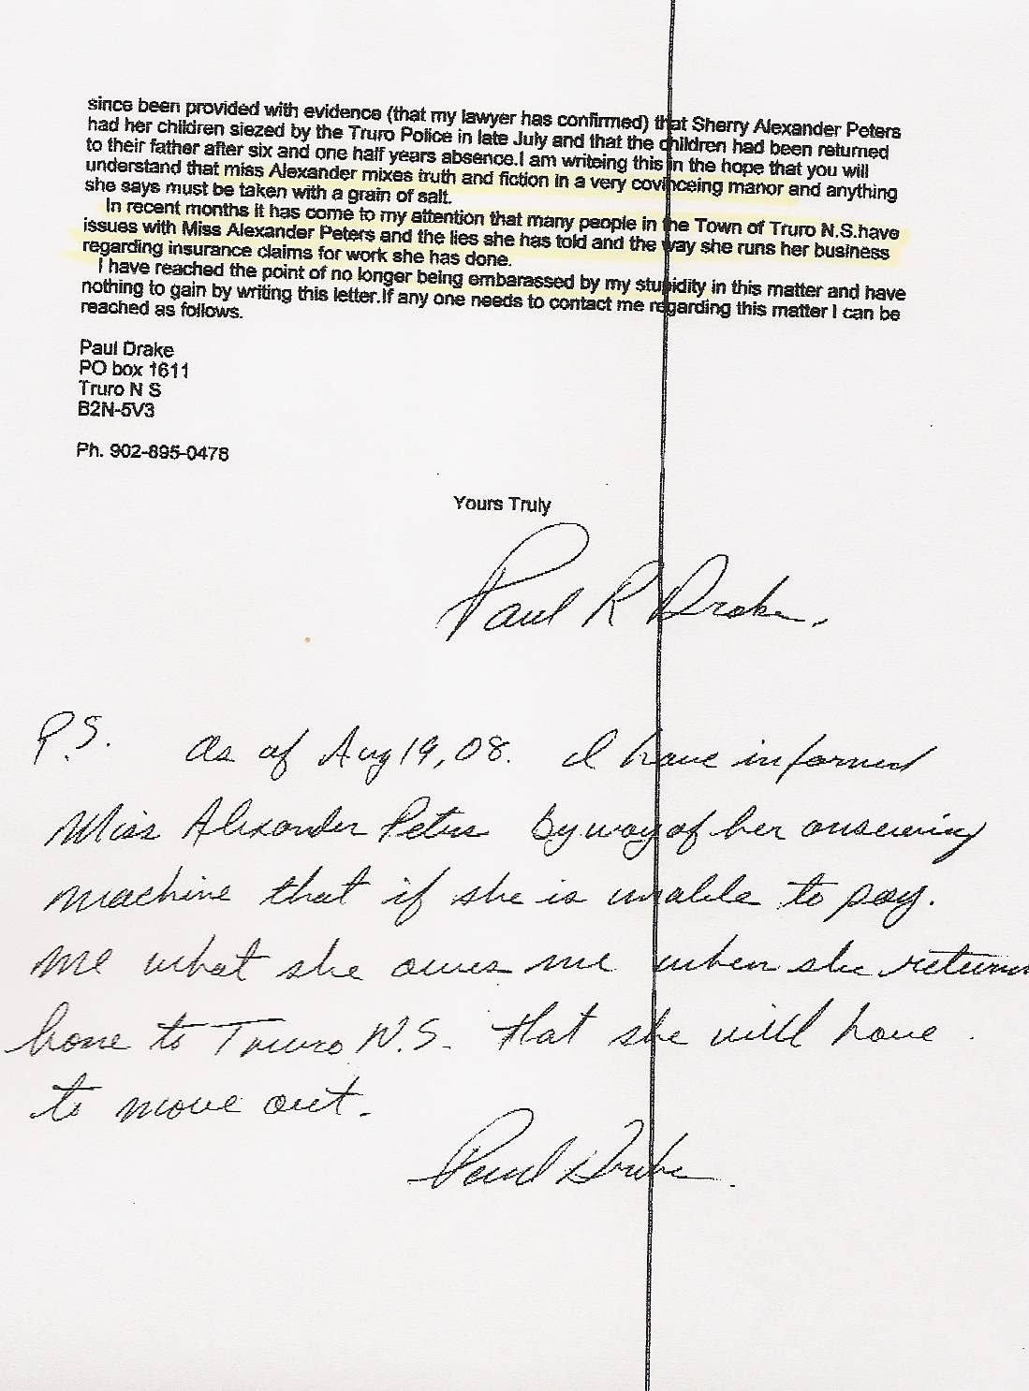

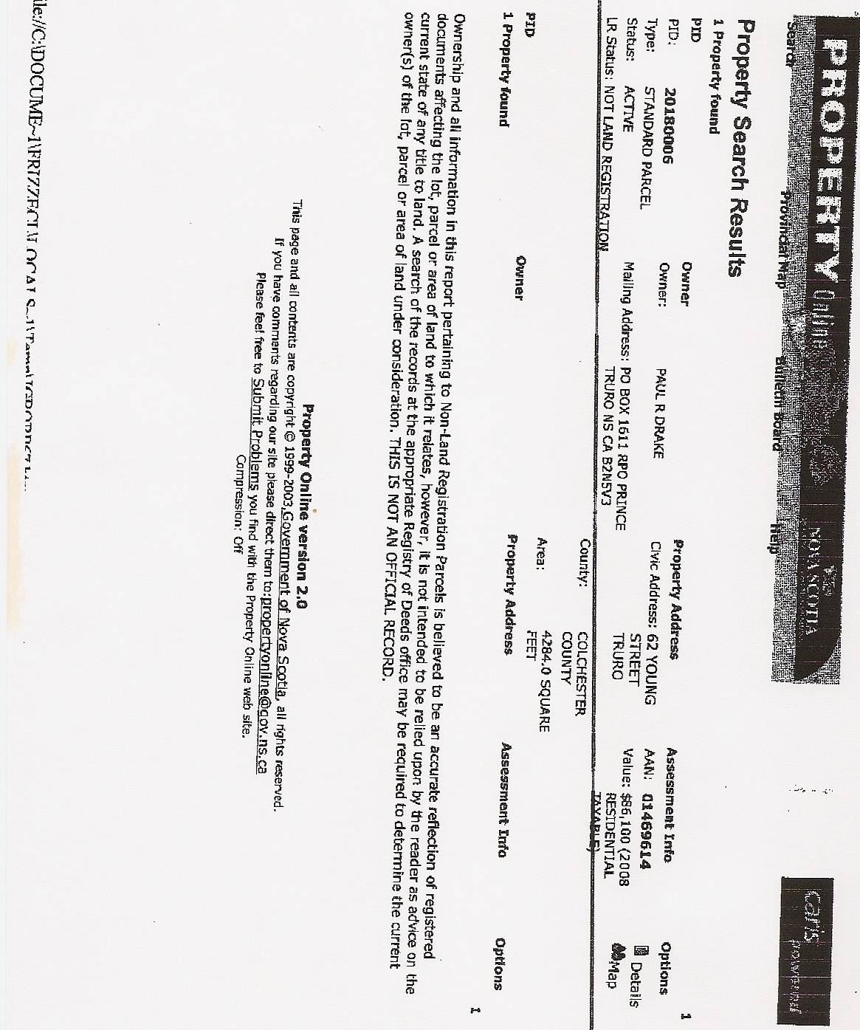

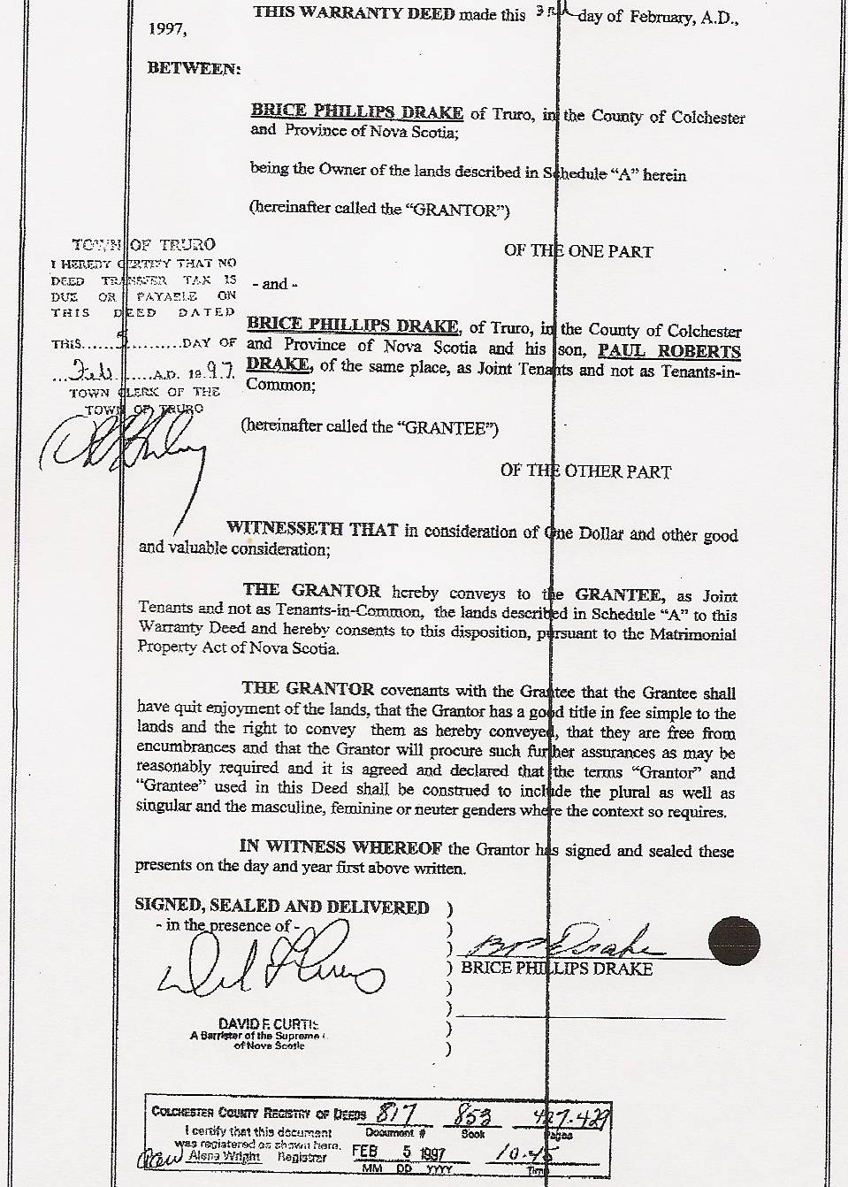

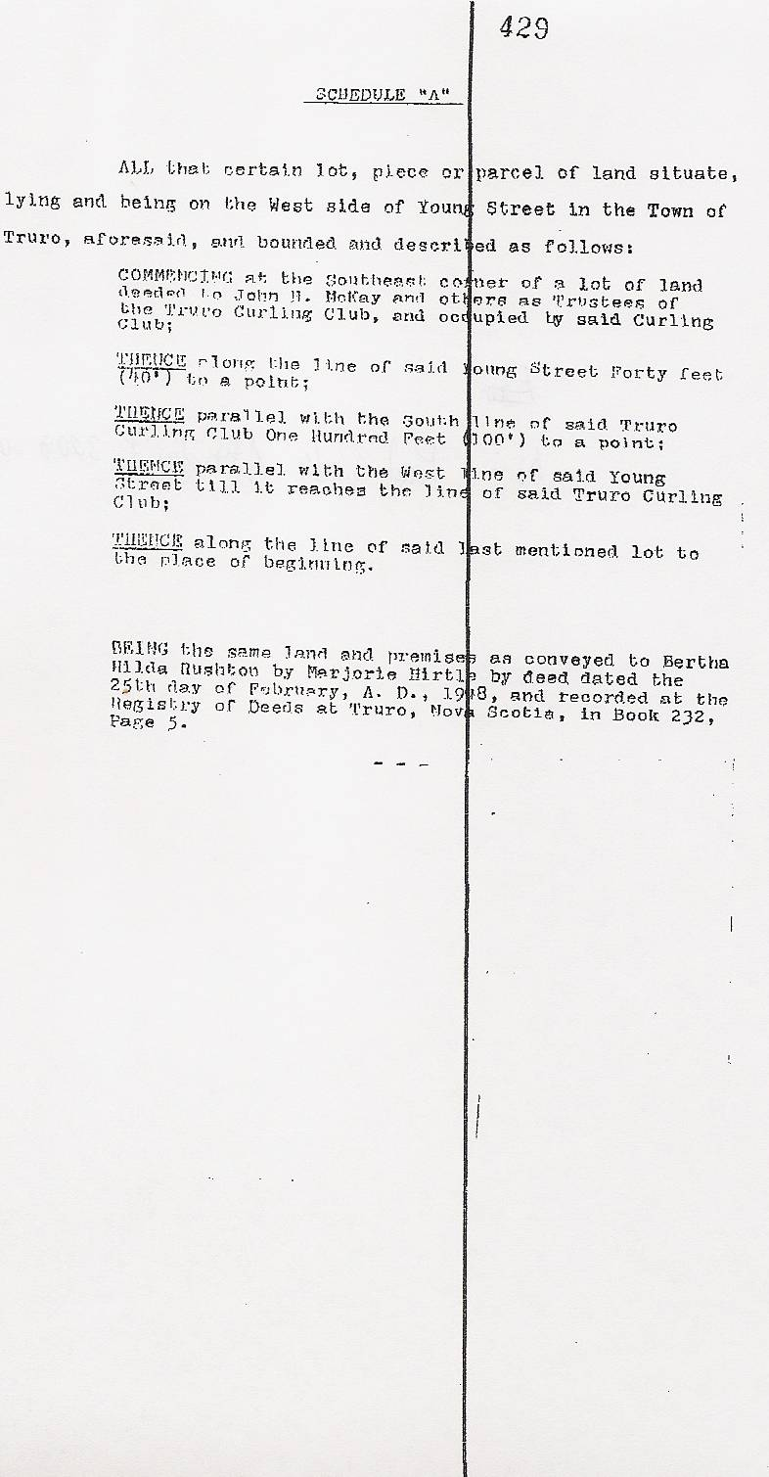

Dan’s Notes:

-Paul Drake was Sherry Major’s landlord between 2004 and August 2008. He was ultimately bilked of over $40,000 in unpaid rent due to Sherry’s lies. As she had done before, Sherry’s lies went beyond little white lies and were extremely “malicious”, just as Judge Lampkin had warned people about in June 2003 at the conclusion of Dan’s trial!

