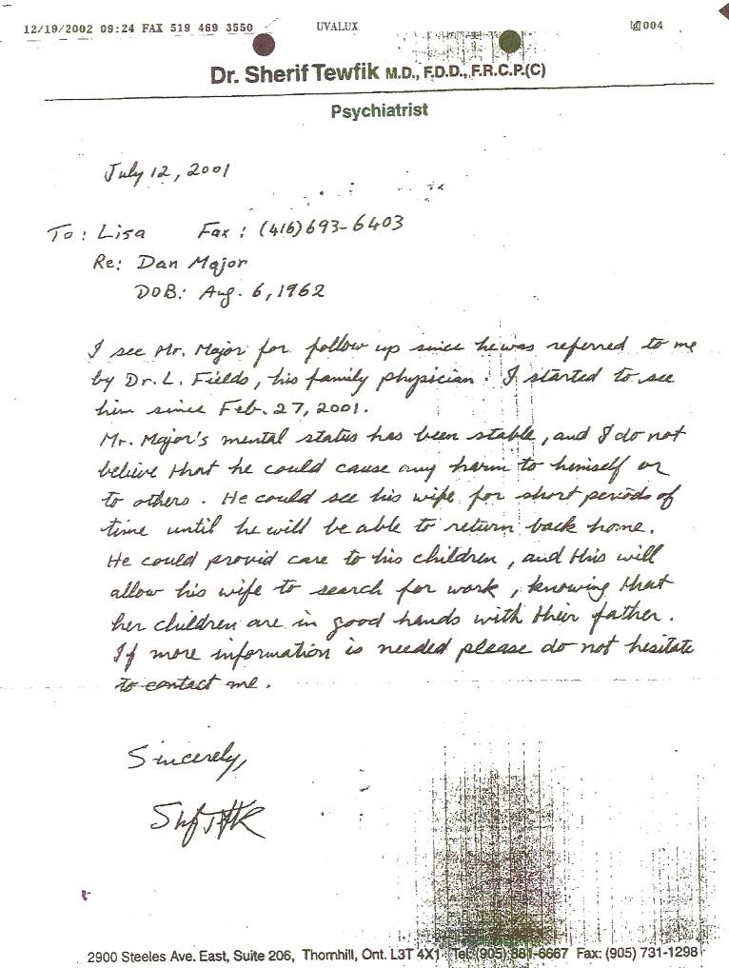

Notes read:

“I see Mr. Major for follow up since he was referred to me by Dr. L. Fields, his family physician. I started to see him since Feb. 27, 2001.
Mr. Major’s mental status has been stable, and I do not believe that he could cause any harm to himself or to others. He could see his wife for short periods of time until he will be able to return back home. He could provid (sic) care to his children, and this will allow his wife to search for work, knowing that her children are in good hands with their father.
If more information is need please do not hesitate to contact me.

Consider that I had just endured the following horrific circumstances and still remained stable!!!

- Was arrested May 24, 2001 on bogus charges

- Forced to move out of my home due to the charges

- Lost my $90,000/yr job

- A fraud victim (many hundreds of thousands of dollars) – perpetrated by my own wife

- Knew I was on the verge of bankruptcy and “losing everything”

All things considered, I thought I was doing remarkably well. Apparently the CAS and YRP felt otherwise.

