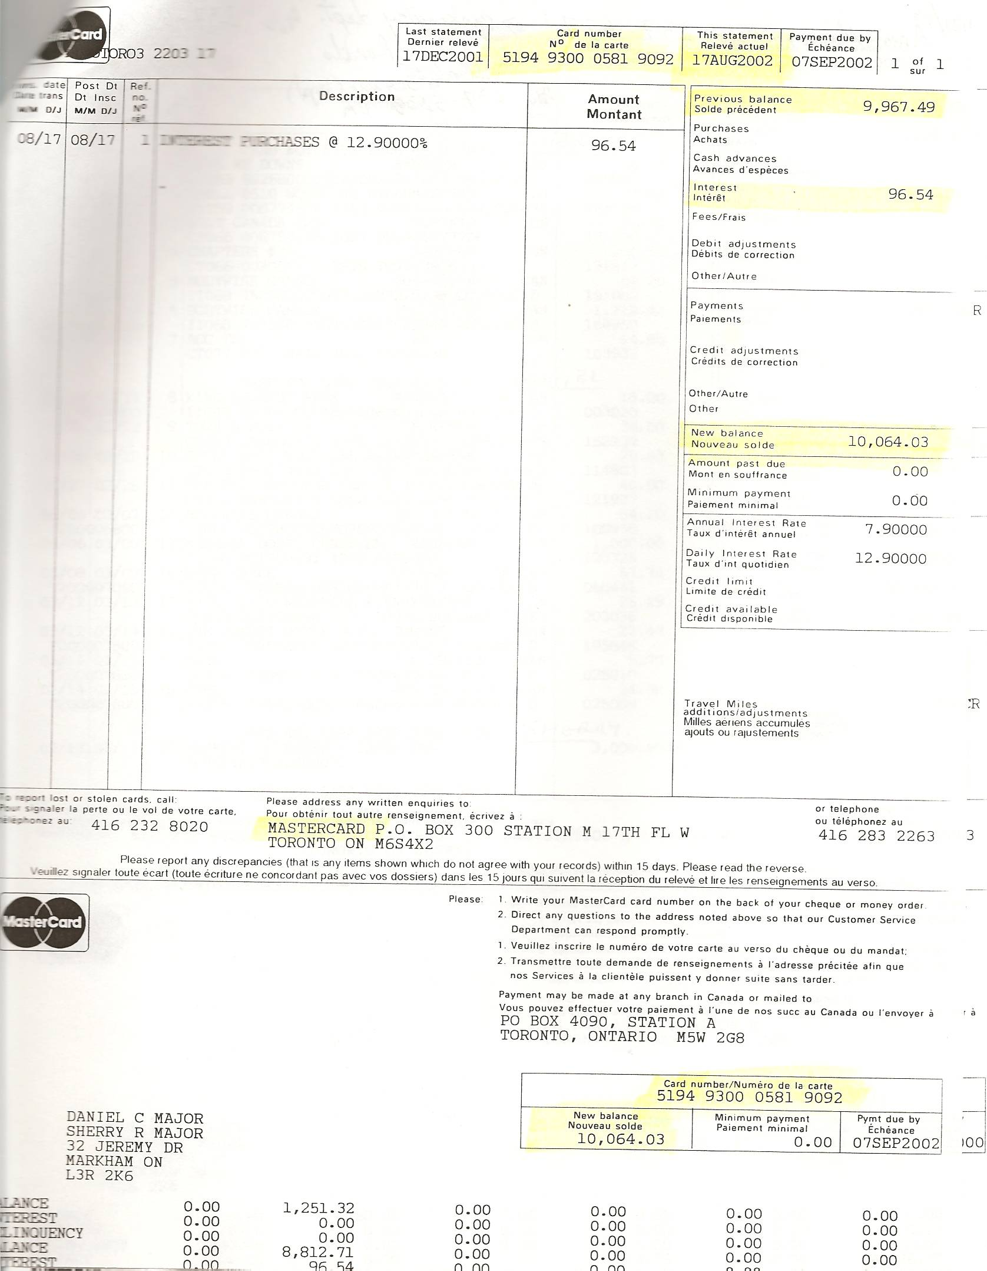

Dan’s Notes:
-I had a handful of charges mixed in with Sherry’s FRAUD on this card, not knowing she had called to increase MY limit so she could get more money
-Bank of Montreal (BMO) Mastercard was VERY uncooperative with me – they didn’t want to admit fault
-Dan recovered account statements from 2000-2002

