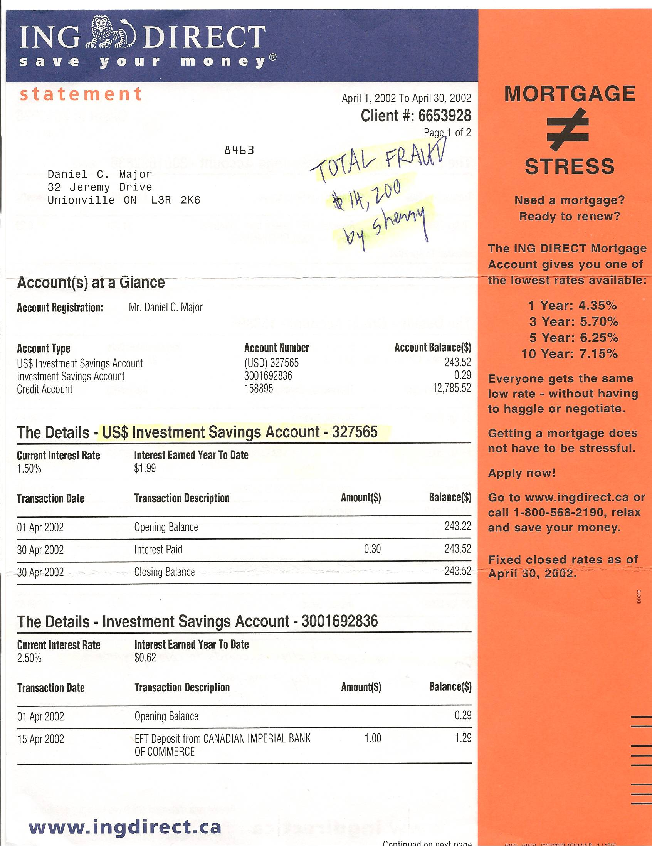

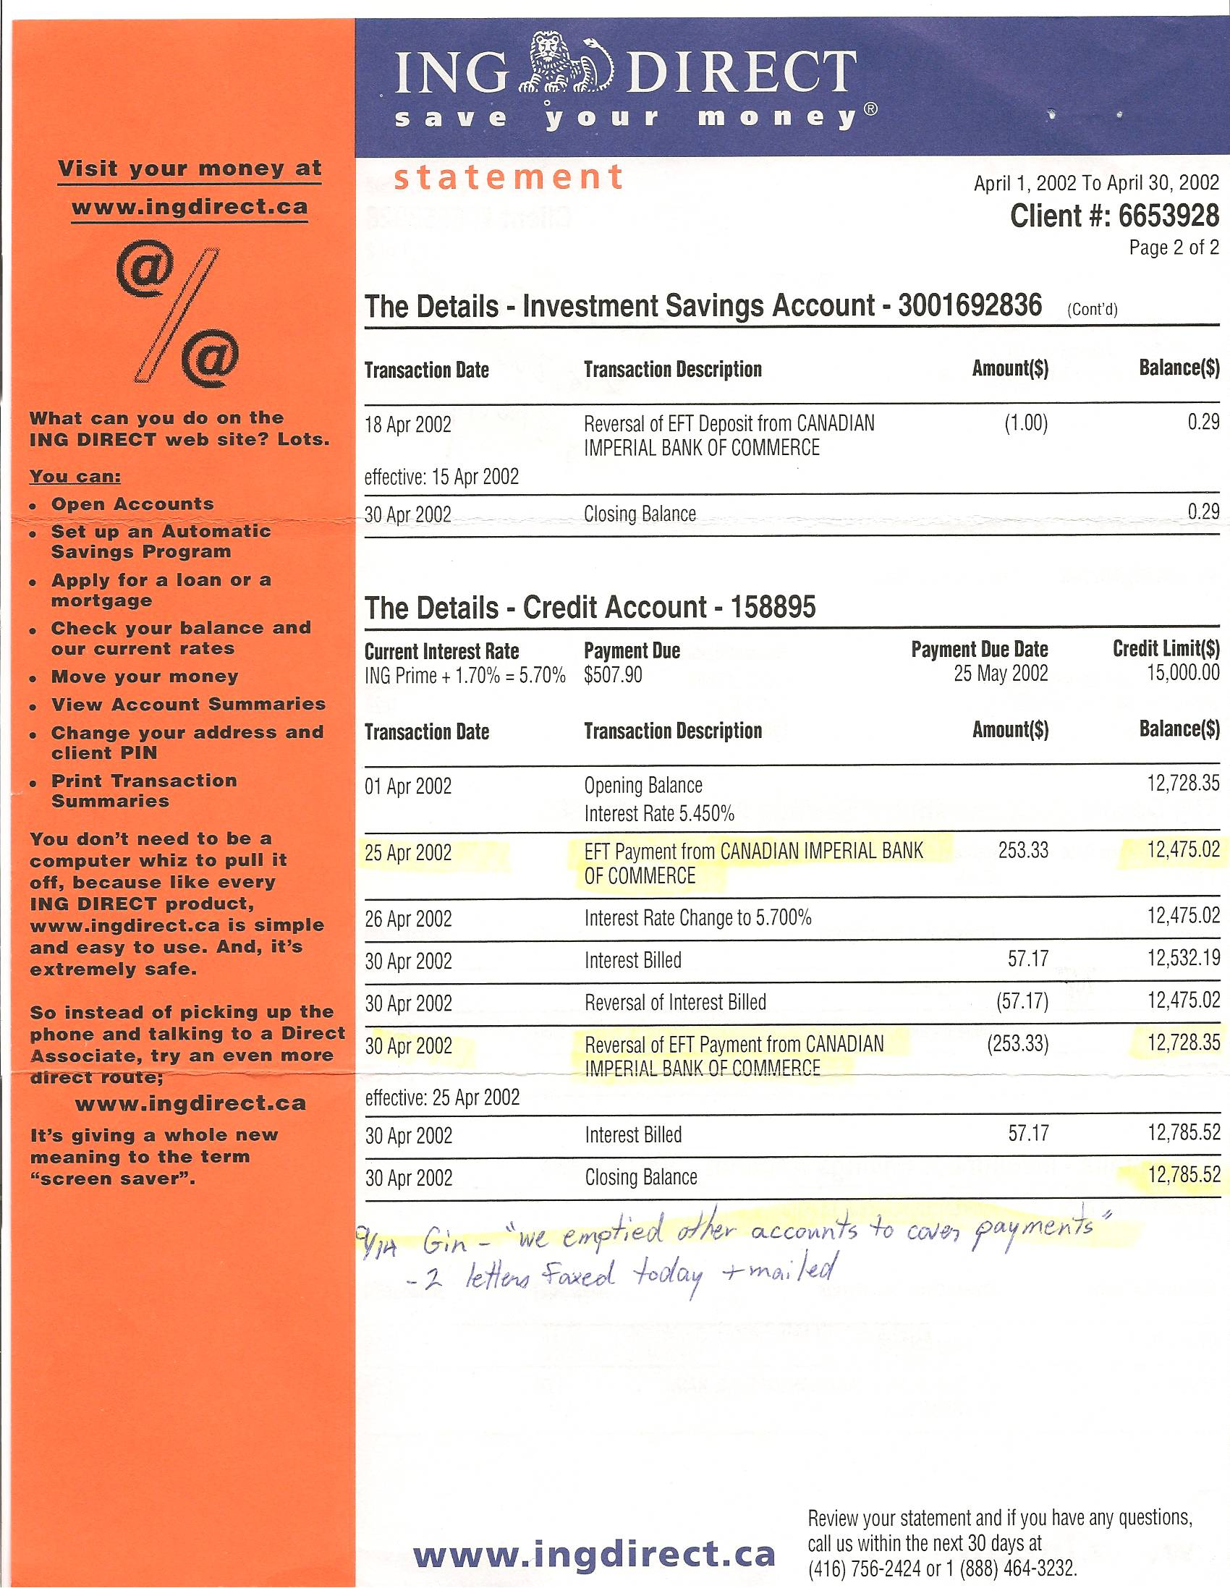

Dan’s Notes:
-this was TOTAL FRAUD by Sherry – and proven as such at my trial (she unbelievably tried to claim her own PIN numbers and account numbers matched mine and that she erroneously took money from the wrong accounts!)
-Sherry fraudulently took $14,200 in cash advances from these accounts of mine – ING then proceeded to take payments from my U.S. dollar account for many months – entirely without my awareness since I rarely used these accounts (and didn’t even know how to use the Internet at that time)
-NONE of this money was ever accounted for (other than that it was traced to “Sherry Vardy” – see ALIASES page – “Vardy” is Sherry Major’s maiden name)

-ING Direct’s FRAUD Investigation Department refused to ever cooperate with me since the investigator was a former cop that openly stated he was offended by my usage of the term “dirty cop” in reference to Sherry Major’s YRP boyfriend Terry Jordan
-there is no statute of limitation for FRAUD – however, even in 2010 ING has been extremely uncooperative with looking into this matter

-in a typical FRAUD case whereby a bank gives someone’s money to a non-account holder does the bank not typically reimburse the account holder and make an attempt to pursue criminal charges against the fraud perpetrator?

