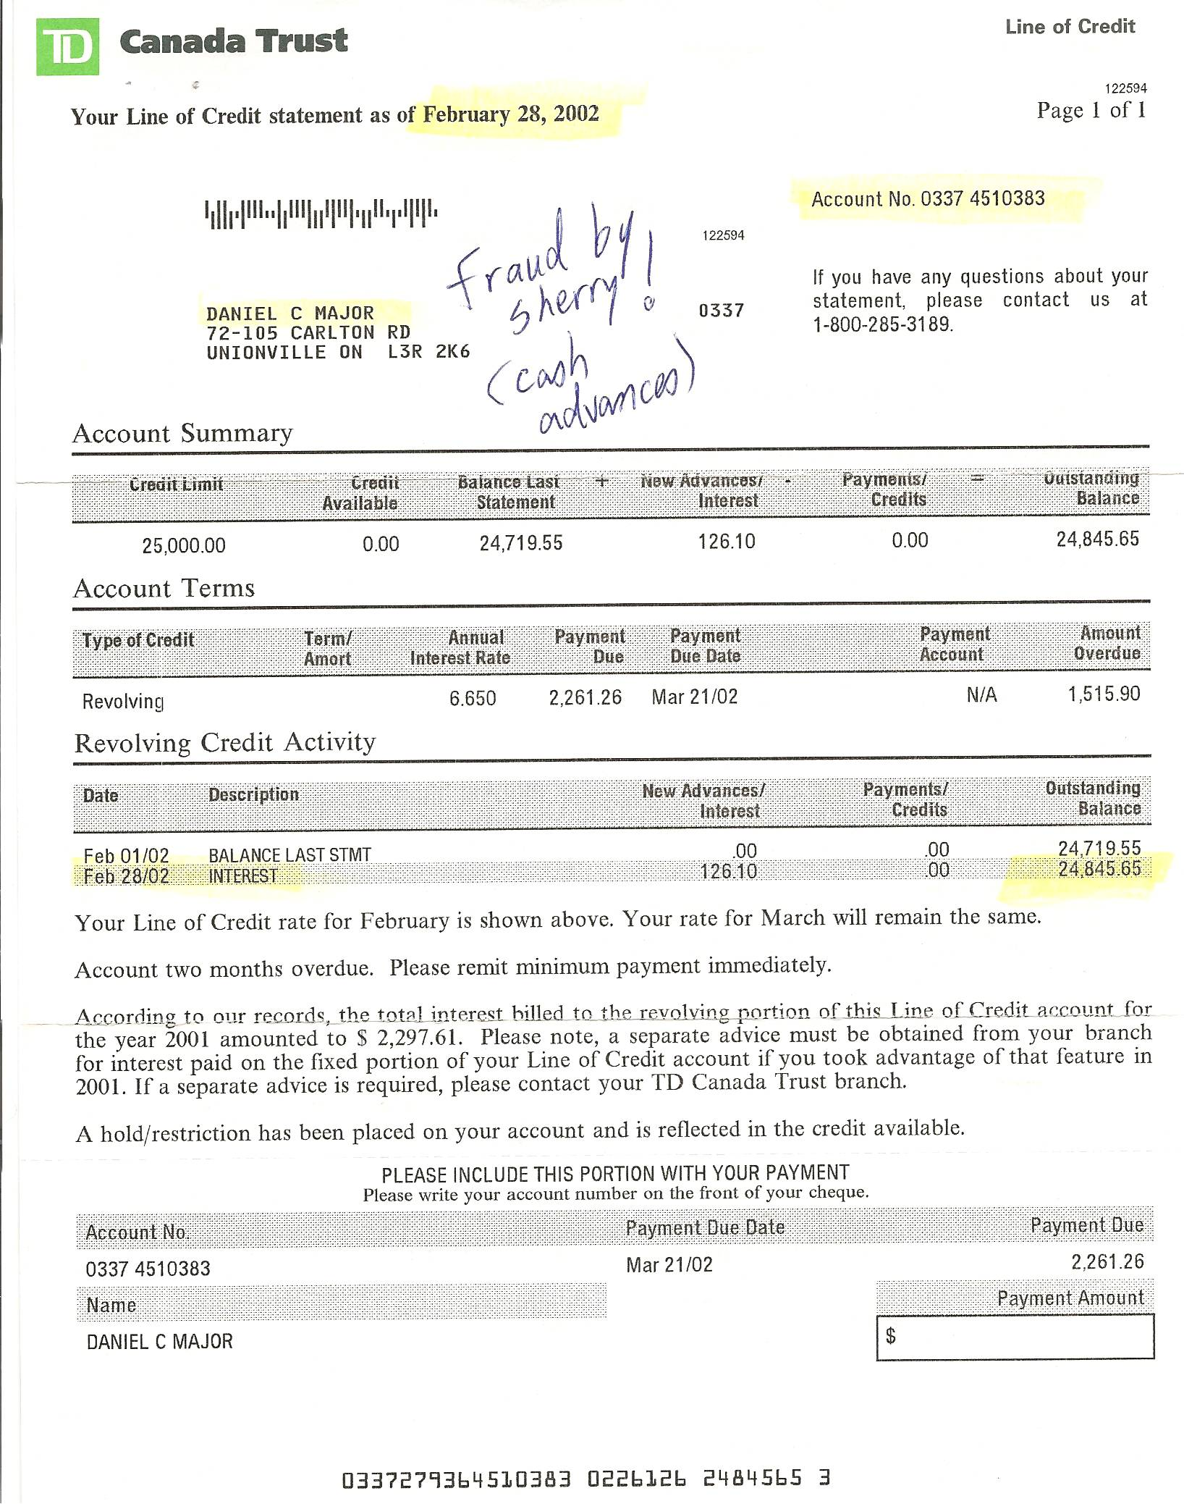

Dan’s Notes:
-I had paid of $50,000 of “school debt” for Sherry in 2001 and she promptly maxed out this $25,000 Line of Credit with cash advances within three weeks – all without my knowledge – I only discovered this eight months later – after meeting with the gynecologist following the Toronto Star “miracle baby” story and realizing much of Sherry’s story did not make sense – this is TOTAL FRAUD!
-the bank never recovered this money (and nor did Dan!)
-this money was NEVER accounted for – it was traced to Sherry Major

