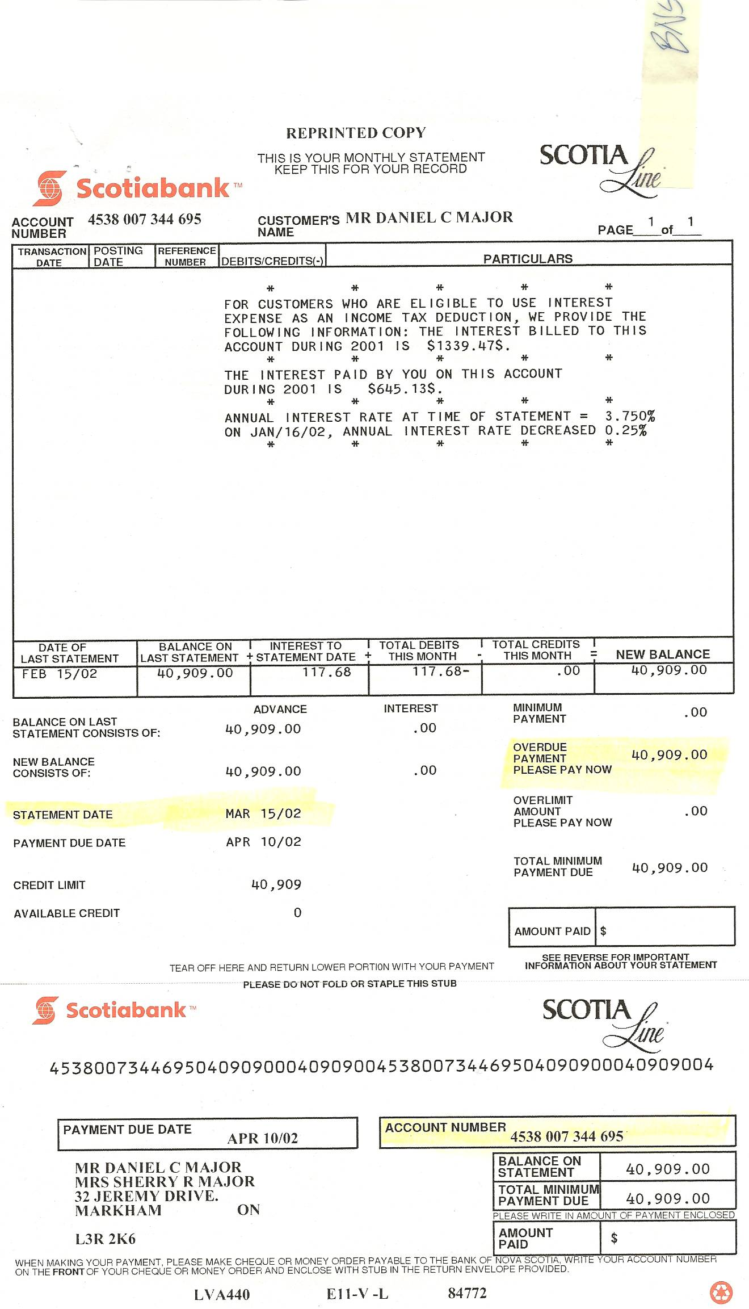

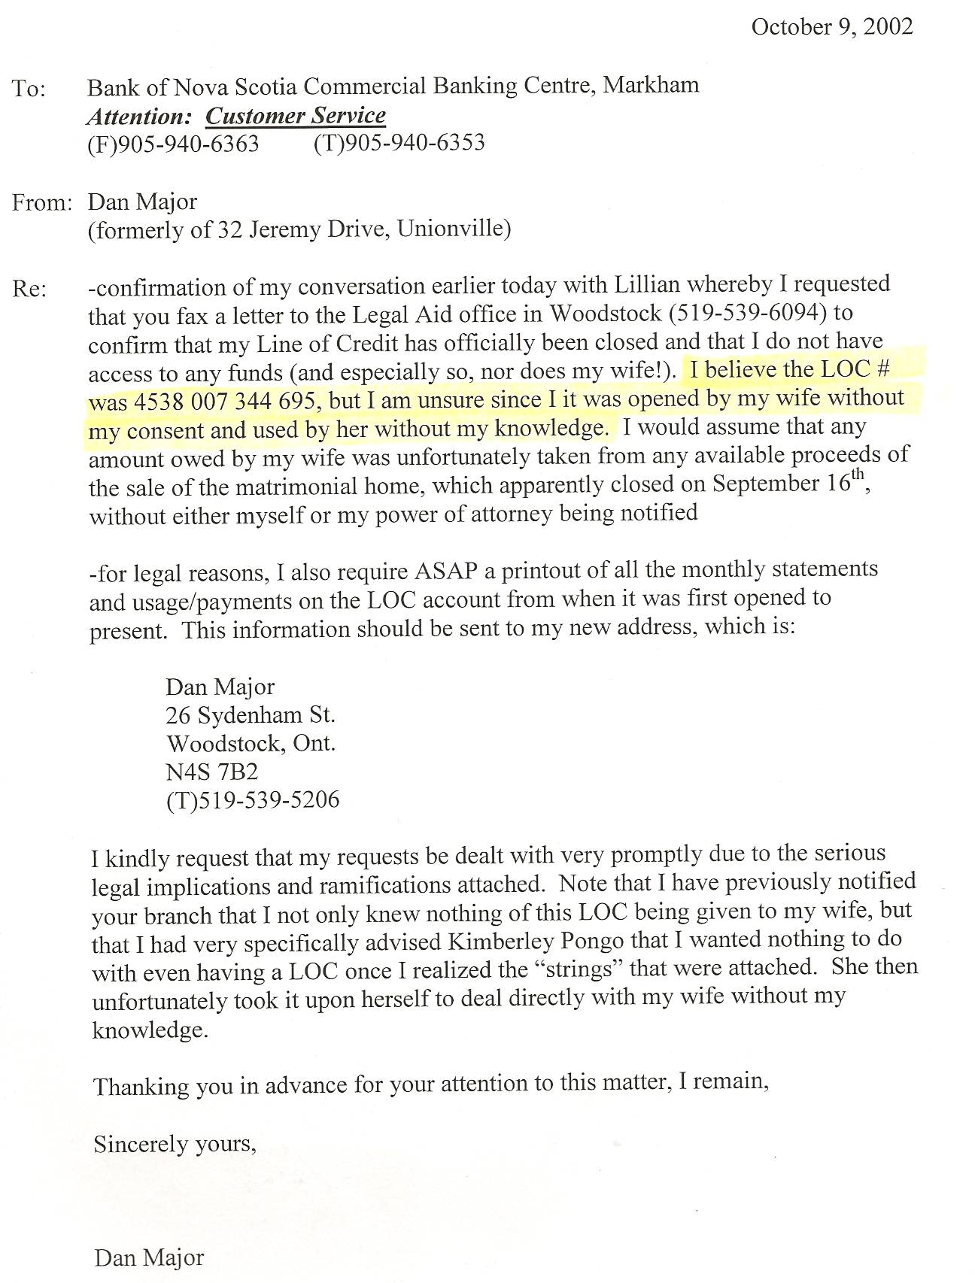
Notes:
-Sherry acquired this LOC entirely without Dan’s knowledge – the bank did NOT have Dan’s signature authorizing this – in fact, Dan expressly advised BNS to NOT go ahead with this LOC!
-Dan’s legal action against BNS remains pending
-Dan has all statements from 1999 – 2002
