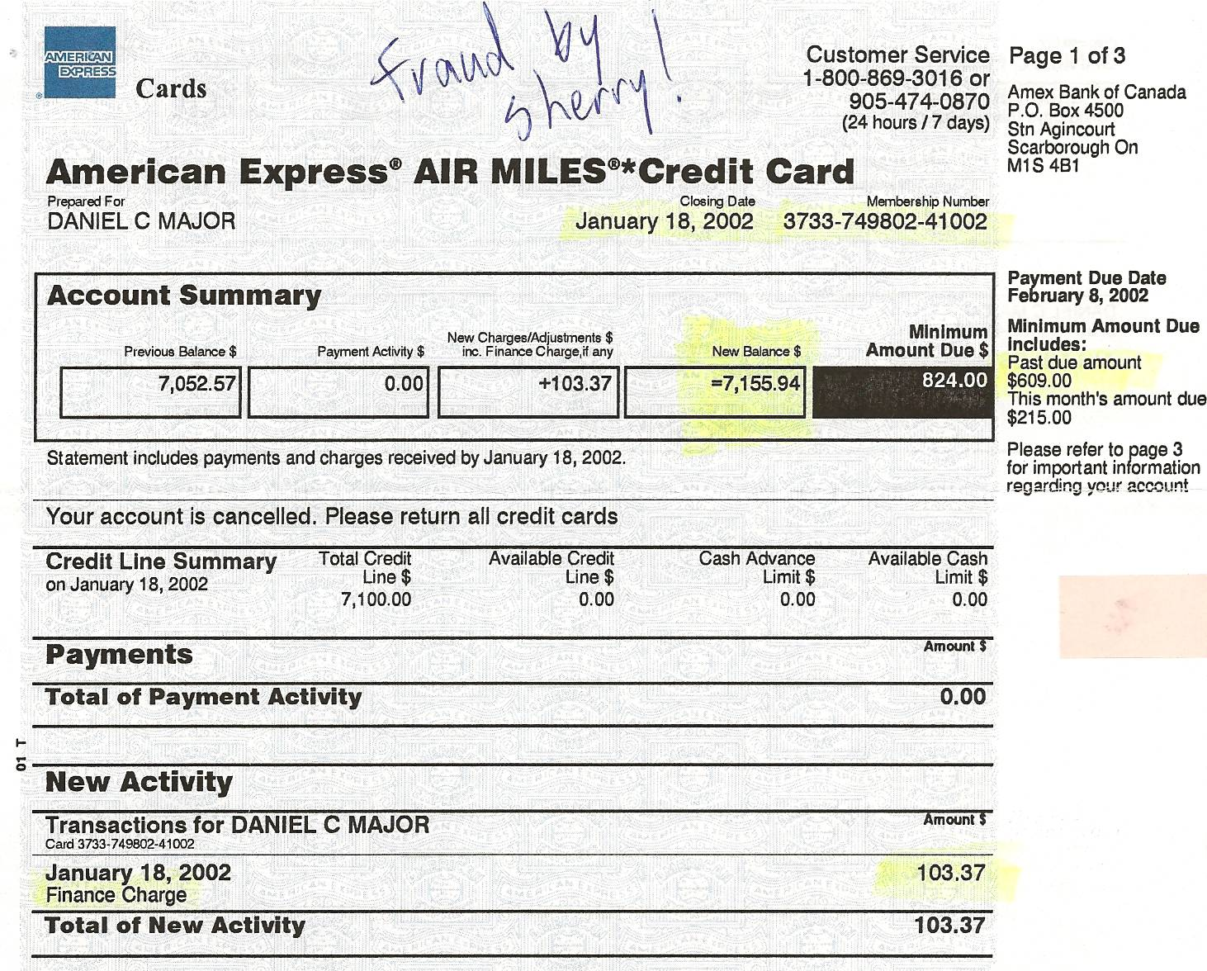

Dan’s Notes:
-more TOTAL FRAUD by Sherry on Dan’s credit cards

