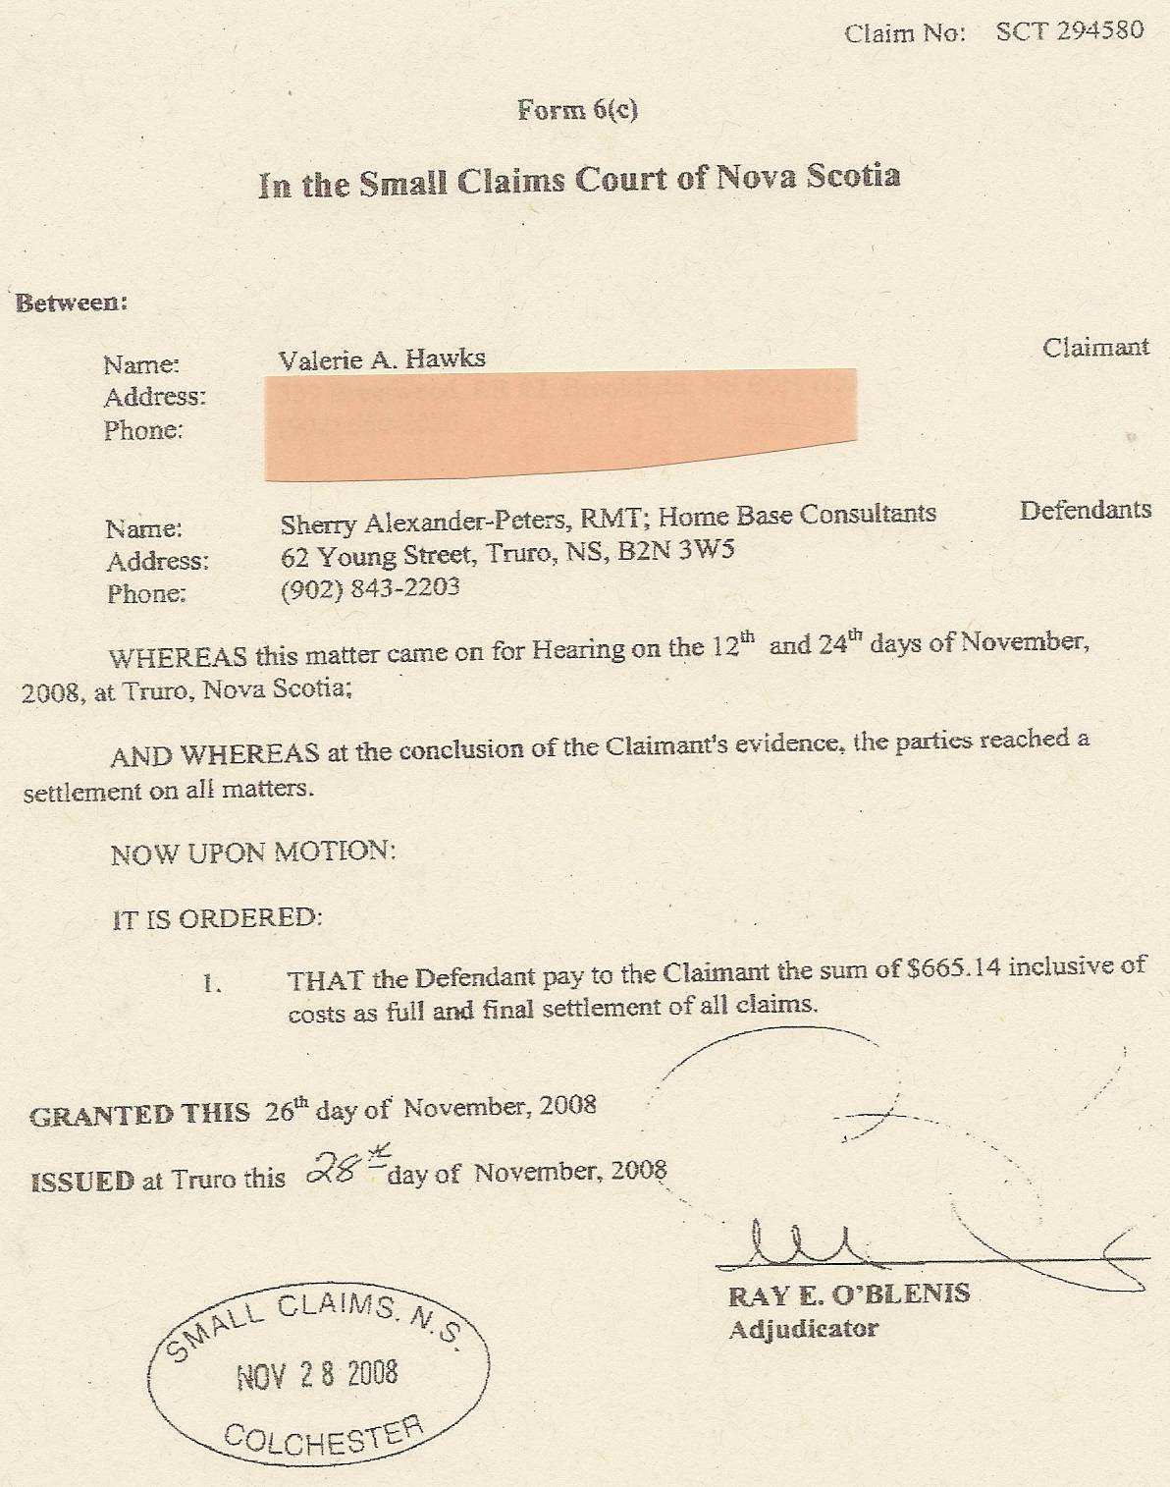

Dan’s Notes:
Sherry actually owed more than this amount. However, the amount is almost inconsequential when one considers Ms. Hawks was Sherry’s bookkeeper. It’s never advisable to screw your bookkeeper when you’re engaged in activities that Revenue Canada would frown upon. :)

