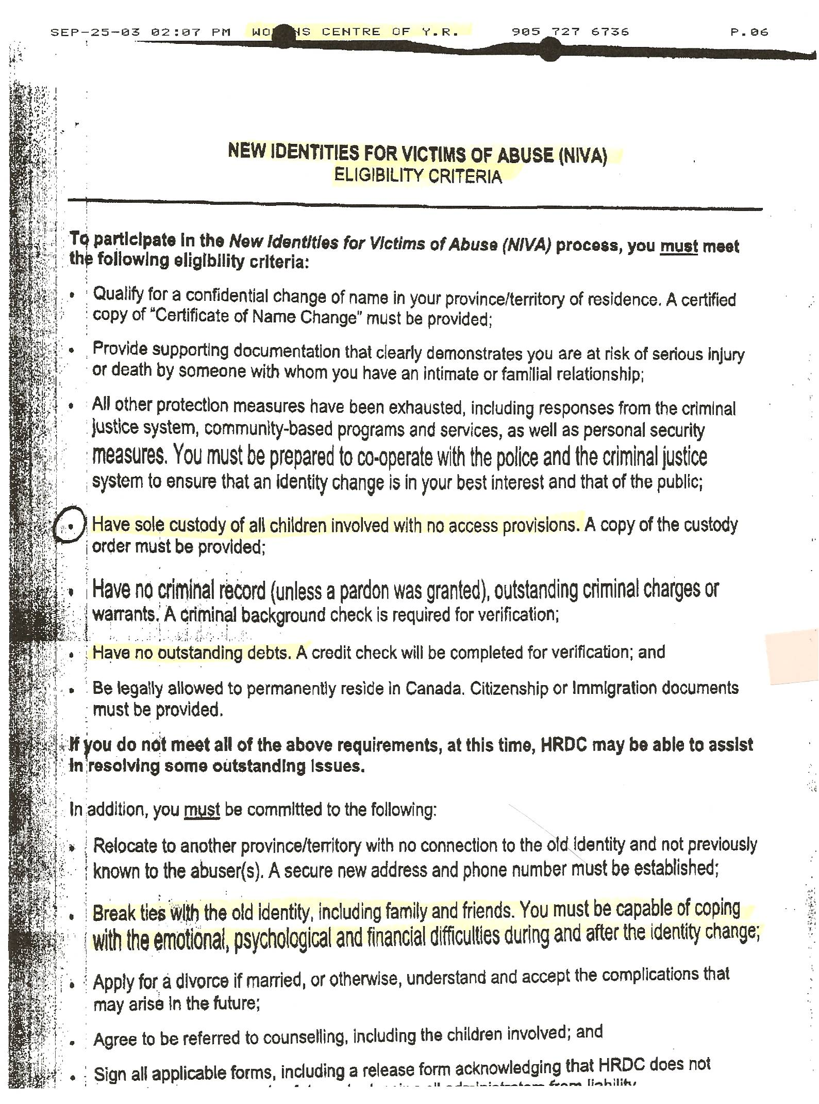

Dan’s Notes:
This was in the 2003 CAS file I received by Court Order in 2008. Date and time stamp at top show CAS was instrumental in encouraging Sherry to flee.

