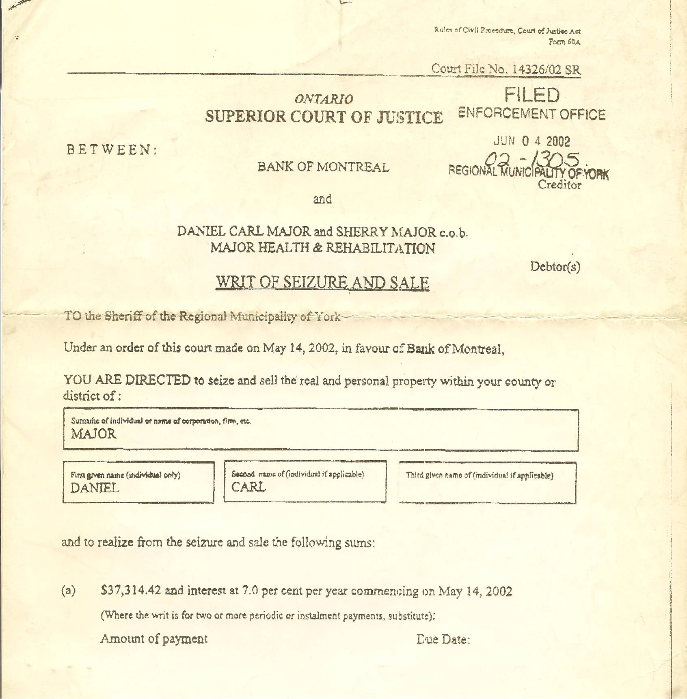

Dan’s Notes:
-I co-signed this Bank of Montreal (BMO) loan to help Sherry establish credit for her registered business, MAJOR HEALTH & REHABILITATION – she told me that the loan was repaid three weeks later – it was not – I never discovered the truth until finding out my house was seized and sold through Power of Sale while he was detained in 2002
-somewhat remarkably, BMO also had another Court Judgment for over $69,000 with my name on it – I was NEVER aware of that loan until AFTER the Judgment came to my attention (again, while I was detained on bogus charges)

-although I did co-sign the original loan it was based on misrepresented information as presented to me (and the bank) by Sherry – this constitutes FRAUD!

