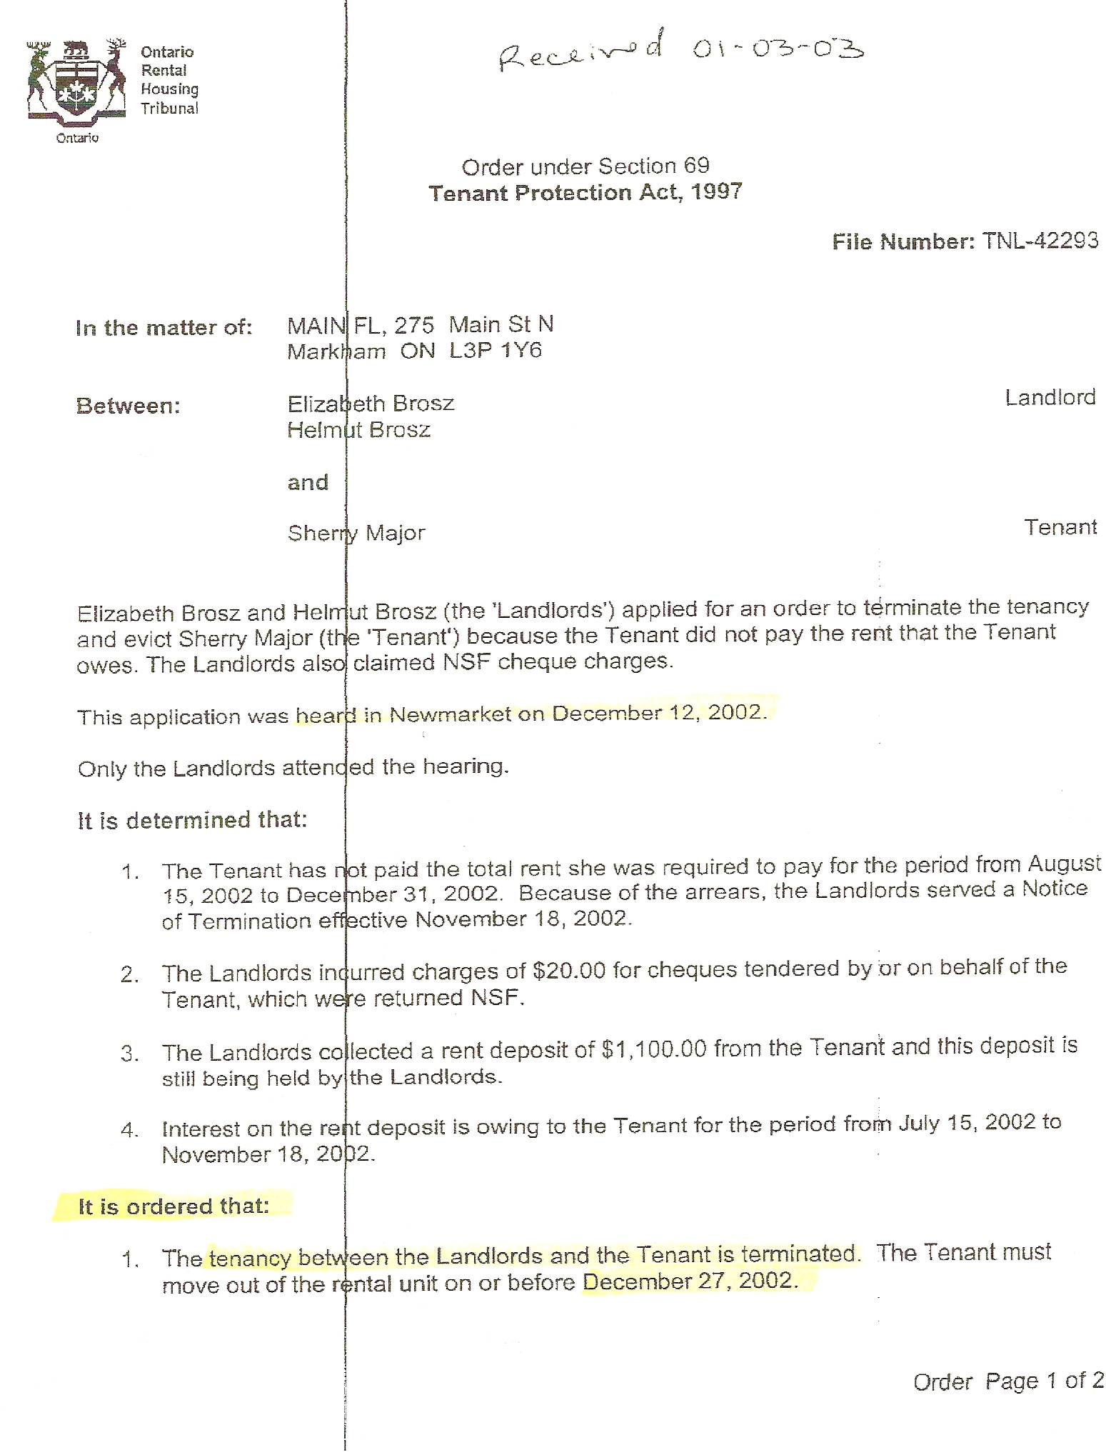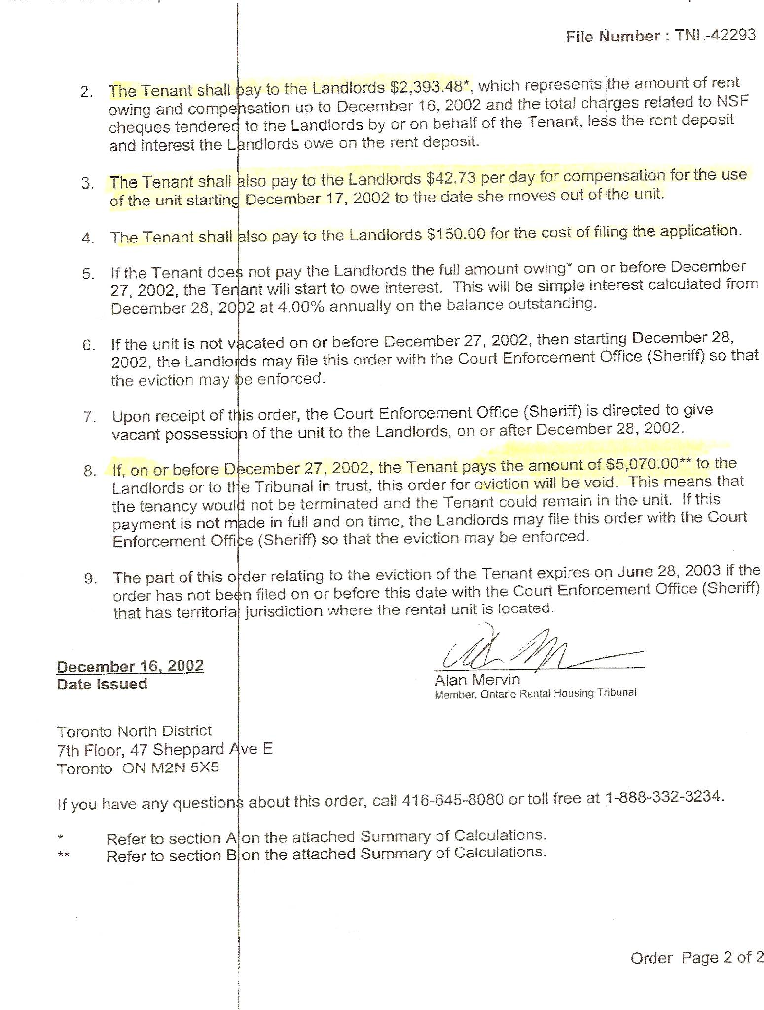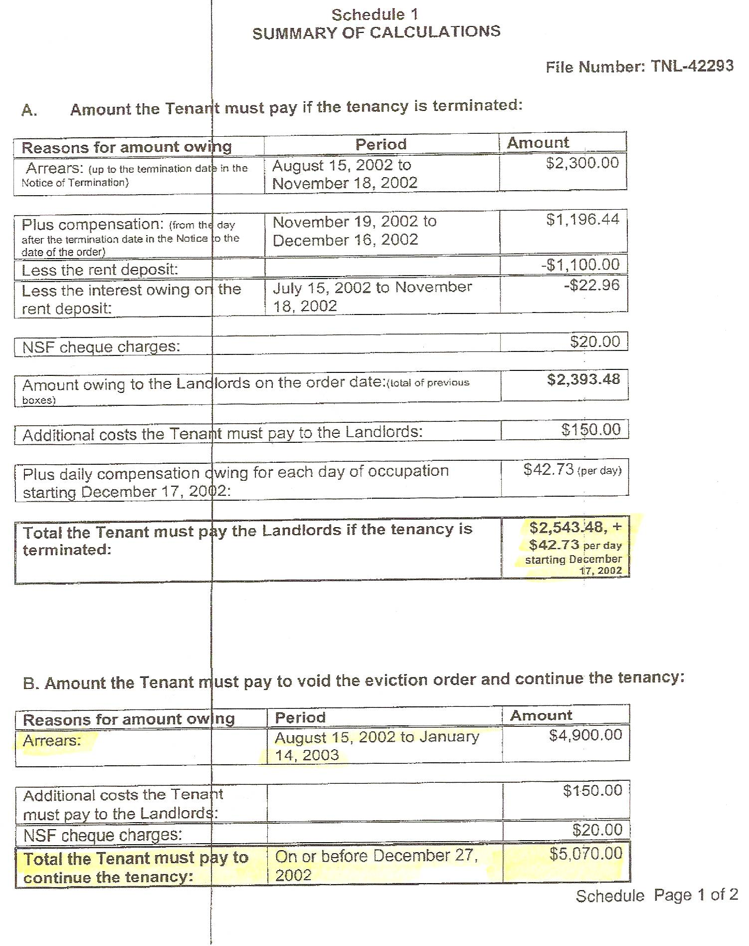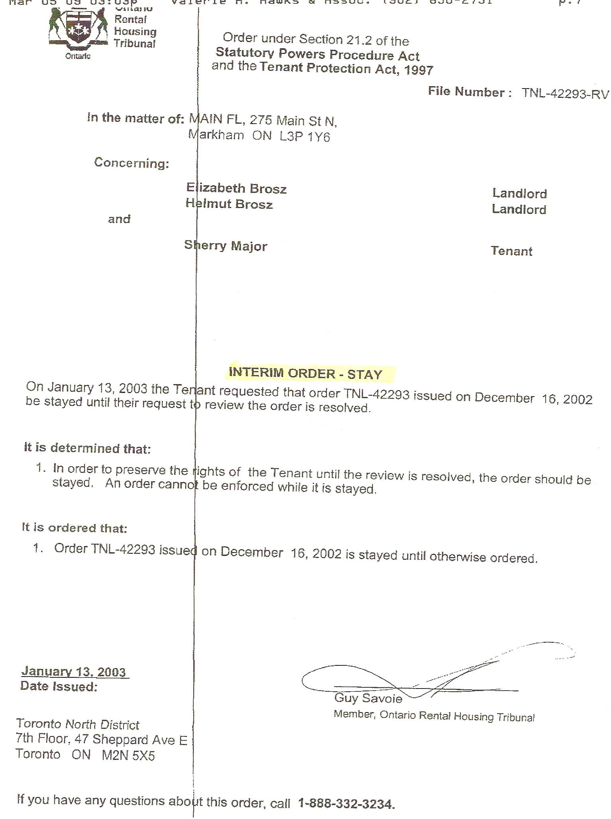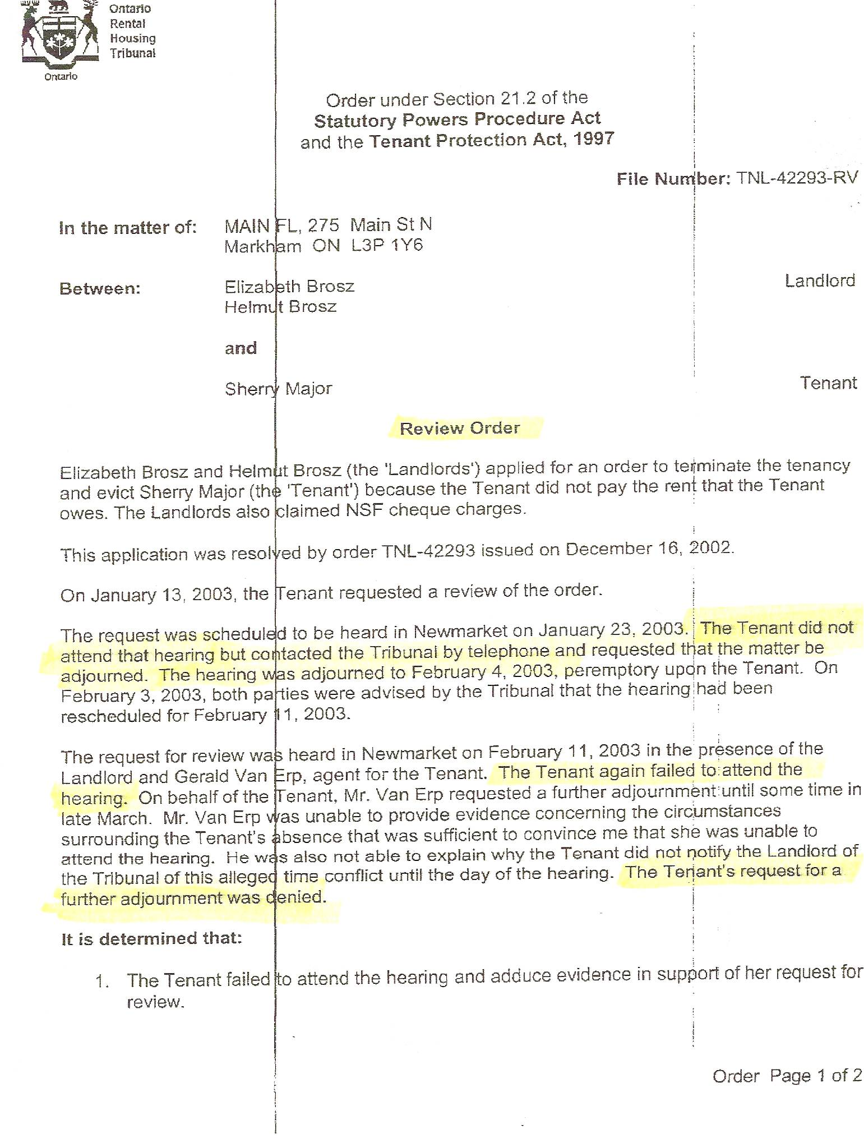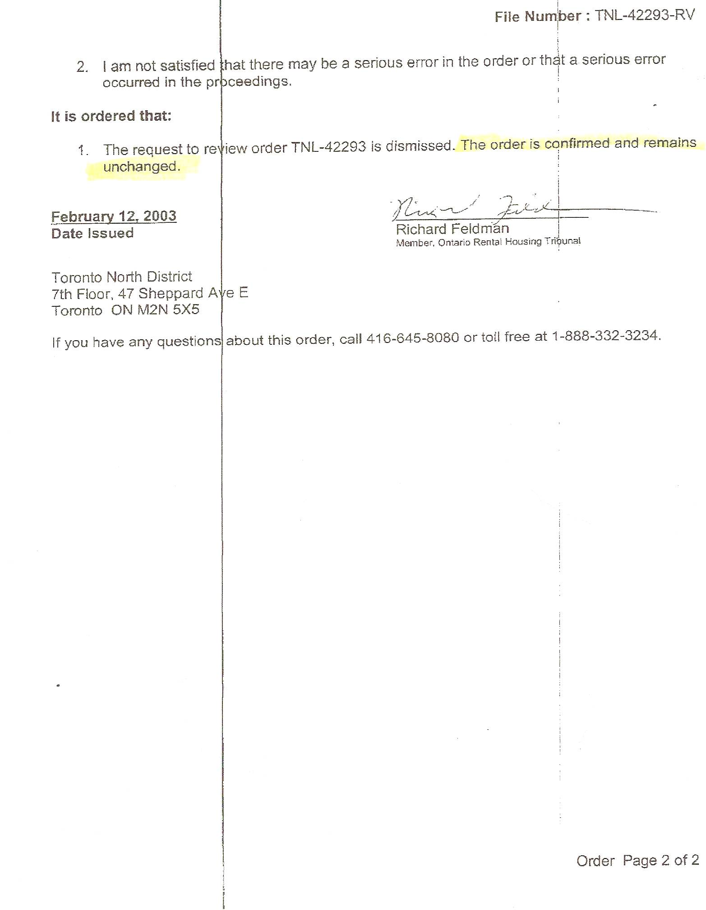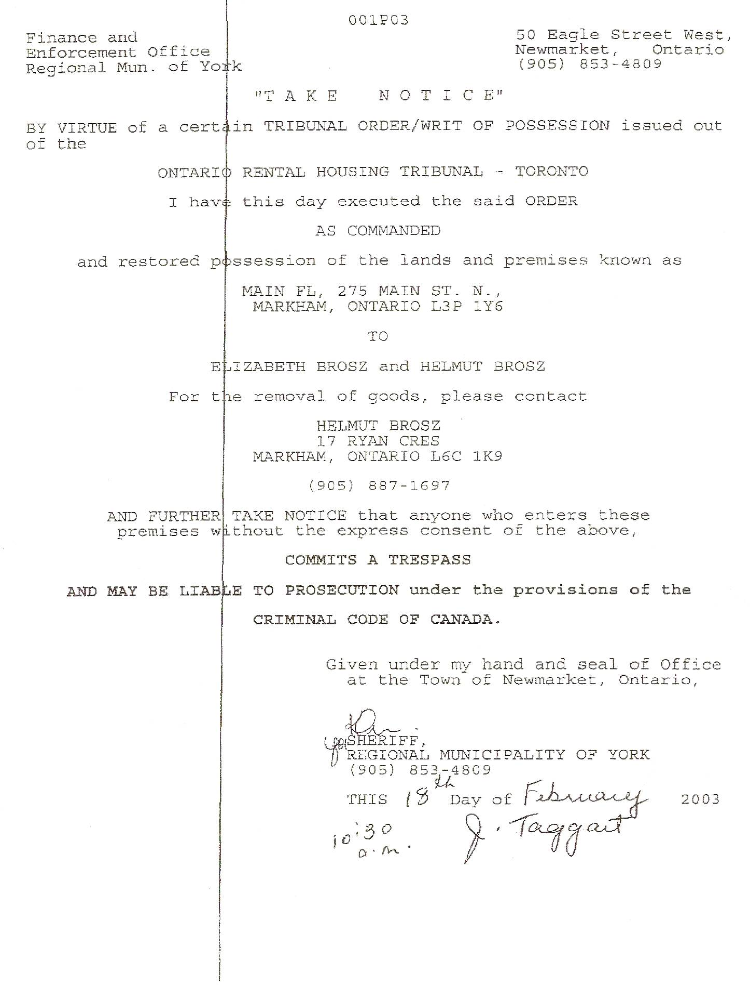
Dan’s Notes:
-I spoke with Ms. Elizabeth Brosz in July 2009. She initially claimed there was no Court Judgment against Sherry Major for the money owed. I advised Ms. Brosz otherwise, noting that I had a copy in my hand at that time. She was very abrupt and did not want to discuss the matter.
-given Sherry Major’s typical modus operandi and Ms. Brosz’s attitude towards me it wouldn’t be far-fetched to believe Sherry had bilked her using the “abused woman” scam

