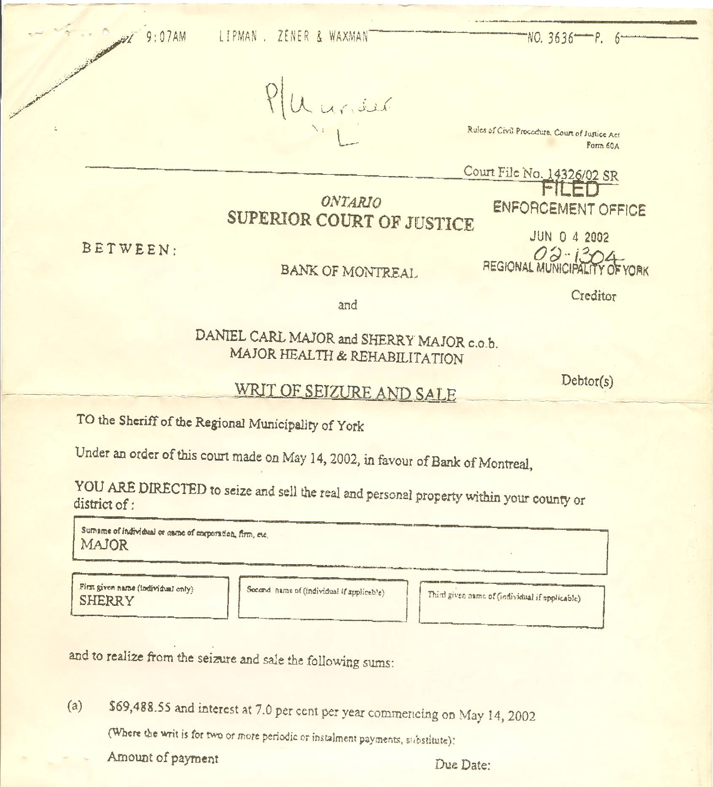

Dan’s Notes:
-the judgment is against me, Sherry and MAJOR HEALTH & REHABILITATION (MHR - Sherry’s registered company!)
-I was TOTALLY unaware this loan even existed until AFTER I became aware of this Court Judgment – I definitely never intended to sign it - Sherry acquired the funds for MHR, perhaps by slipping me a document to sign inadvertently
-Bank of Montreal was VERY uncooperative with me when I sought documentation – I have yet to ever see the original loan document that supposedly has my signature on it – perhaps Sherry even had someone else forge my signature??
-regardless, THIS IS FRAUD due to the misrepresentation involved
-I did co-sign for a different ($37,000) Bank of Montreal loan to help Sherry establish credit – she told me that loan was repaid three weeks later – I discovered it was not only after hearing of a Court Judgment regarding that loan as well – again, since the loan was acquired using misrepresentation by Sherry to me (and probably the bank also) THIS IS FRAUD!

-since the bank recovered their money through my equity when my house was sold (while I was detained on bogus charges) they truly didn’t care – they never cooperated with my request seeking documentation (it seems that whether concerning abducted children or stolen money, possession is 99.9% of the law – what a bunch of crap!)

