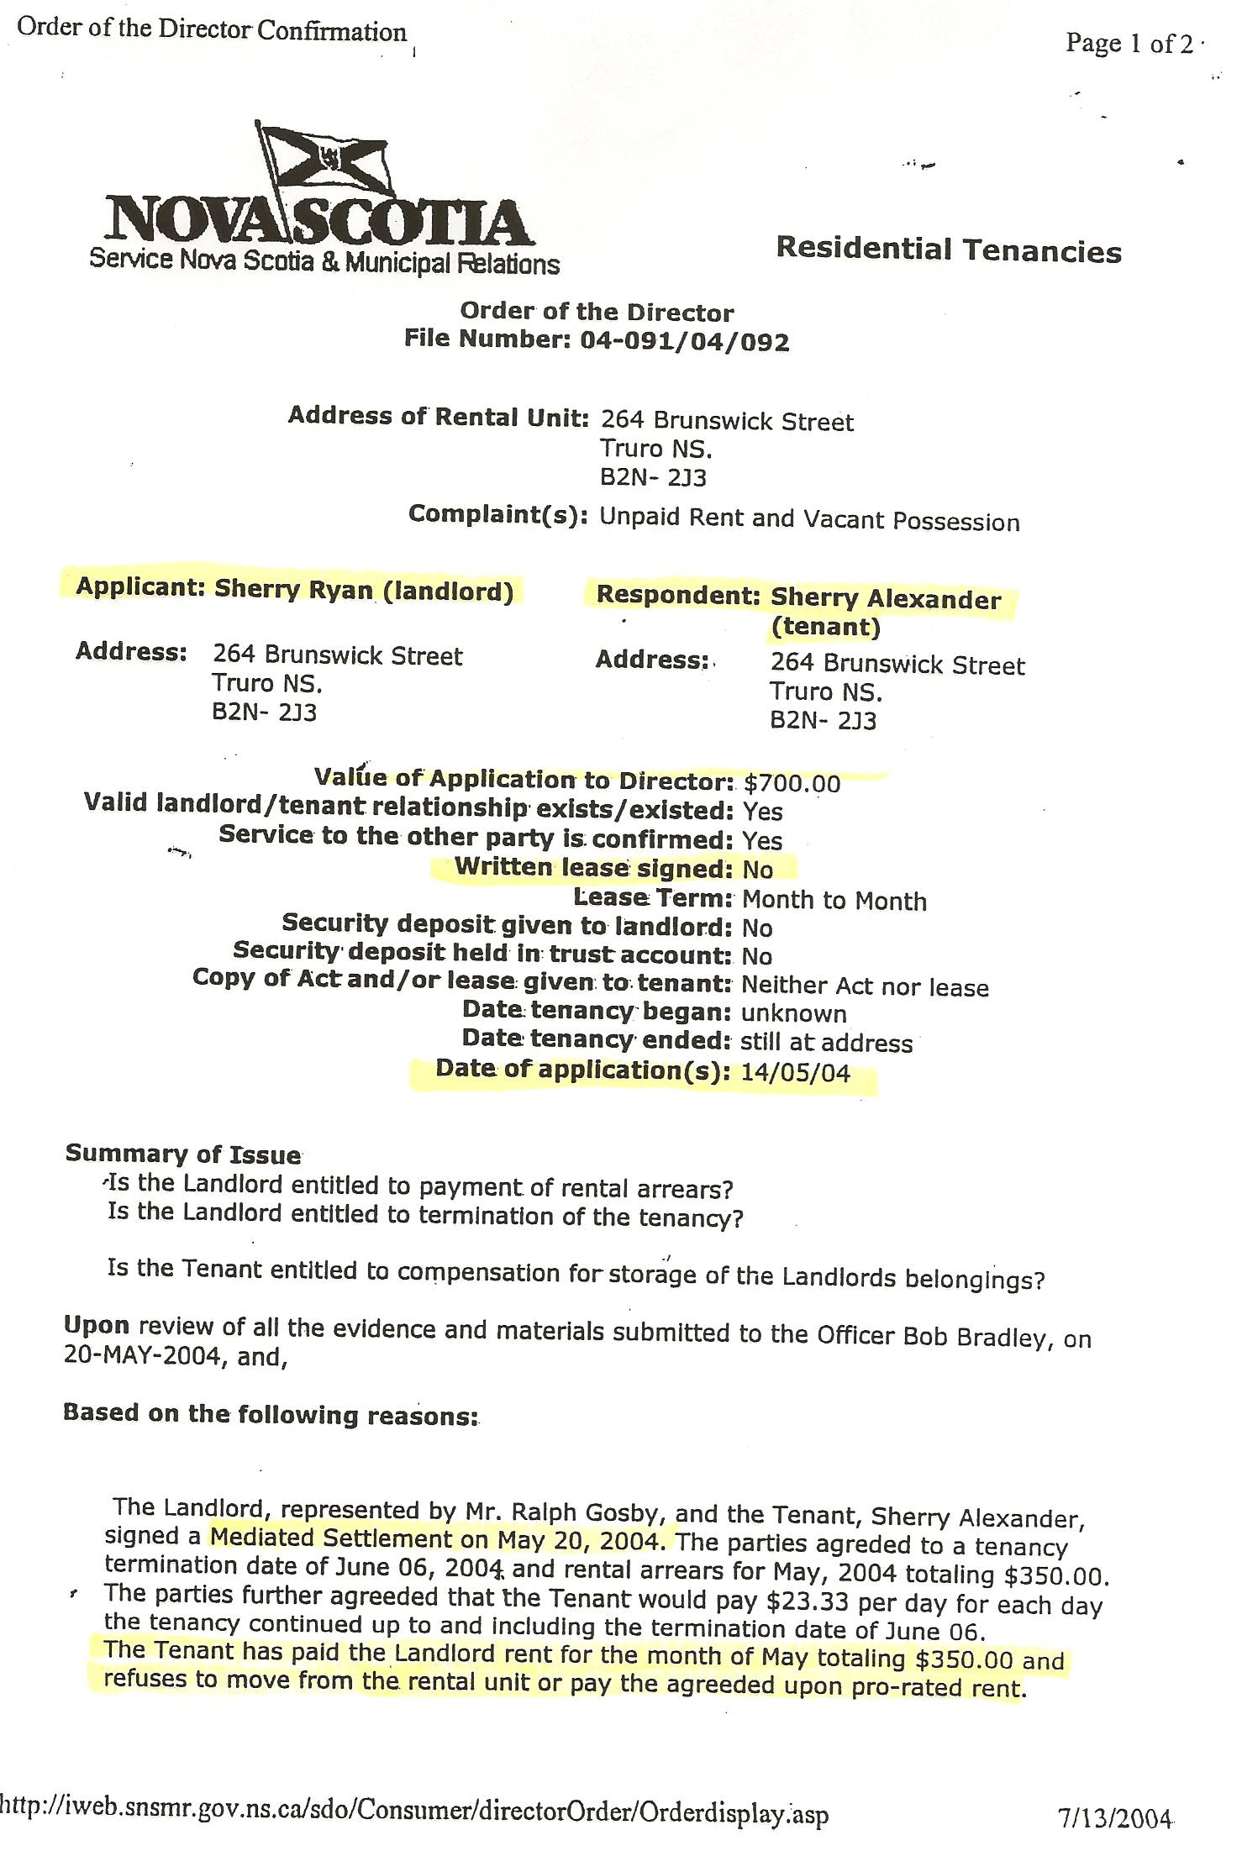
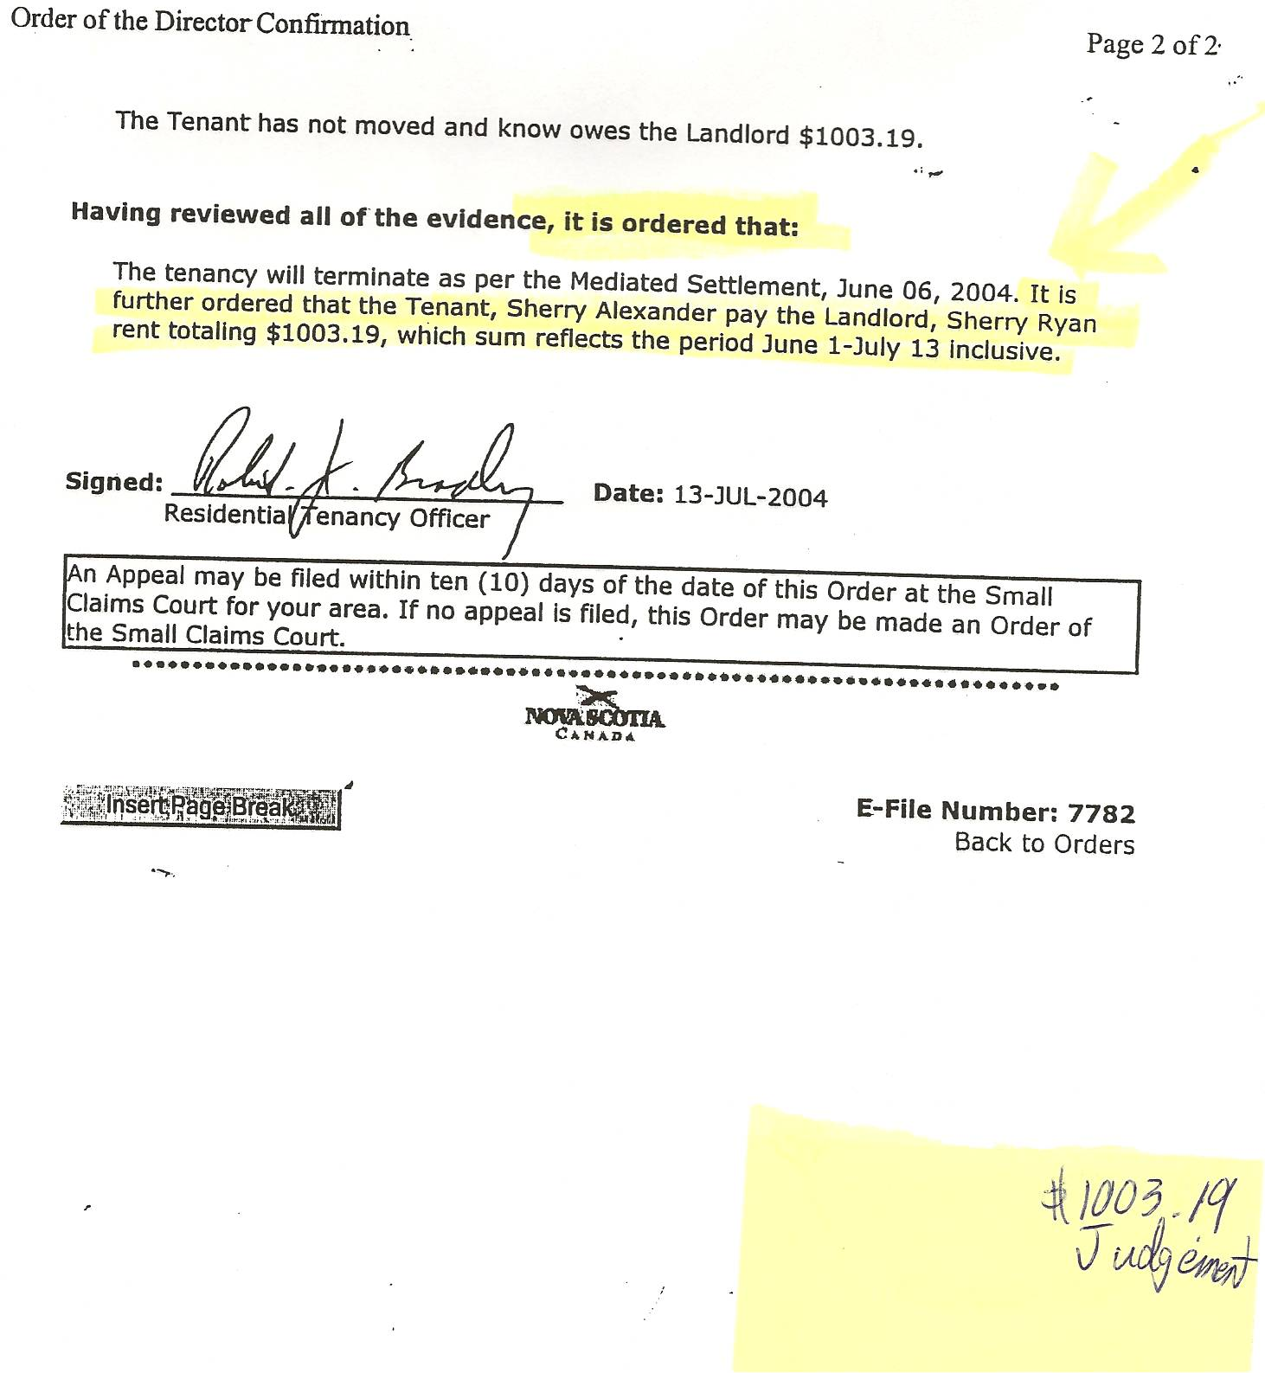

Dan’s Notes:
-rather sadly, it appears the opportunity cost of her inability to have Sherry Major removed from her premises in a timely manner led to the property owner, Ms. Sherry Ryan, losing this property to the bank due to non-payments (but our government still claims that white collar crime is non-violent because no one gets hurt …. Hmmm?)

