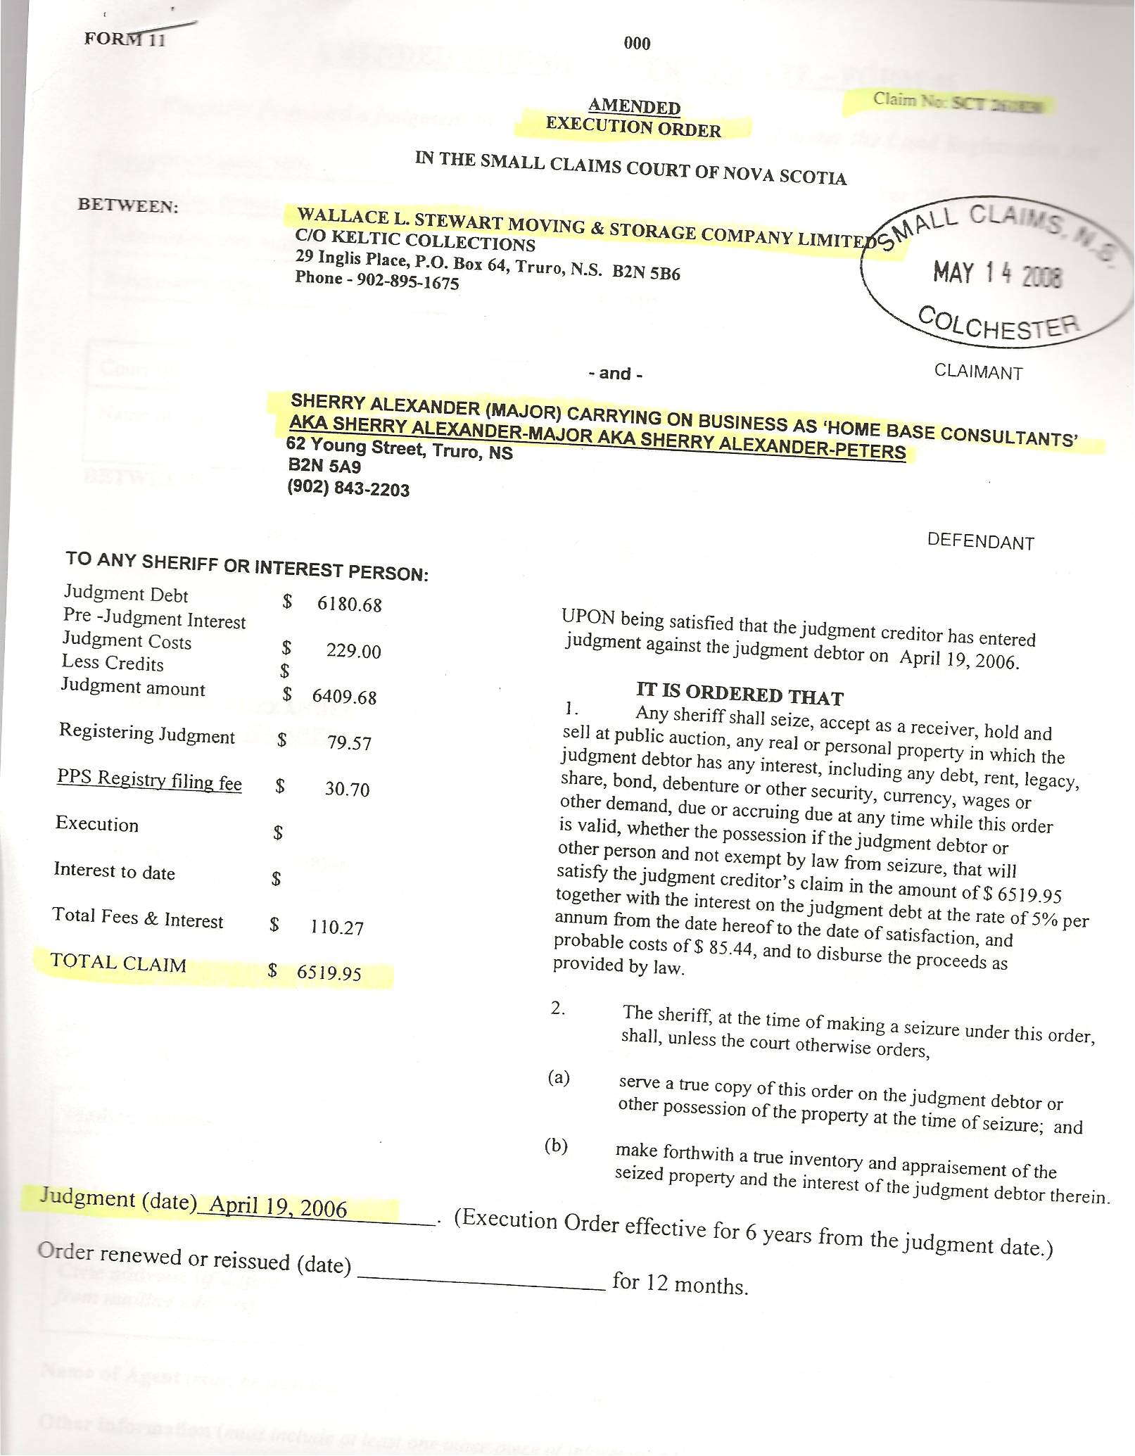
Dan’s Notes:
-Sherry bilked the mover by using the “abused woman” scam to have Wally’s Moving take two trips of thousands of kilometers to move belongings from Ontario to Nova Scotia, claiming the money was soon to follow and they would get “every cent”. Ya, right!!! Wally’s Moving has been forced to strictly enforce a new policy whereby NOTHING ever gets unloaded until payment in full is made!

