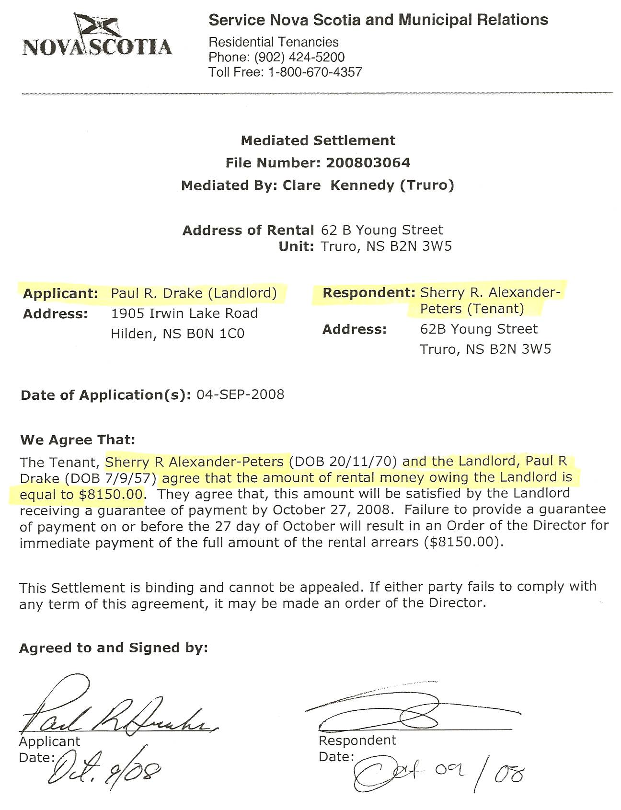
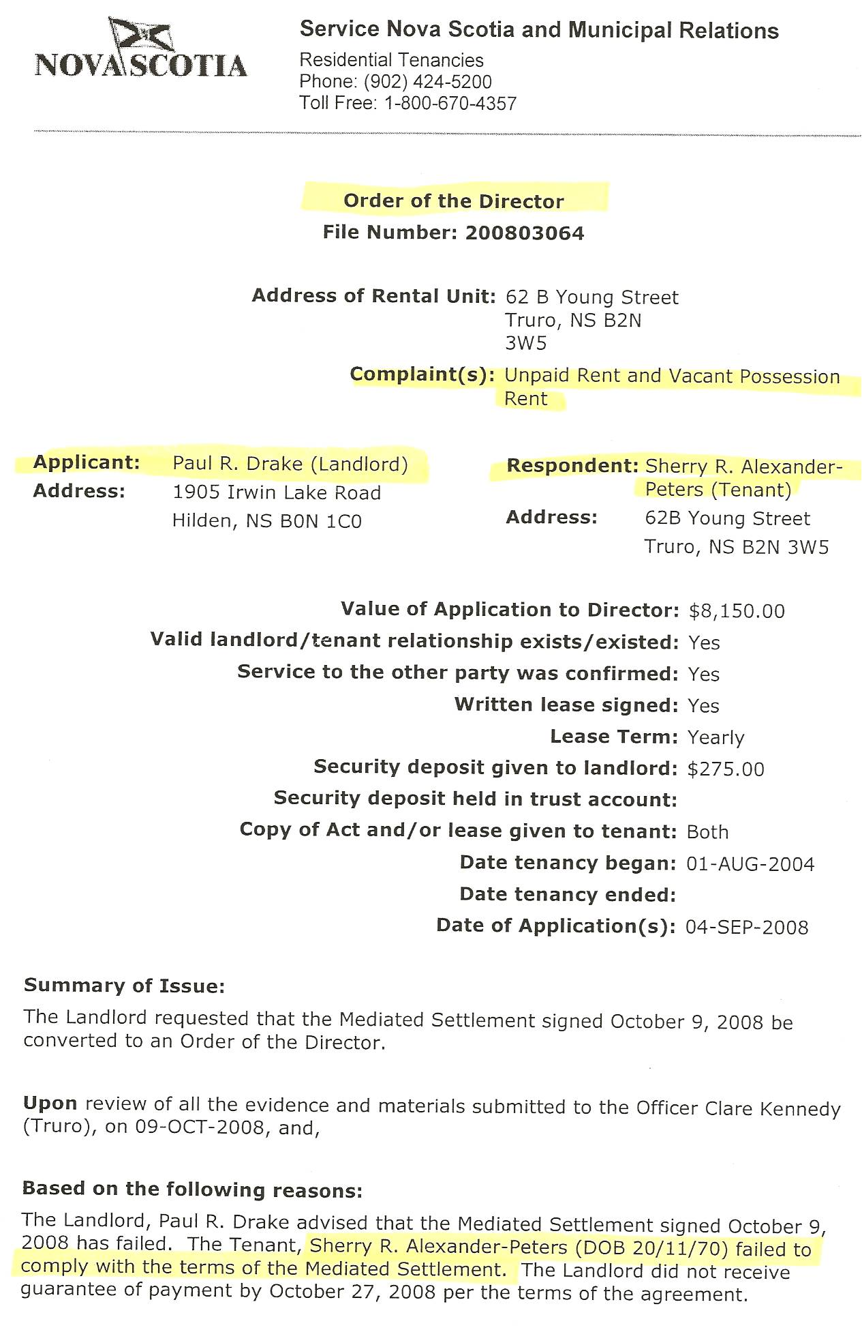
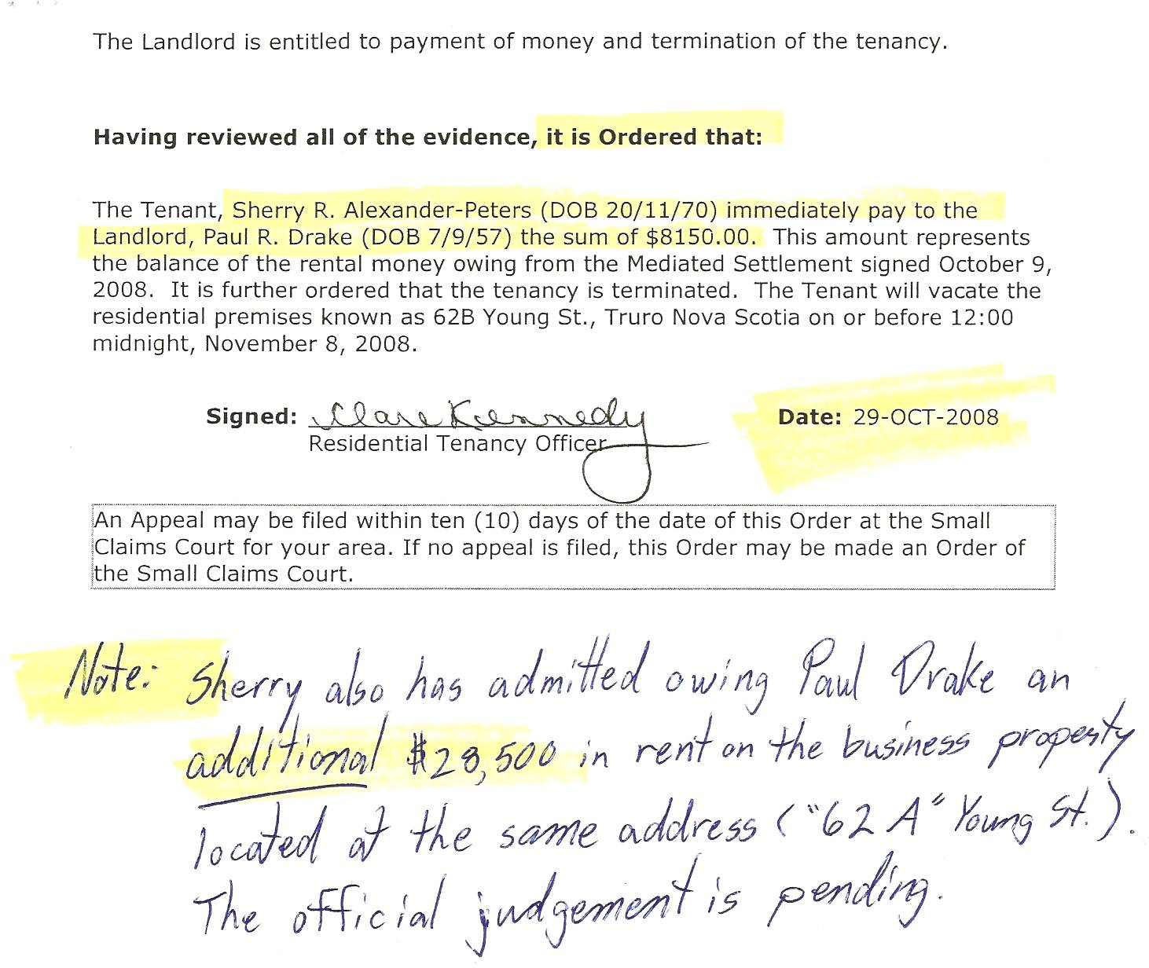

Dan’s Notes:

Sherry Major actually bilked Paul Drake of over $40.000 (as acknowledged in an OCL document) but he never bothered acquiring further Court Judgments since they would likely be a waste of time, effort and money due to the inability to collect any amount owed.

