+
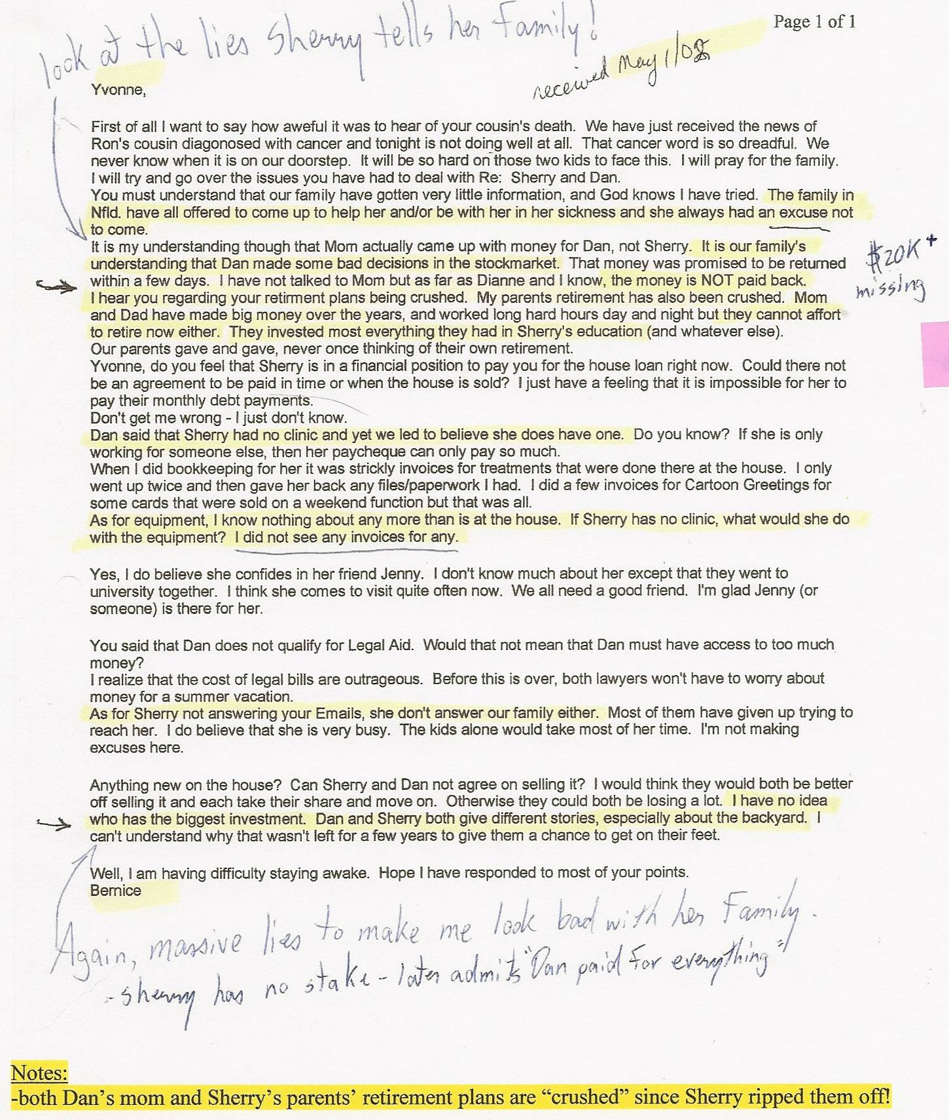
-Sherry’s also ripped off her “best (only!) friend” Genny, a single mother who sold her house to move to Toronto and earn $50,000/yr working for “Dr. Sherry Major” – then returned to Guelph three weeks later without ever being paid one red cent after quickly realizing Sherry was a fraud artist (who was evicted from her clinic location after compiling unpaid rent totalling $7,281.70” (to Dr. Pirouzi) – after just scamming landlord Elizabeth Brosz for over $5,000 – she then moved to Aurora and scammed landlord Hector Nesta for over $5,000

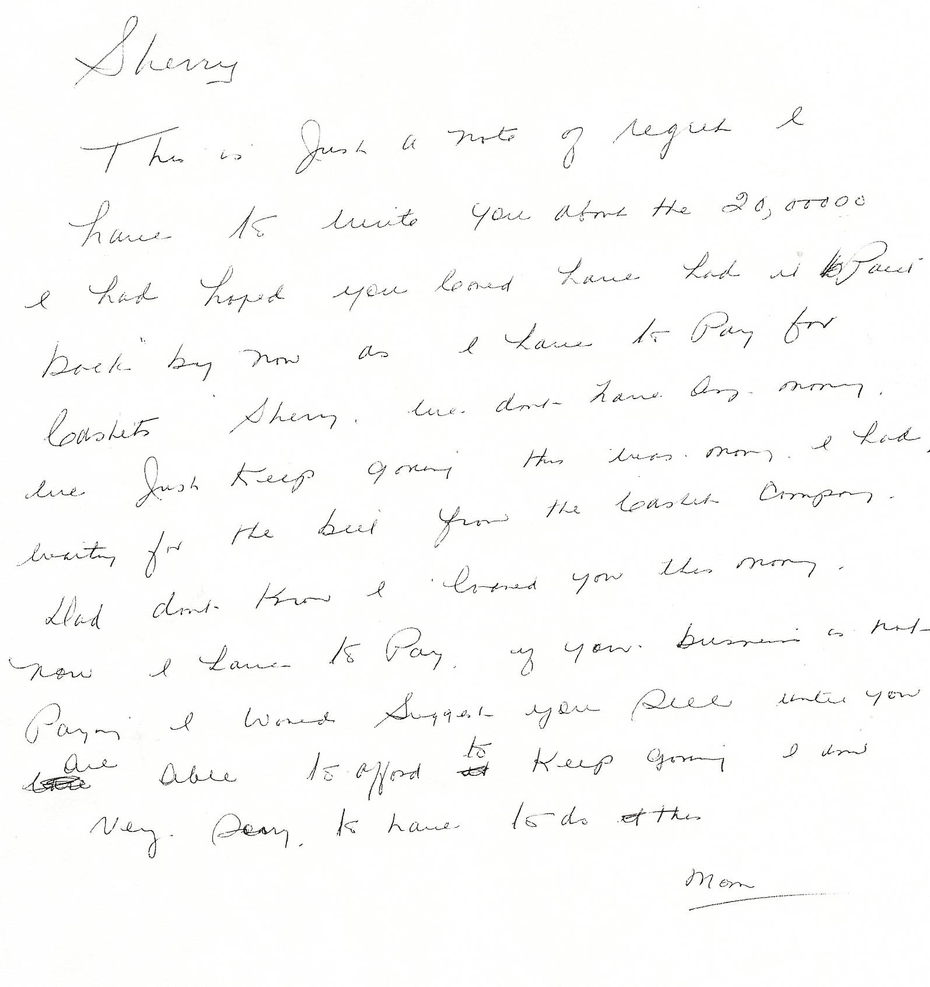
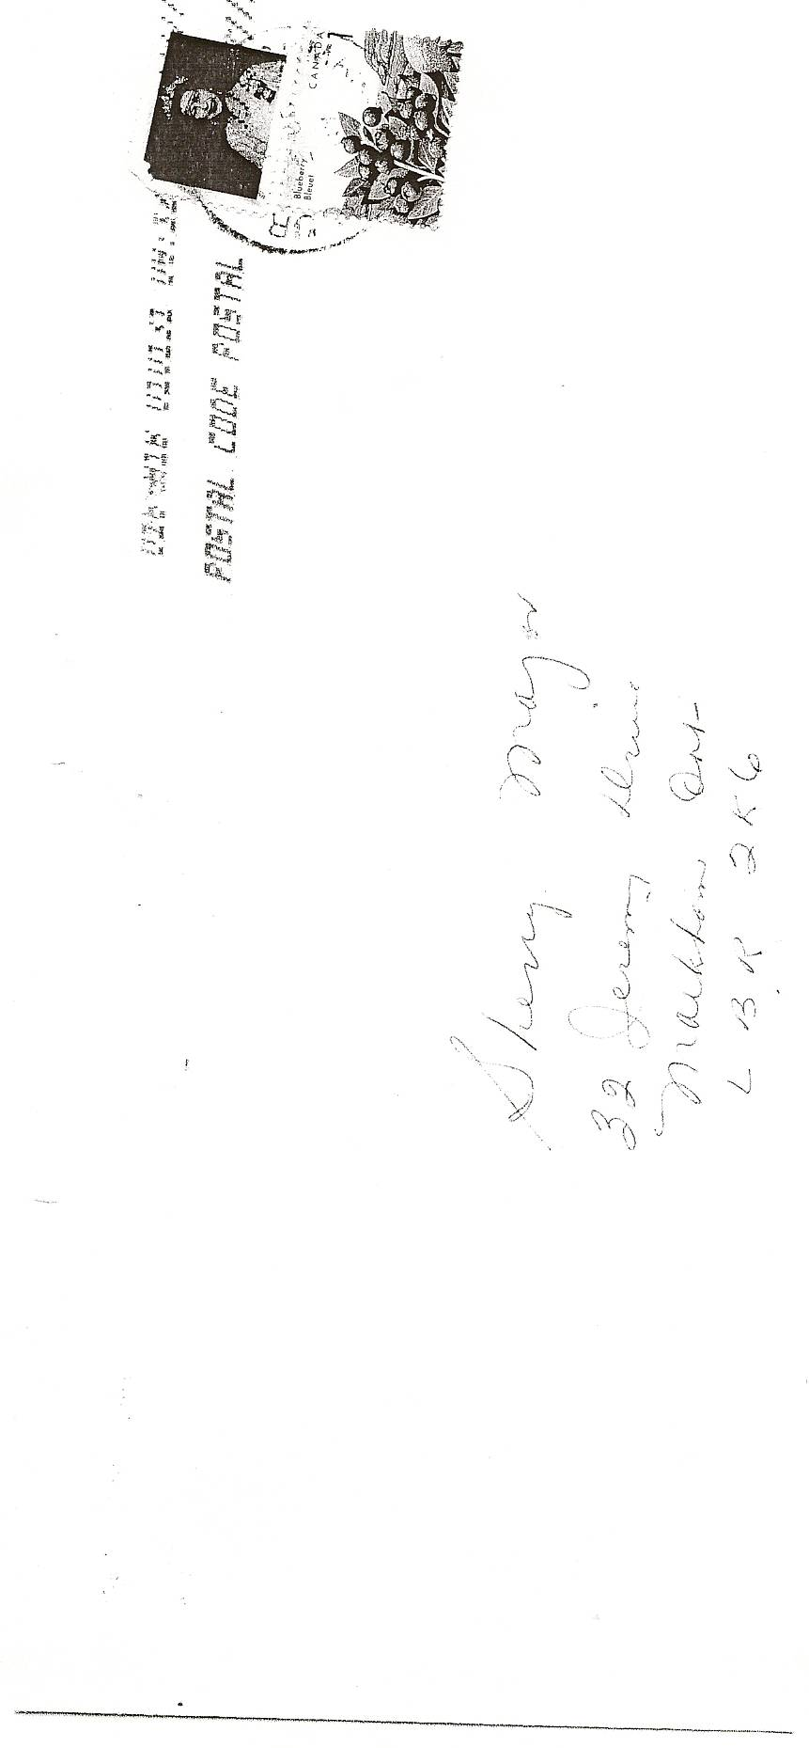

Translation of mother’s letter

This is just a note of regret I have to write you about the $20,000.00 I had hoped you could have had me paid back by now as I have to pay for caskets. Sherry we don’t have any money. We just keep going. This was money I had waiting for the bill from the casket company. Dad don’t know I loaned you this money. Now I have to pay. If your business is not paying I would suggest you sell until you are able to afford to keep going. I am very sorry I have to do this.
Mom

Dan’s Notes:

-This 2002 letter is from Sherry’s mother – Sherry ripped her off for another $20,000 (in addition to previous amounts when claiming she was in university for four years)

How did Sherry pull this scam off?
-after Sherry put over $100,000 in cash advances on my credit cards and lines of credit in Y2K I felt the only way to possibly make the money back was in the stock market – but I needed capital – Sherry created the problem so she needed to help solve it – she borrowed $20,000 from her mother for my usage but never told her mother this!!
-just as promised, I repaid the full amount + $500 interest in about 5 months – I have the records to prove the payments
-I later discovered Sherry kept the $20,500 for herself and never repaid her own mother!!!

