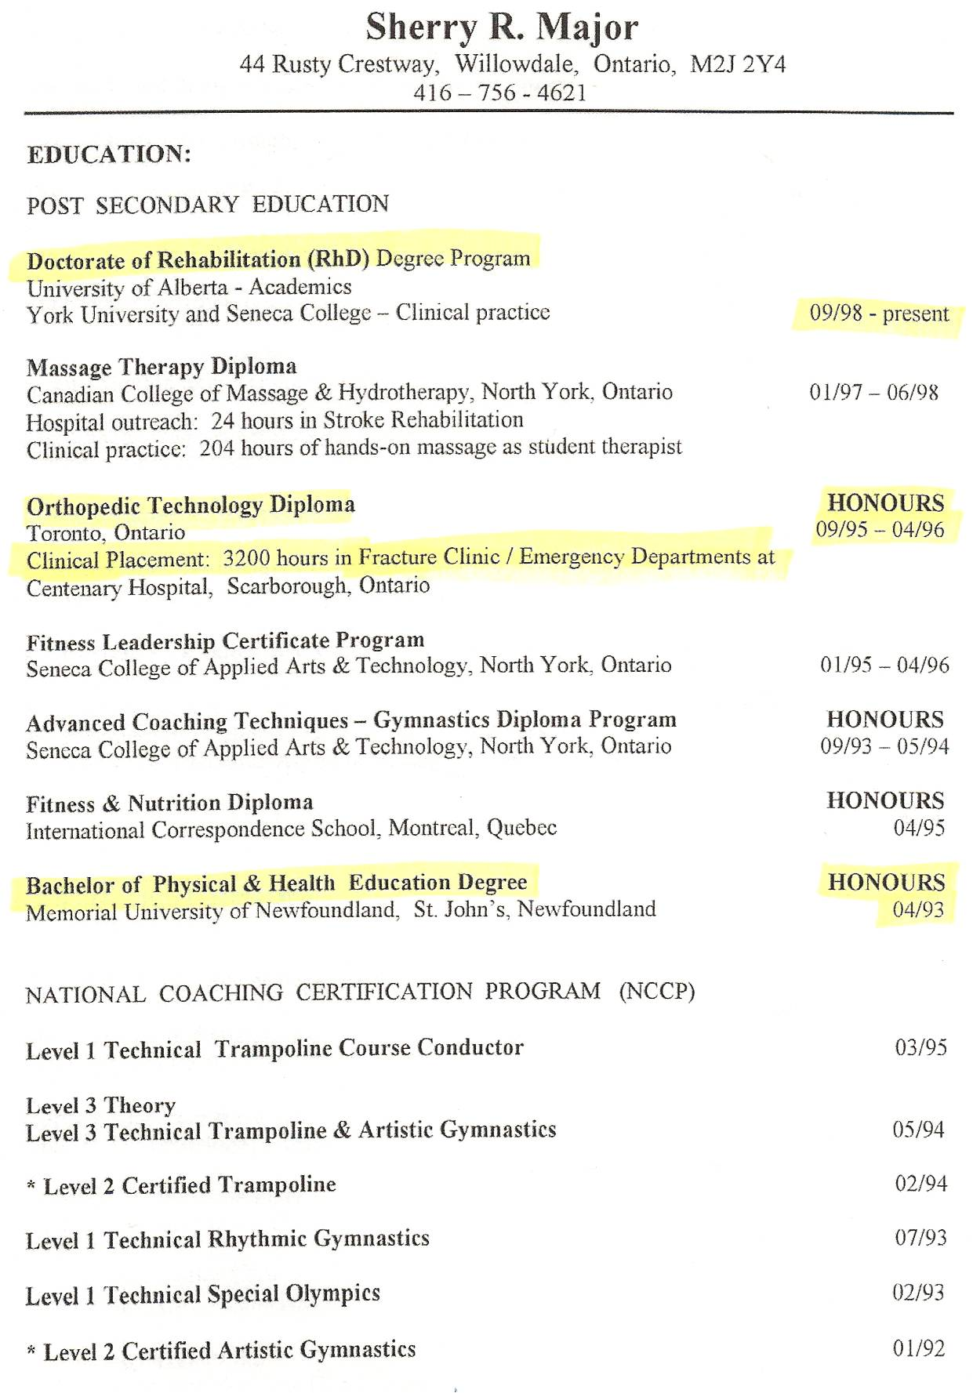

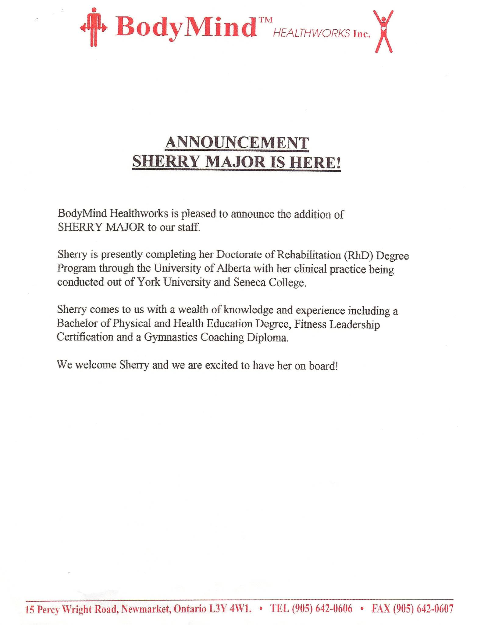

Dan’s Notes:
-Mary Cawfield owned this clinic and was thoroughly duped by Sherry. Sherry was eventually fired.
-Sherry admitted under oath in 2003 that she had NO DEGREES and was never in the Rh.D. program
-obviously Sherry did NOT have 3200 clinical hours within an eight-month period – HUGE LIE!! (I never saw this document until 2009)

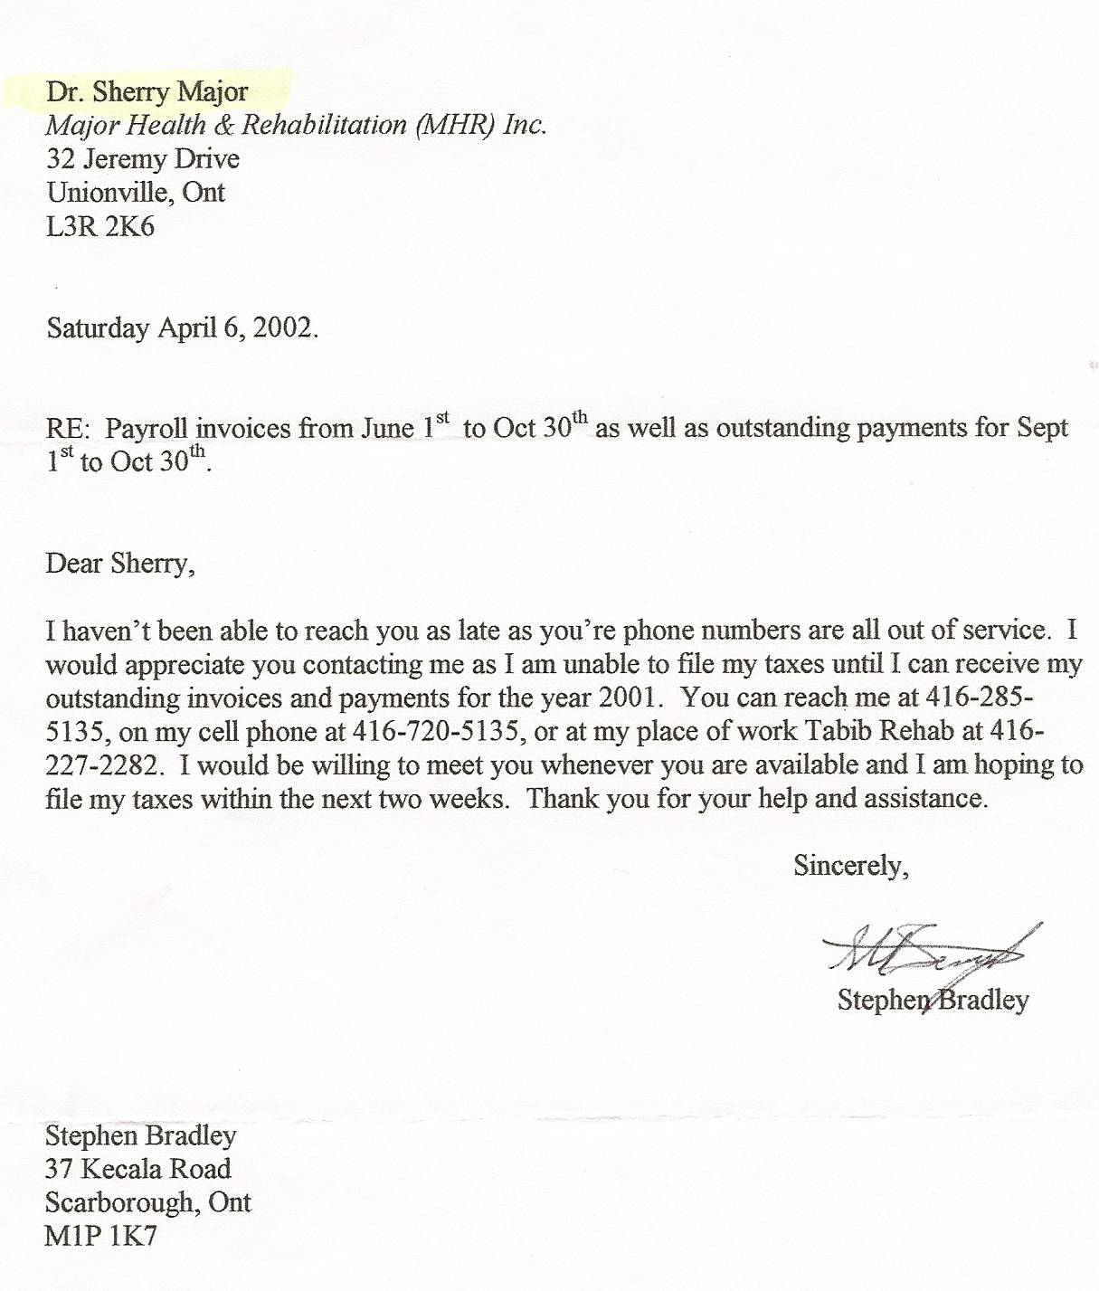

Sherry’s EMPLOYEE Stephen Bradley obviously thought his boss was a doctor!!!

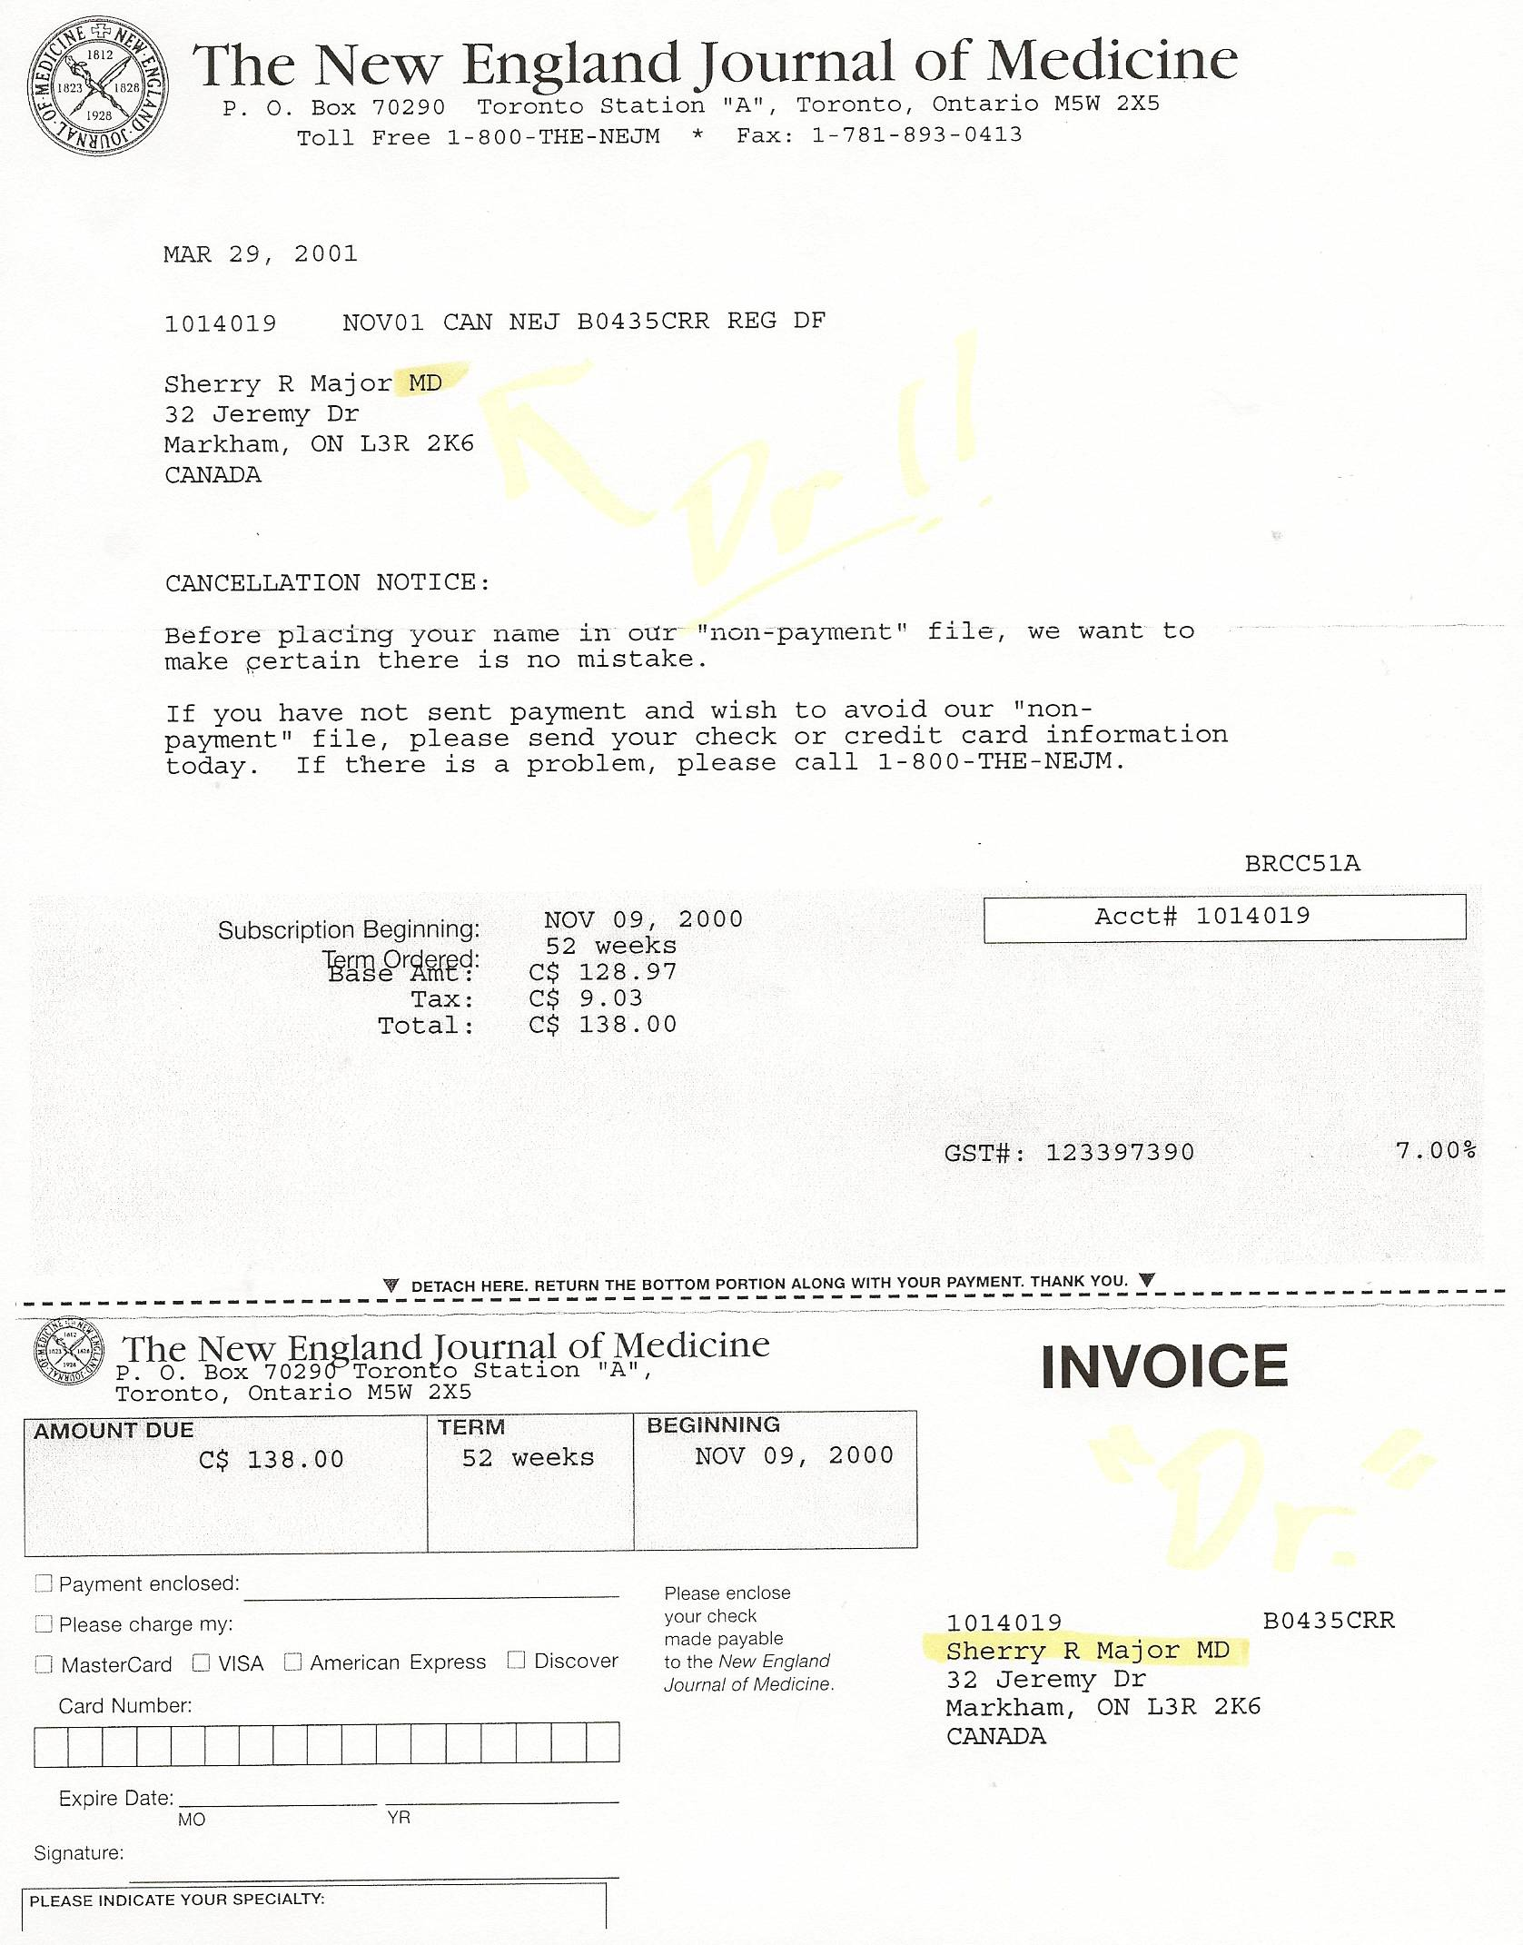

Notes:

In early 2003 while testifying against her husband at his trial (necessitated by her lies) Sherry claimed she never told anyone she was a doctor. Here’s further evidence she lied.

*Below are other items where Sherry was registered as a doctor – such as with Canadian Business magazine

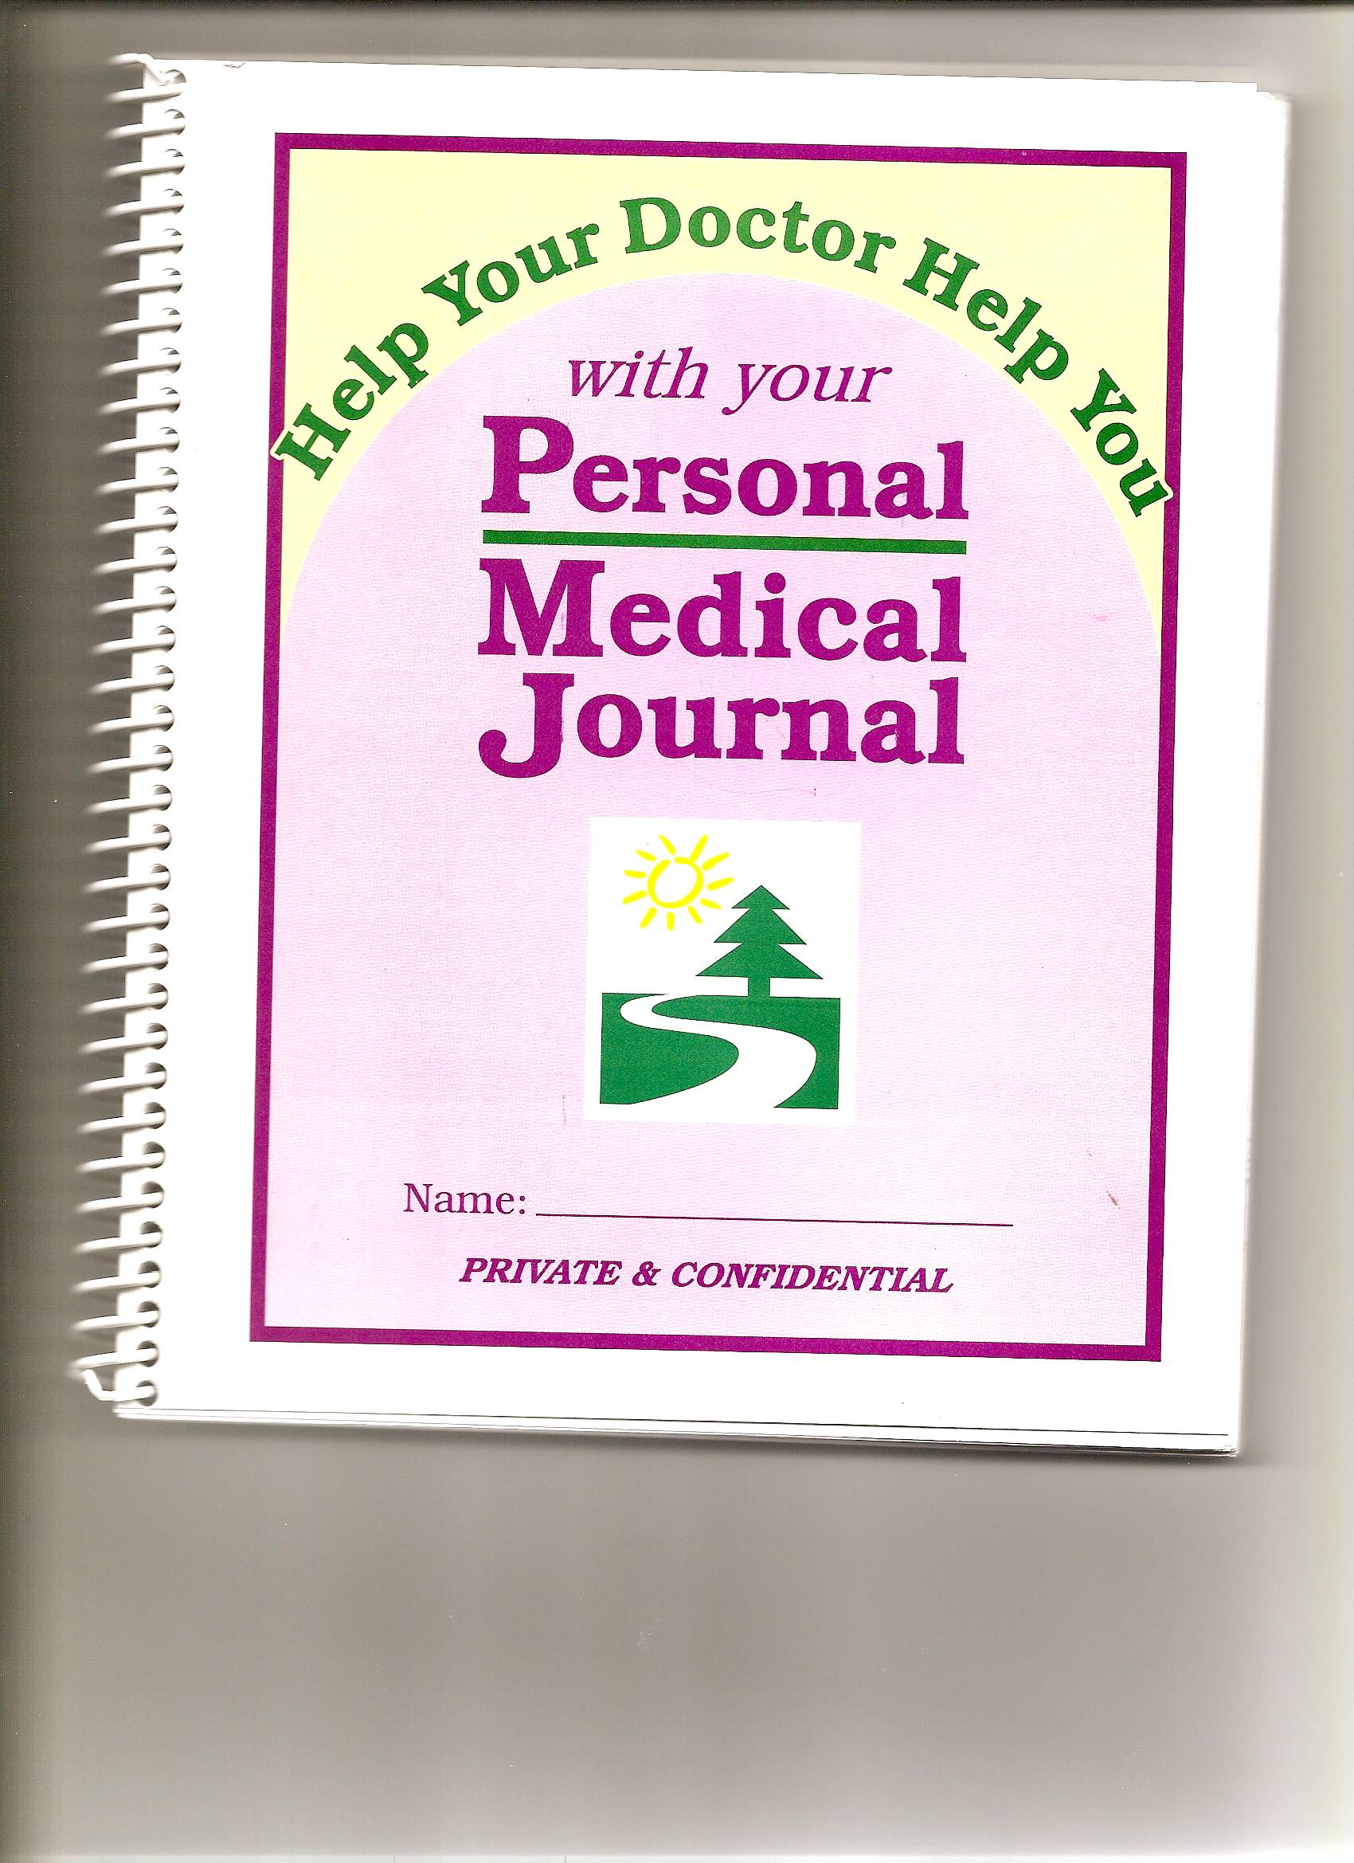

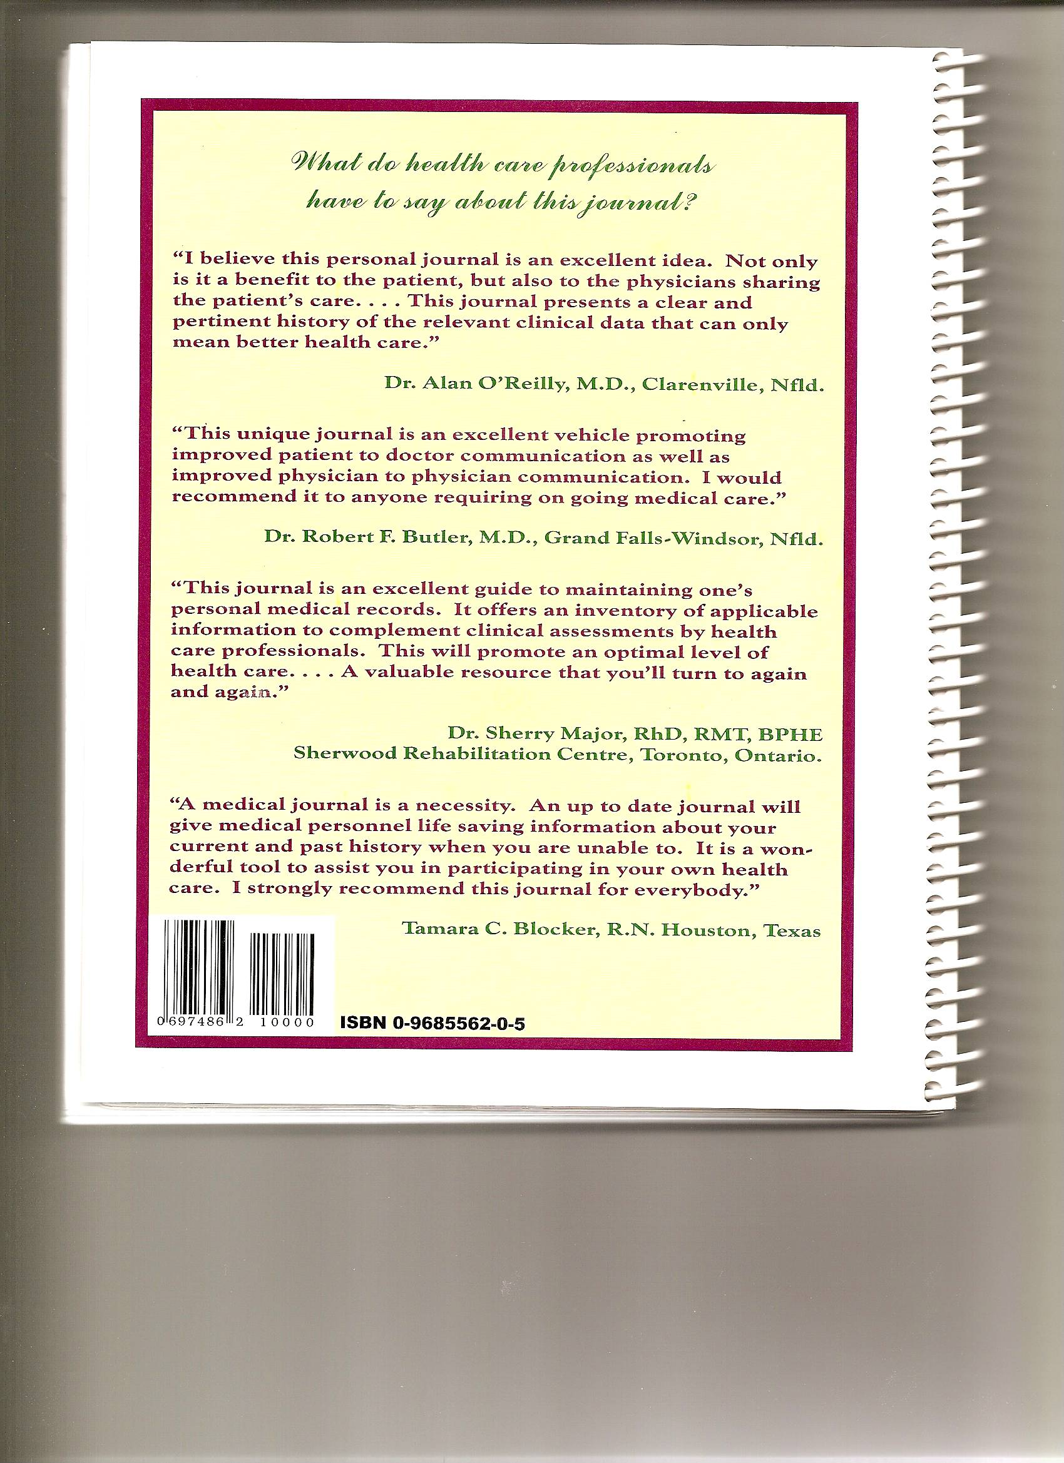

-in 2008 Sherry was still selling this journal at her N.S. business for $9.95 and admitting to others that she is “Dr. Sherry Major” (note that people there knew her as Sherry Alexander) – this is five years after Dan already exposed her as impersonating a doctor at trial in 2003!

