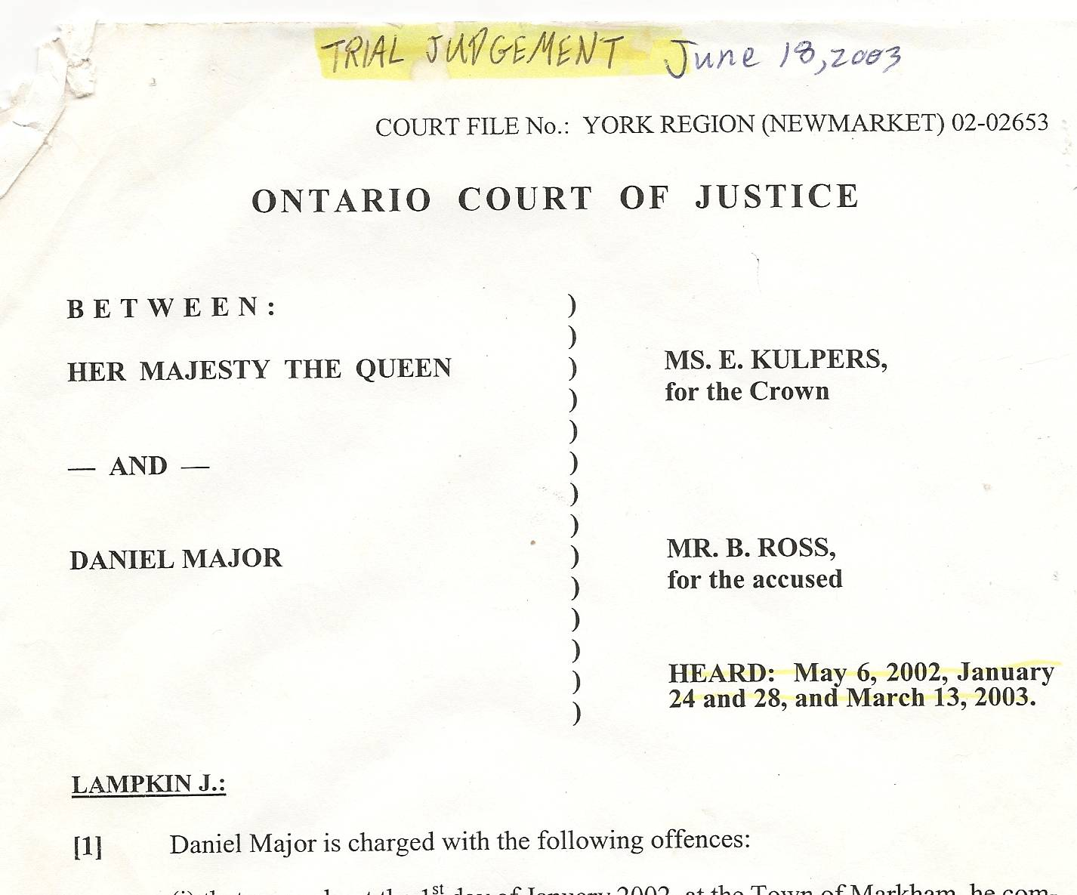

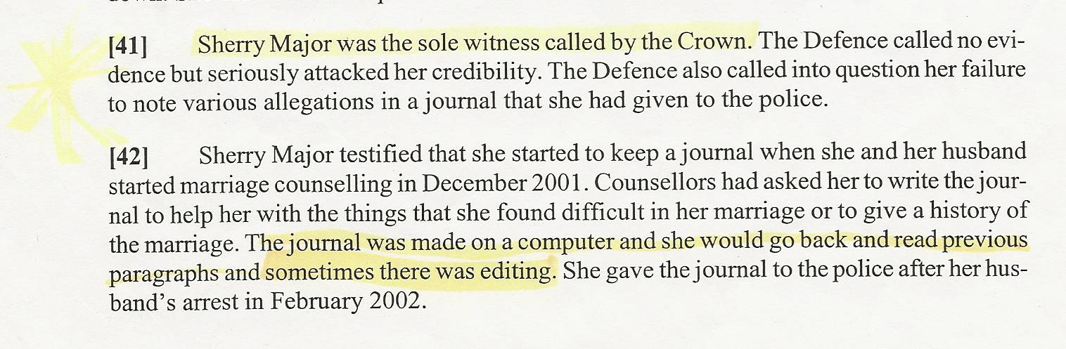

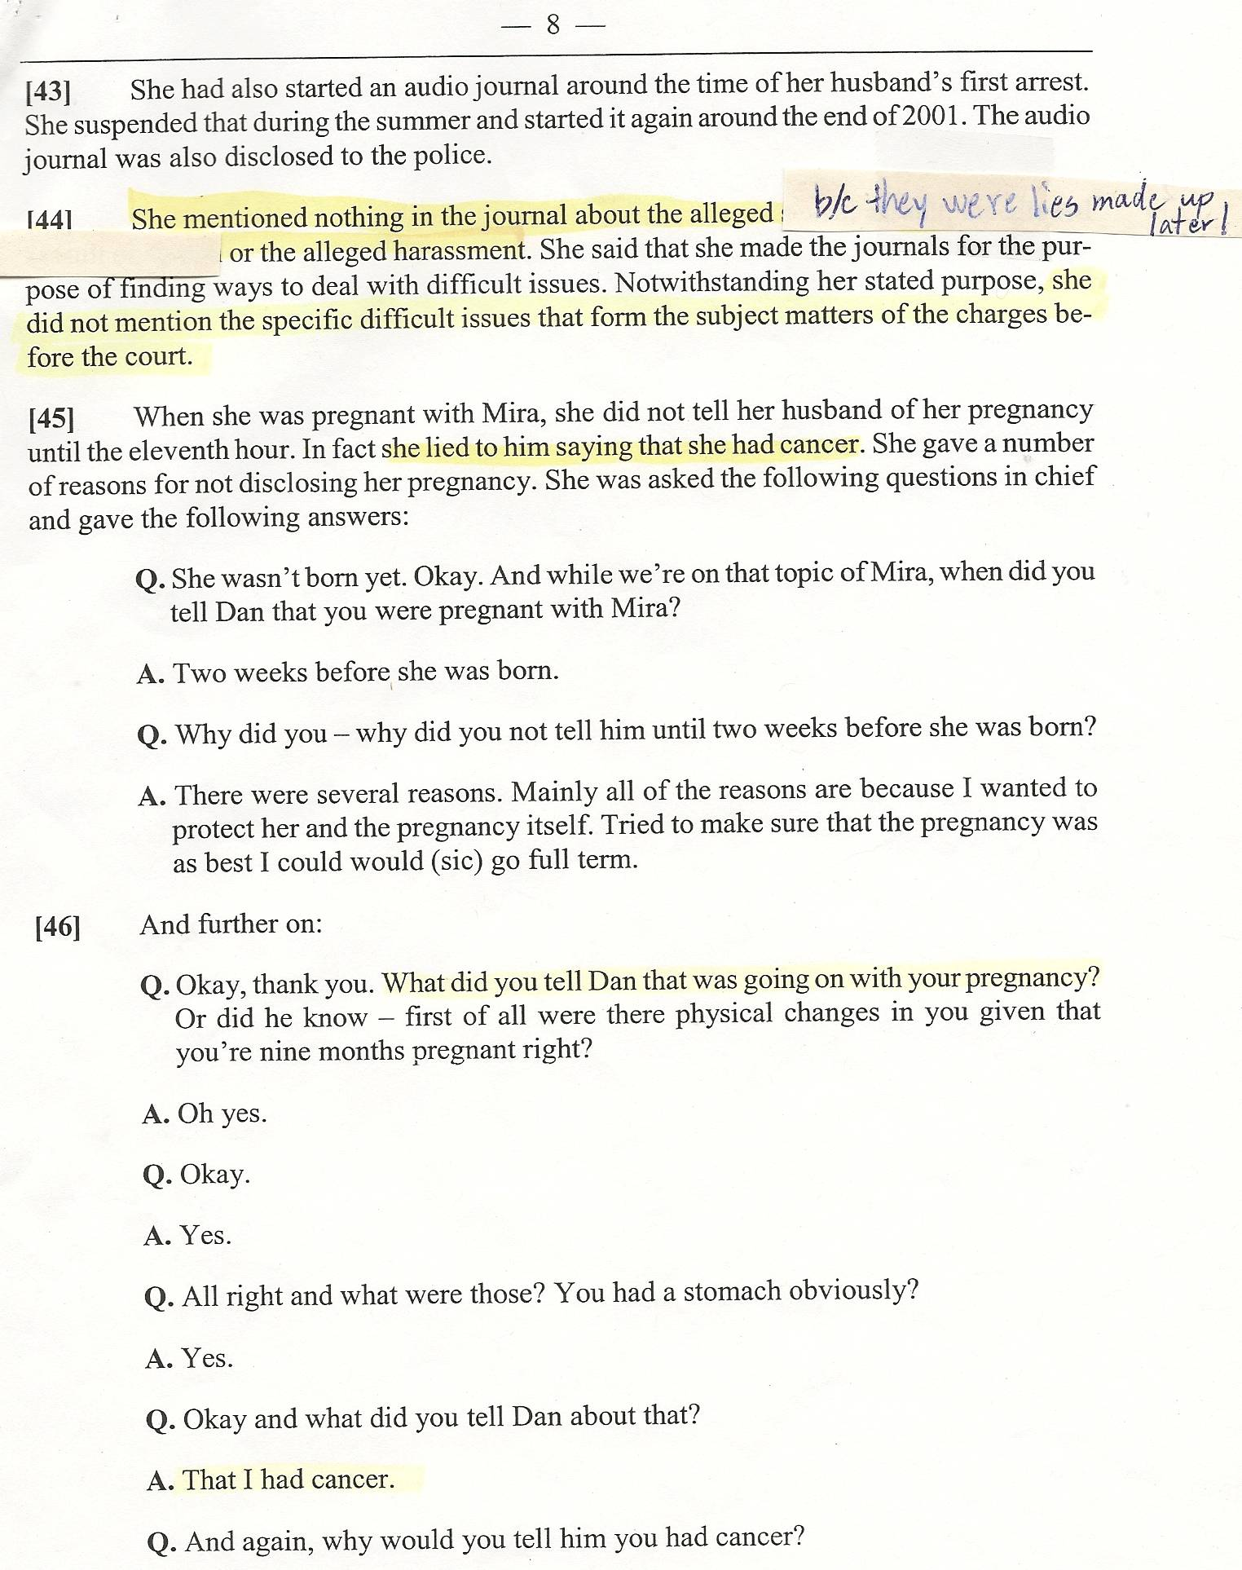
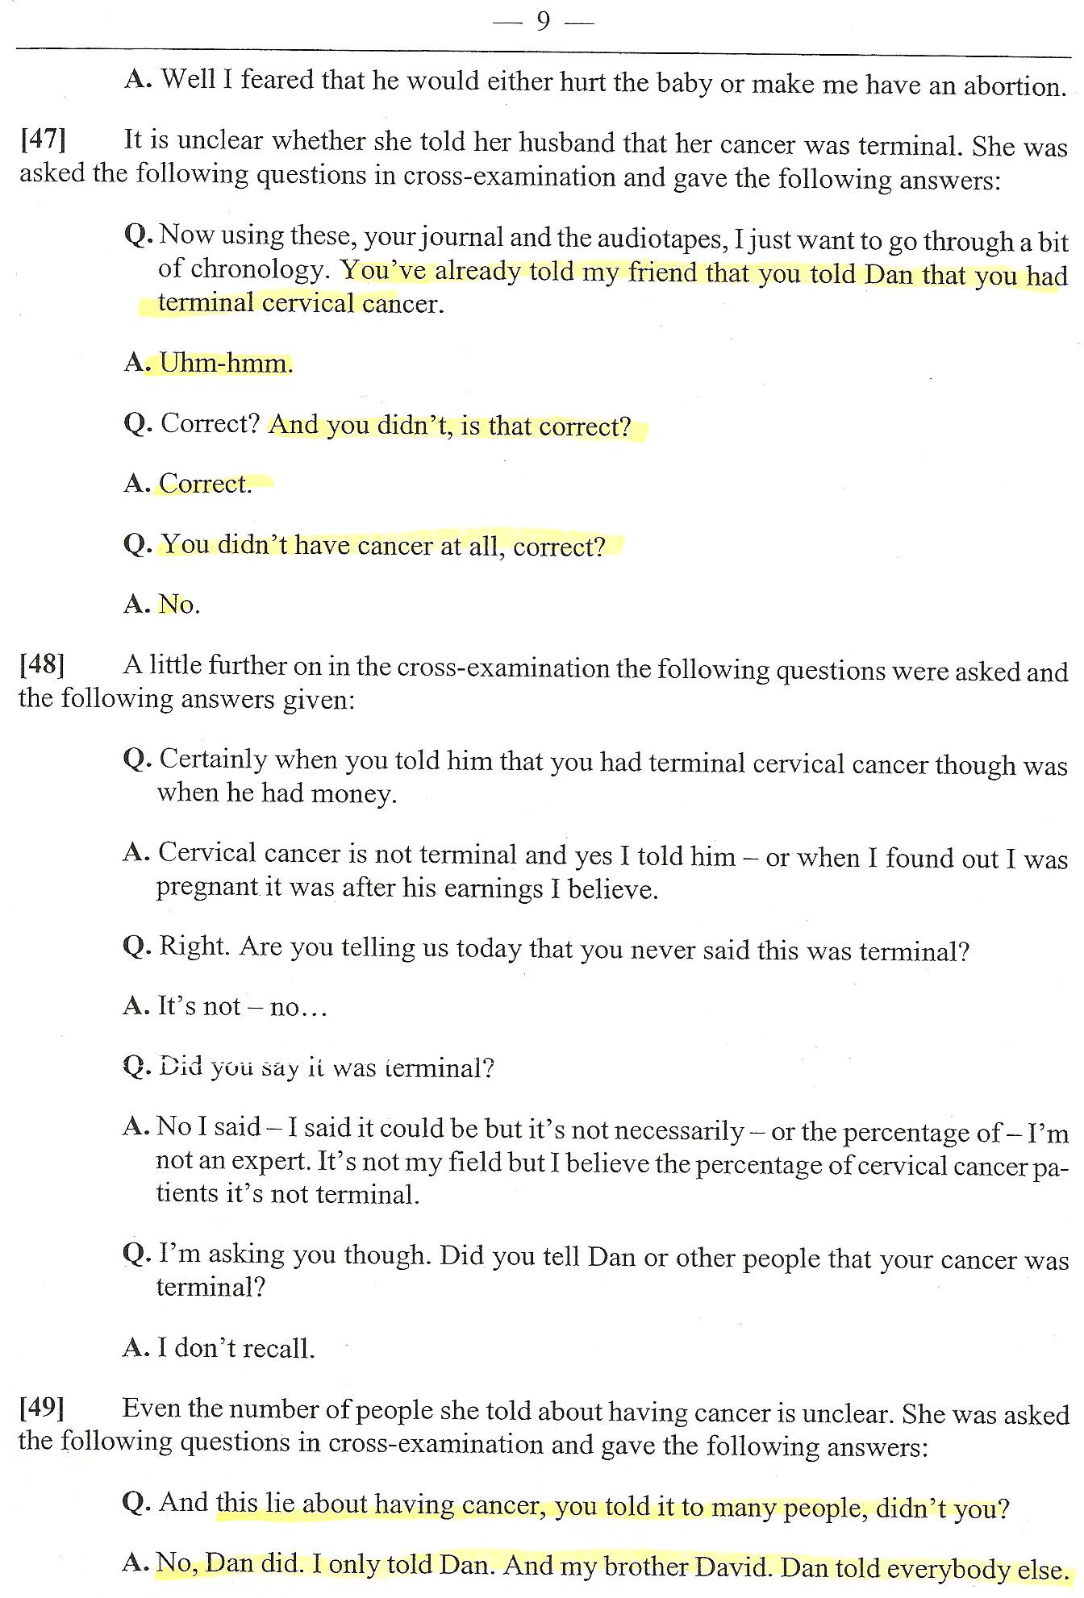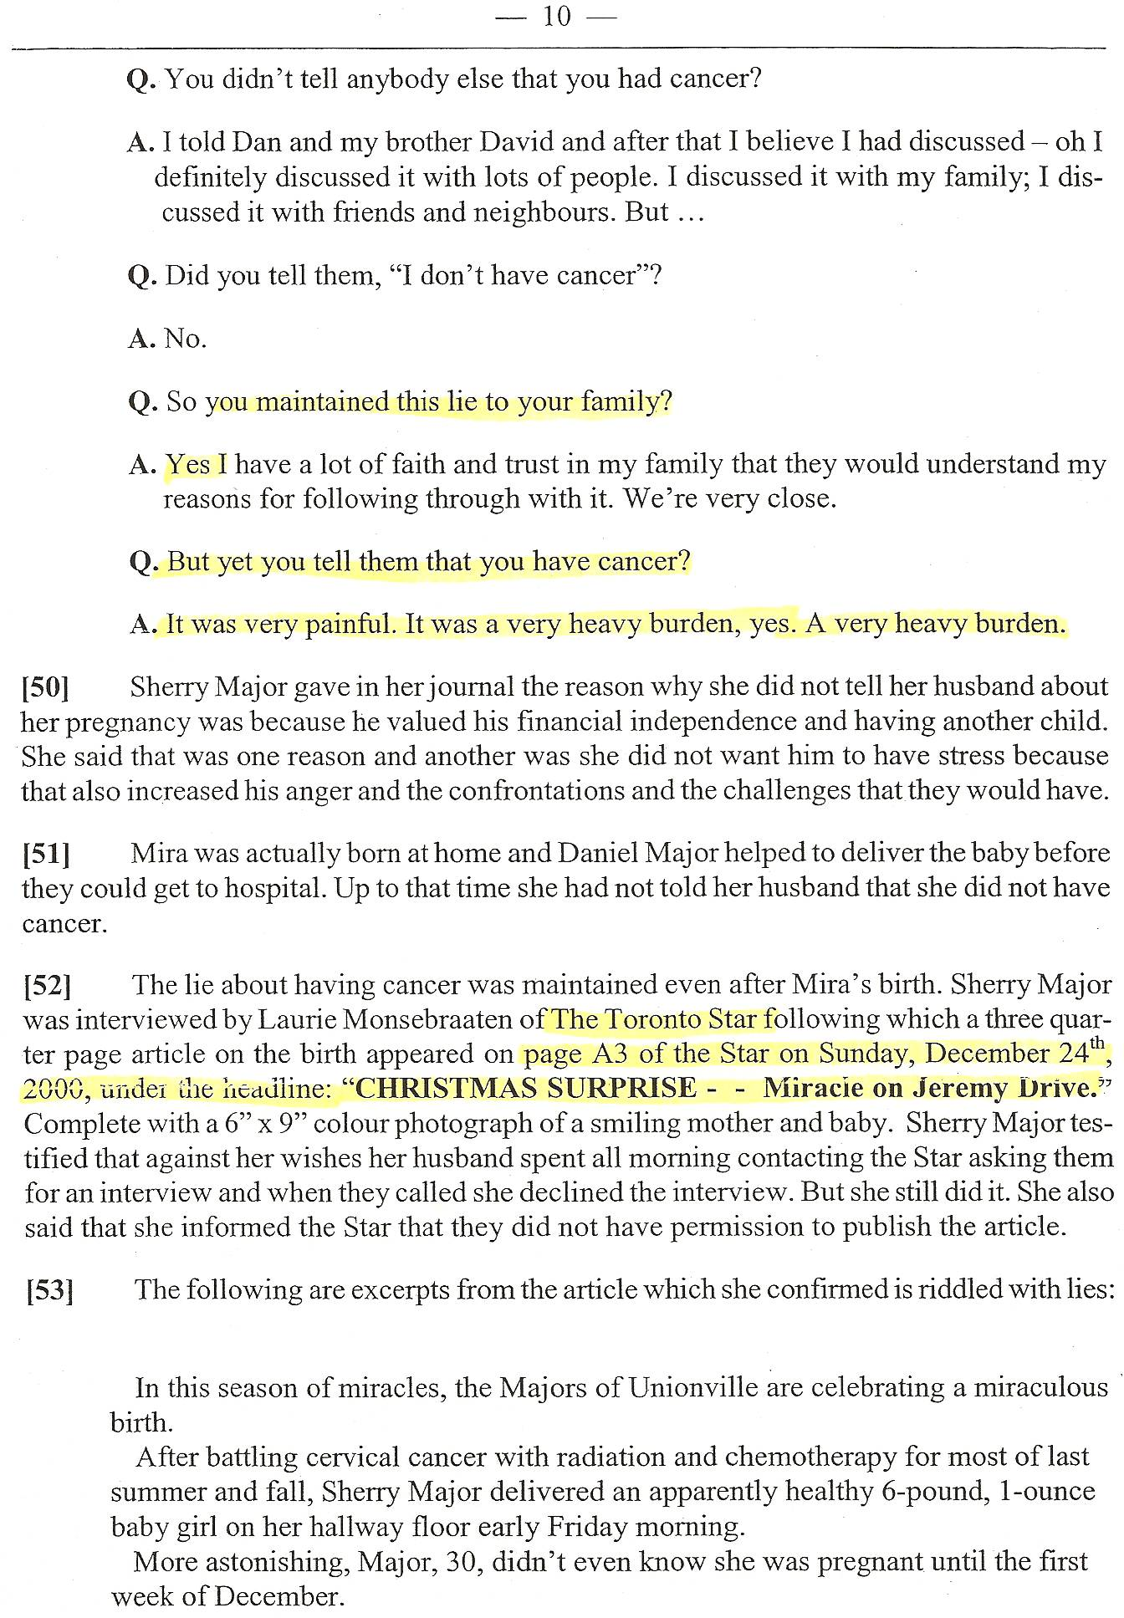
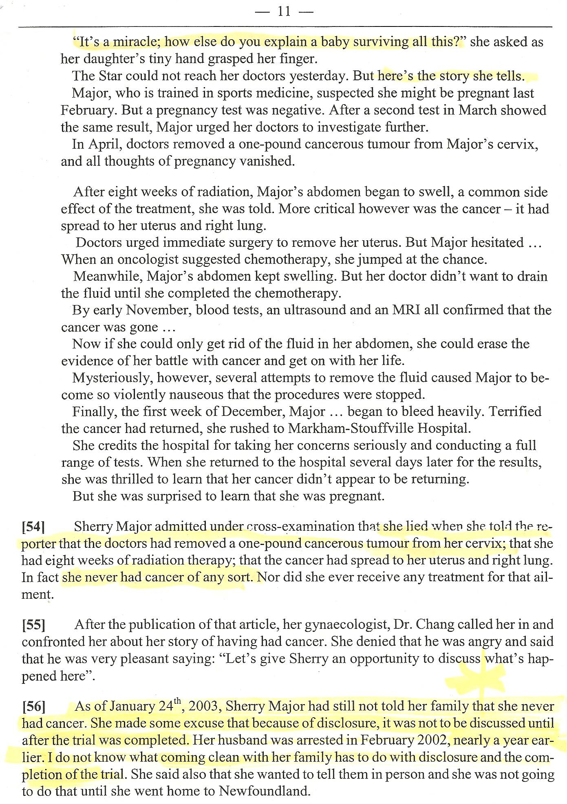
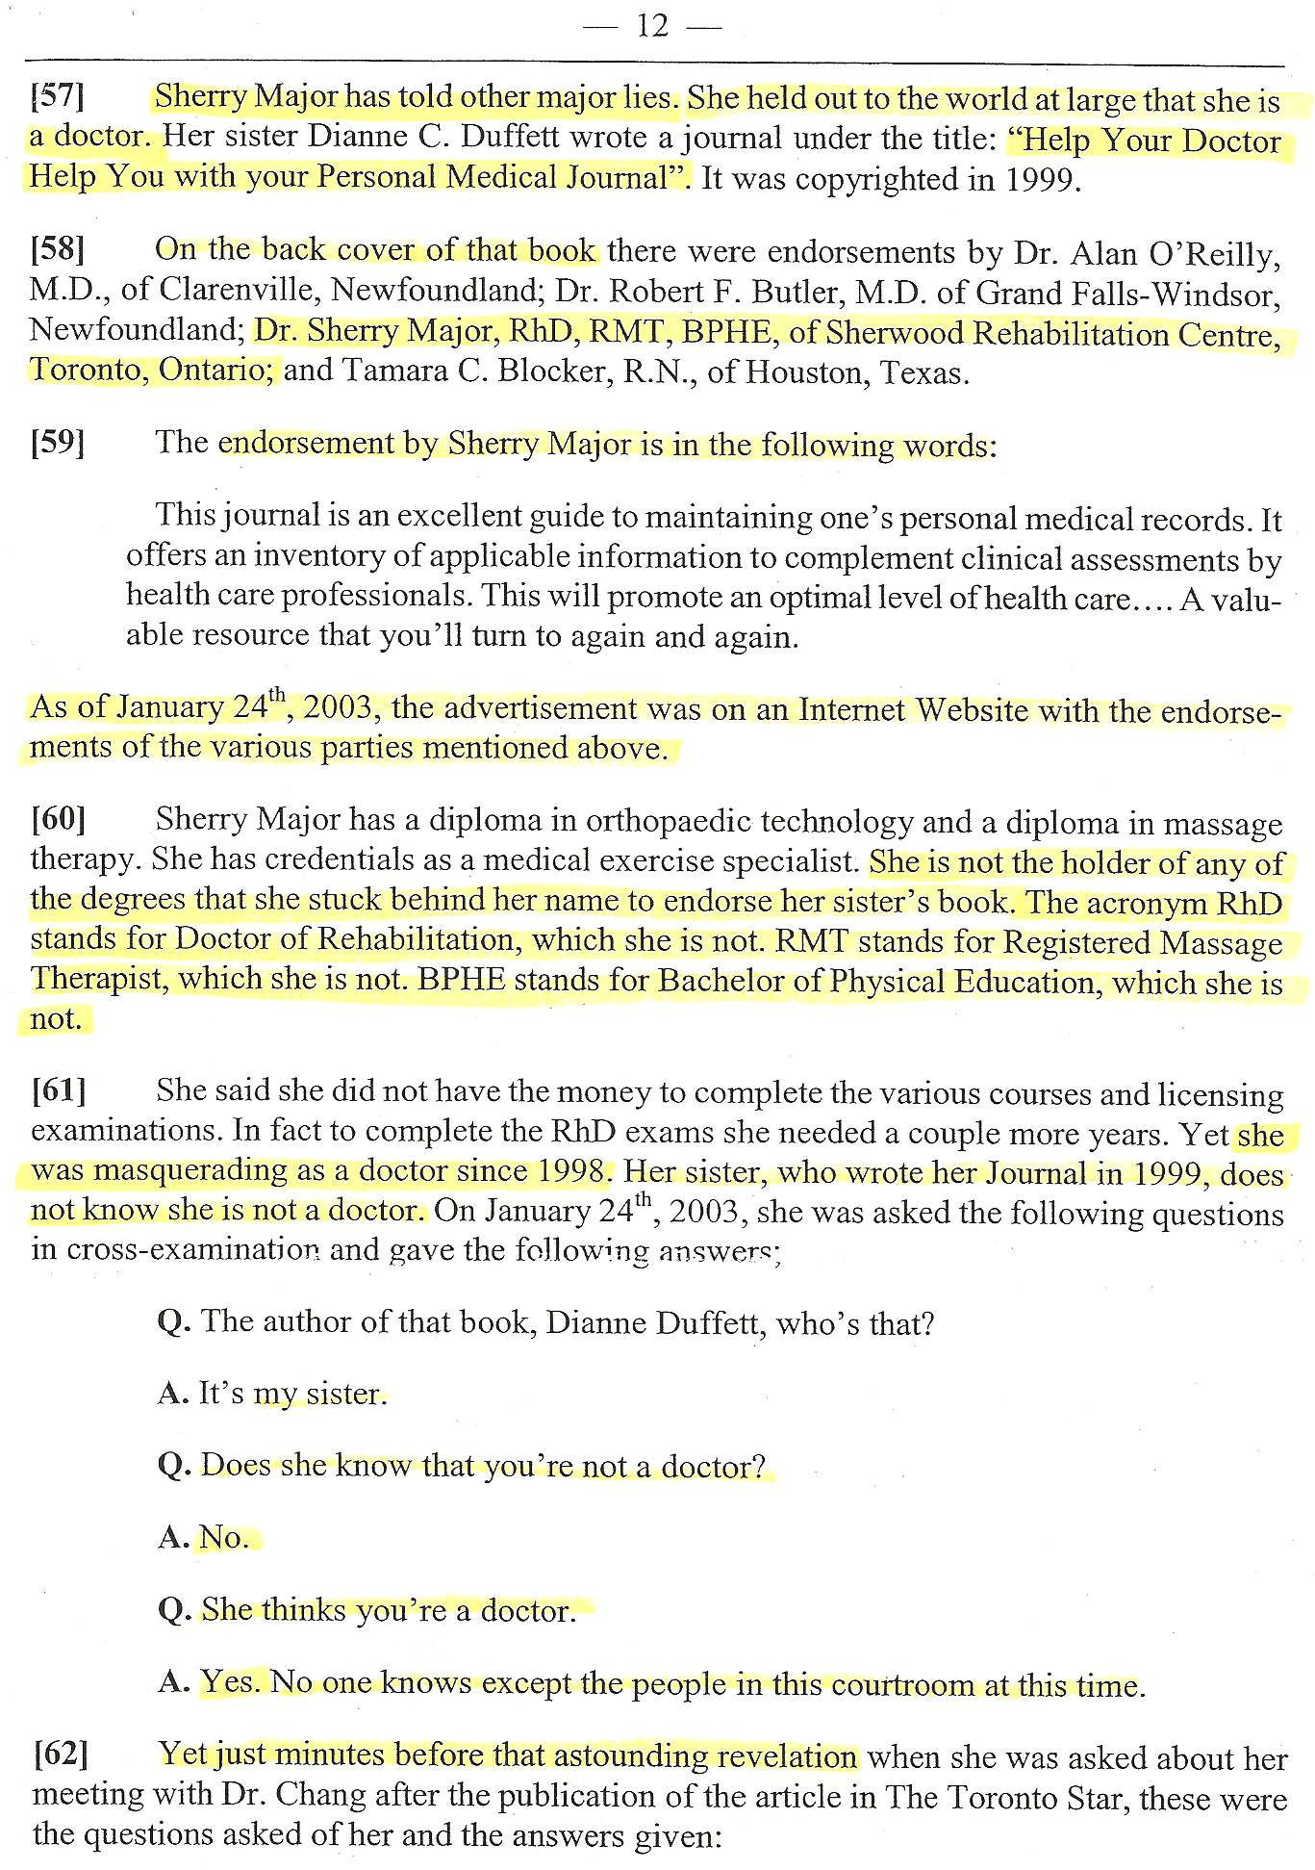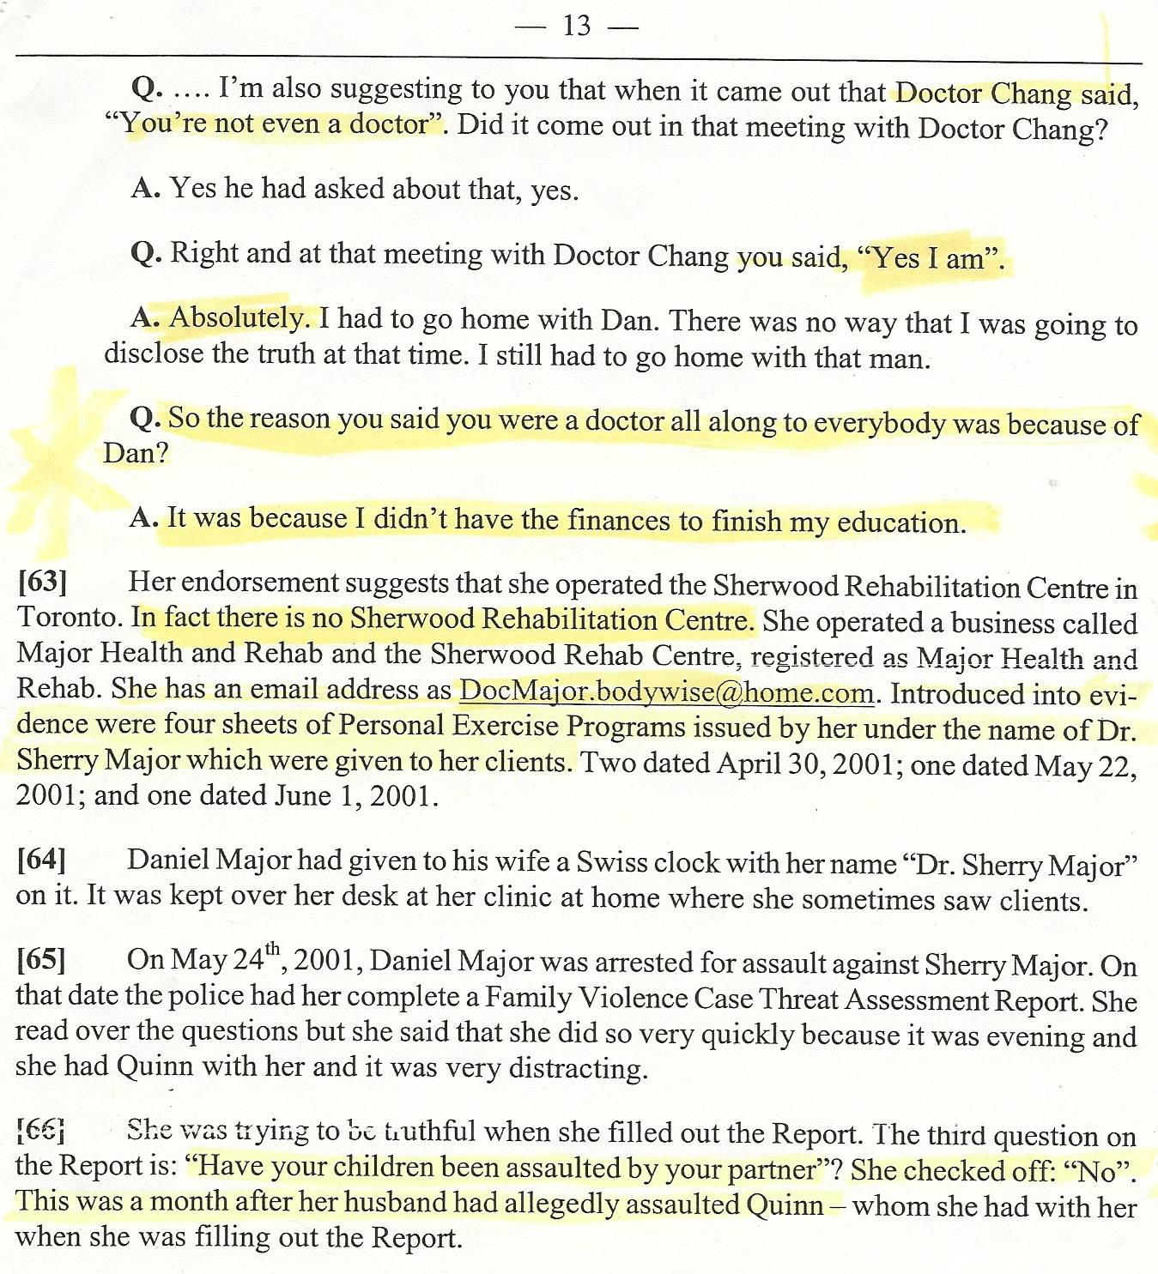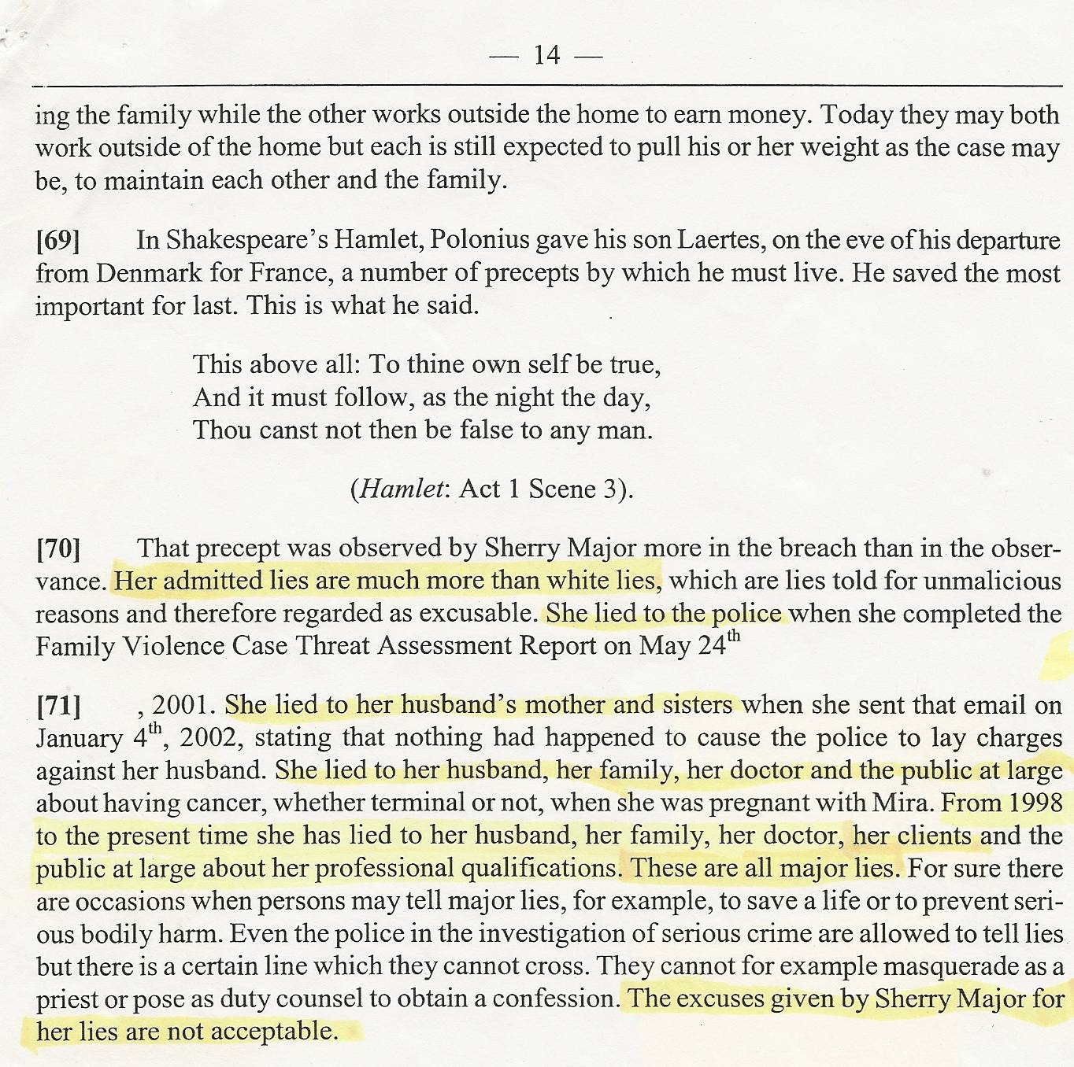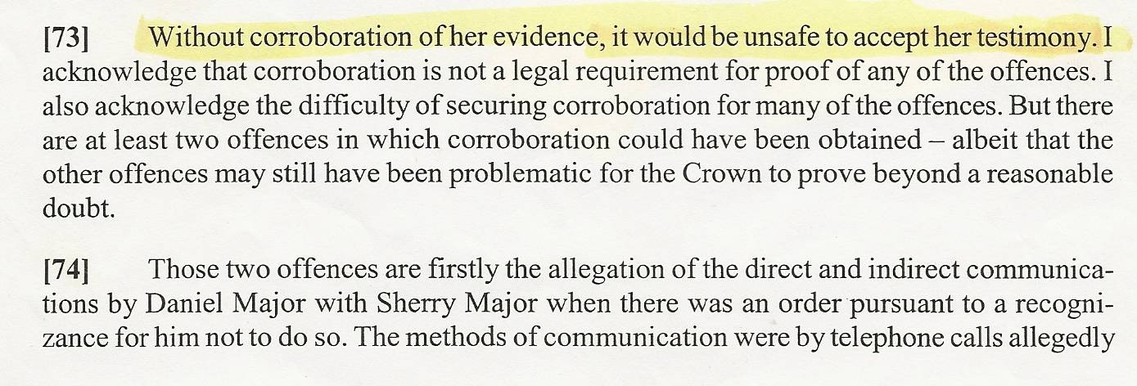

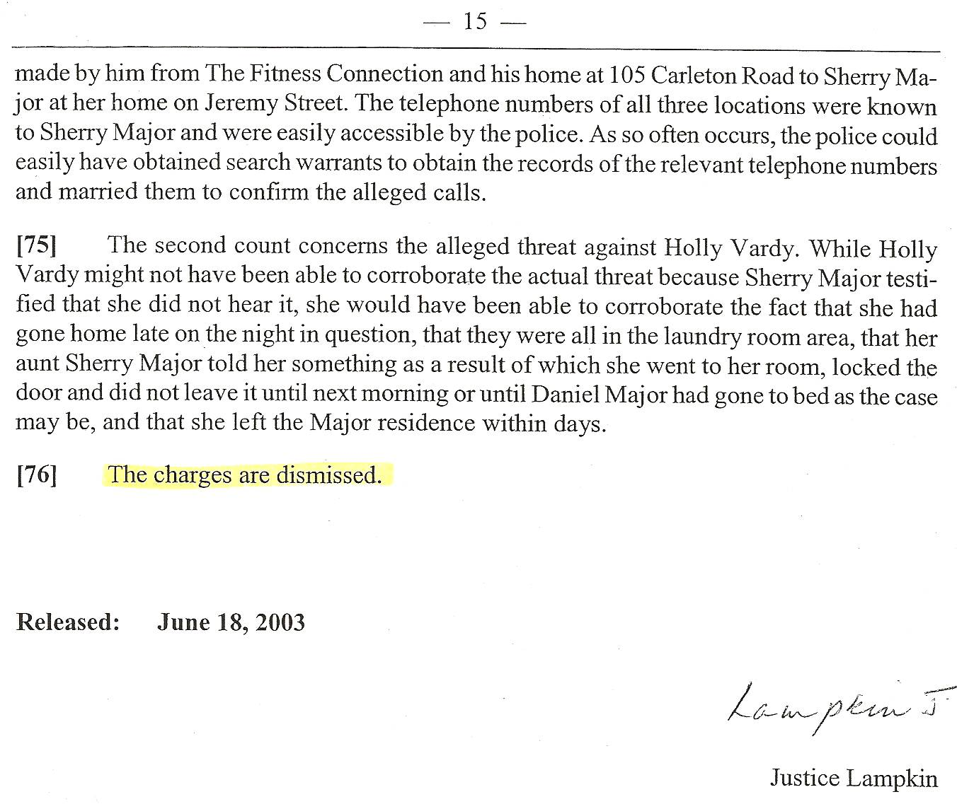

Dan’s Notes:

Re: item 60 – Sherry only claimed to have a “diploma in orthopaedic technology” but this was NEVER proven – she claimed lots of things that were proven as lies – IF she does have this course, it’s not as impressive as it sounds – it takes two weekends to complete

Re: item 61 – Judge was totally mistaken (Re: “to complete the RhD exams she needed a couple more years”) – Sherry did not even have an undergrad degree (she conned her parents into paying for the four years she spent at Memorial University in Newfoundland supposedly earning the BPHE degree that was discovered at trial she did not have – this was before Sherry knew Dan (proving she was a con artist long before knowing Dan since she had already bilked her own parents!) – it appears she was never in the Rh.D. program since she lacked the prerequisite undergrad degree – this is no different than a high school graduate (which Sherry apparently is) making a bogus claim to only have “a couple of years left”

