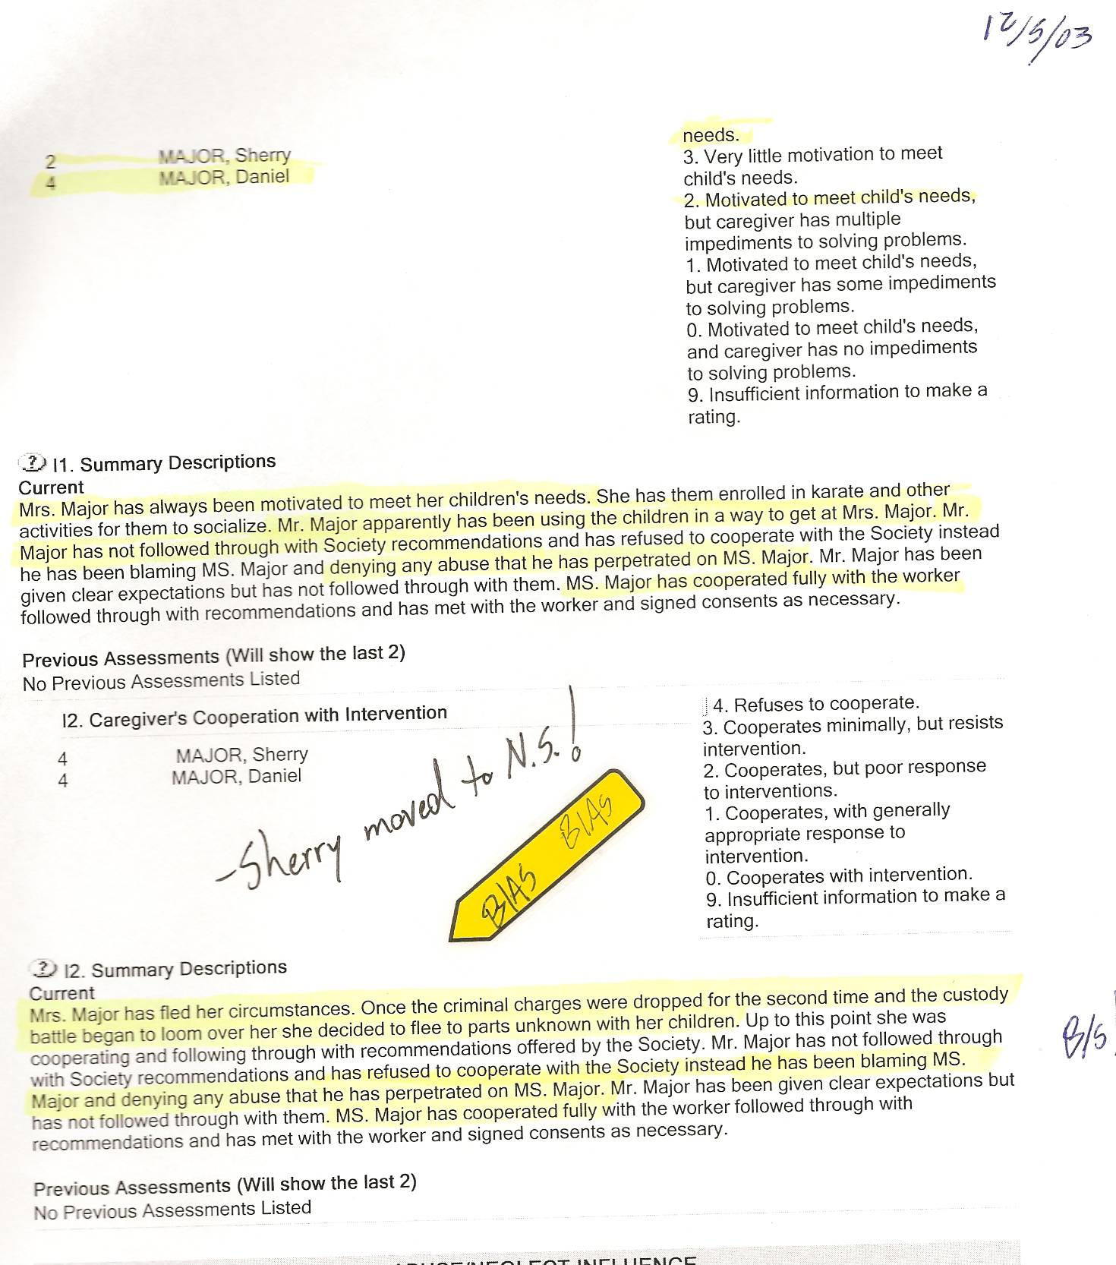

MOTIVE!!!
FACT: Even CAS admits Sherry fled not out of supposed “safety” concerns, but rather out of concerns of (losing) a custody battle.

Dan’s Notes:

-How the heck was I possibly “using the children”?? I hadn’t seen them in 22 months!!! CAS notes admitted I didn’t need to give them another psych assessment, especially since I had already done so.
-“Mr. Major … has been blaming Ms. Major and denying any abuse he has perpetrated on Ms. Major”
-Of course I denied abuse! The CAS knew Sherry was a chronic liar – and a fraud artist.

-How has Ms. Major “cooperated fully with the worker”? Was this by taking the criminal step of abducting out of the province to N.S. with my children, just as the CAS had coached/encouraged her to do?

-once again, CAS fully turns a blind eye to everything Sherry does – including much CRIMINAL activity
-once again, CAS blames Dan for anything and everything – as usual, they do so without merit to support their position – their only reason to label me is due to Sherry’s KNOWN LIES since they have already admitted their awareness that she is a “chronic liar” – their actions now are simply to further their cause to hide their mistakes!!!

-CAS claims Sherry fled to “parts unknown” despite being fully aware she had headed to a Transition House in Nova Scotia since they had coached/encouraged her to make this move for the last 1-1/2 years!!! About 2-3 weeks later in the CAS file Walter Sienko actually telephones Sherry and noted “LM”. He obviously left her a message. How could he have possibly left her a message unless he knew her telephone number!!! He knew she was in NS and was obviously just touching base to ensure she arrived there safely!

-the CAS notes 2003-11-10 clearly acknowledge they knew Sherry intended to move out of the province

-CAS notes 2003-11-28 STRONGLY question Sherry’s mental/emotional health, awareness she is a chronic liar, and her undiagnosed pathology yet THEY REMARKABLY HAVE NO CONCERNS ABOUT THE CHILDREN’S WELFARE!!

-What a load of crap!! They knew they screwed up and by having Sherry “disappear” and then refuse to cooperate with me as to ever locating them the CAS felt they could hide all their mistakes!!!

