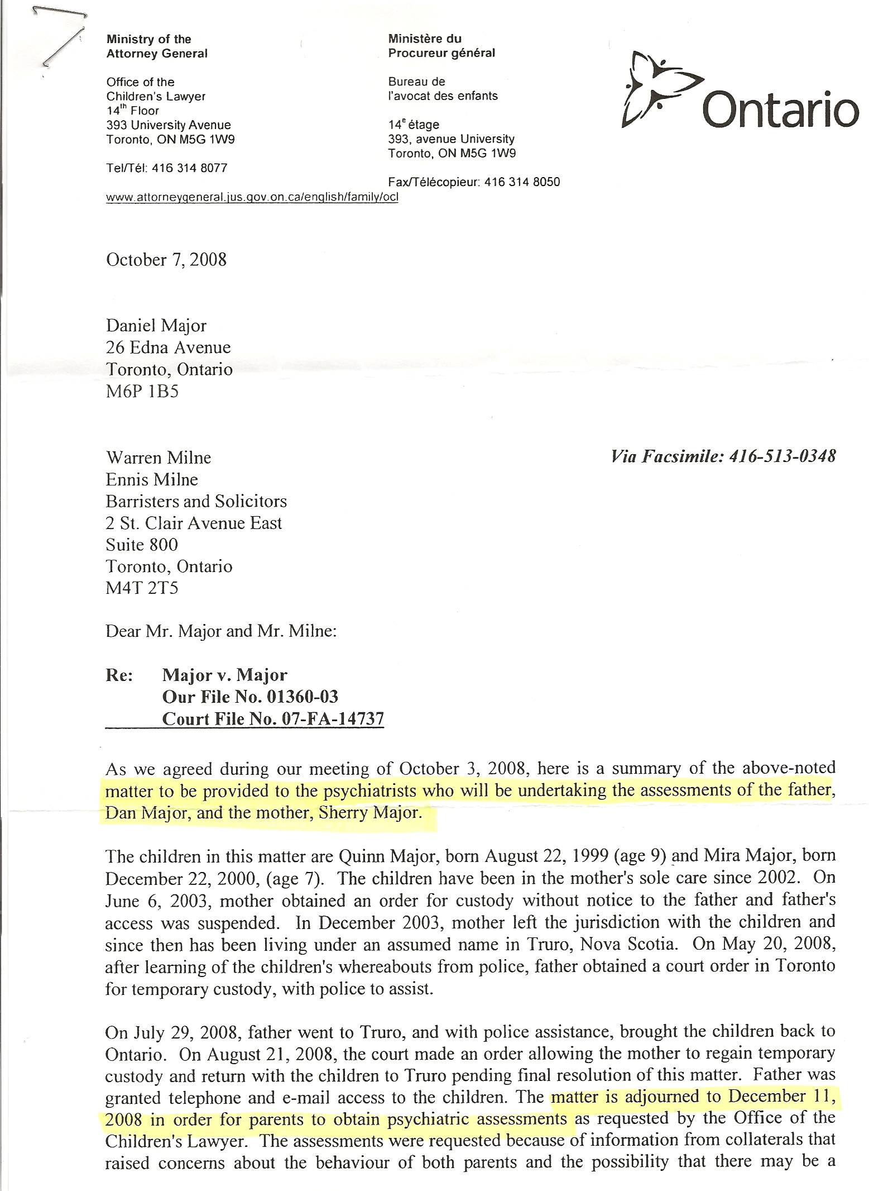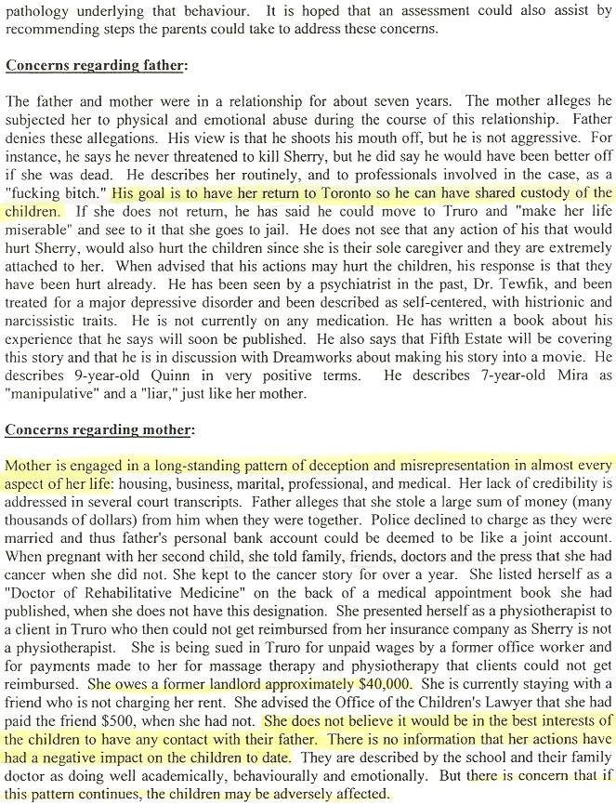

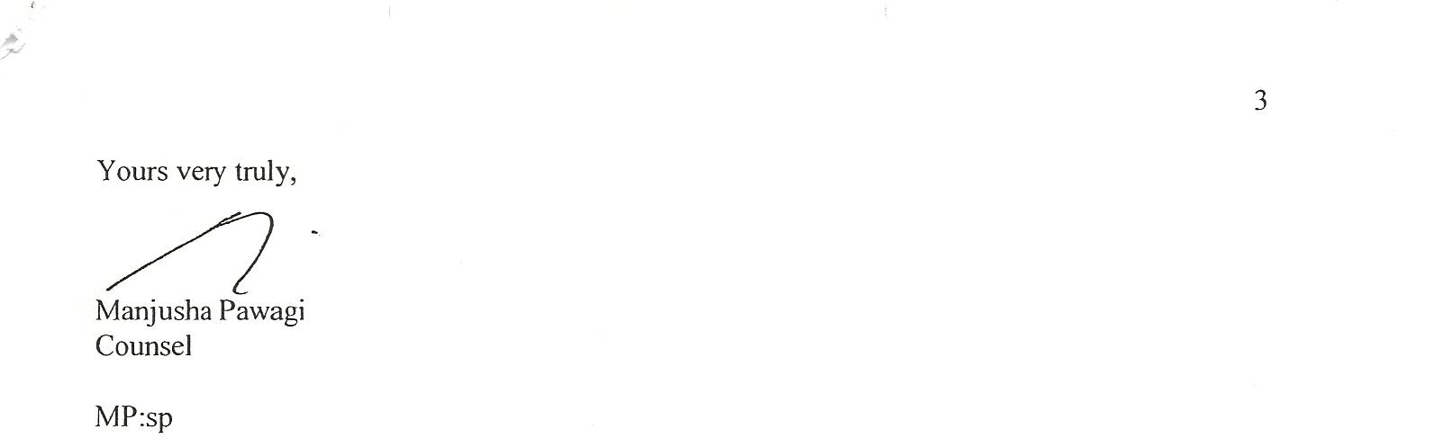

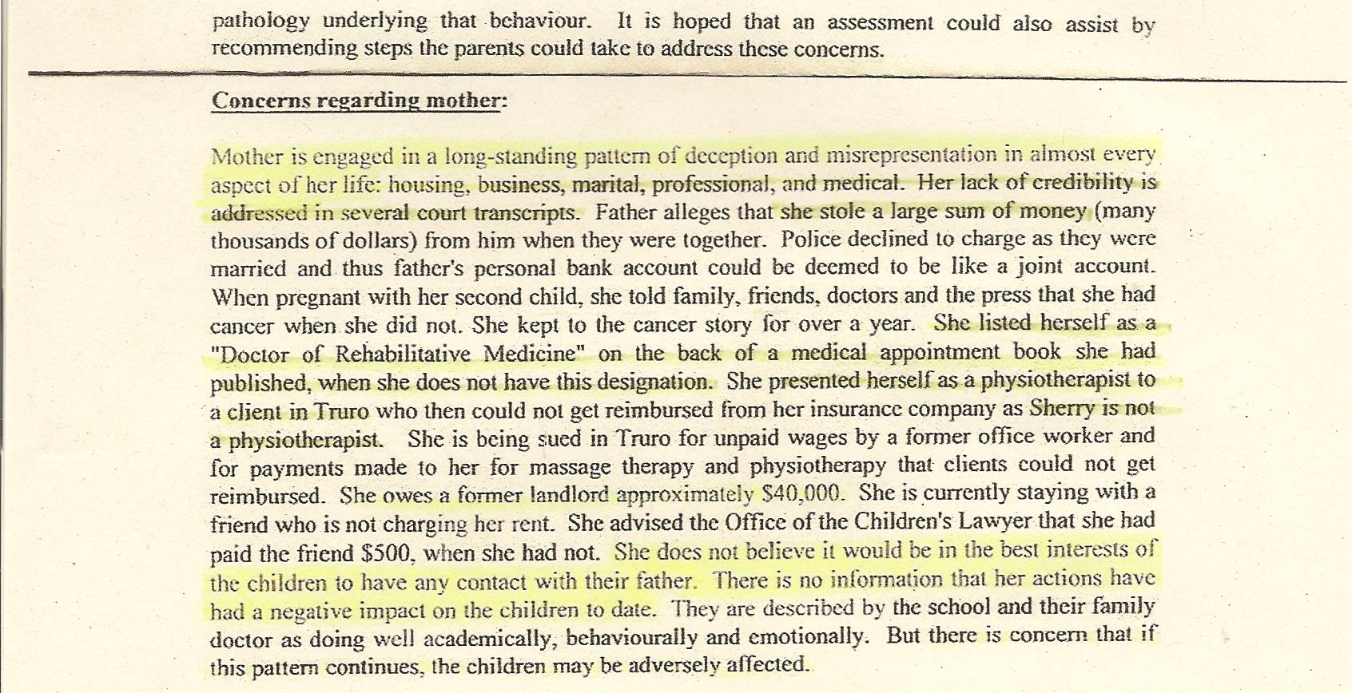

FACTS
-the OCL has bungled the Major family matter ever since their initial involvement in 2003 – Dan’s 2009 lawyer called their actions a “disgrace” in his Affidavit
-as hard to believe as it might seem, the OCL has actually softened their overview of Sherry in order to justify their position (i.e. cover their asses and make it appear their actions were based on competent decision making)
-the OCL knowingly lied to Dan and the Family Court judge as to their intents and capabilities, falsely claiming they could and would travel to N.S. to interview the children and “collateral witnesses” – this decision encouraged the judge to allow the abducted children to return to N.S. – as Dan’s lawyer wrote, once the horse was out of the barnyard it was very difficult to get it back in
-Dan wrote several letters in 2009 complaining of the OCL’s intentional deceit and pointing out their “mistakes” – the OCL refused to ever respond
-the OCL assessment is frequently factually incorrect
-Sherry bilked Dan of $500,000, not “many thousands of dollars”
-police never charged Sherry because they were part of the cover up! A police officer was having an affair with Sherry – and possibly ended up with all or some of the $200,000 cash that is missing to this very day!
-the “friend” was charging Sherry rent – Sherry simply never paid it!
-for the OCL to claim Sherry’s actions have had no negative impact on the children is insulting and extremely offensive, akin to believing that O.J. Simpson is actually looking for his wife’s killer. Sherry’s extreme Parental Alienation against Dan is well documented.

