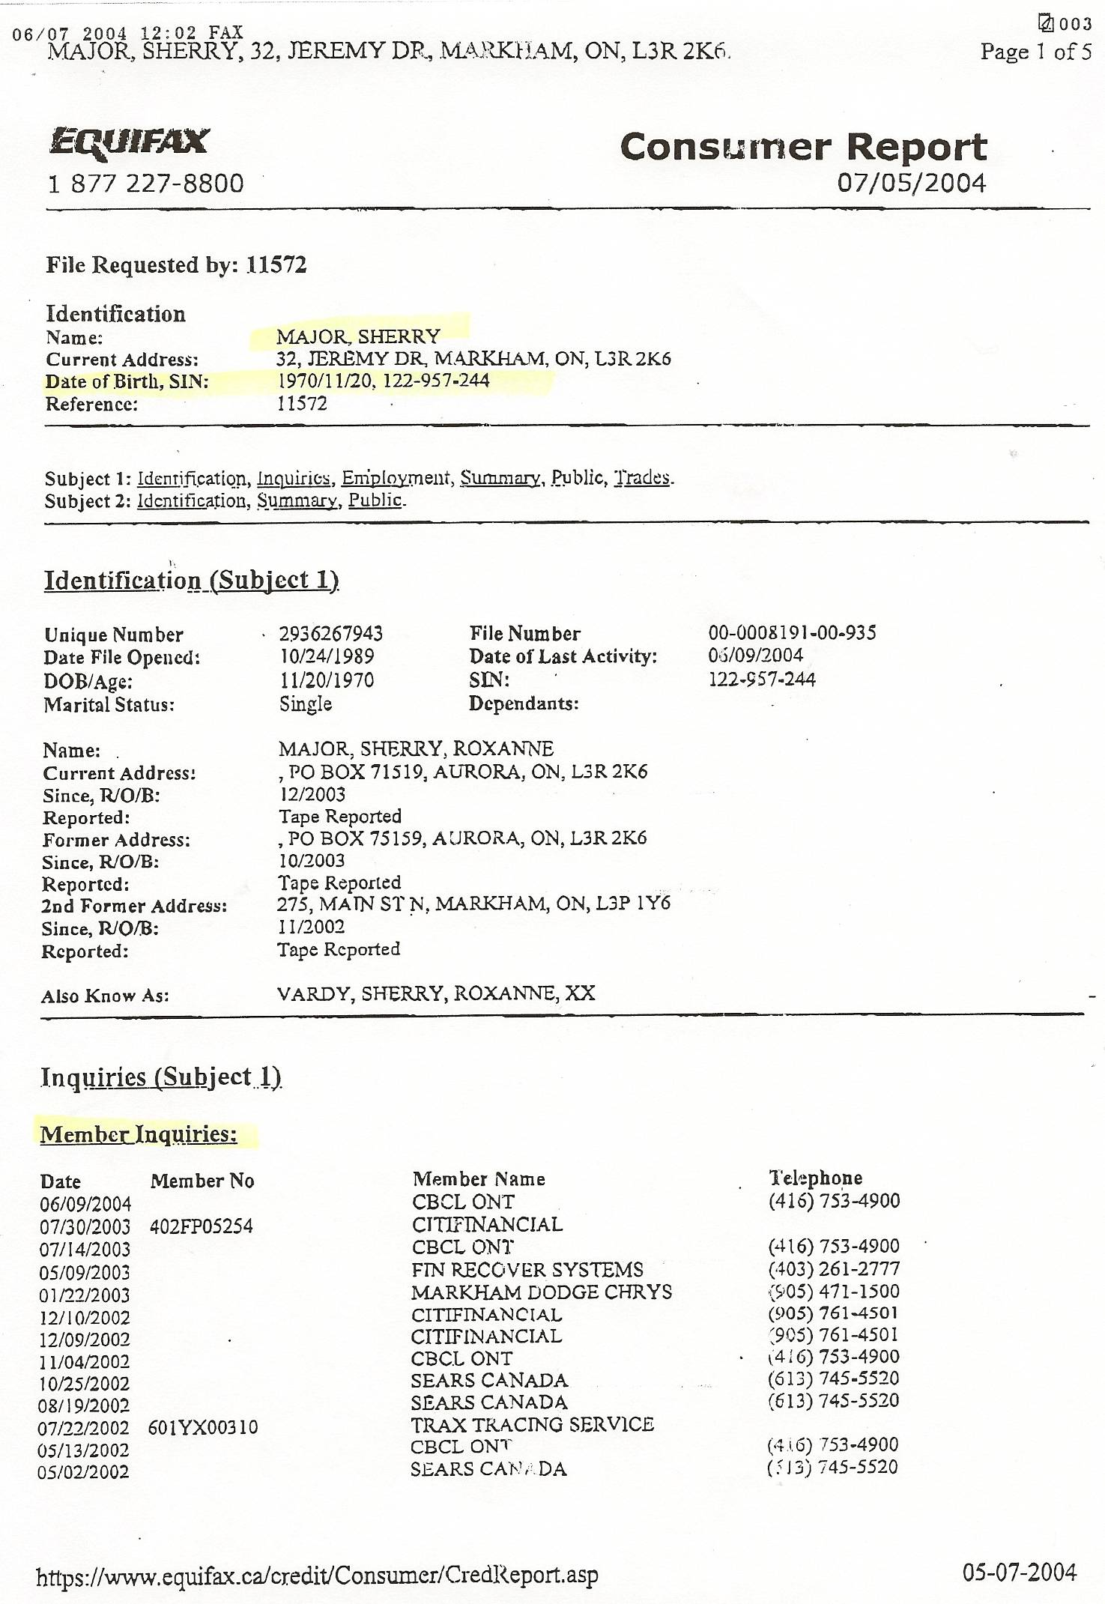
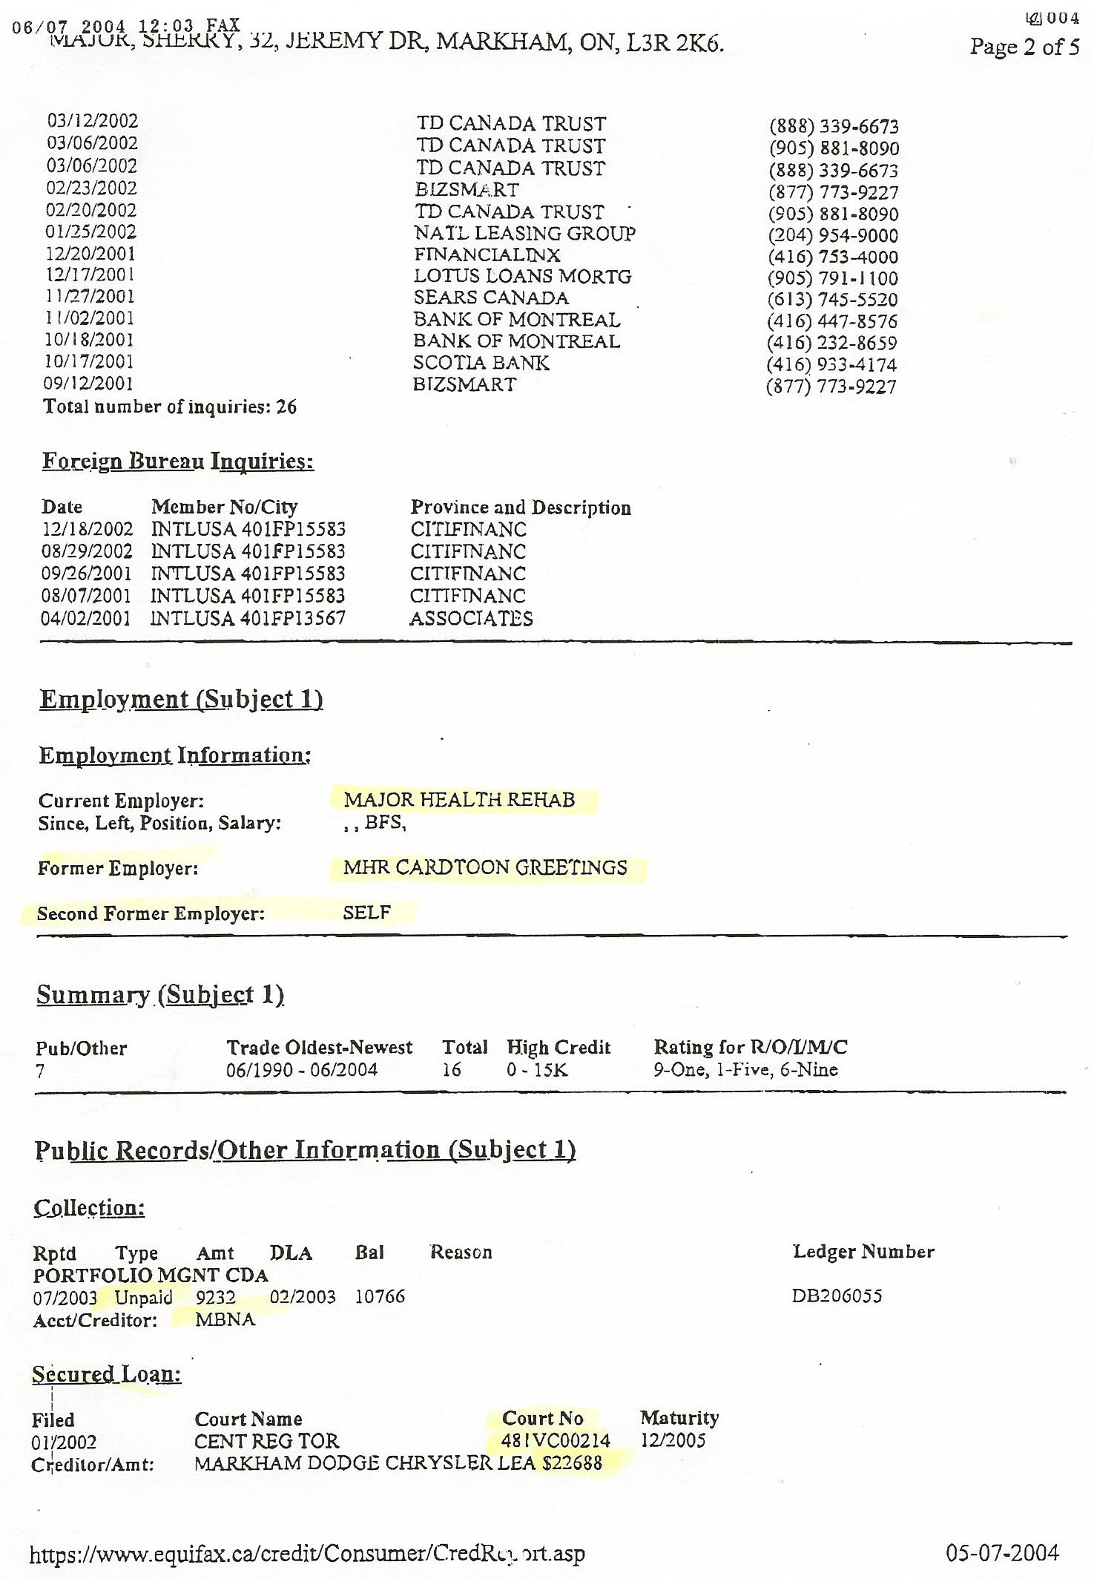
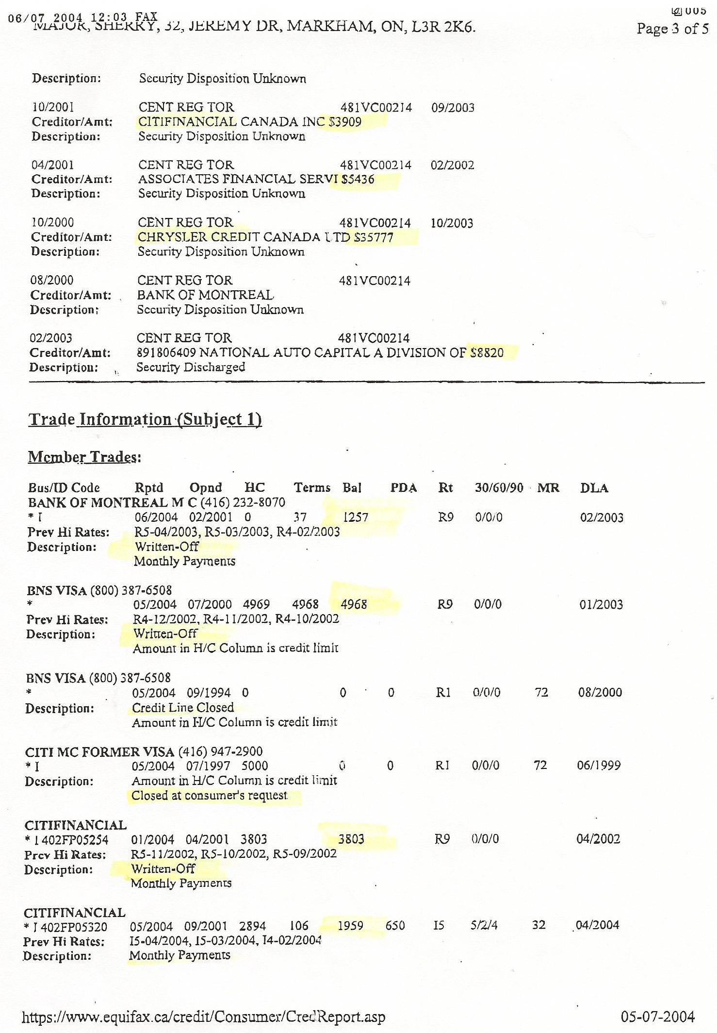
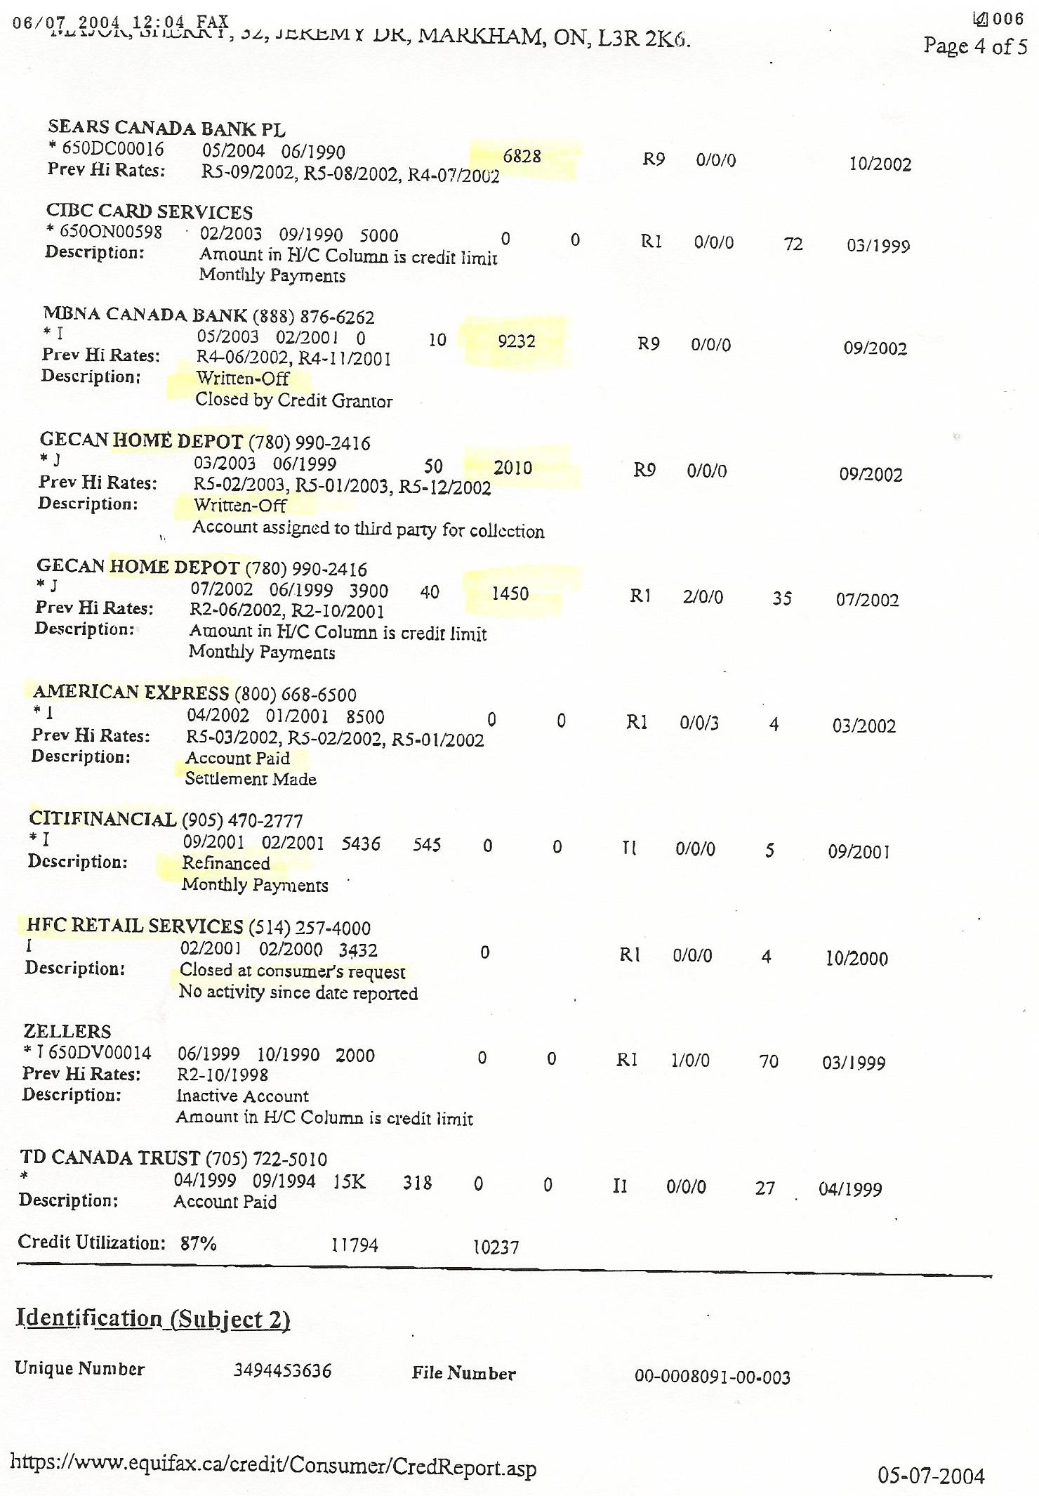
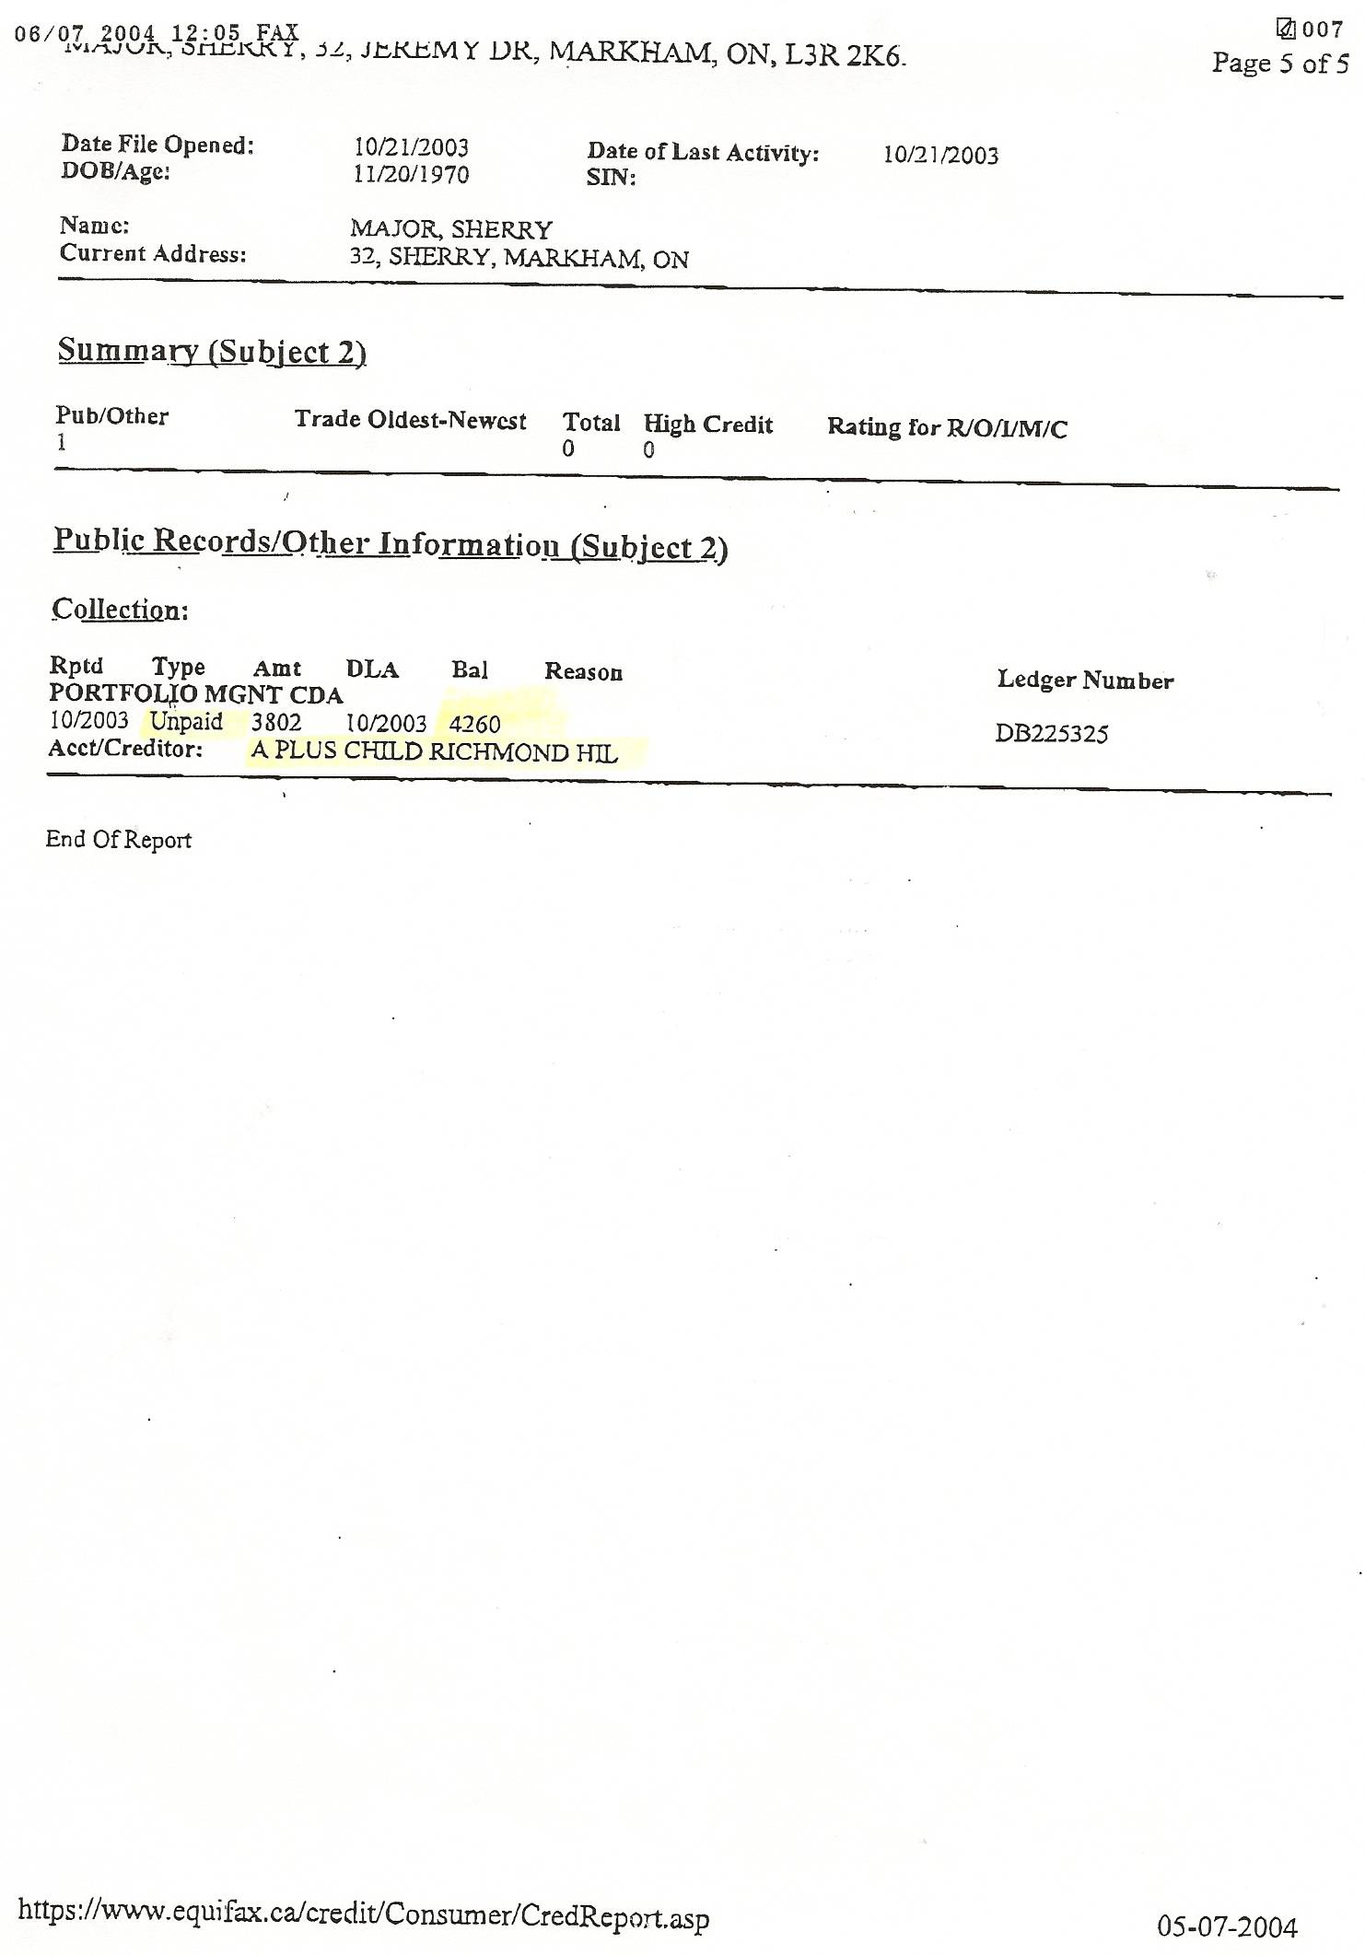

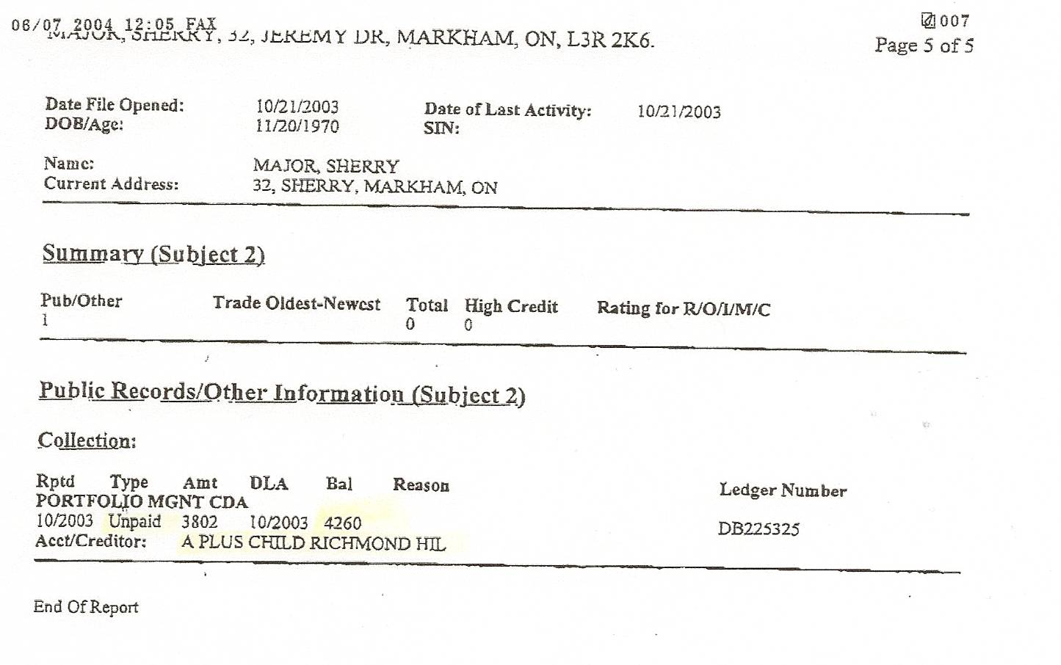

Dan’s Notes:

This long list of Sherry’s debts is FAR from complete since she did hundreds of thousands of dollars of fraud using my name and some of her TEN aliases too. Sadly, while I was detained, some of her creditors were paid off with my home equity when the matrimonial home was sold without my awareness!

