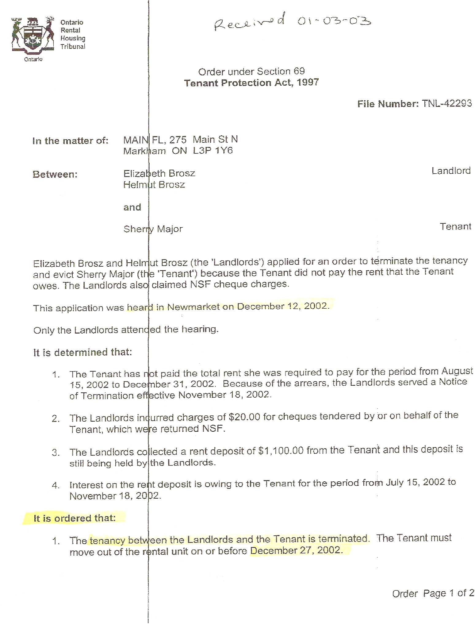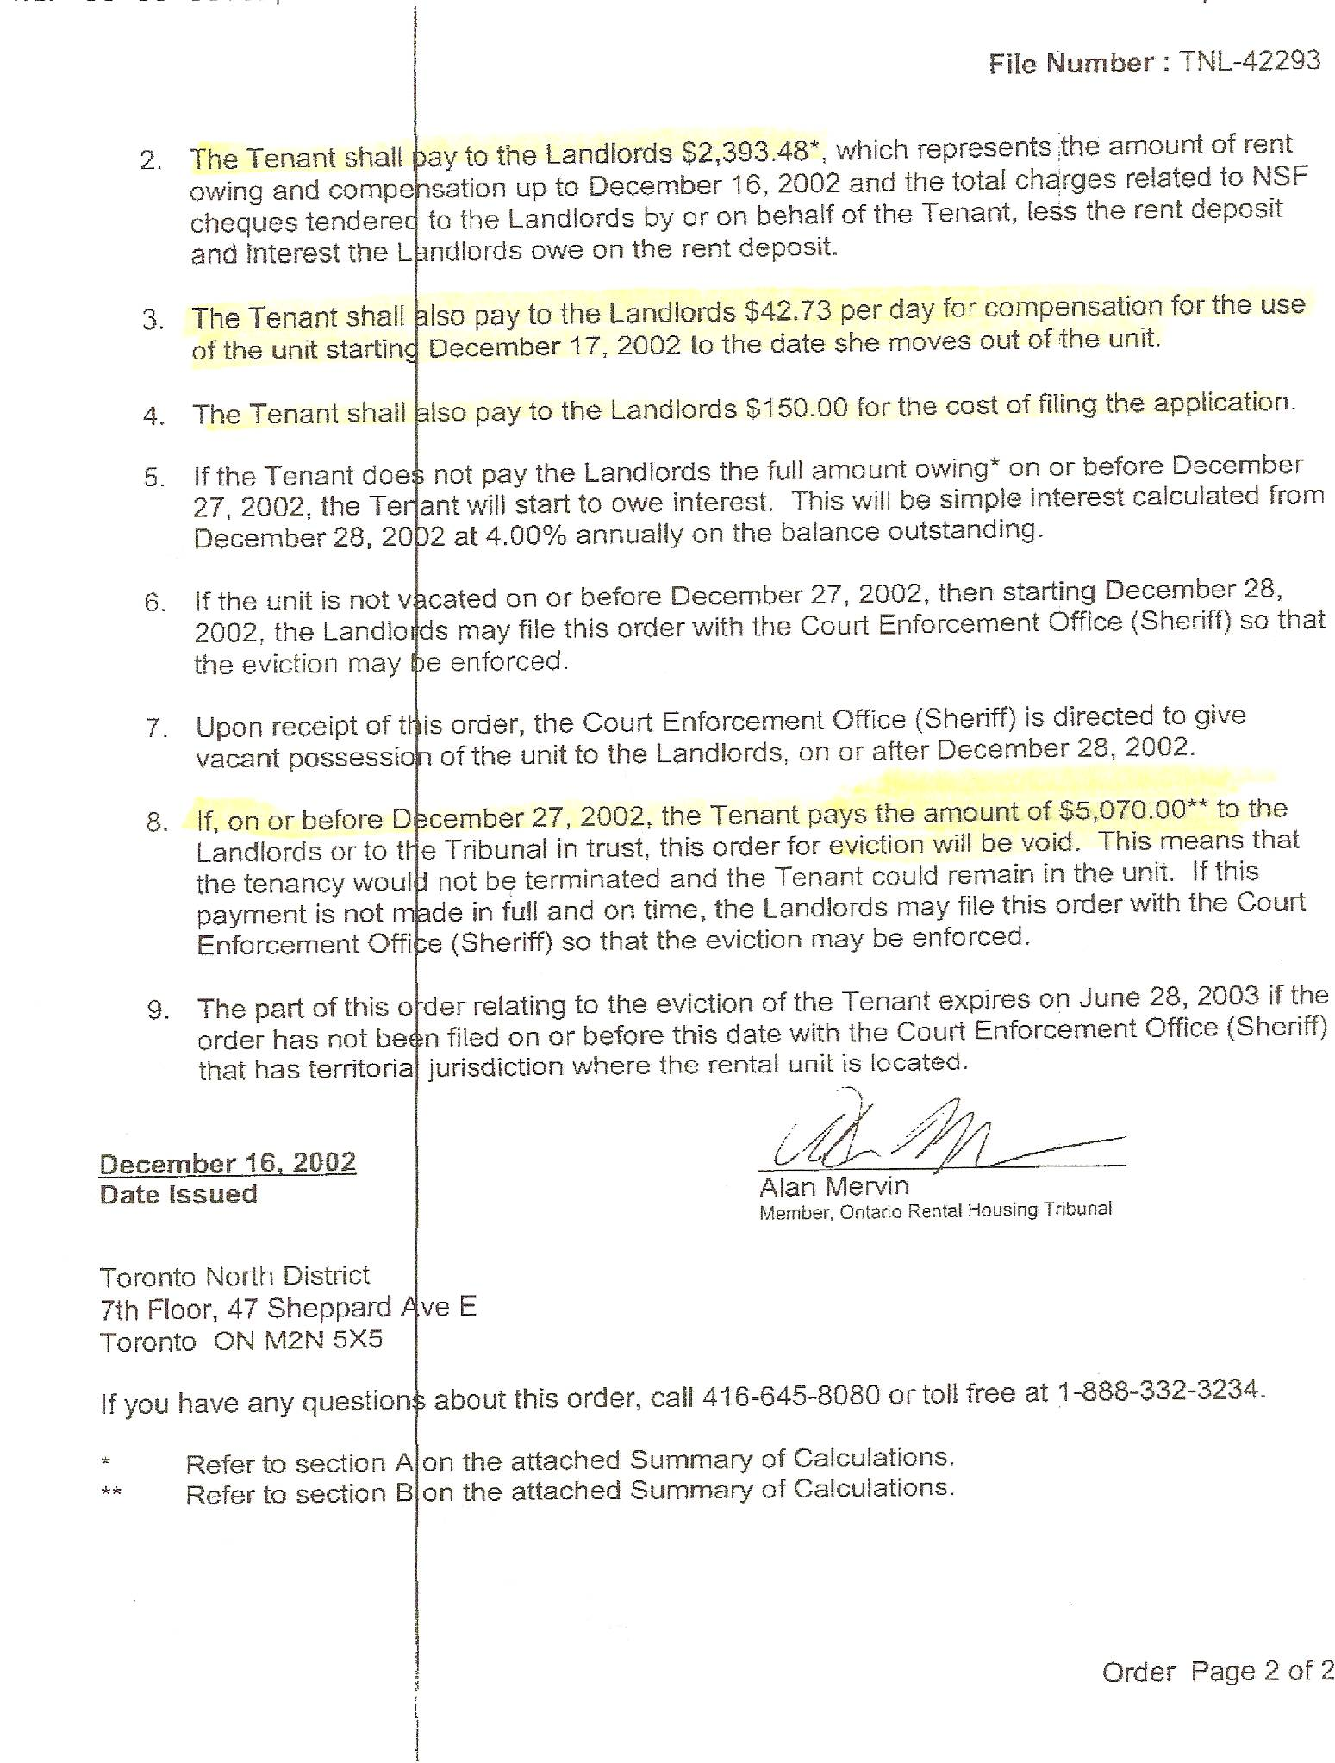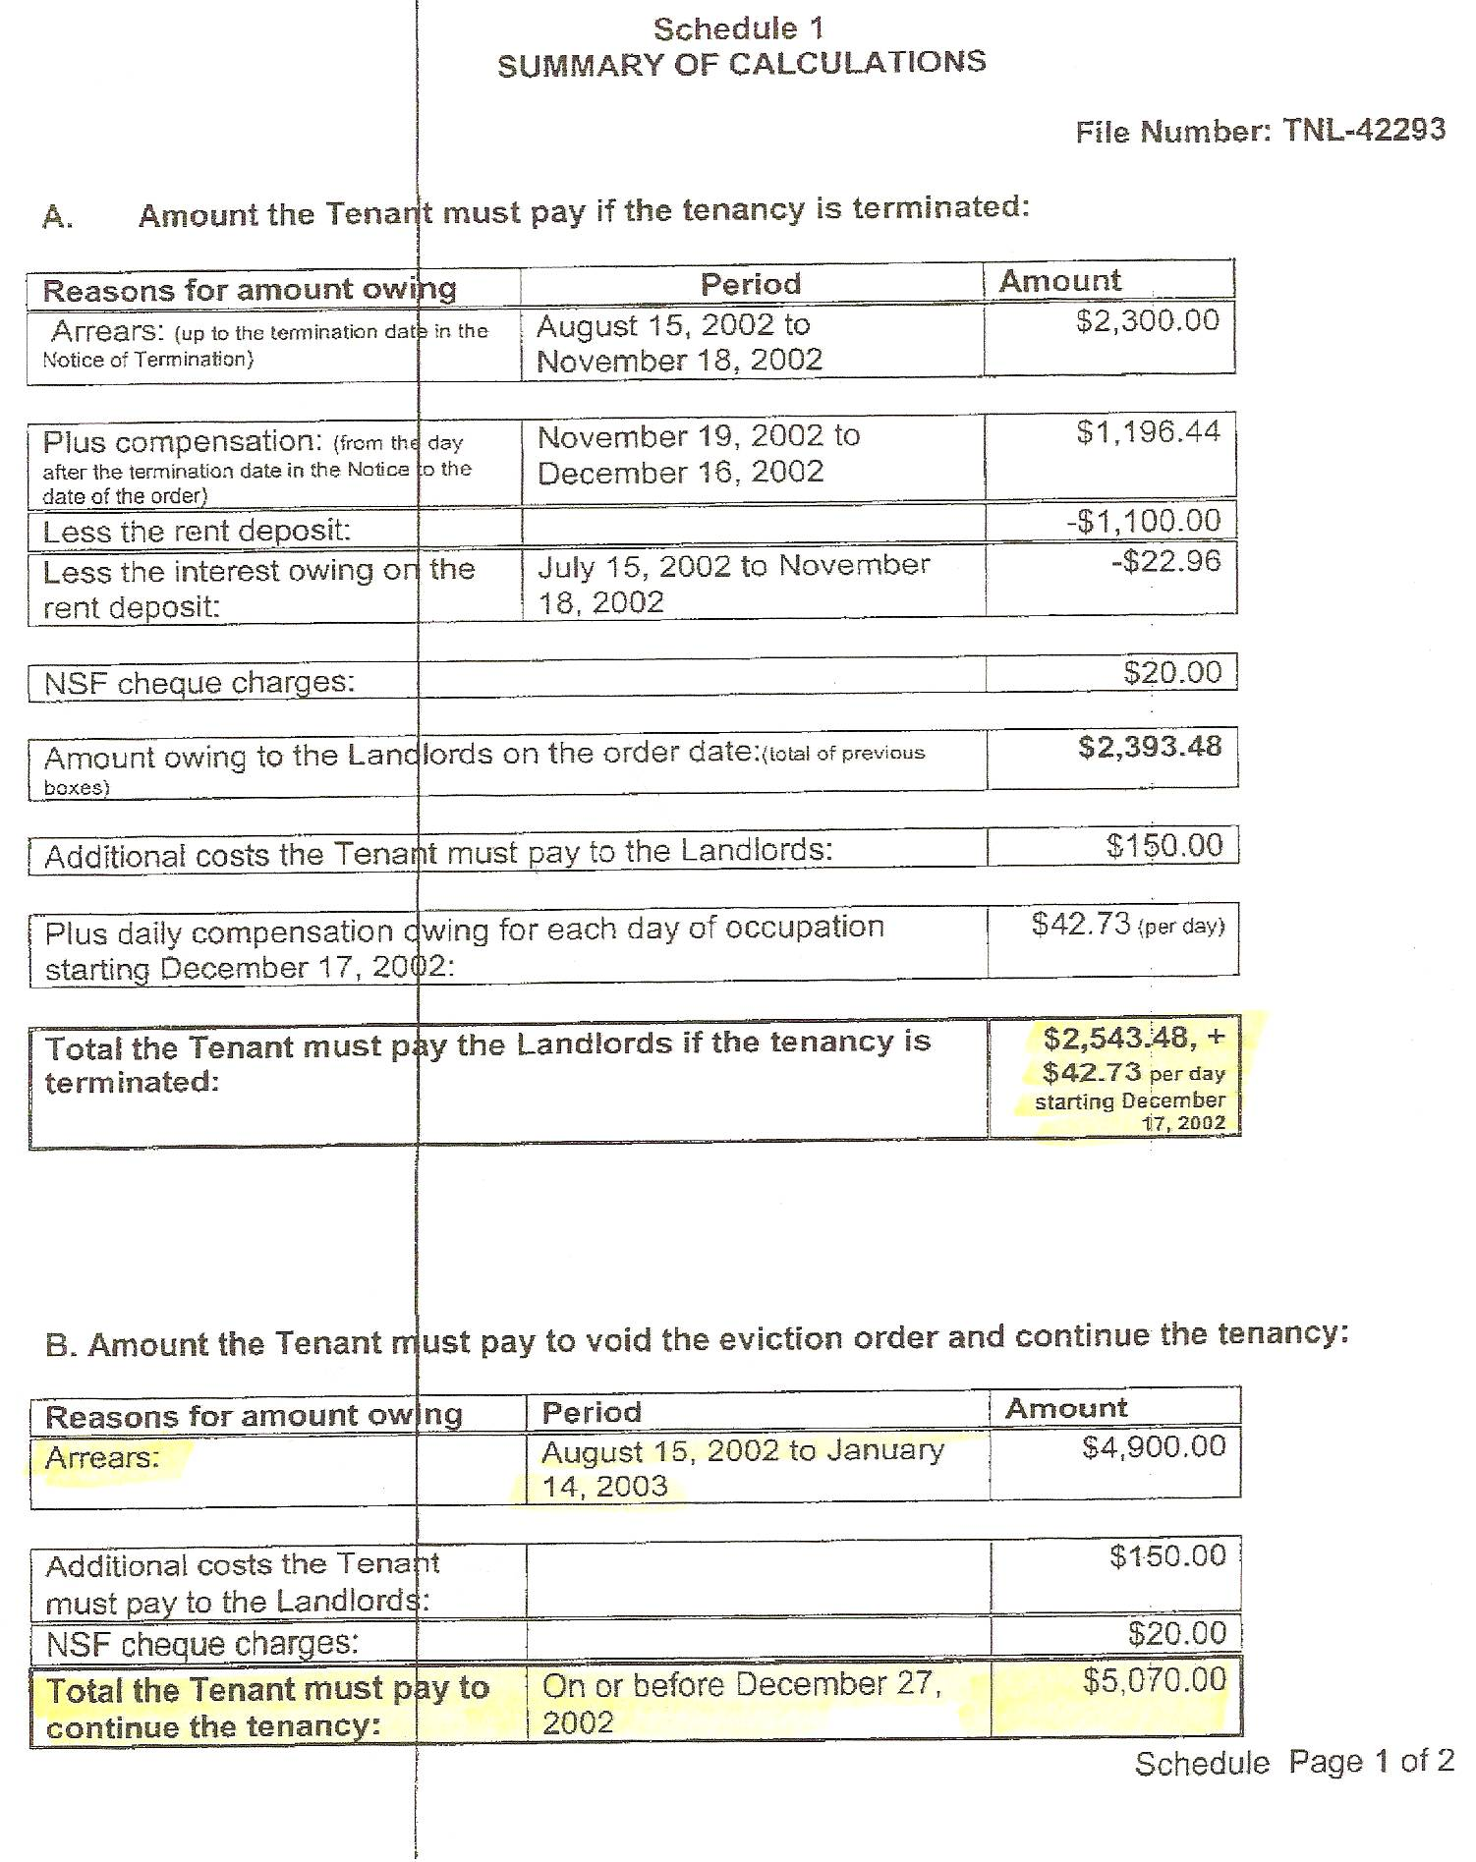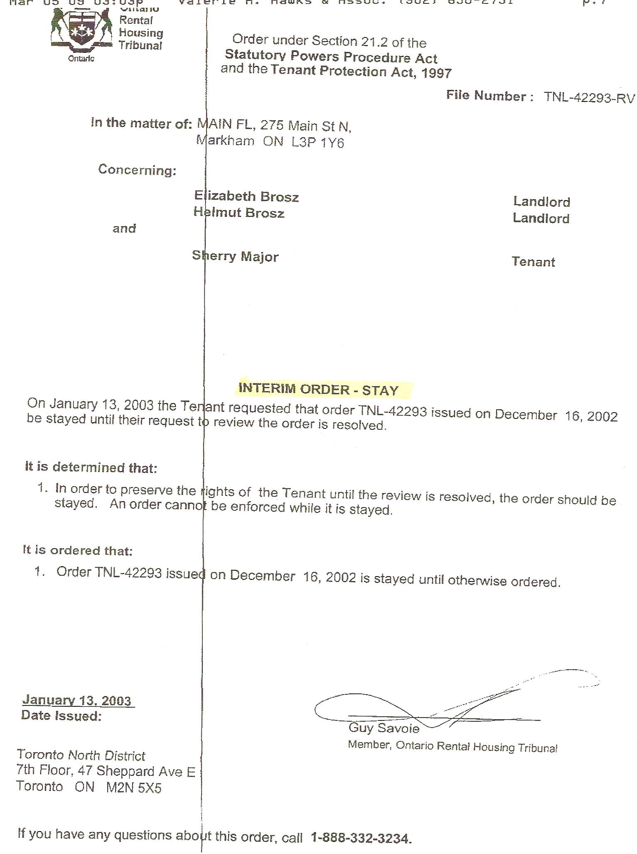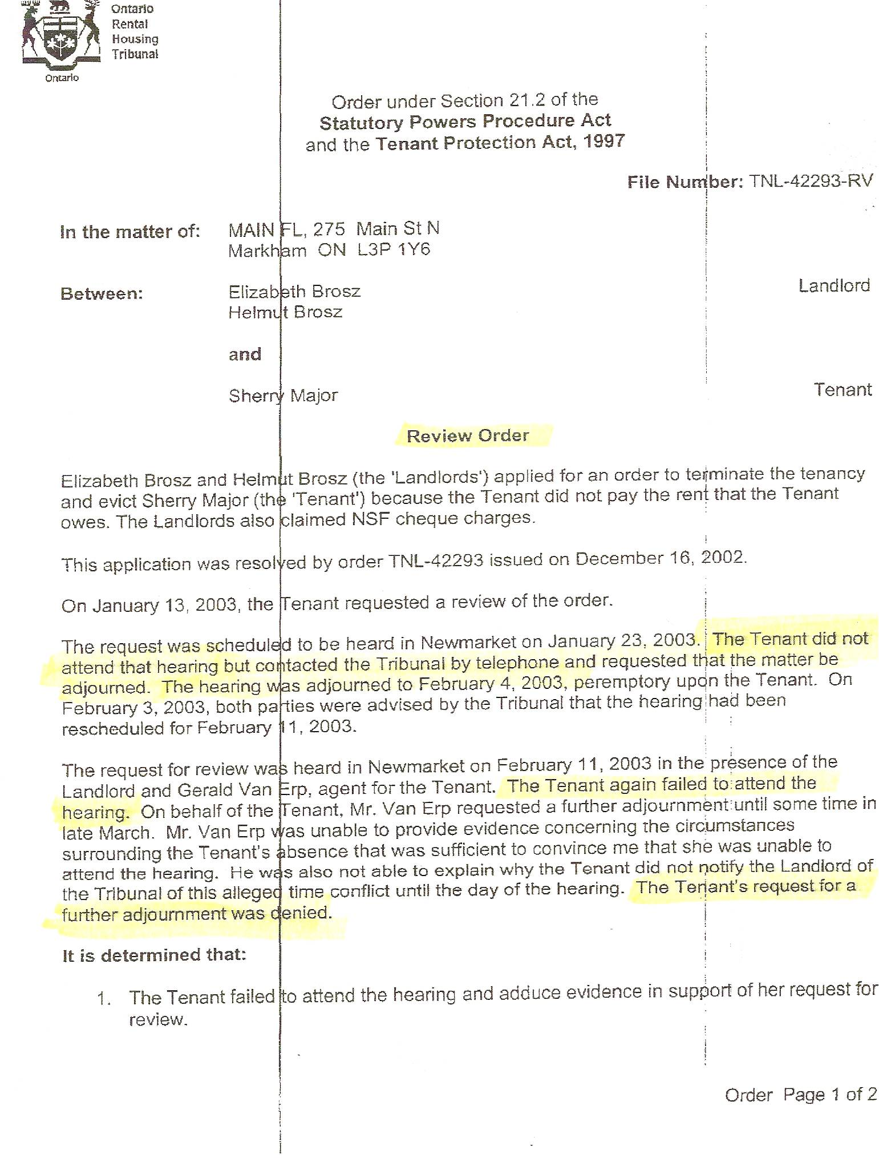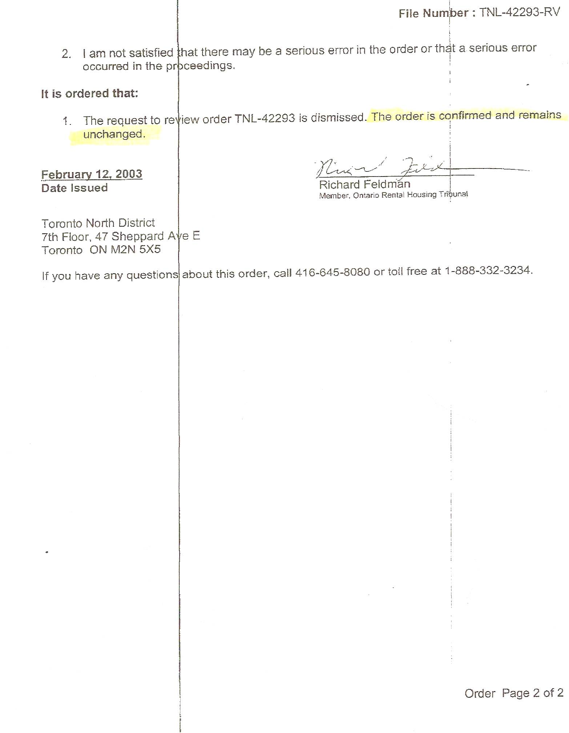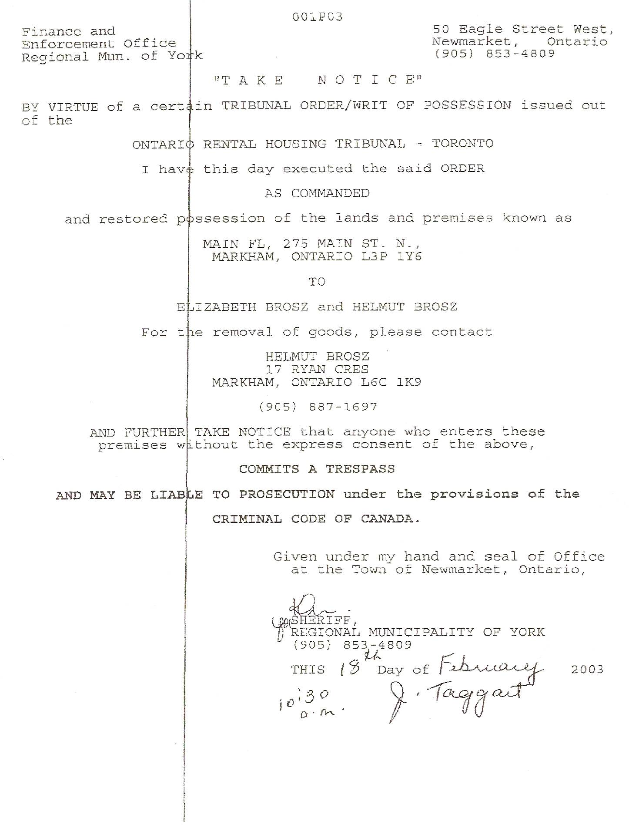

Dan’s Notes:

-I spoke with Ms. Elizabeth Brosz in July 2009. She initially claimed there was no Court Judgment against Sherry Major for the money owed. I advised Ms. Brosz otherwise, noting that I had a copy in my hand at that time. She was very abrupt and did not want to discuss the matter.

-given Sherry Major’s typical modus operandi and Ms. Brosz’s attitude towards me it wouldn’t be far-fetched to believe Sherry had bilked her using the “abused woman” scam

    - LM at 905-887-1697 Brosz & Associates (this is the home #)

-also spoke to daughter Jen at the office (905-472-6660) – she advised to call mother Elizabeth once back from holidays next week since she is away on holidays with Helmut right now and she is the one that handled everything with Sherry

7-10 Elizabeth: -she initially claimed they didn’t have a court judgement against Sherry Major – I jogged her memory and noted the creditor had been located and one other debtor had recently recovered their money. She was very abrupt and said, “At this time we’re not interested in pursuing this. Thank you. Bye.”

