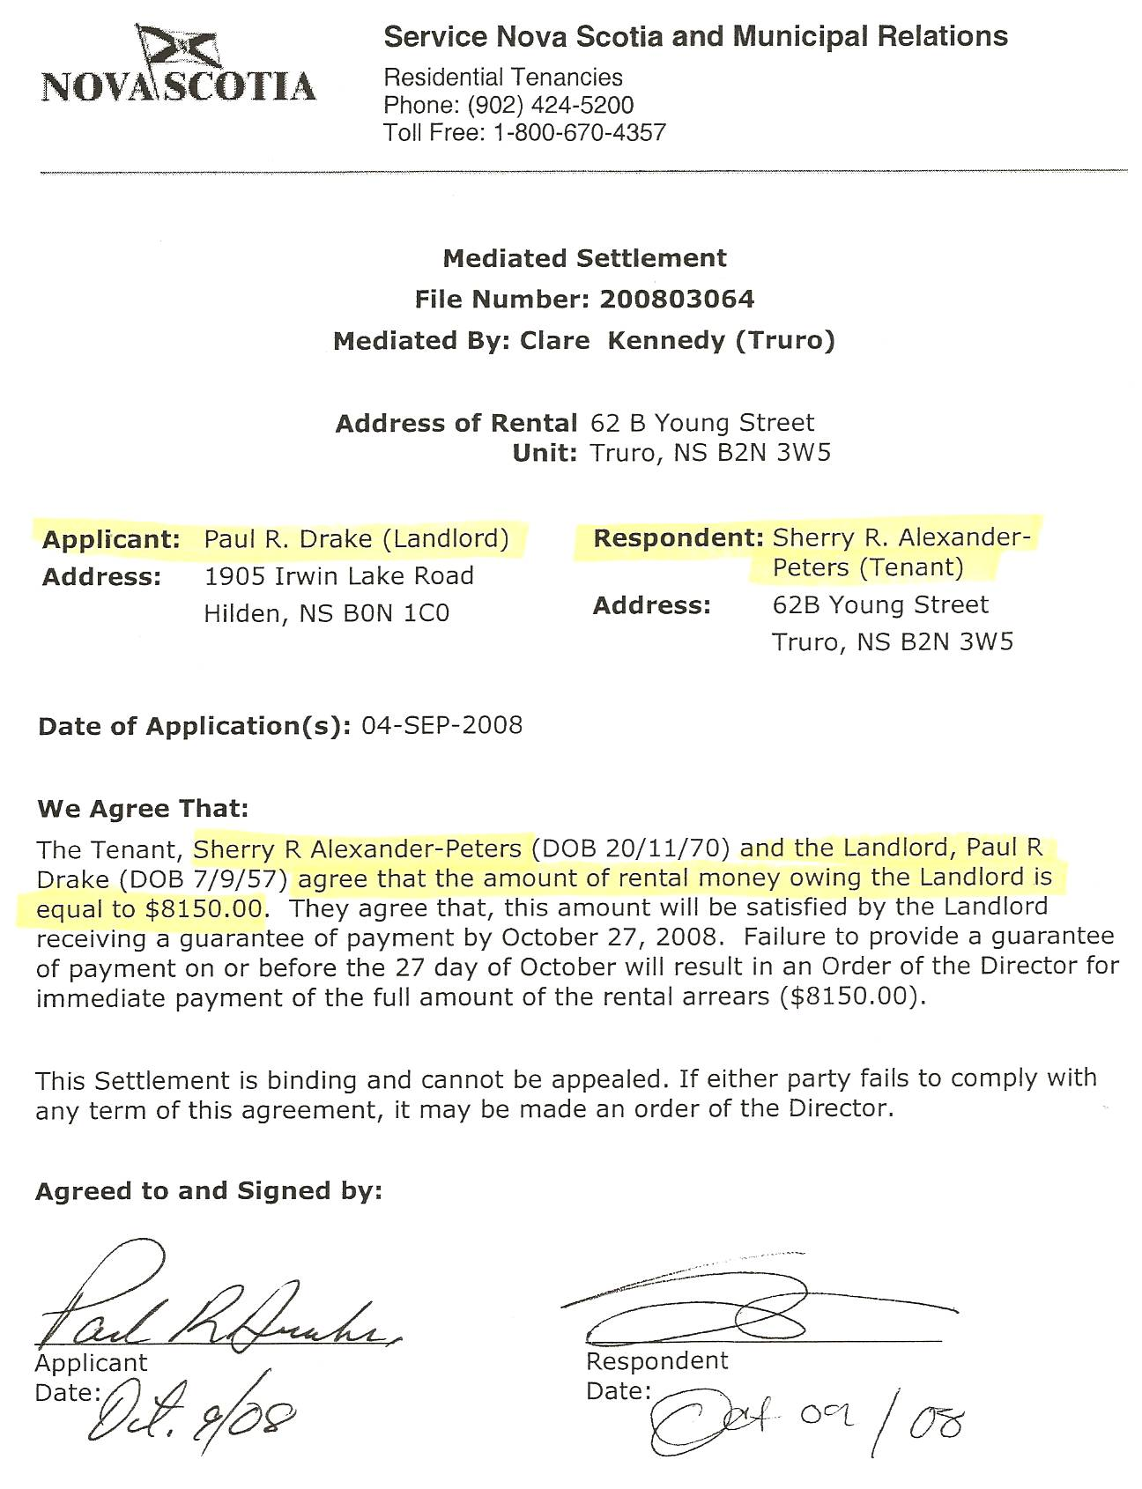
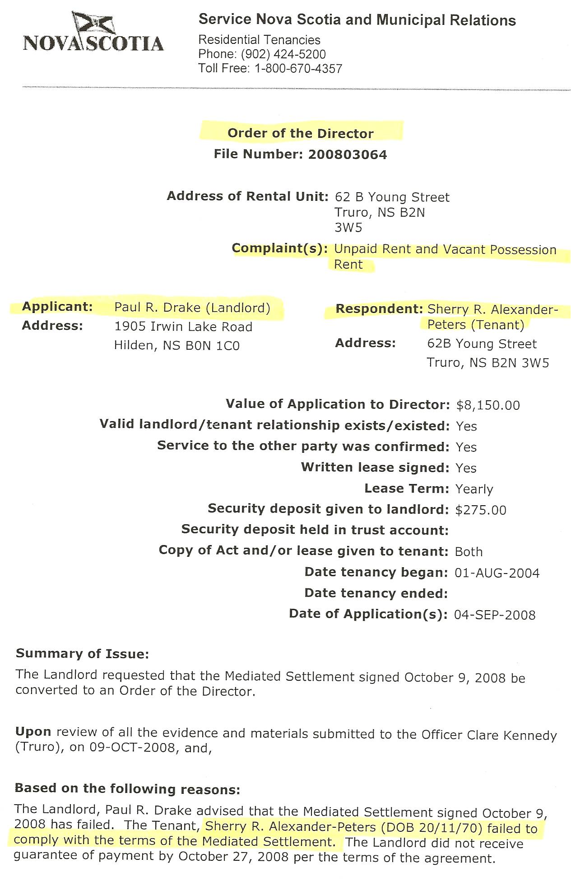
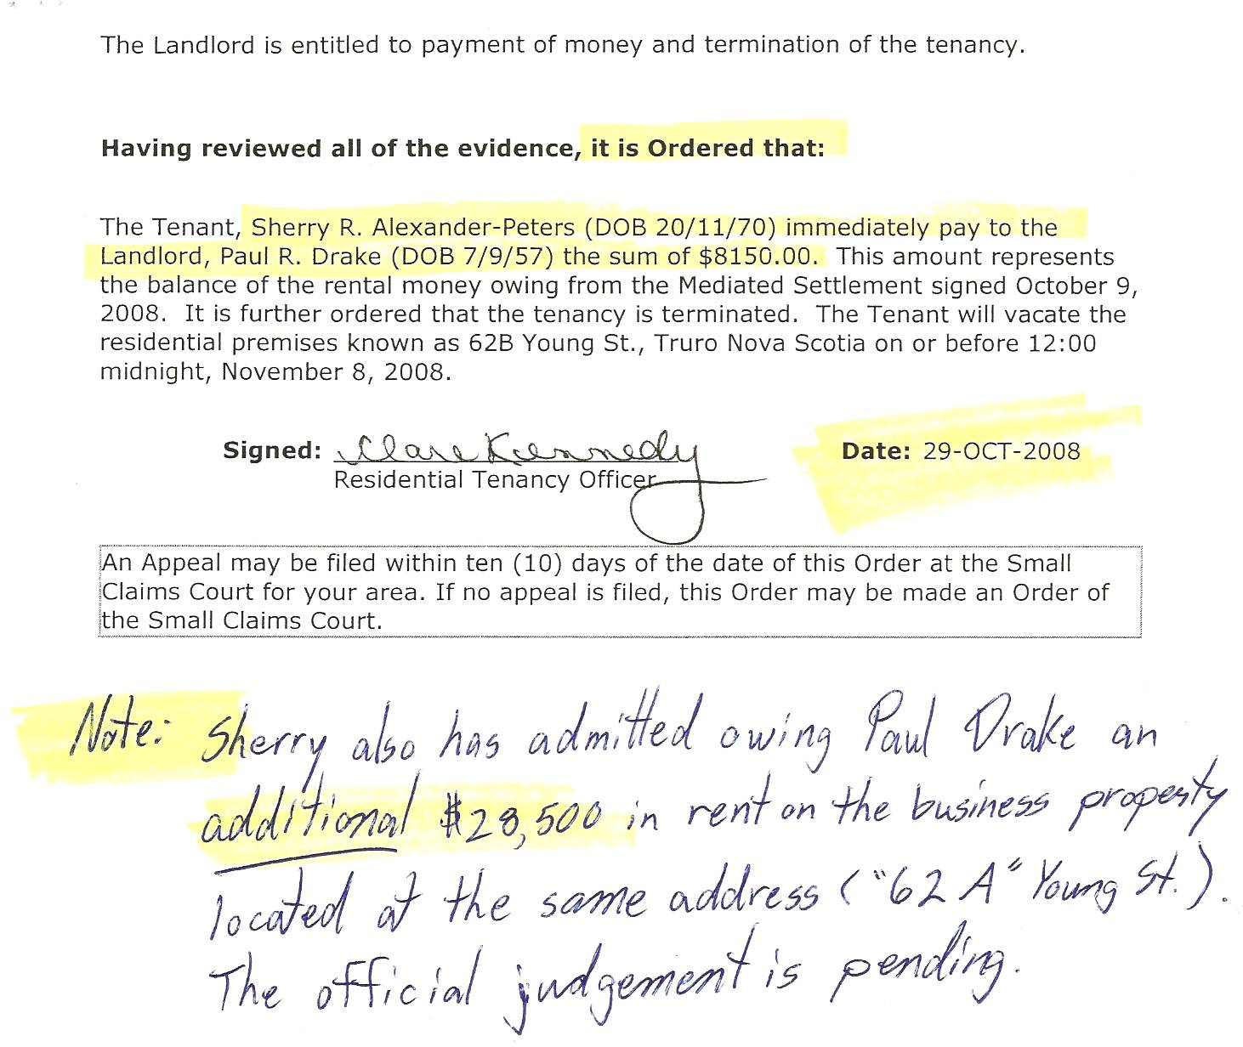

Dan’s Notes:

Sherry Major actually bilked Paul Drake of over $40.000 (as acknowledged in an OCL document) but he never bothered acquiring further Court Judgments since they would likely be a waste of time, effort and money due to the inability to collect any amount owed.

Sherry repeatedly convinced Paul that she was in NIVA and the Witness Protection Program, with her money held in escrow until her new identity was approved. In 2008, Paul notified Sherry on his intent to evict her and he posted notices on the windows of the property. Sherry then claimed she was expecting a $350,000 divorce settlement from me. Soon thereafter, I located and recovered the children, exposing Sherry as a massive fraud artist. Paul evicted her.

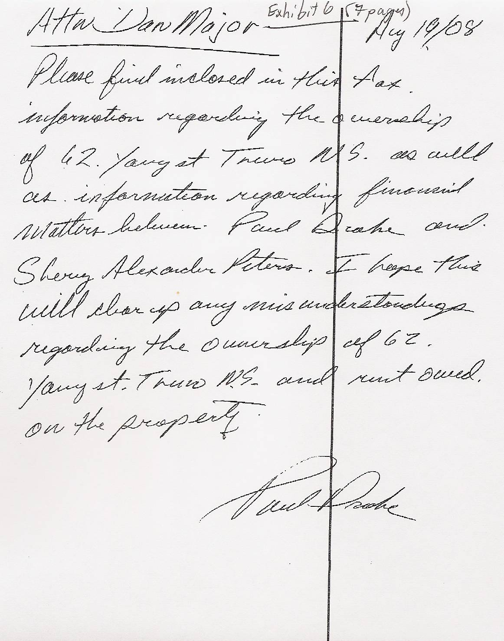

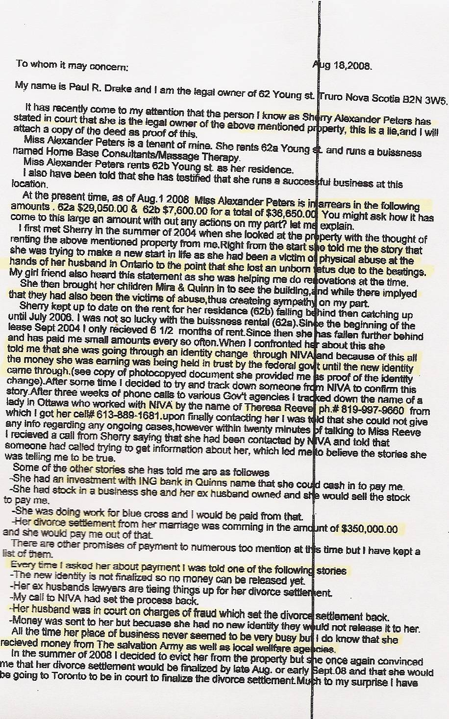
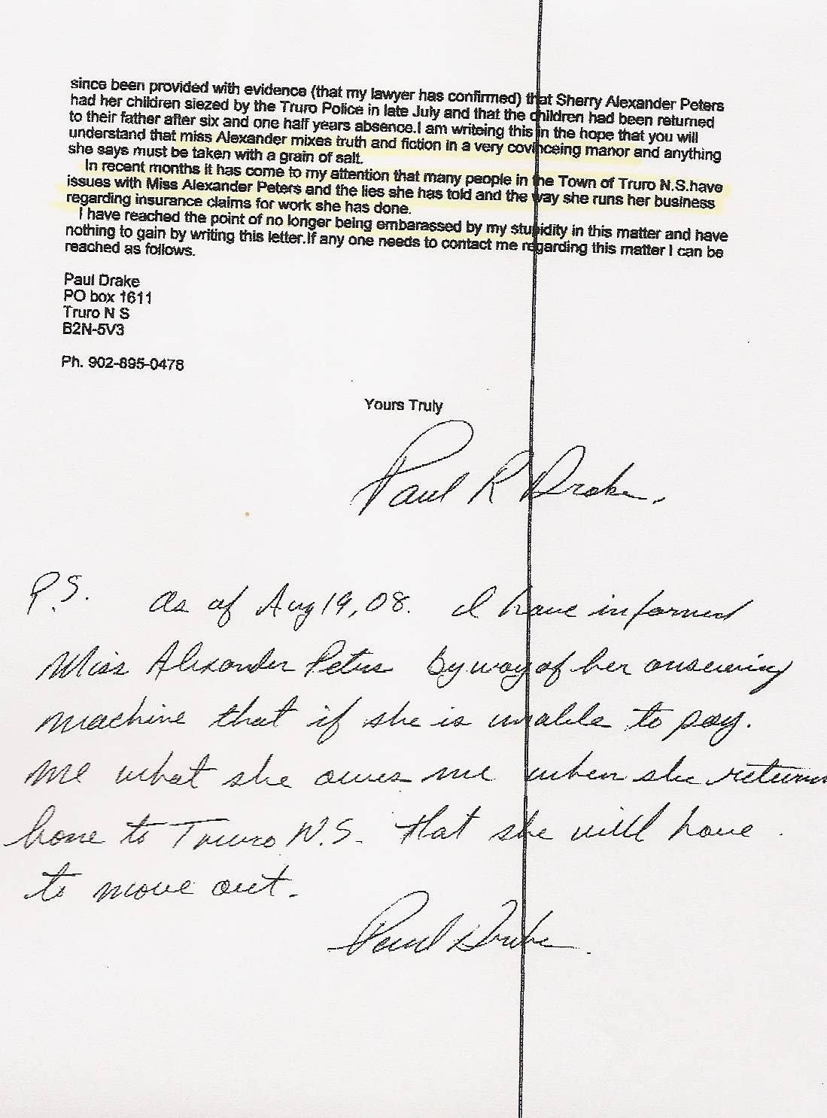

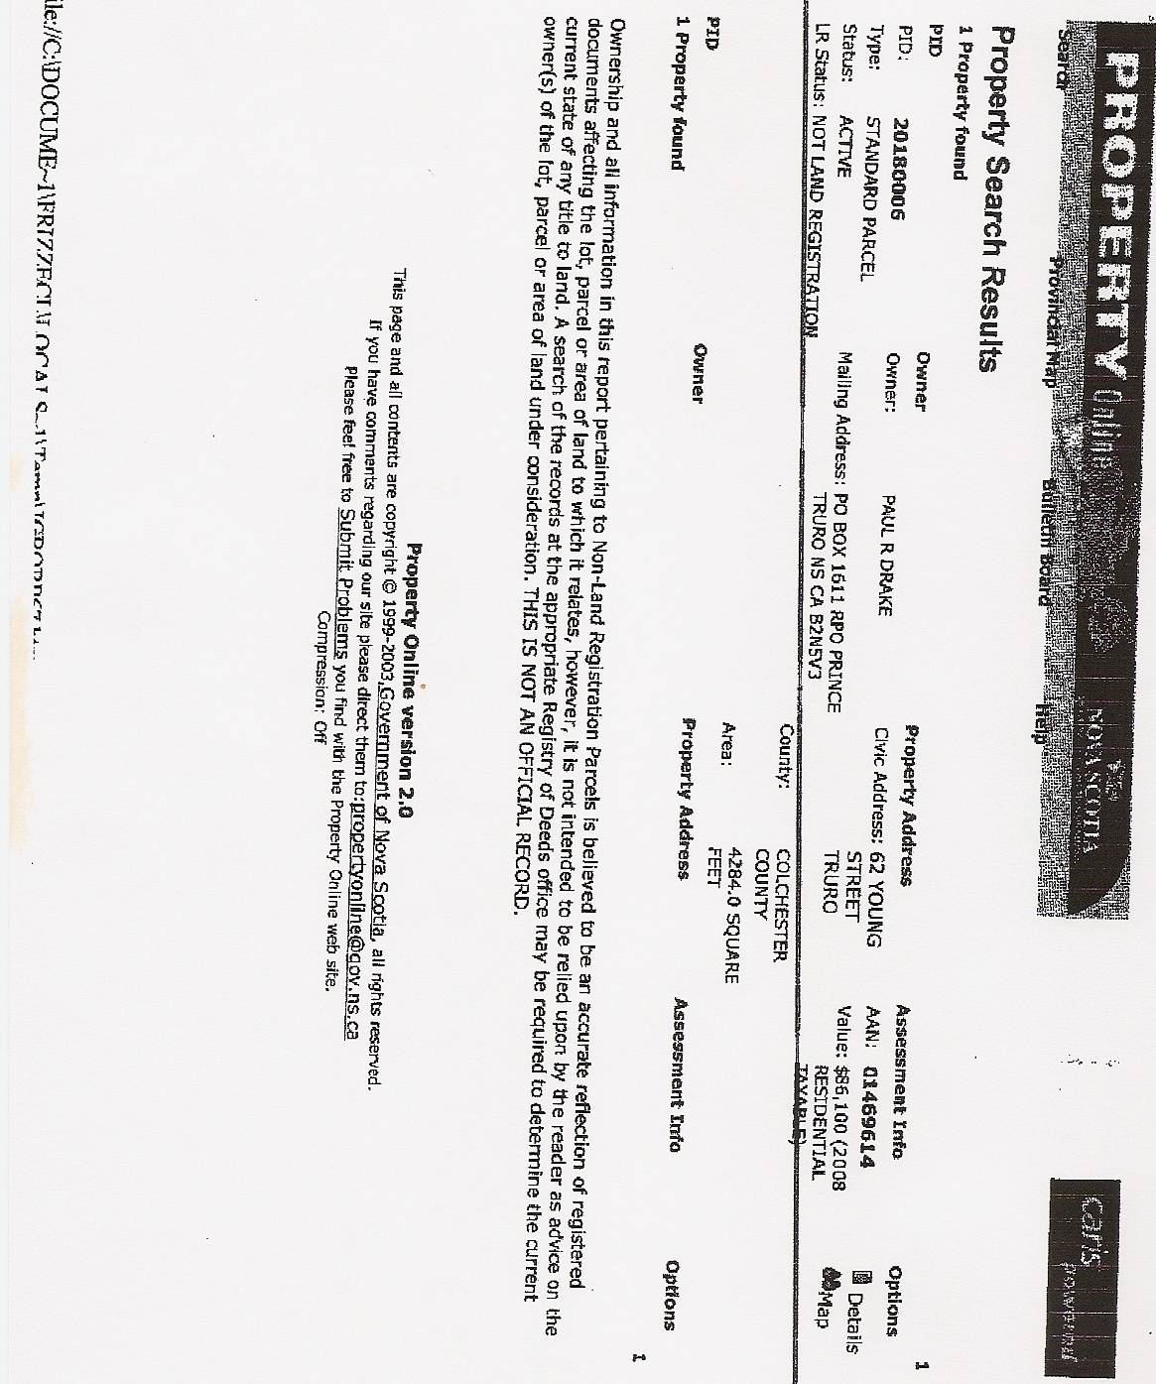

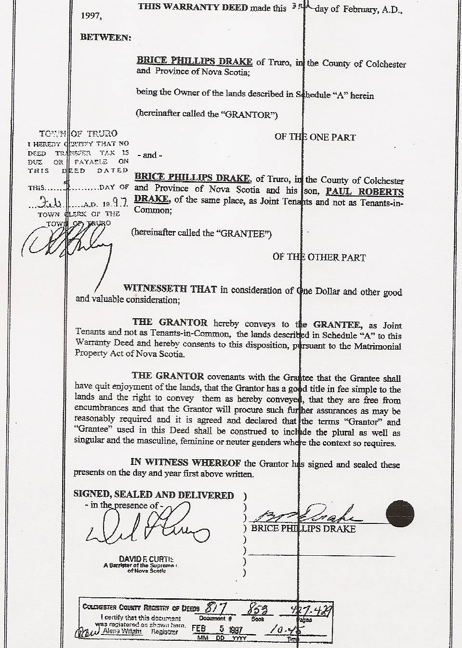

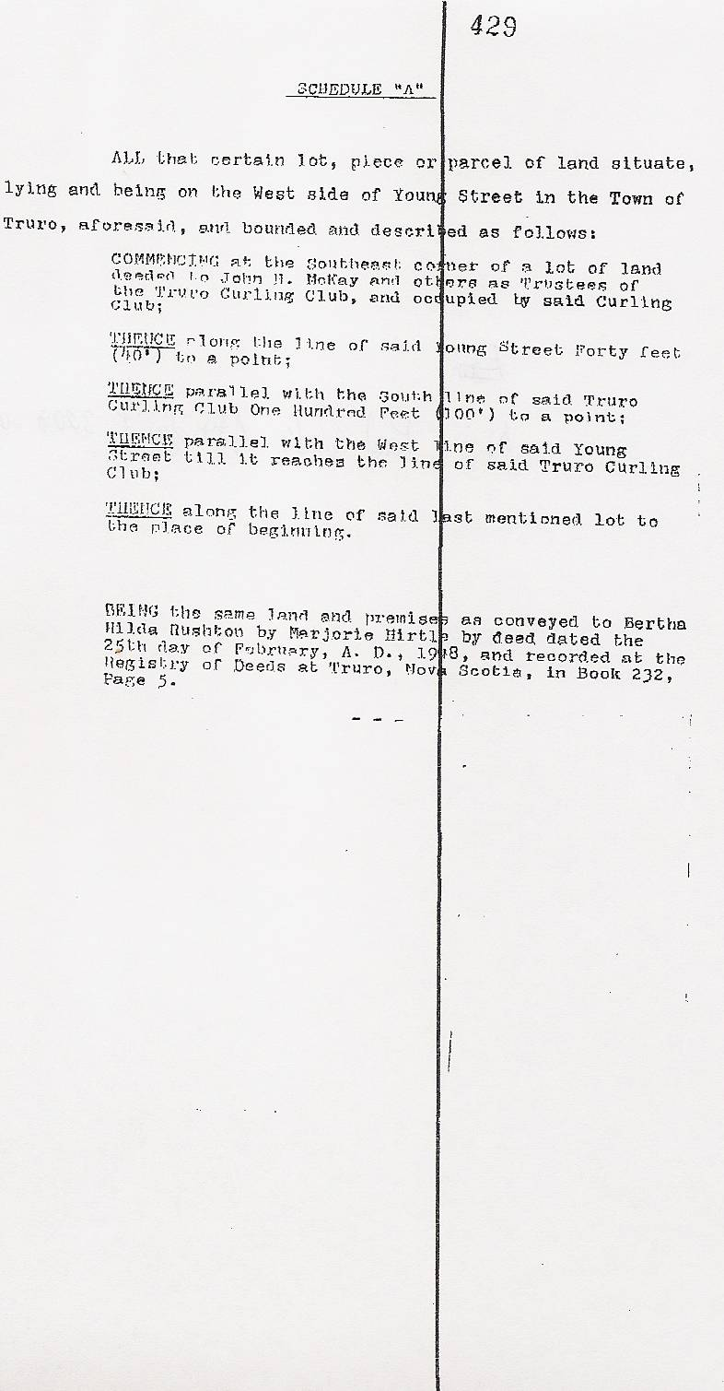

Dan’s Notes:

-Paul Drake was Sherry Major’s landlord between 2004 and August 2008. He was ultimately bilked of over $40,000 in unpaid rent due to Sherry’s lies. As she had done before, Sherry’s lies went beyond little white lies and were extremely “malicious”, just as Judge Lampkin had warned people about in June 2003 at the conclusion of Dan’s trial!

